Part 3:
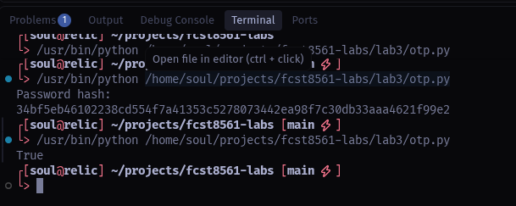

Part 5:
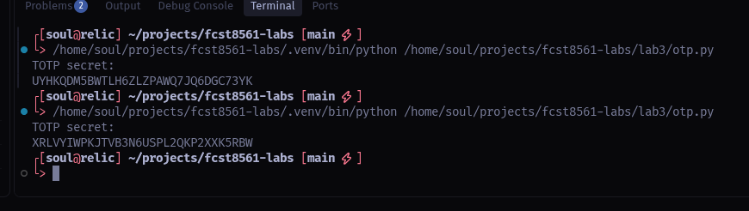

Part 8:
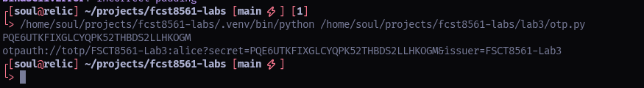

Part 10:
