Part 1:
The “Image description” field can carry other data.
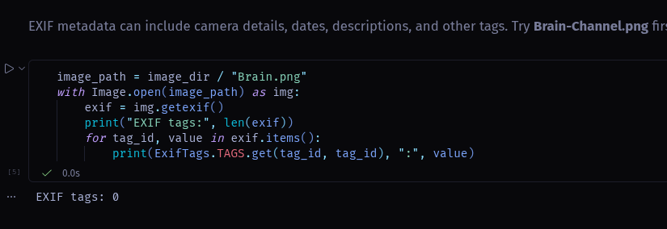
Another one of the images. Having no tags does not mean there is no metadata, as is confirmed with exiftool.
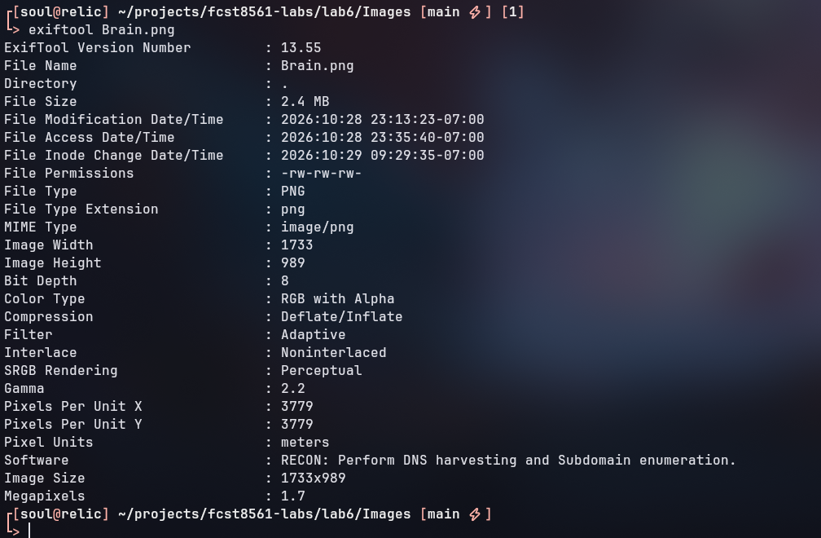

Part 2:
The “software” field contains hidden data as well.
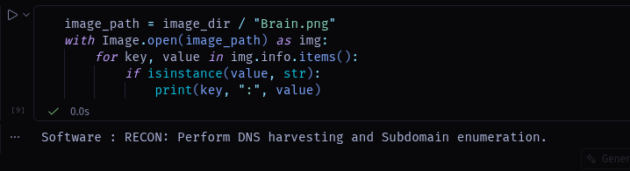
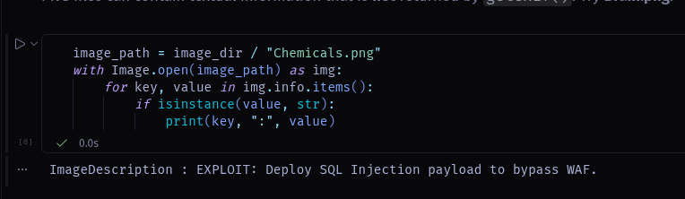

Step 3:
The XML metadata for Dopamine.png. The hidden data is in the XML “MakerNote” field. This is seperate from the direct EXIF data in the image.
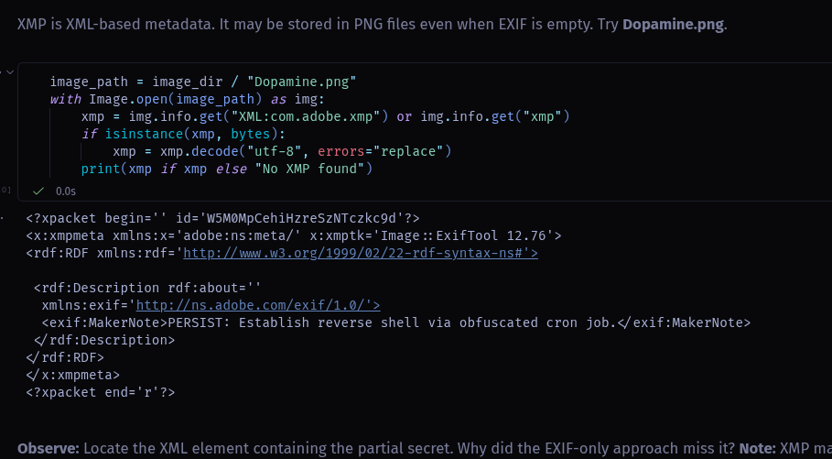

Step 4:
Hidden base64 string in Music.png
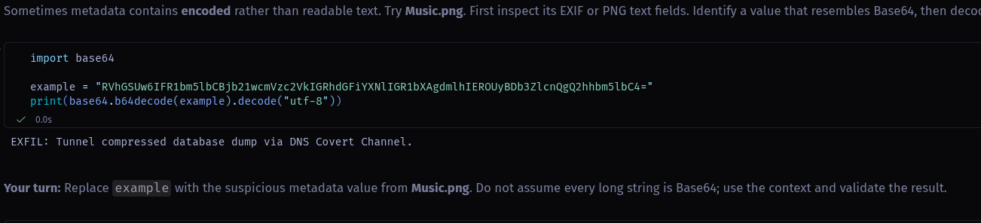

Step 5:
Image | Metadata field | Decoding needed? | Partial secret
Activation.png | User comment | No | VULN: Identify unpatched CVE-2024-XXXX in web gateway.
Brain-Channel.png | Image descriptor | No | LATERAL: Pivot to internal Domain Controller using Mimikatz.
Brain.png | Software | No | RECON: Perform DNS harvesting and Subdomain enumeration.
Chemicals.png | Image description | No | EXPLOIT: Deploy SQL Injection payload to bypass WAF.
Dopamine.png | Maker note | No | PERSIST: Establish reverse shell via obfuscated cron job.
Music.png | Music | Yes | EXFIL: Tunnel compressed database dump via DNS Covert Channel.

Step 6:
- RECON: Perform DNS harvesting and Subdomain enumeration.
- VULN: Identify unpatched CVE-2024-XXXX in web gateway.
- EXPLOIT: Deploy SQL Injection payload to bypass WAF.
- LATERAL: Pivot to internal Domain Controller using Mimikatz.
- PERSIST: Establish reverse shell via obfuscated cron job.
- EXFIL: Tunnel compressed database dump via DNS Covert Channel.
This is the most plausible attack order. The public information must be gathered via recon and enumeration, then a vulnerbility would be identified for the outward facing WAF. The exploit would be used to gain access, and then the attacker would pivot to the domain controller which holds sensitive data. A persistent tunnel would be established, and data would be exfiltrated via DNS.

