Part A:
A1. The response code is the code from the server (ie. 200, 404, 403, etc.) where the response length is the length of the actual message
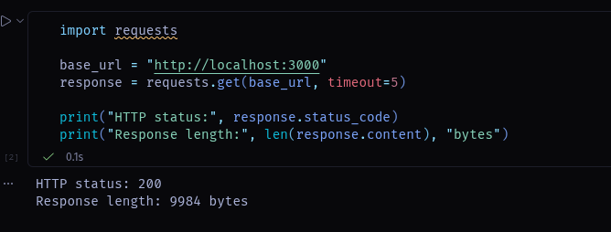
A2. Slicing the response cuts the characters that are printed
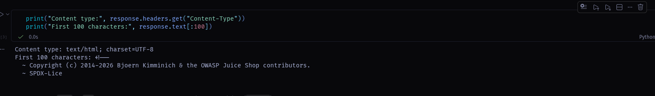
A3.
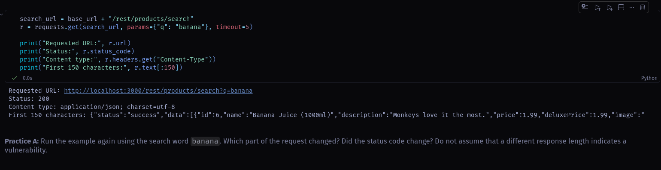
A4. It is a reponse code for trying to misuse an api
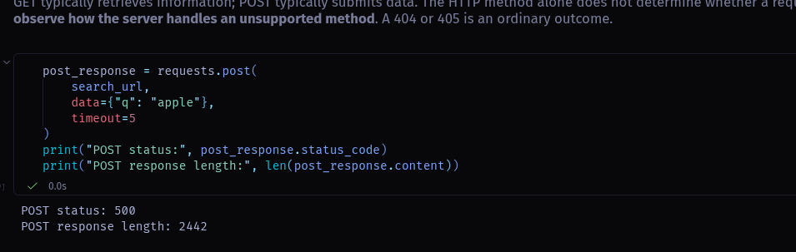

Part B:
B1.
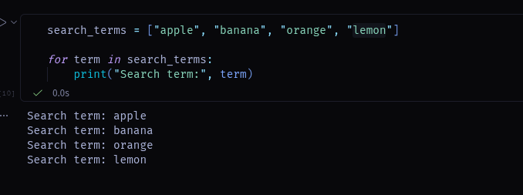
B2.
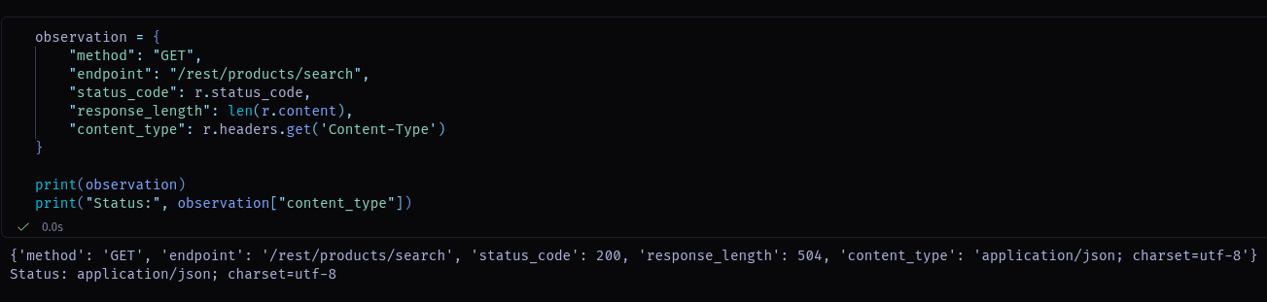
B3. A dictionary makes it easier to access values than an indexed list
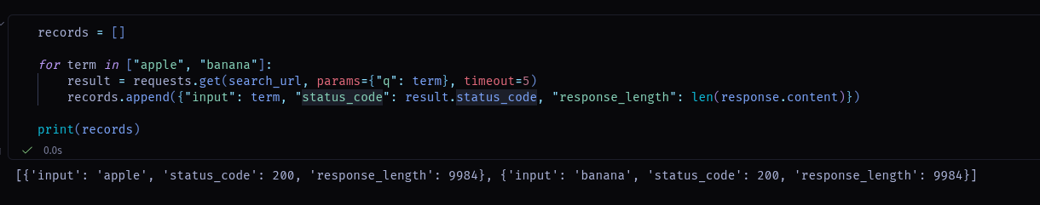
B4. Search word is the parameter that will be used as the search query ?q=
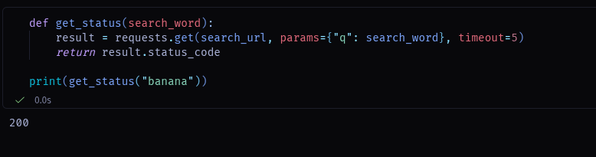
B5. If the scanner does not handle the exception, it could hang or crash
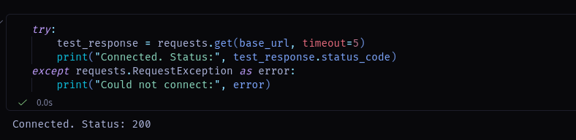

Part C:
C1. No it does not
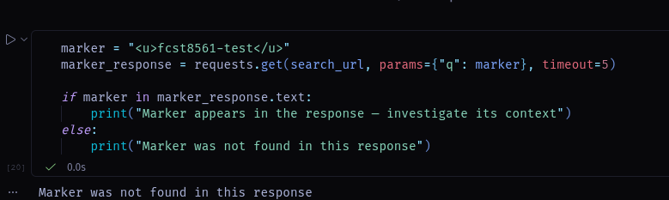
C2. Because it is important to see if the server is handling the request differently than we would expect
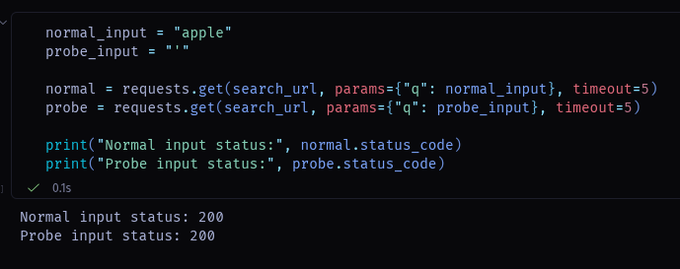
C3. SQLITE_NOMEM, SQLITE_AUTH. There could be an error that doesn’t cause any kind of vulnerability.
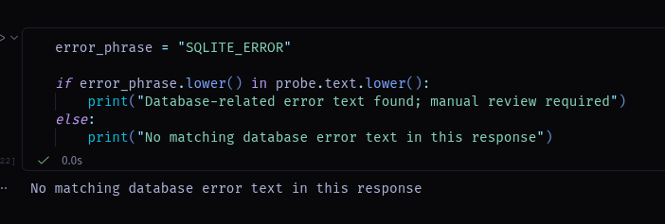
C4. It can give information about the web server itself, but no specific informtion about vulnerbilities
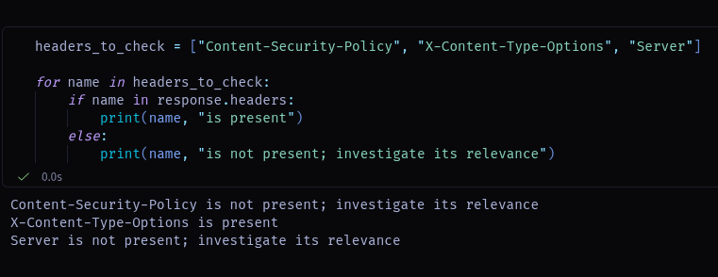
C5. The set only stores messages that have been seen already.
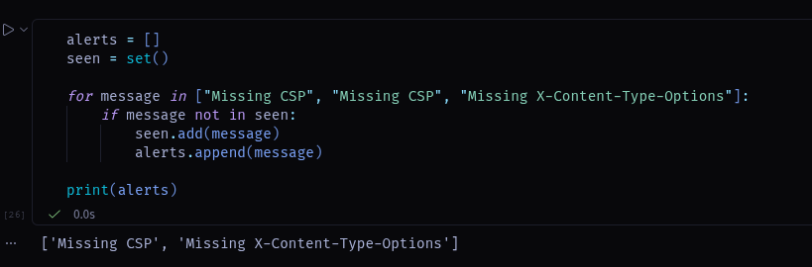
C6. The column headings are endpoint, and status
