Part 1:
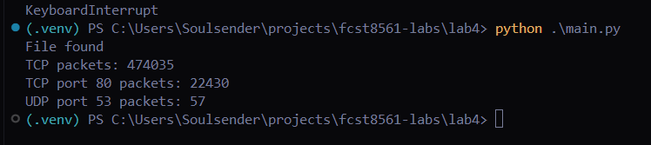
- 47035, 22430, 57
- DNS or HTTP packets can be sent from another port
- Filtering by protocol specifically looks for the headers of the application protocol (like HTTP), and filtering by port just looks at the port and the service that commonly runs on that port.

Part 2:
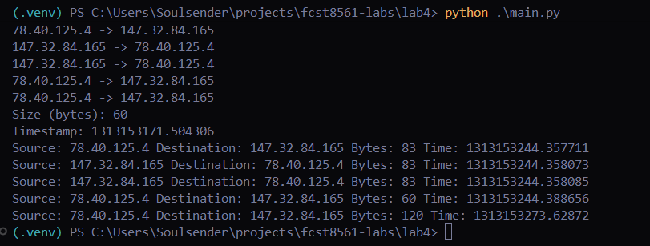
- Where the client and server are
- They show if packets are SYN, SYNACK, or ACK
- To see if all the packets are coming at the same time

Step 3:

