Information.html page
Understanding Prostate Cancer
Prostate cancer is one of the most common cancers affecting men in New Zealand. This page provides clear and reliable information about the prostate, prostate cancer, diagnosis, treatment options, and living well after treatment.
Information here is based on trusted New Zealand resources, including Prostate Cancer Foundation NZ, Cancer Society NZ, and Prostate Matters.
What is the Prostate?
The prostate is a small gland, about the size of a walnut, located just below the bladder. It produces seminal fluid, which nourishes and transports sperm. As men age, the prostate often enlarges naturally, which may or may not cause problems.
What is Prostate Cancer?
Prostate cancer develops when abnormal cells in the prostate gland grow uncontrollably. It often grows slowly, but some types can be aggressive and spread outside the gland.
Learn more at Prostate Matters
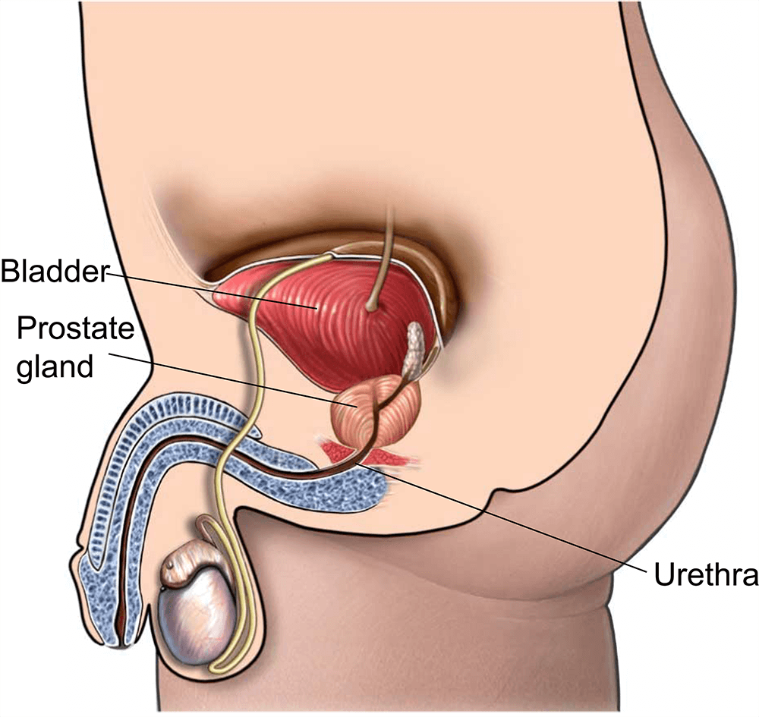
Symptoms & Risk Factors
Early prostate cancer often has no symptoms. When symptoms occur, they may include:
- Frequent urination, especially at night
- Difficulty starting or stopping urination
- Weak or interrupted urine flow
- Blood in urine or semen
- Discomfort in the pelvic area
Risk increases with age (especially over 50), having a family history of prostate cancer, and for Māori and Pasifika men. Lifestyle factors such as diet and physical activity may also play a role.
Information & Support for Māori Men
Māori men are at higher risk of prostate cancer and may face unique challenges in accessing healthcare. Early detection is vital, and support is available to ensure culturally appropriate care.
Key Insights
- Māori men are more likely to be diagnosed at a later stage and have higher mortality rates.
- Cultural and systemic barriers can affect timely healthcare access.
- Family and whānau involvement is important in health decisions.
Support & Resources
- Te Whatu Ora – Māori Health: Offers comprehensive information on Māori health services and programmes across New Zealand.
- Healthify – Māori Health Support: A directory to locate Māori health services and support groups in your area.
- Te Aka Whai Ora (Māori Health Authority): Although disestablished in 2024, their website remains a valuable resource for understanding past initiatives and services.
Māori men are encouraged to have regular check-ups, PSA monitoring, and involve whānau in health decisions. Early engagement with culturally sensitive health services can improve outcomes.
Testing & Diagnosis
If prostate cancer is suspected, doctors may use several methods to confirm the diagnosis:
- PSA Test: A blood test that measures prostate-specific antigen levels.
- Biopsy: Tissue samples are taken for testing (Transperineal Biopsy PDF).
- Gleason Score: Assesses how aggressive the cancer is (Learn More).
- Staging: Imaging tests (MRI, bone scans) show if cancer has spread (Details).
Treatment Options
Treatment depends on the stage and type of prostate cancer, as well as personal health and preferences. Options include:
Active Surveillance / Watchful Waiting
Regular monitoring for slow-growing cancers that may not need immediate treatment.
Learn More →
Surgery (Radical Prostatectomy)
Surgical removal of the prostate gland, which may affect urinary control and erections.
Patient PDF →
Radiotherapy
Uses high-energy rays to target and destroy cancer cells while preserving healthy tissue.
More Info →
Hormone Therapy & Other Treatments
Lowers testosterone levels to slow cancer growth; often used alongside other treatments.
Clinical Trial Info →
Living with Prostate Cancer
After treatment, many men experience changes such as urinary incontinence or erectile dysfunction. Support is available to help manage these challenges.
- Diet and lifestyle guidance
- Prostate Cancer Patient Empowerment Programme (PC-PEP)
- Continence care after surgery (CDHB PDF)

