Research & Prevention
Ongoing research shows that simple lifestyle choices — including diet, exercise, and weight management — can play a big role in preventing or slowing prostate cancer.
Diet & Nutrition

Eating plenty of fruits, vegetables, and whole grains is linked to a lower risk of prostate cancer. Foods like tomatoes (rich in lycopene), broccoli, and green tea contain antioxidants that help protect prostate cells.
Try to limit red and processed meats and high-fat dairy. A balanced diet can support prostate and overall men’s health.
Exercise & Physical Activity
Regular activity helps reduce risk and improve recovery. Walking, cycling, swimming, or even brisk gardening for 30 minutes a day can make a difference.
Exercise also improves immune function and hormone balance — both important for prostate health.

Prost-FIT: PCFNZ’s Prost-FIT programme offers tailored exercise for men at any stage of prostate cancer treatment or recovery. Classes combine physical and cognitive activities in a supportive, social environment, helping participants stay active, improve wellbeing, and connect with others. Sessions are free but require registration.
Learn more about Prost-FIT.
Kegel Exercises for Men
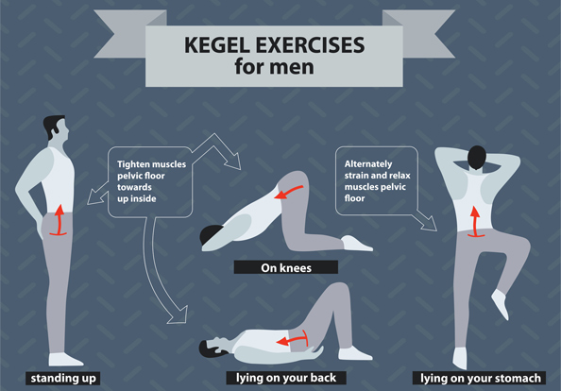
Kegel exercises help strengthen the pelvic floor muscles — the same muscles that control urination and support sexual function. Regular practice can improve bladder control, erectile function, and recovery after prostate surgery.
To get started, focus on tightening the muscles used to stop urinating, hold for 3–5 seconds, and then relax. Repeat 10–15 times, three times a day, while standing, sitting, or lying down. Over time, this simple routine can make a real difference in pelvic health.
Healthy Weight & Lifestyle
Maintaining a healthy weight and avoiding smoking or heavy drinking can reduce your cancer risk. Research links obesity to more aggressive prostate cancer.
Even small daily changes — such as eating better and moving more — make a long-term difference.
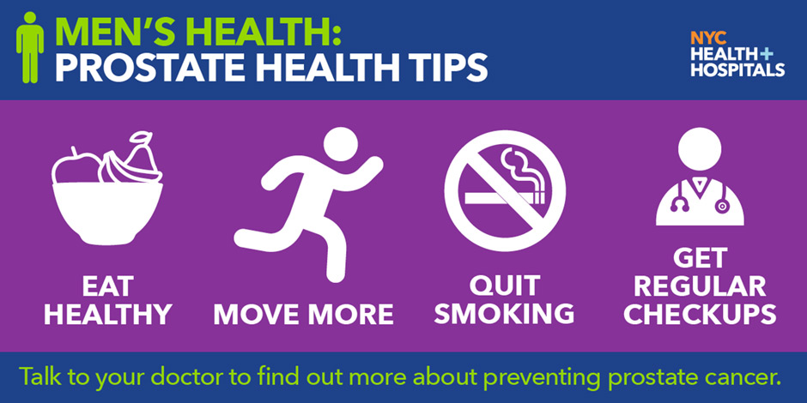
Latest Research in New Zealand
- University of Otago – researchers are investigating how diet and gut health may influence prostate cancer development and progression.
- Auckland Cancer Society Research Centre – focusing on understanding cancer mechanisms and developing targeted therapies to improve patient outcomes.
- Prostate Cancer Foundation NZ – supporting research projects on lifestyle, early detection, advanced imaging, and clinical trials for better prostate cancer care.
Learn more at Prostate Cancer Foundation NZ Research .
K9MD Cancer Detection Trials in New Zealand
K9 Medical Detection (K9MD) trains dogs to detect cancer and other medical conditions through scent. Trials in New Zealand show that trained dogs can identify prostate cancer from urine samples with high accuracy, offering a promising non-invasive screening method.
Dogs involved in K9MD trials have also detected other cancers, including bowel and ovarian cancer, as well as COVID-19 and hypoglycemia. The programme demonstrates the potential for early detection, supporting traditional diagnostic methods and improving patient outcomes.
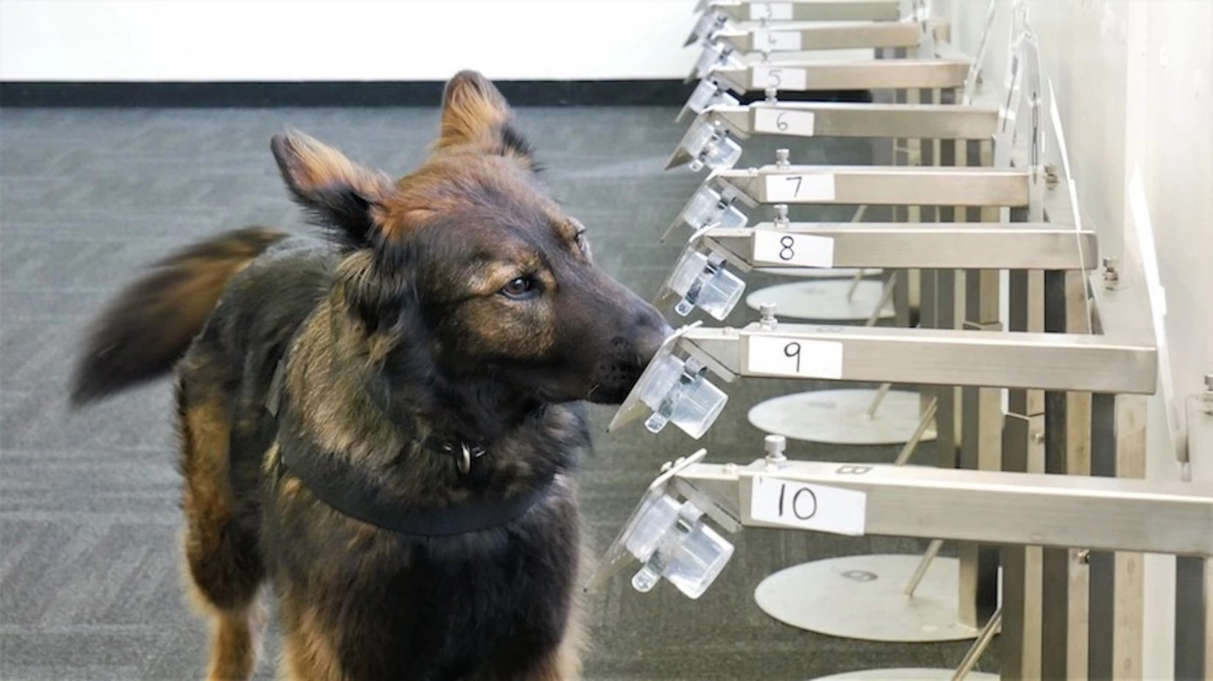
Learn more about K9MD trials and research: K9MD Research .

