

**Recollect – Revise - Resell**

**Founders: A1 Batch**

2023

Shaikh Salif (18)

Souma Chakraborty (19)

Lavanya Upadhya (20)

Arya Jadhav (21)

Paritosh Thakur (22)

May2023

# **“BOOKABOOK”- AN ONLINE BOOK RESALE BUSINESS PROJECT**

1. EXECUTIVE SUMMARY

We may call it a prototype or a start-up. Are you tired of visiting a number of stationaries to buy text books? In spite of this, are you finding those books to be expensive? Are you still struggling to get second hand books in a good condition? This idea is not implemented in the market yet as per our knowledge. No one asked for it either but everyone needed it. Education sector is one of the most service related sector in our country today. India is one of the biggest educational hubs in the world. It produces one of the most significant number of professional Engineers, Doctors, CA’S, IAS, IPS, etc. every year. In today’s world we are trying to make everything reusable and hoping for clean energy. So let's apply the idea of REUSE in Educational Sector as well. When students reach out to book sellers for reselling or buying the so called second hand books, the shopkeepers don't have enough amount of used-books to provide according to their need and henceforth the books not reaching to students. Due to a very short reach of local stationaries, students finds it difficult to find a proper textbook/reference book at an affordable price. Keeping the thought of demand and supply, the demand for second hand books is just getting more and more day by day. Our idea will make the process of buying and selling of used Reference books easier and effective at the same time. As this is the need of every student in Maharashtra and Mumbai so this will be very useful for school as well as college students. At initial low cost margin will be taken by us . Therefore, many students will be attracted towards us. If we will grab Mumbai and Maharashtra students trust, later we can expand up to much larger scale. Advertisement of our idea does not require big investment because we can reach student easily by various social media platforms. Our team is also young and highly energetic so the management of our product can be easily executed. This idea has not been implemented yet and there are no competitions in the market which will lead us to gather a high amount of students all at once. Most important is that our mode is completely online so the reach of our product to students will be much greater than any other platform.

1. COMPANY DESCRIPTION

1) Name of our business: BookABook

Name of founders:

Salif Shaikh (18)

Souma Chakrabarty (19)

Lavanya Upadhya(20)

Arya Jadhav(21)

Paritosh Thakur(22)

Our retail business is focused on providing affordable and accessible books to the community through the resale of our gently used books. Our company's mission statement reflects this goal. We value sustainability, affordability and accessibility. We want to be known as a reliable source of affordable books for all types of readers and our unique selling proposition is sustainability as well as affordability of our books, making them accessible to everyone. Within the first year of establishment we aim to establish a strong presence within the educational community, build a loyal customer base and generate enough revenue to cover operating costs. The long-term goal is to expand to nearby cities, establish partnerships with local libraries, schools, book clubs and colleges and increase our online presence to reach customers outside of physical locations. Our target market is primarily students who value affordability and we aim to promote our service to book enthusiasts and educators.

1. PRODUCTS AND SERVICES

1.Your company’s products and/or services:

We at our company specialize in providing high-quality used books at affordable prices. Our primary product will be high-quality used books in a variety of genres including fiction, non-fiction, children's books, textbooks, and more. All of our books undergo a thorough inspection process to ensure they are in excellent condition and ready for resale. We could offer book appraisal services to customers who want to know the value of their books.

Our business involves a low cost of goods sold (COGS), as the books are acquired at a relatively low cost. Profit margins are typically modest, but a high volume of sales can generate significant revenue.

In terms of relationships with suppliers, manufacturers, and partners, our business may work with various book wholesalers and distributors to acquire inventory at a lower cost. We can also partner with other book resellers to exchange inventory or collaborate on marketing efforts.

Additionally, our business must rely on online marketplaces such as Amazon or eBay to sell its inventory. In this case, the business may need to maintain positive relationships with these platforms and adhere to their policies and guidelines.

Developing strong relationships with suppliers, manufacturers, and partners can be essential to delivering a high-quality product or service to customers.

2.The problem the product or services solve:

Many people are passionate about reading but may not have the financial means to purchase new books at full retail price. We provide customers with access to a wide selection of used books at a lower cost, making reading more accessible and affordable. As consumers become more environmentally conscious, a growing desire is to reduce waste and promote sustainable consumption. We contribute to this effort by providing a market for used books that might otherwise end up in landfills.

We often carry rare or out-of-print books that may be difficult to find elsewhere. This provides customers with a valuable resource for acquiring books that may not be available through traditional retail channels.

Overall, we provide a valuable service to customers by making books more accessible, affordable, and sustainable. It also supports small businesses and promotes the availability of hard-to-find books.

3.What are its benefits, features and unique selling propositions?

The benefits of our business include access to affordable books, sustainable consumption practices, support for local businesses, and access to hard-to-find books. In addition to these benefits, we also provide a wide selection of books, Quality assurance, competitive pricing, and personalized service.

The unique selling proposition of our business is the combination of affordability, sustainability, and access to hard-to-find books. By offering a wide selection of used books at a lower cost, our business makes reading more accessible to a wider audience. Additionally, by promoting sustainable consumption practices, our business appeals to customers who are environmentally conscious. Finally, by offering access to rare or out-of-print books, our business provides a valuable resource for book collectors and enthusiasts.

Compared to other companies, our business may have the advantage of offering a wider selection of used books at a lower cost, as well as promoting sustainable consumption practices. Additionally, by specializing in used books, our business can offer a unique shopping experience that may not be available through traditional retail channels.

4.Any features that gives you a competitive advantage:

We Offer a wide variety of books to our customers, including rare and hard-to-find titles. This makes our business a go-to destination for book collectors and avid readers. We will set our prices lower than our competitors, while still maintaining a profitable margin. Customers will appreciate the value we offer and will be more likely to return to our business. We will make it easy for customers to find and purchase books on our website or in the app. This includes features such as search filters, user-friendly navigation, and multiple payment options.

We would ensure that books are shipped promptly and arrive in good condition. Customers will appreciate the speed and care we take in delivering their purchases.

Also, we will provide excellent customer service by responding promptly to inquiries, resolving issues quickly, and offering personalized recommendations based on customers' interests.

We will build a strong social media presence to connect with customers and promote our business. Share news about new arrivals, sales, and events, and engage with customers through comments and messages. By focusing on these features, we can differentiate our business from competitors and attract loyal customers who appreciate the value you offer.

5.How you will price your product or service:

In our business, the pricing structure typically involves buying books at a low cost and then reselling them at a higher price to make a profit.

We will assess the condition of the book and assign it a condition grade (such as "like new," "very good," "good," or "acceptable") based on established industry standards. Books in better condition should be priced higher than books in poor condition. Research the market to determine the typical price range for similar books in similar condition. This can include checking prices on online marketplaces, looking at competitor pricing, or consulting pricing guides. Also, If the book is rare or out-of-print, we can price it higher than the typical price range for similar books in similar condition. We will consider the demand for the book, both locally and nationally. If there is high demand for the book, we may be able to price it higher than similar books in similar condition.

Once we have assessed the above factors, we will determine the markup we want to apply to the cost basis of the book to arrive at the final sale price. This markup should take into account any overhead costs (such as rent, utilities, and employee salaries) associated with running our business.

In terms of fees or subscriptions, we can charge a membership fee to access exclusive deals or discounts, while others may offer a flat fee for shipping or handling. We will research competitors in our market and ensure that our pricing falls within a reasonable range.

1. MARKETING PLAN

Industry/target market research is an assessment of the overall appeal of the industry and the target market for the product or service being proposed. This section provides details on the industry, the competitive landscape, our target market and how we will market our business to those customers.

1.Industry attractiveness:

A book resale business would fit into the retail industry, specifically the second hand or used goods sector. This would include other types of resale businesses, such as thrift stores, consignment shops, and online marketplaces like eBay and Amazon Marketplace. Regardless of its classification, this resale business would operate within the broader retail industry and would face competition from other retail businesses in the same sector.

The book resale industry can be considered attractive for several reasons. Firstly, the market for used books has been growing steadily over the past few years, driven by the increasing popularity of sustainable and eco-friendly living, as well as the rising interest in vintage and rare books. Secondly, with the proliferation of online marketplaces and social media platforms, it has become easier than ever for sellers to reach a wide audience and connect with potential buyers. Additionally, the low start-up costs associated with a book resale business make it an accessible option for aspiring entrepreneurs, and the potential for high profit margins is also an appealing factor. Finally, the industry can offer a sense of fulfilment for book lovers who are passionate about sharing their favourite reads with others, while also contributing to the circular economy.

The retail industry is constantly evolving and experiencing fluctuations in growth and shrinkage based on various economic and societal factors. However, despite the challenges posed by e-commerce and changing consumer behaviour, the retail industry as a whole continues to grow. According to Statista, the global retail industry was valued at $20.8 trillion in 2020 and is projected to grow to $31.9 trillion by 2025.

To succeed as a book resale business within the retail industry, several critical success factors are necessary. Firstly, it is essential to have a deep understanding of the target market and its preferences, including factors such as genre, age group, and reading habits. Secondly, creating a unique value proposition that sets our business apart from competitors is crucial, such as offering rare or collectible books, providing excellent customer service, or creating a cozy and inviting atmosphere in physical store locations. Thirdly, leveraging technology and digital marketing strategies to reach a broader audience and increase sales is essential, particularly given the growth of e-commerce. Finally, establishing strong relationships with suppliers and continuously refreshing the inventory with quality books is necessary to meet customer demands and remain competitive.

**2.Barriers to entry:**

While the low startup costs associated with a book resale business make it an accessible option for aspiring entrepreneurs, there are still some barriers to entry that should be considered.

One significant barrier to entry is the competition within the industry. While there are opportunities for niche markets or specialties, the book resale industry as a whole is relatively saturated, with many established businesses and online marketplaces already dominating the market. This can make it challenging for new businesses to gain traction and attract customers.

Another significant barrier to entry is the need for a robust and diverse inventory. To be successful, a book resale business must have access to a wide variety of books, including popular and classic titles, as well as more niche or specialized genres. Building a quality inventory can be time-consuming and costly, particularly for businesses looking to acquire rare or collectible books.

Logistics can also present a barrier to entry, particularly for businesses with physical store locations. Rent, utilities, and other overhead costs can be significant, and securing a prime location in a desirable area can be challenging and expensive.

Finally, regulatory and legal considerations can also present a barrier to entry, particularly when it comes to copyright and trademark laws. We must ensure that we are not infringing on intellectual property rights when selling books and should have a good understanding of the legal requirements surrounding the resale of books.

**3.Timelines of entry into the target market:**

There are several benefits to starting a book resale business now, particularly given the current economic and social climate.

Firstly, there is a growing interest in sustainable living and eco-friendly practices, which has led to an increased demand for secondhand goods, including books. This provides an opportunity for book resale businesses to tap into a growing market and meet the needs of environmentally conscious consumers.

The COVID-19 pandemic has accelerated the shift towards e-commerce and online shopping, making it easier for book resale businesses to reach a wider audience through online marketplaces and social media platforms. This has also led to an increase in demand for at-home entertainment and self-education, which can be satisfied through books.

The rise of niche markets and specialized genres in the book industry provides an opportunity for book resale businesses to cater to specific interests and preferences. Whether it's rare books, out-of-print titles, or a focus on a particular genre, book resale businesses can differentiate themselves from competitors and appeal to a specific audience.

Starting a book resale business can be a fulfilling venture for book lovers who are passionate about sharing their favourite reads with others while contributing to the circular economy. With low startup costs and the potential for high profit margins, our business is an accessible and rewarding opportunity for aspiring entrepreneurs.

**4.Product or service features:**

Audience will get different offers on same product due to multiple sellers (such options are not available in offline stores) . Chances of success are higher because offline stores offer and their features are limited up to a certain point/level. Most important is that our mode is completely online so the reach of our product to students will be much greater than any other platform. Maintenance of product (app) is also low cost.

THIS IS AN EVERGREEN market , people will definitely buy books even in recession also.

Online platform (features), high demand will give strong opposition to our competitors

**5.Target customers:**

* Bargain hunters: People who love to read and are always on the lookout for good deals on books.
* Students: College and university students who need textbooks for their courses but want to save money by buying used books.
* Collectors: People who are interested in rare and hard-to-find books, and are willing to pay a premium for them.
* Educators: Teachers and professors who need books for their classrooms, increase in their professional knowledge, who don’t mind used books and are looking for affordable options to keep their costs down.
* All in all, this business attracts environmentally conscious consumers i.e. people who are concerned about the environment and want to reduce their carbon footprint by buying used books instead of new ones.

**6.Competition:**

Currently there is less competition in online platform of such idea specially which is dedicated for MU, SSC, HSC, JEE, NEET, NDA ,Pune University.

On a smaller scale, bookstores and libraries within and near the college premises are the major competition but better rates and access and delivery of books on the click of a button gives our business an advantage as it provides a more time and energy efficient way. There is also a threat in competition as there is a surge in the availability of e-books.

**7.Marketing and advertising tactics:**

* Events and promotions: Host events such as workshops in colleges, book signings, book clubs, or author readings to bring in more customers and generate interest in your business.
* Social media marketing: Create social media accounts for our business on platforms such as Facebook, Instagram, and Twitter. Use these platforms to showcase our inventory, share information about upcoming sales or promotions, and engage with our customers.
* Email marketing: Build an email list of your customers and send regular newsletters with information about new arrivals, discounts, and promotions.
* Content marketing: Create valuable content for our website and social media platforms that will appeal to your target audience. This could include book reviews, reading lists, author interviews, and more.
* Referral program: Offer discounts or other incentives to customers who refer their friends and family to our business.

1. OPERATIONS PLAN

Since delivery is the main area to look after except the tech involved, for our initial stage, we have planned to tie-up with pre-established some delivery partners that would give us the access to the entire of the Mumbai for now. Later on as we expand, we plan to do deliveries on our own by hiring delivery executives.

For the tech part, we will build an application of the name ‘Book-A-Book’ from where one can login using phone number/email-id and then can access both the buy and sell options. For a seller, it will be compulsory to upload images of the book from at least 3-4 different angles along with the description of the condition of the book and the price he wishes to get. The interested buyer will then read the description and check the images and the cost and can either bargain and/or proceed to buy. Once the finalized amount is paid by the buyer (including 1% company charges), the seller gets a notification confirmation and the book shall be collected from his/her home by our delivery executive, they will check and confirm the condition of the book with reference to the said description and then will deliver the book to the buyer.

Since we charge 7% from both the parties and the buyer pays us the total amount in advance, we transfer book amount stated by the seller after 1% deduction for which he/she will be informed.

1. STARTUP EXPENSES AND CAPITALISATION

|  |  |
| --- | --- |
| **CAPITAL INVESTMENT** | **AMOUNT (Rs.)**  **(ONE TIME)** |
| App Listing on Play store | 2500 |
| Computer and accessories | 400,000 |
| Server | NULL |
| Furniture and fixtures | NULL |
| Vehicles | NULL |
| Property | NULL |
| Warehouse | NULL |
| **GROSS TOTAL :** | **402500** |

|  |  |
| --- | --- |
| **OPERATING EXPENSES** | **AMOUNT**  **(Monthly)** |
| **PROFESSIONAL SERVICES :** |  |
| Customer Support Service (4) | 20,000 |
| Accounting Service (2) | 30,000 |
| Delivery Service | 40,000 |
| App Developers (2) | 60,000 |
| **ADVERTISING AND PROMOTIONS :** |  |
| Social media marketing | 80,000 |
|  |  |
| **UTILITIES :** |  |
| Internet | 5000 |
|  |  |
| **LICENSE AND PERMITS :** |  |
| App Layout and Idea Patent | 50,000 (20 Year Validity) |
| Trademark | 9000 (10 Year Validity) |
| **Net Total (Operating Expenses) :** | **294,000** |
|  |  |
| **TOTAL STARTUP FUNDS REQUIRED :** | **431900** |

|  |  |  |  |
| --- | --- | --- | --- |
| **PROJECTED INCOME STATEMENT\*** | **YEAR 1** | **YEAR 2** | **YEAR 3** |
| **SALES :** |  |  |  |
| Total Sales | 672,000 | 3,900,000 | 9,800,000 |
|  |  |  |  |
| **COST OF SALES :** |  |  |  |
| Purchases | 402,500 | 500,000 | 750,000 |
|  |  |  |  |
| **Monthly Expenses :** |  |  |  |
| Salaries | 200,000 X 12  = | 300,000 X 12 | 500,000 X 12 |
|  | 2,400,000 | 3,600,000 | 6,000,000 |
| **Net Profit :** | **-2,130,500** | **-200,000** | **3,050,000** |

1. DEMO / PROTOTYPE

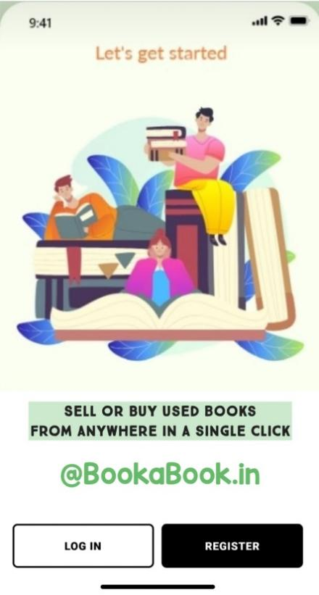 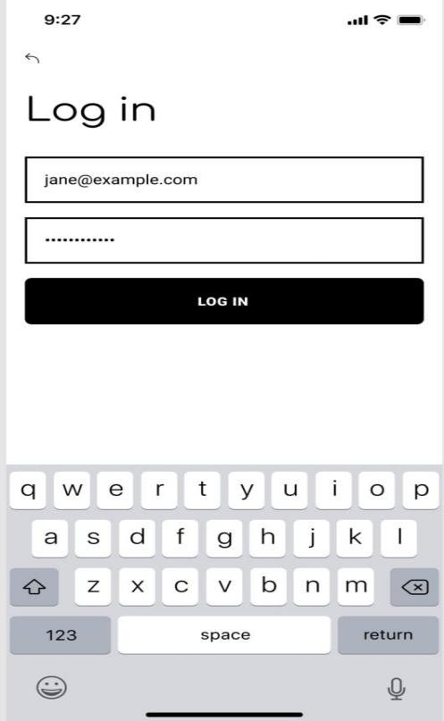

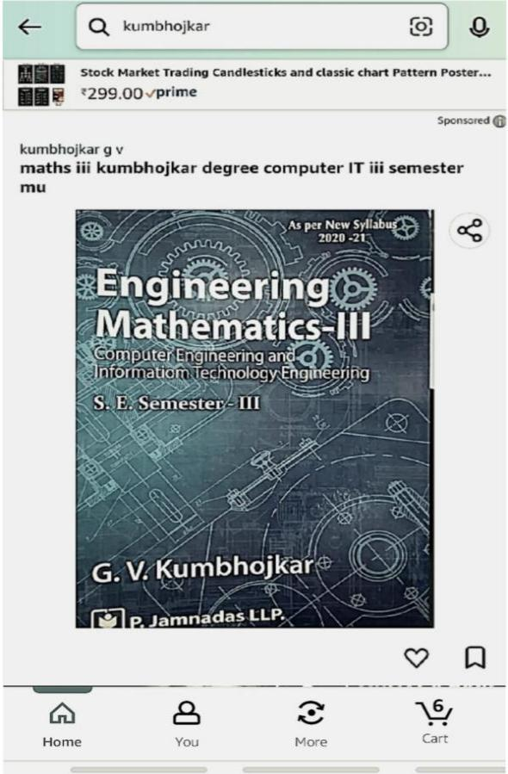 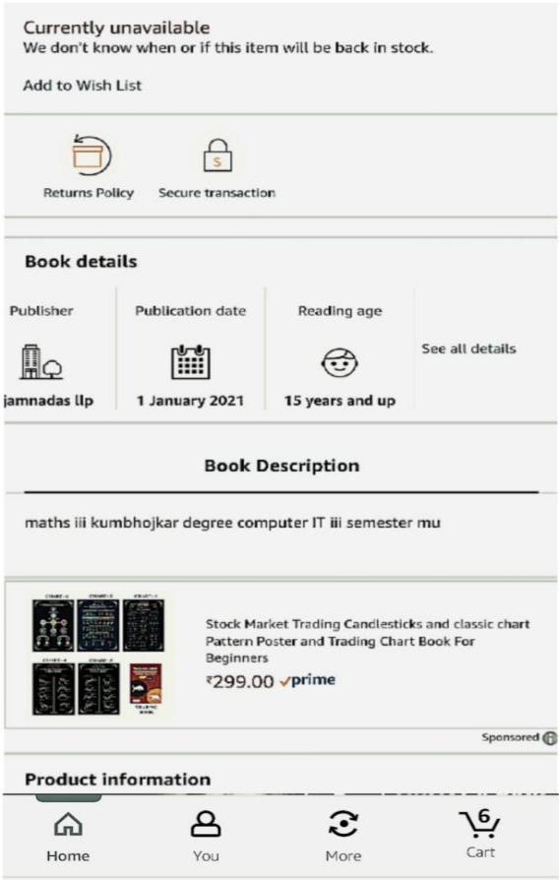

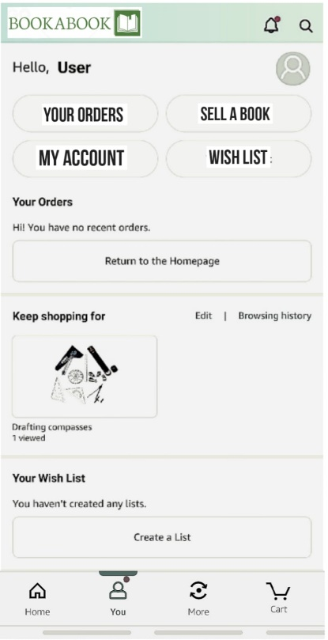 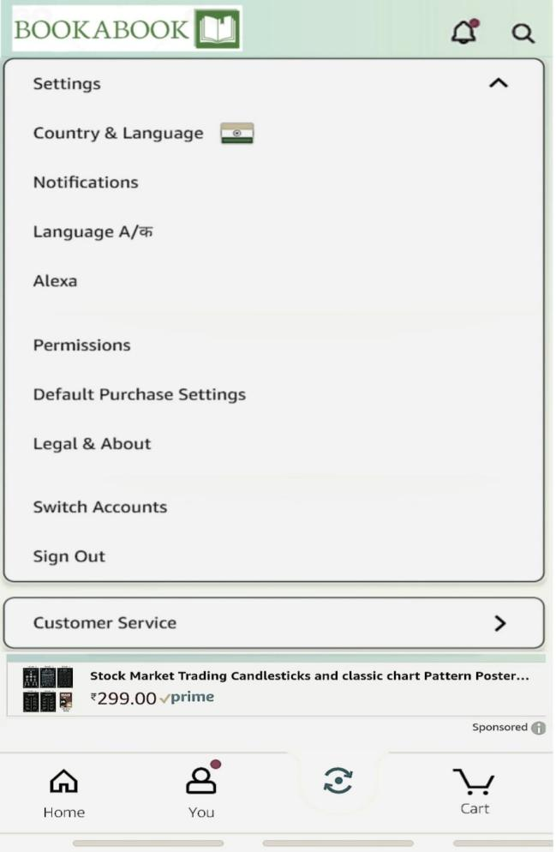

1. CONCLUSION

Ours is a unique business model that solves the problem of affordability and accessibility to quality reading material with sustainability in mind.

Future goals:

-Become a trusted brand

-Increasing the product offerings and capacity

-Increasing efficiency.

-Increasing revenue and developing a loyal customer base.

-Improving our marketing efforts

-Diversifying: Introducing audio books or expanding into related areas like music.

Initially we expect our rate of growth to be 7% and gradually increasing to 25%.

Our exit strategy is to pass it on to future generations. If the business fails our exit strategy would be to close down the business and sell off any remaining assets to pay off any outstanding debts and return any remaining funds to the owners or investors.