**7. Write a Program in JAVA to create an abstract class Figure. Create two classes Square and Circle and compute the area of each class. Implement the program using method overriding.**

*Ans: -*

import java.util.*;

abstract class Figure {

final static double pi = 3.14; abstract void area();

}

class Circle extends Figure{

int r;

Circle(int r1) { r = r1; }

void area() {

System.out.println("The area of the circle is : " + (pi*r*r));

}

}

class Square extends Figure{

int b;

Square(int x) { b = x; }

void area() {

System.out.println("The area of the Square is: " + (b*b));

}

}

public class Area {

public static void main(String[] args) {

Scanner obj = new Scanner(System.in);

System.out.println("Enter the radius of the circle: ");

int x = obj.nextInt();

Circle c1 = new Circle(x); c1.area();

System.out.println("Enter the side of the square: ");

int y = obj.nextInt();

Square s1 = new Square(y); s1.area();

}

}

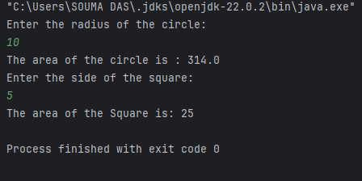**Output:**

**8. Write a Program in JAVA to compute the result of a student using multiple inheritance.**

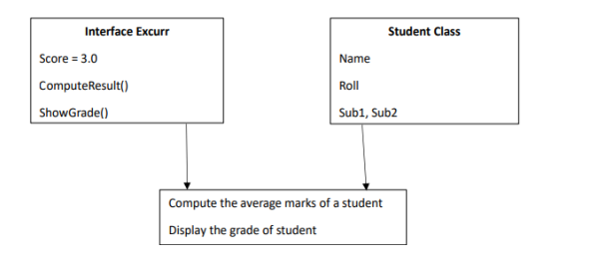

*Ans: -*

import java.util.*;  
interface Excur {  
 static double *Score* = 3.0;  
 void grade();  
 void result();  
}  
class Student {  
 String name;  
 int roll, sub1, sub2;  
 Student(String n, int r, int s1, int s2) {  
 name = n; roll = r; sub1 = s1; sub2 = s2;  
 }  
}  
class Result extends Student implements Excur {  
 Result(String n, int r, int s1, int s2) {  
 super(n,r,s1,s2);  
 }  
 @Override  
 public void grade() {  
 double avg = (sub1+sub2)/2;  
 if (avg >= 85)  
 System.*out*.println("Grade: A");  
 else if (avg >= 70)  
 System.*out*.println("Grade: B");  
 else if (avg >= 55)  
 System.*out*.println("Grade: C");  
 else  
 System.*out*.println("Grade: F");  
 }  
 public void result() {  
 double res = ((sub1 + sub2)/2) + *Score*;  
 System.*out*.println("Name: " + name + "\nRoll: " + roll + "\nSubject 1: " + sub1 + "\nSubject 2: " + sub2+  
 "\nResult: " + res);  
 }  
}  
public class Grade {  
 public static void main(String[] args) {  
 Result s1 = new Result("A", 15, 85, 90);  
 Result s2 = new Result("B", 16, 60, 60);  
 s1.result();  
 s1.grade();  
 s2.result();  
 s2.grade();  
 }  
}

**Output:**

