# **Summary**

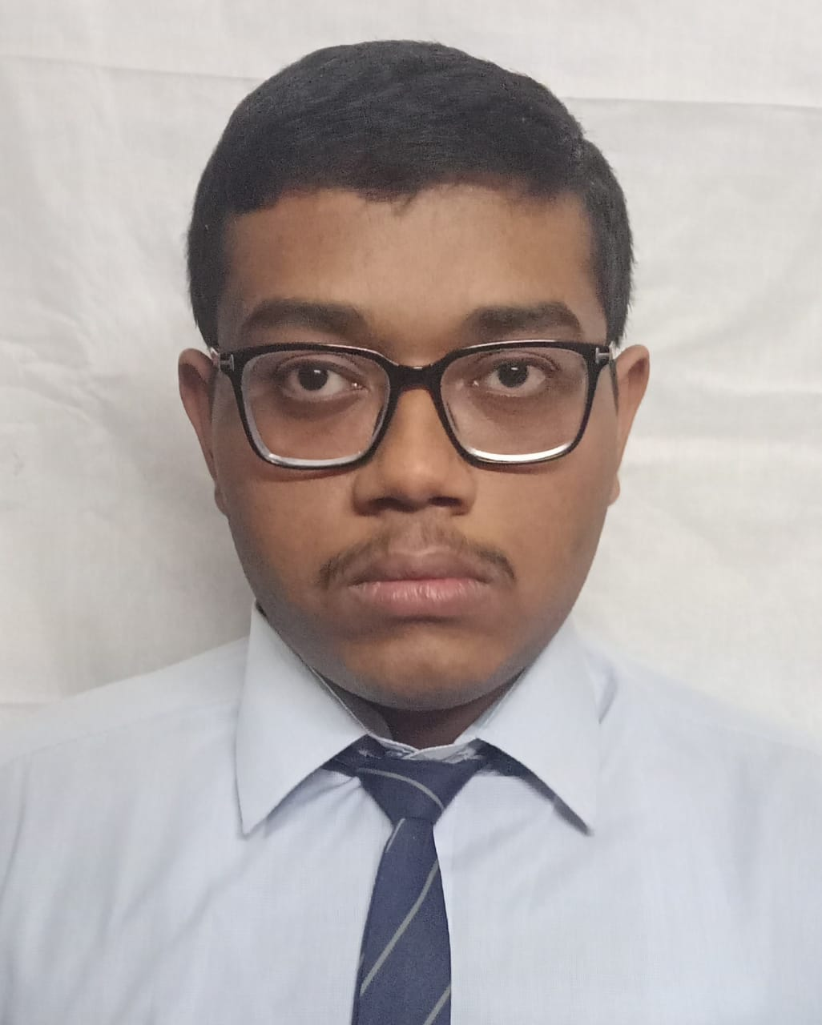

**Soumabha Saha**

*B.Tech Student | Computer Science Engineering*  
📧 [soumabhasaha1509@gmail.com](mailto:soumabhasaha1509@gmail.com)

📞 +91 74395 69806

Dedicated B.Tech student in Computer Science Engineering with strong academic performance and hands-on experience in full-stack development, programming, and databases. Eager to apply technical skills to innovative projects.

### **Education**

* **Secondary (10th)** – grade:87.85%
* **Higher Secondary (10+2)** – grade:80.4% [aggregate:77%]
* **B.Tech, CSE** – Guru Nanak Institute of Technology, average-grade:8.26 (upto 6th sem)

### **Technical Skills**

* **Languages:** C, C++, Java, JavaScript, TypeScript, Python
* **Frameworks/Libraries:** Nest.js, Express, Django, React, Tailwind CSS, Daisy UI, Chakra UI
* **Databases:** MongoDB, Oracle, MySQL, SQLite

### **Projects**

* **Library Management System (Django)** –

Web-based system for book inventory & user management | [GitHub](https://github.com/SoumabhaSaha15/library-manager-django-)

* **Enhanced File Explorer (Chrome Extension)** –

Advanced file exploration tool | [GitHub](https://github.com/SoumabhaSaha15/ENHANCED-FILE-EXPLORER-DARK)

* **Contact Manager** –

Contact management app using command line | [GitHub](https://github.com/SoumabhaSaha15/phone-book)

* **Weather Application** –

Weather data display using APIs | [Live Demo](https://bharat-intern-roan.vercel.app/)

* **Web Editor** –

Real-time text editor | [Live Demo](https://web-editor-five.vercel.app/)

### **Certifications**

* [C++ (Coursera)](https://www.dropbox.com/scl/fi/8zc946rxiupkz3zogyklc/Coursera_C-_PDF.pdf?rlkey=mfuee3httpiptsh7vq22ome9r&dl=0)
* [Django Web Framework (Online Course)](https://www.dropbox.com/scl/fi/hg0dntu57npeauue5rjtf/bct.pdf?rlkey=rn3kjgsvu4yx7t7gp1v4ftbas&dl=0)
* [Introduction to Generative AI](https://www.dropbox.com/scl/fi/47nrsud8roxlx0rgej1i6/gen_ai.pdf?rlkey=jmpiufnhj3yfdu2z2o25dkjne&st=gagn6bm1&dl=0)
* [Soft Computing Techniques (NPTEL)](https://www.dropbox.com/scl/fi/wipw0b0t5g9hh7y5cb4fr/Soft-Computing-Techniques.pdf?rlkey=uoi0euymly2v8whs1sb1jzh86&st=z6tdo9o0&dl=0)