# Introduction

This document details:

* Setup ngrok on laptop
* Setup webhook on TTN so that data can be extracted from TTN
* The setup is working with LORA_NODE, sending each pixel data (LocalImageSendTry_v1.py) at a time, and the data is being pulled into the laptop and translated (pythonProject_ImageReceiveTTN -> main.py), and the image is being reconstructed.

The current setup allows following data flow:

LORA_NODE 🡪 TTN 🡪 LAPTOP (via webhook)

This is one direction communication, from LORA_NODE to laptop.

# Pre-Requisites

The LORA_NODE shall be able to send data to TTN, or the data shall be available in TTN. This is visible on TTN as shown below:

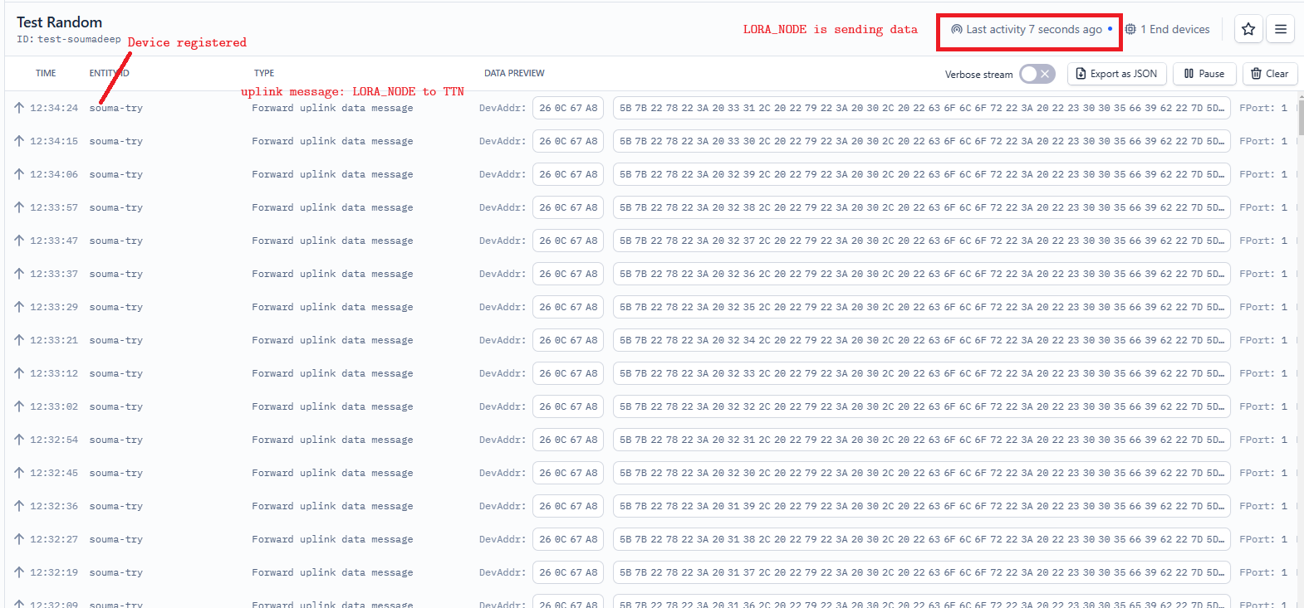

# Setup ngrok on Laptop

* Start ngrok application
* Run command: ***ngrok http 5000***. The result will look something like this:

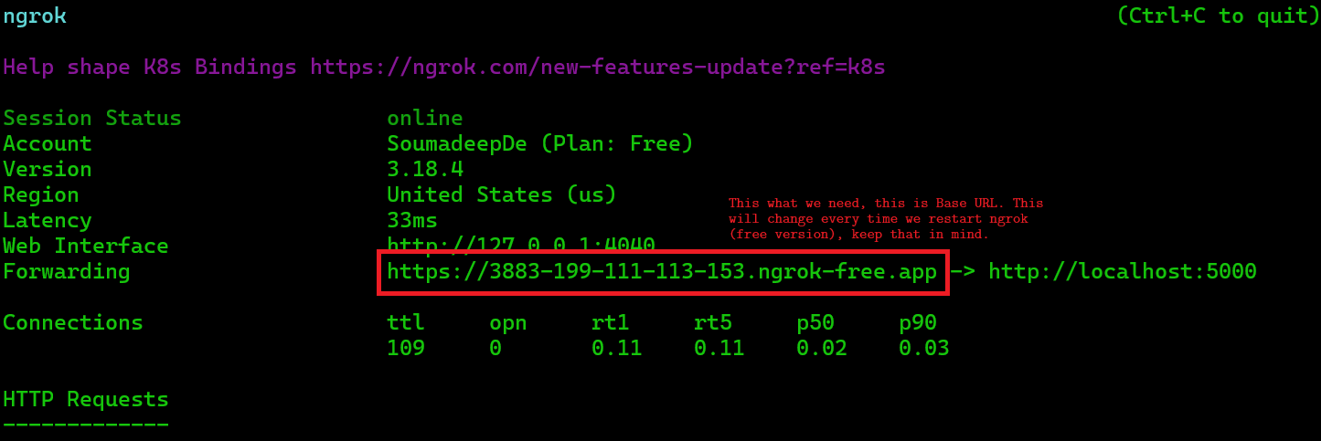

* The Forwarding address: https://... Will be used as Base URL in webhook.
* If everything is working fine; meaning that the data is being pulled from the TTN to laptop, the result will be as follows:

* If the Python code on laptop is not running, you will get 502 Bad Gateway error:

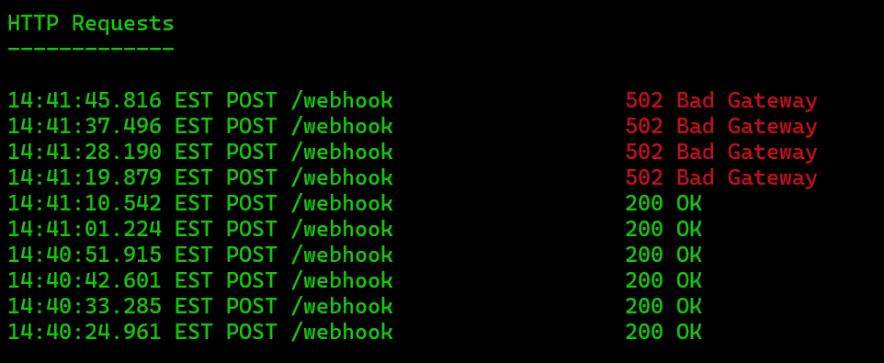

* If there is some error in the Python program, you’ll get some other kind of error (most likely an internal error).

# Setup webhook on TTN

The webhook can be found under Applications 🡪 Integrations 🡪 Webhooks

Go to Add Webhook 🡪 Custom webhook. Keep the settings as shown below:

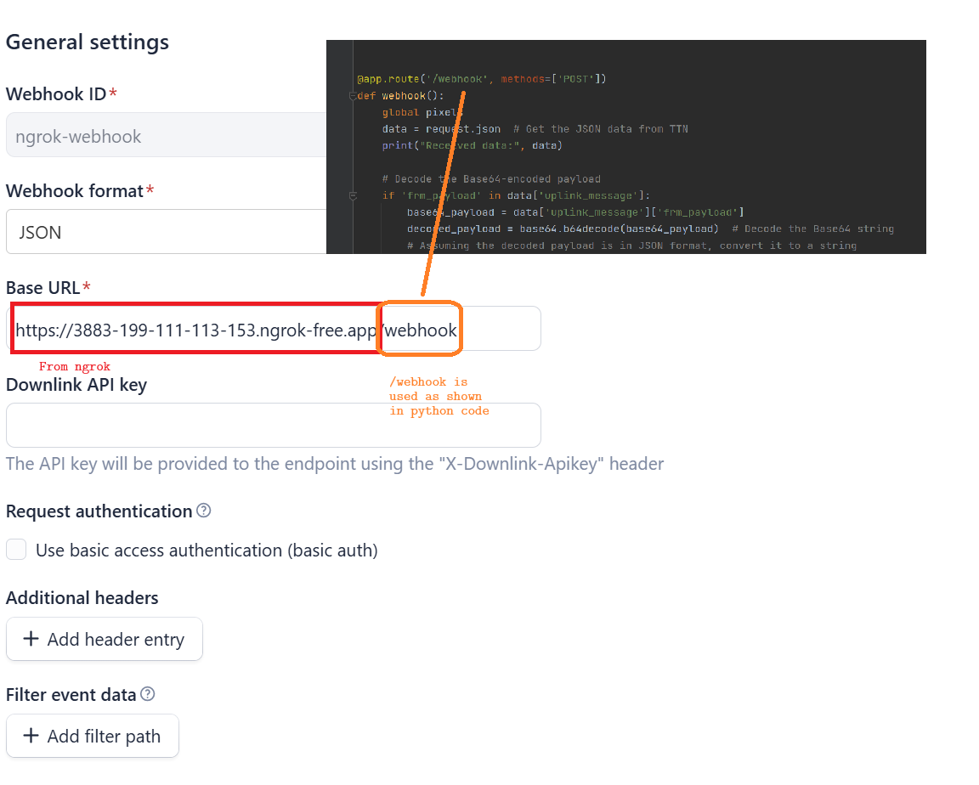

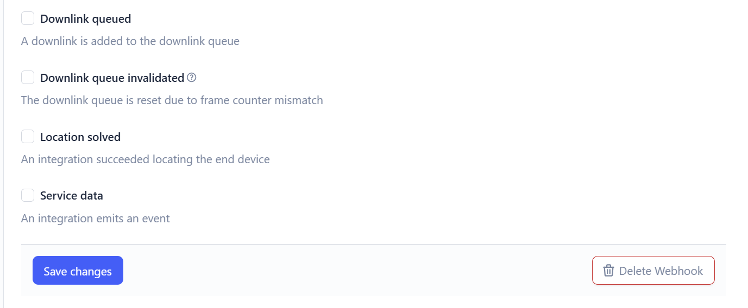

If everything is fine, the TTN will show status of webhook as healthy:

