**--- DATABASE creation**

create database Consumer_Complaint;

use Consumer_Complaint;

**-- Data Cleaning (Column Name error)**

**-- KPI**

**-- 1. Number of Complaints**

select count(Complaint_ID) from consumer_complaints;

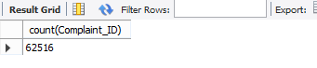

**-- 2. Number of products**

select count(distinct Product) from consumer_complaints;

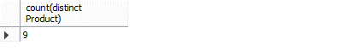

**-- 3. Most common Issue**

select Issue, count(Issue)

from consumer_complaints

group by Issue order by count(Issue) desc limit 1;



**-- Insights**

**-- 1. Customer complaint pattern (Focusing on products), (Focusing On the complaint medium)**

select Product, count(Issue)

from consumer_complaints

group by Product order by count(Issue) desc;

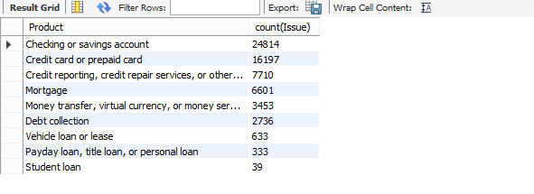

select Submission_medium, count(Issue)

from consumer_complaints

group by Submission_medium order by count(Issue) desc;

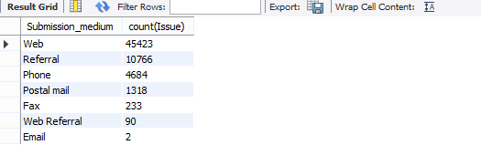

**-- 2. Complaint resolved type**

select Company_response_to_consumer, count(Company_response_to_consumer) as Total

from consumer_complaints

group by Company_response_to_consumer order by Total desc;

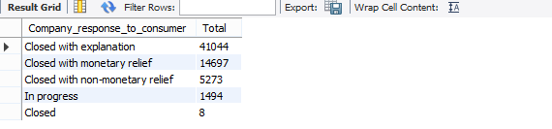

**-- 3. Untimely response**

select (select Count(Timely_response) from consumer_complaints where Timely_response = "No")*100/(select count(Complaint_ID) from consumer_complaints) as Untimely_response_Percentage;

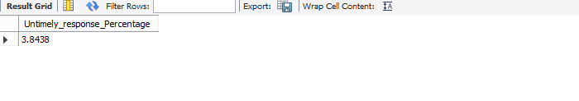

**-- 4. Refunding issues**

select Issue, count(Issue)

from consumer_complaints

where Company_response_to_consumer ="closed with monetary relief"

group by Issue order by count(Issue) desc;

