-- database Creation

Create database walmart_sales;

use walmart_sales;

-- data table import using csv

select * from sales;

-- data processing

-- Adding new column time of the day

set sql_safe_updates =0;

alter table sales add column time_of_day varchar(20);

update sales

set time_of_day =

case

when time between '00:00:00' and '12:00:00' then 'Morning'

when time between '00:01:00' and '16:00:00' then 'AfterNoon'

else 'Evening'

end;

-- adding new column dayname

alter table sales add column day_name varchar(20);

update sales

set day_name = dayname(date);

-- adding new column monthname

alter table sales add column month_name varchar(20);

update sales

set month_name = monthname(date);

-- business questions

-- total number of cities

select count(distinct city) from sales;

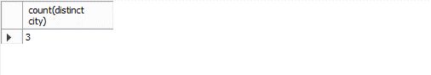

-- number of brunches in each city

select city, count(branch)

from sales

group by city;

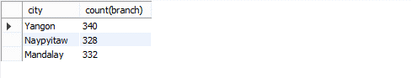

-- KPI

-- total quantity Sales

select sum(quantity) from sales;

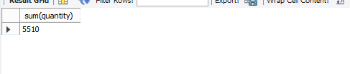

-- total income

select round(sum(total),2) from sales;

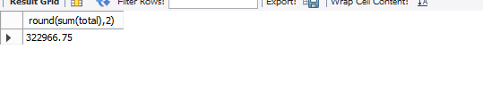

-- total records

select count(id) from sales;

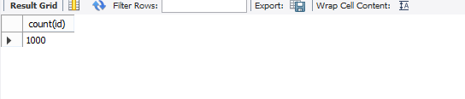

-- total quanity sales

select product_line, sum(quantity)

from sales

group by product_line

order by sum(quantity);

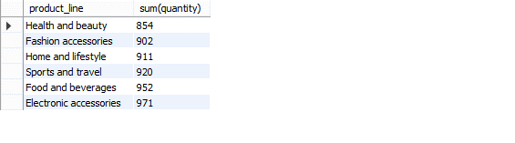

-- total revenue

select product_line, round(sum(total),2)

from sales

group by product_line

order by sum(total) desc;

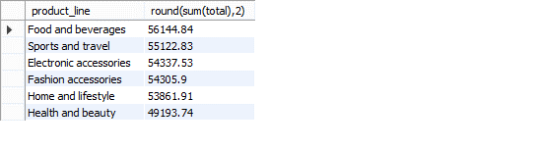

-- rating of the products

select product_line, round(avg(rating),2)

from sales

group by product_line

order by avg(rating) desc;

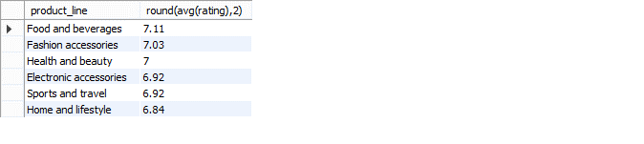

-- sale day

select day_name, sum(quantity)

from sales

group by day_name

order by sum(quantity) desc;

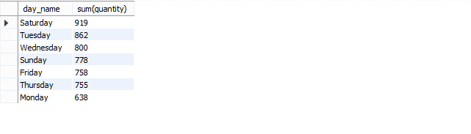

-- sale time

select time_of_day, sum(quantity)

from sales

group by time_of_day

order by sum(quantity) desc;

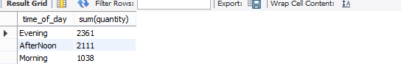

-- payment method

select payment, count(payment)

from sales

group by payment

order by count(payment) desc;

