Programming : Programming is a way to interact with computers and assign them various tasks. Computers only understand binary i.e. 0’s & 1’s and we communicate with them using a high-level language (programming language).
There are 3 major categories of programming languages:
1. Procedural –
- Specifies a series of well-structured procedures to form a program
- Uses functions/procedures to organize code
- Follows a top-down approach (code is executed sequentially)
- Uses loops, conditionals, and function calls
- Data is often global or passed between functions
- More focused on "how" to do things
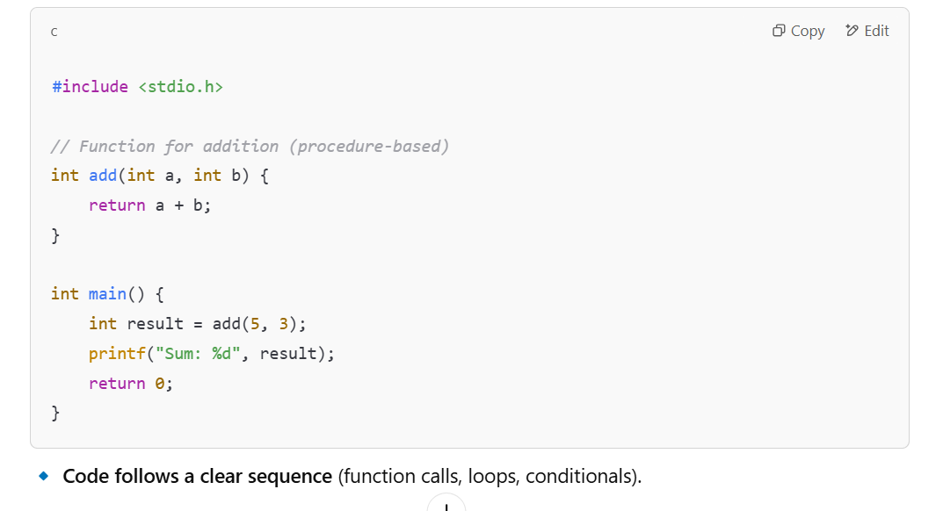
- Examples of Procedural Languages:
C, Python, Java BASIC

2. Functional –
- Involves writing a program only in pure functions i.e. never modify variables but create new ones as output.
- Treats functions as first-class citizens (can be passed as arguments).
- Used when we have to perform the same operations on large datasets(ML).
- Examples – JavaScript (partial), Python (partial)
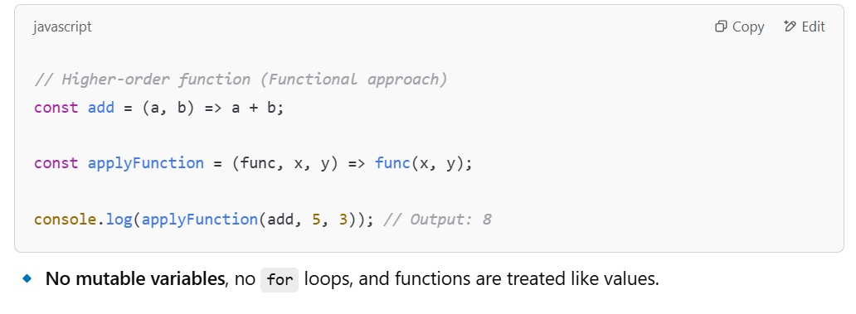
- Focuses on "what to do" instead of "how to do"
3. Object-Oriented -
- based on the concept of objects, which encapsulate data (attributes) and behaviour (methods) together.
- Uses classes as blueprints to create objects
- Encapsulation: Hides data inside objects
- Abstraction: Hides unnecessary details from the user(access specifiers – private, public, protected, default)
- Inheritance: Allows classes to inherit features from other classes
- Polymorphism: Enables a single interface to represent multiple functionalities
- More focused on "what" to do rather than "how"
- Developed to make it easier to develop, debug, reuse and maintain software.
- Examples : Java, C++, Python, Kotlin
One programming language can be of all 3 types like- Python”
Java Follows procedural and object oriented both types
Compile time means when source code written by user is getting converted to machine code(byte code)
Runtime means when computer is actually executing that byte code.

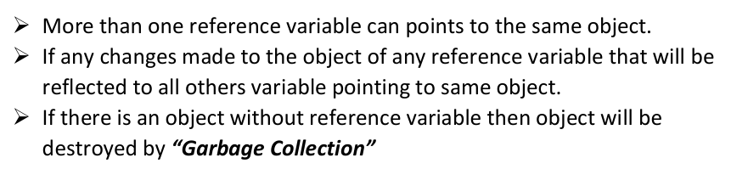
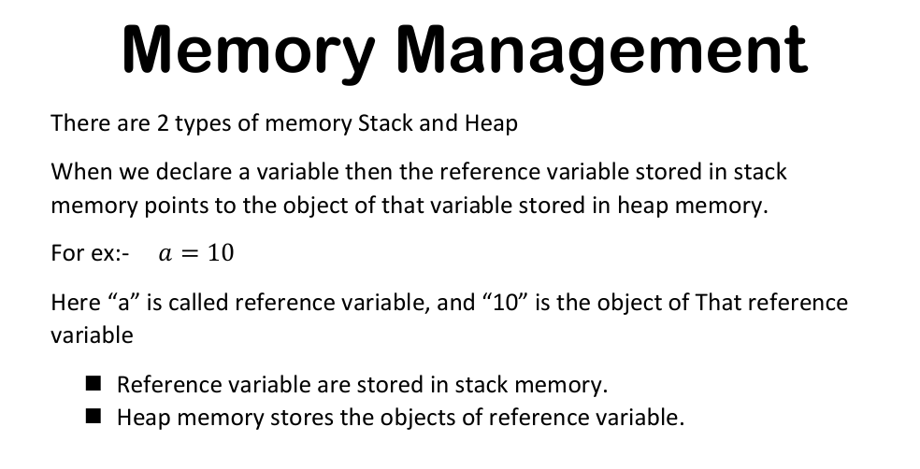
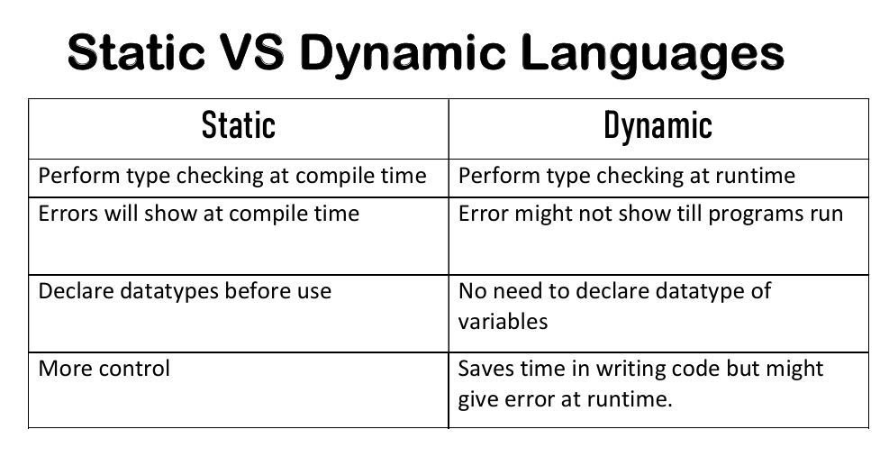

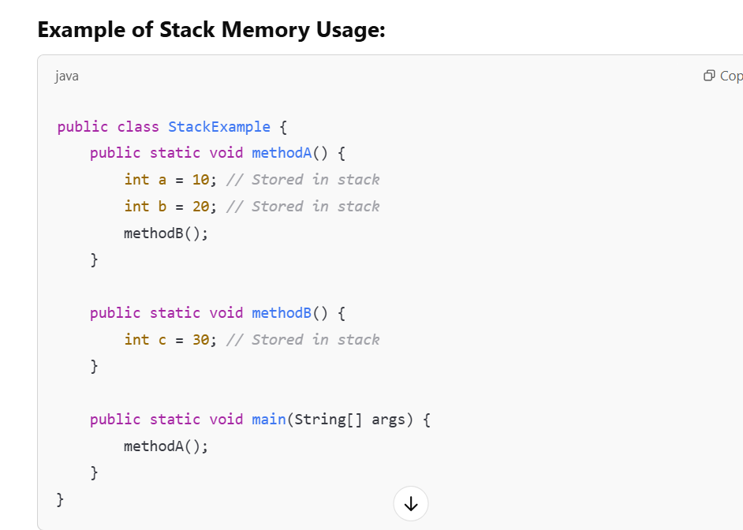
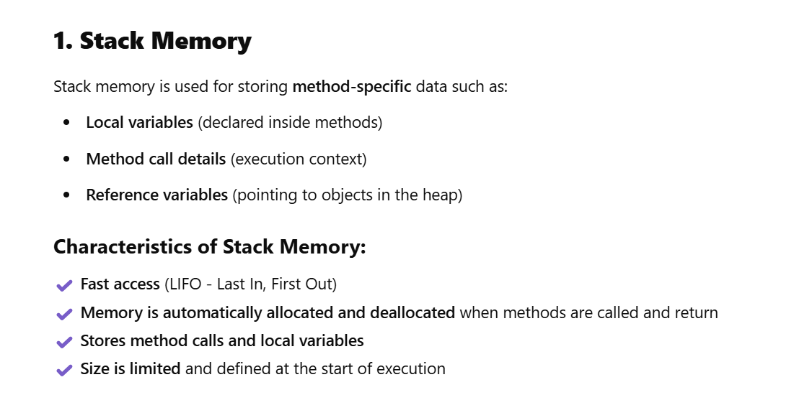

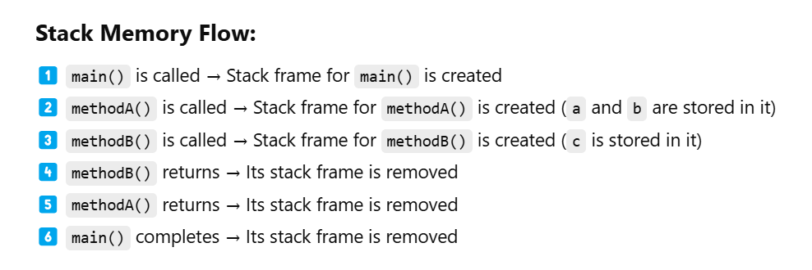

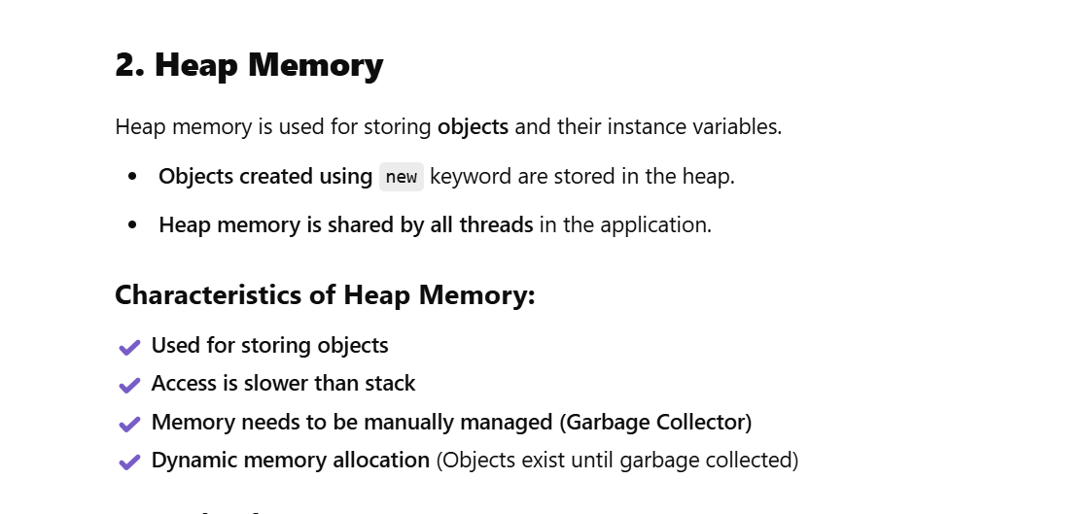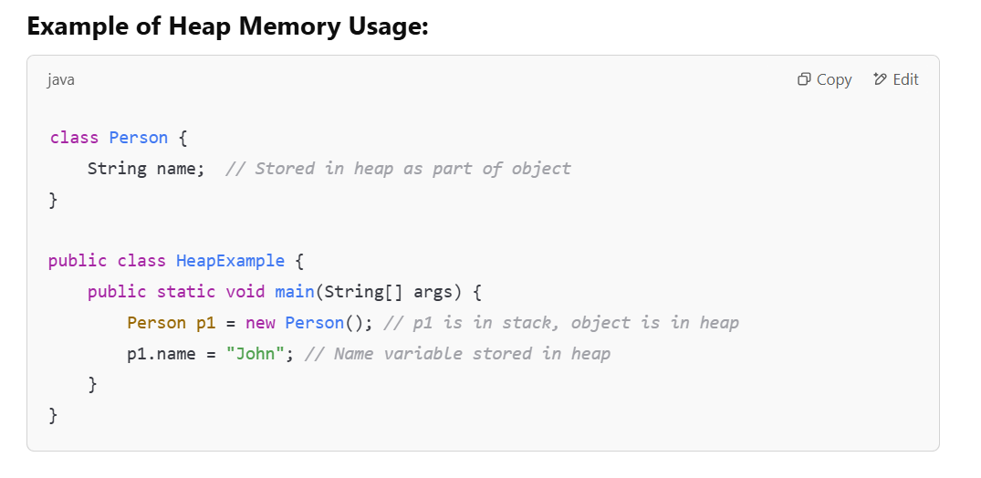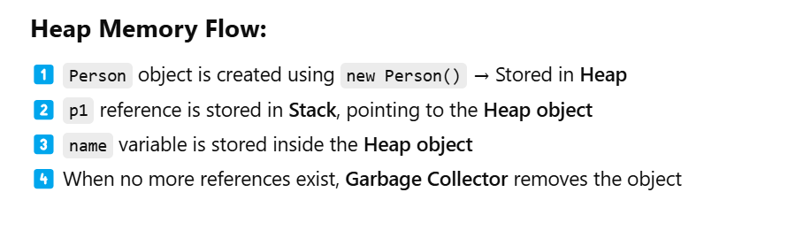

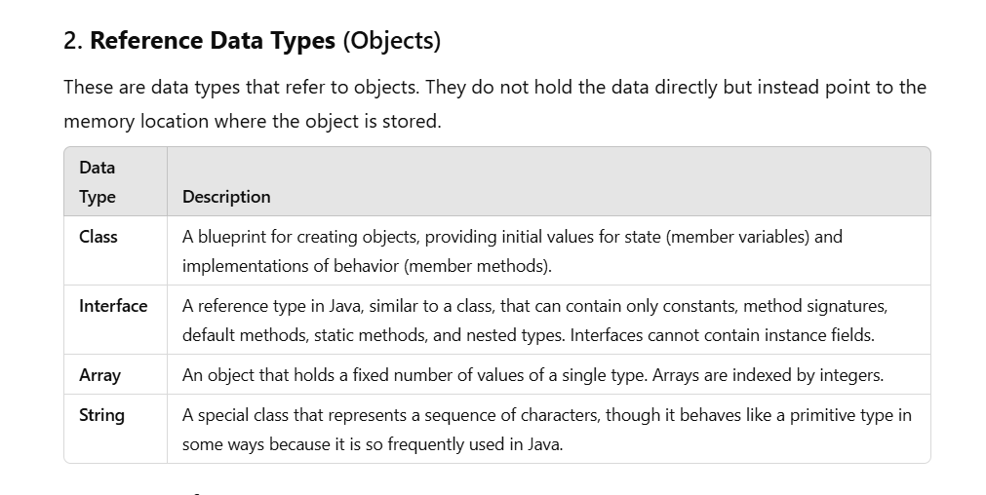
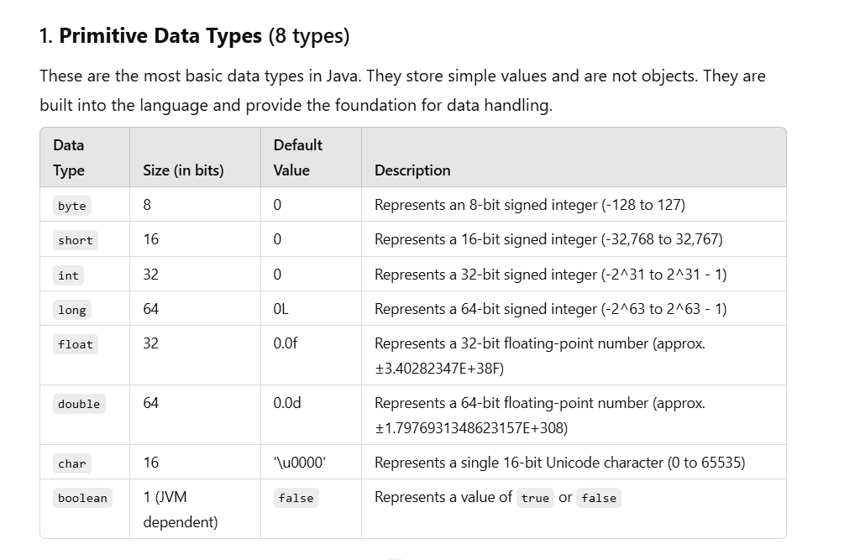
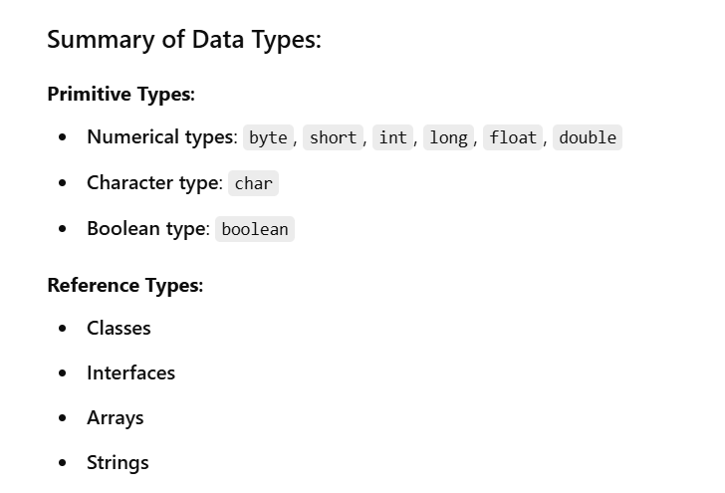
- We write code in a .java file in VS Code or any text editor.
- We hit the play button or type javac MyProgram.java in the integrated terminal of VS Code.
- The terminal is the command-line- interface(CLI) which allows us to write text commands and execute them and thereby helps in interacting with the operating system. The shell is the program running inside the terminal that interprets the commands we enter.
- The shell has access to environment variables, like the PATH variable, which tells the shell where to look for executable programs (like javac and java).
- When we install the Java Development Kit (JDK), it includes the bin directory, which contains executables like javac (the Java compiler) and java (the Java runtime) which are code written in Binary for the system to understand and compile and run our source code. The location of this bin directory is stored in the PATH environment variable.
- When we run javac MyProgram.java, the Java compiler (invoked through the shell) reads our Java source code, converts it into bytecode (stored in a .class file).
- The Java Runtime Environment (JRE), which is responsible for executing the bytecode, loads the .class file, runs the program, and displays the output in the terminal.

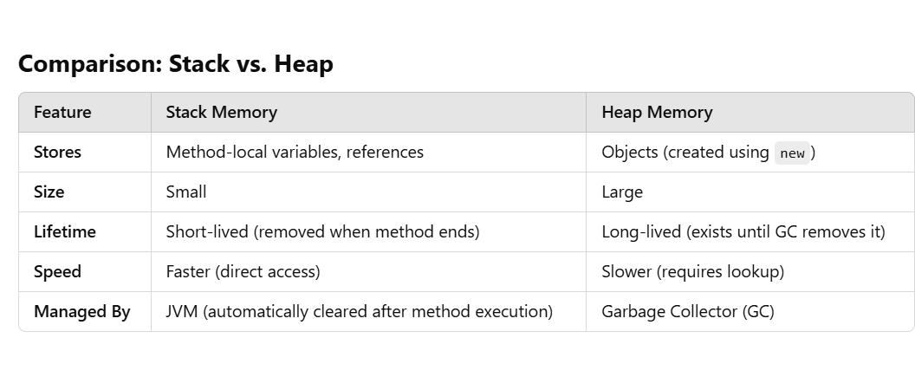
- Q.1) Why are objects separately stored in the heap memory and not in the reference variables itself like values are stored in the primitive variables in the stack memory?
A.1: Stack is small and used for short-lived variables. Objects can be large.
Stack memory is automatically managed (when a function/method ends, all local variables are erased). If objects were stored in the stack, they would be destroyed as soon as the method ends, even if still needed. Storing objects in the heap allows them to persist beyond method execution. Objects in the heap can be accessed from different methods, threads, or even globally. The stack is local to a method, meaning if an object was stored there, it wouldn't be accessible outside that method. Java uses Garbage Collection (GC) to remove unused objects automatically. If objects were in the stack, Java wouldn't be able to track and free them dynamically. Heap storage allows Java to manage memory efficiently.
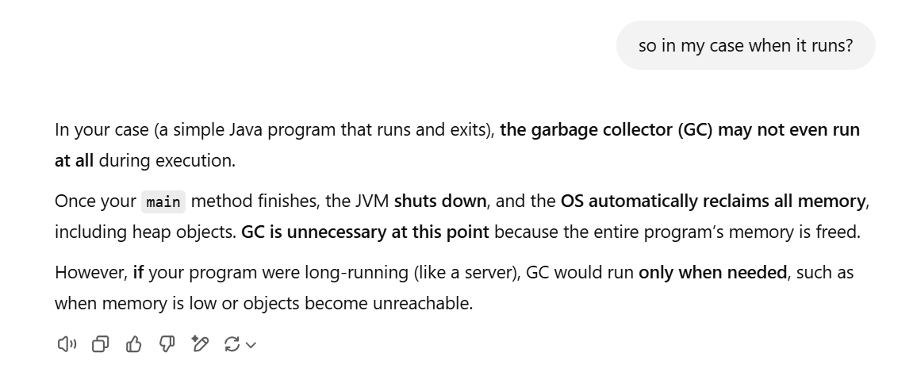
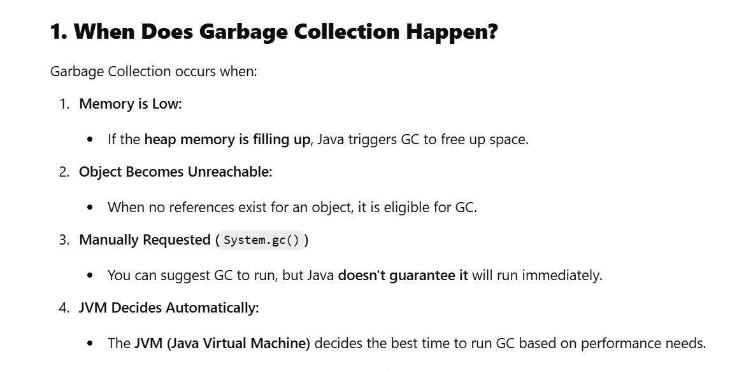

Static
static is a keyword used for memory management. It can be applied to variables, methods, blocks, and nested classes. When a member is declared as static, it belongs to the class rather than instances (objects) of the class. Static members are common to every object of the class and are accessed using the class name.

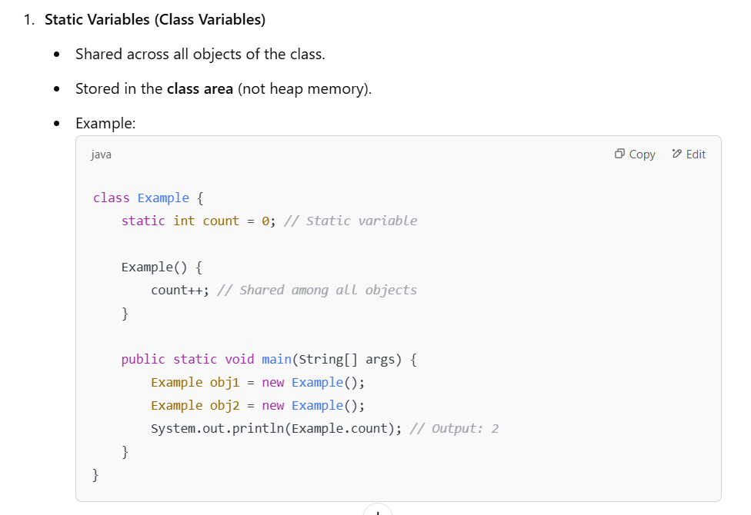
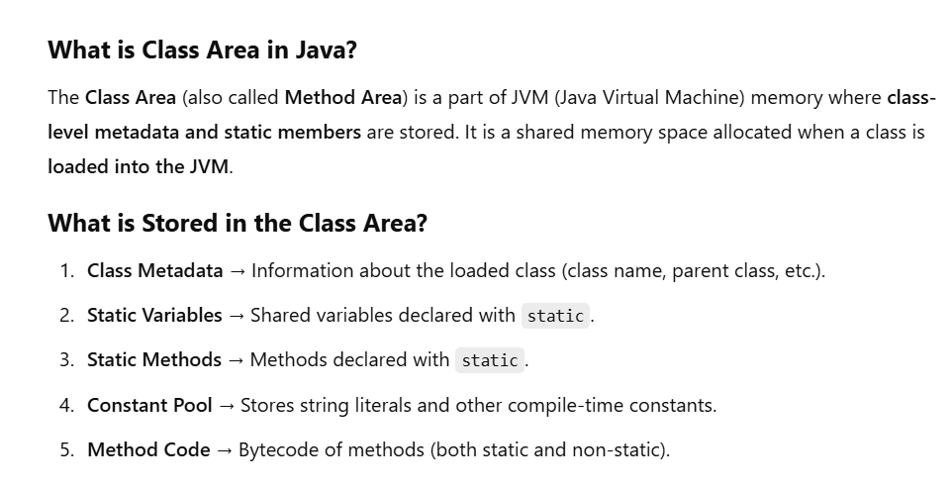

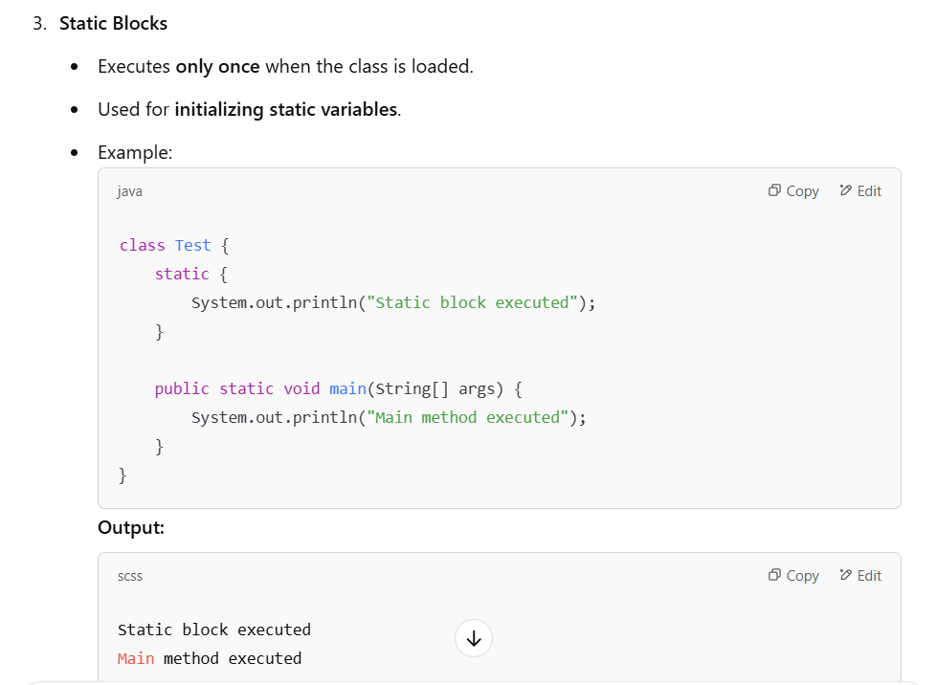
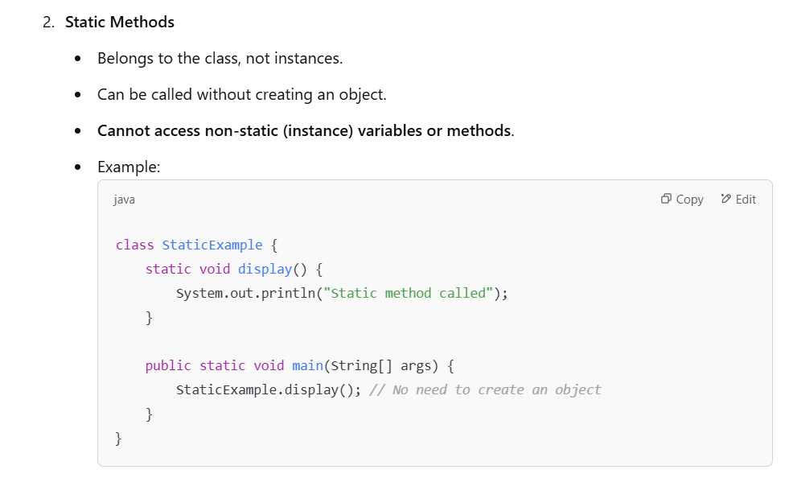
jnj

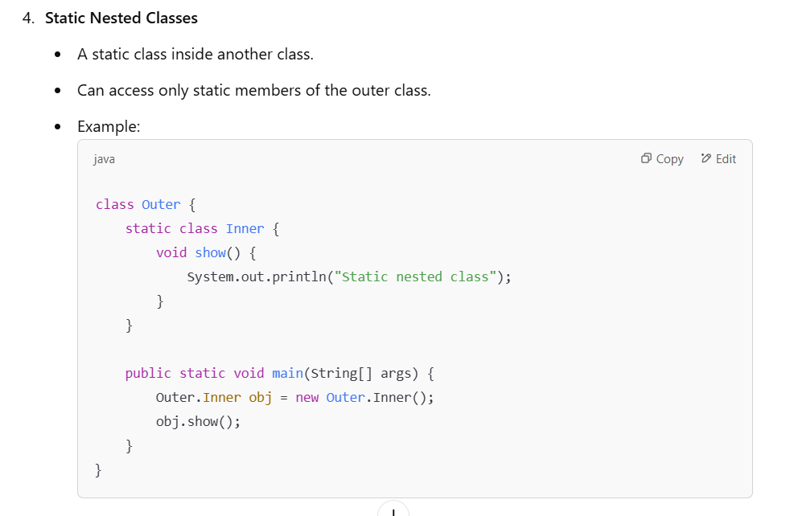
Key Points:
- Static members are shared across all instances.
- Static methods cannot access instance variables directly.
- Static blocks execute only once when the class is loaded.
- Static nested classes don’t require an instance of the outer class.
Non-static
Non-static members (variables and methods) belong to objects, not the class itself. Each object has its own copy of non-static members, and they are stored in Heap memory.
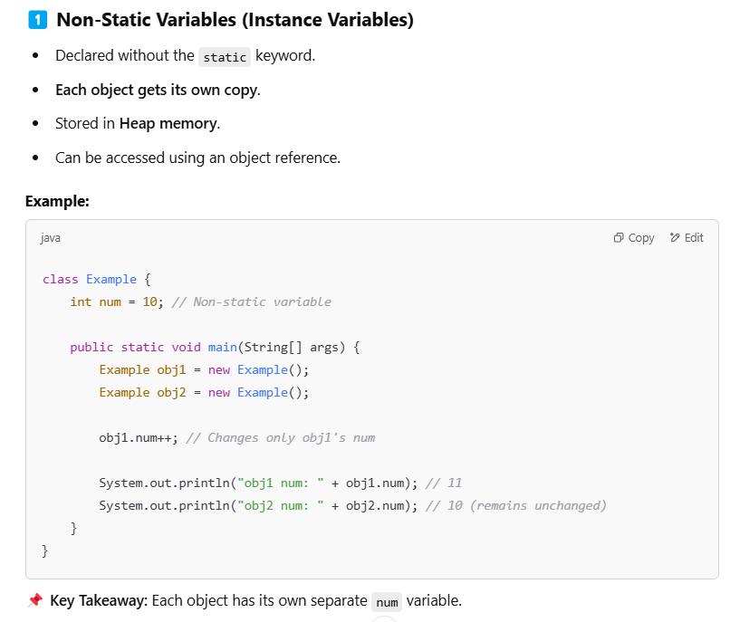

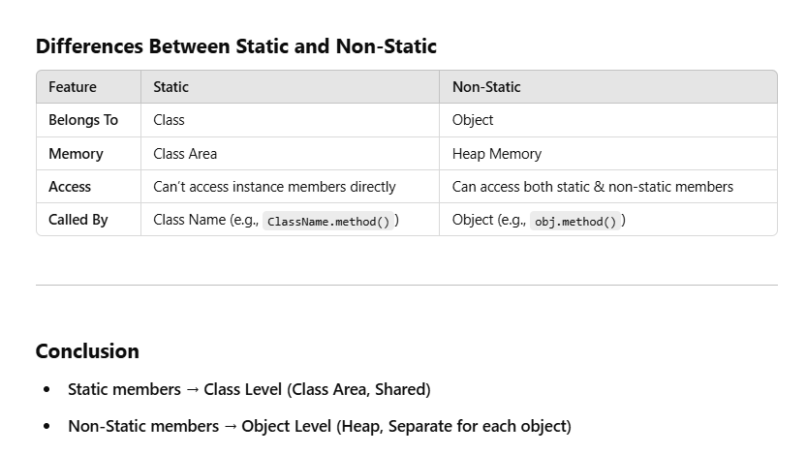
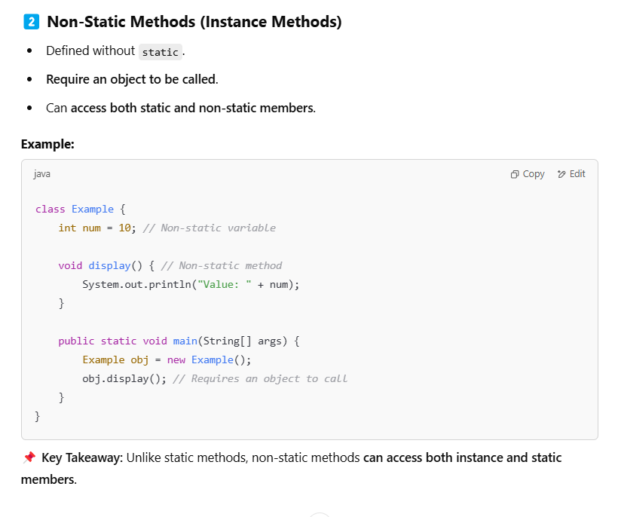
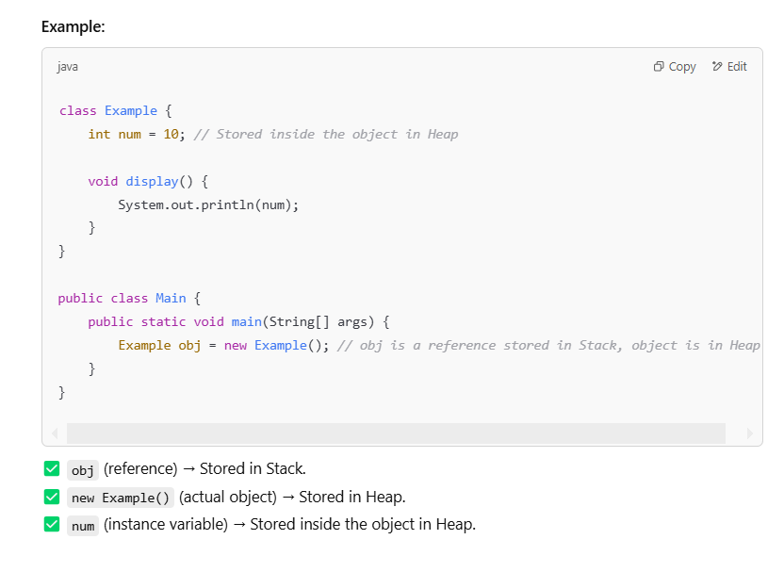
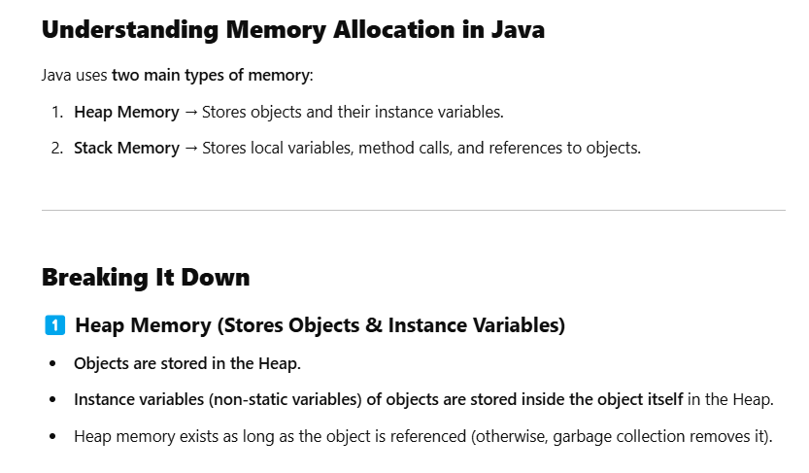

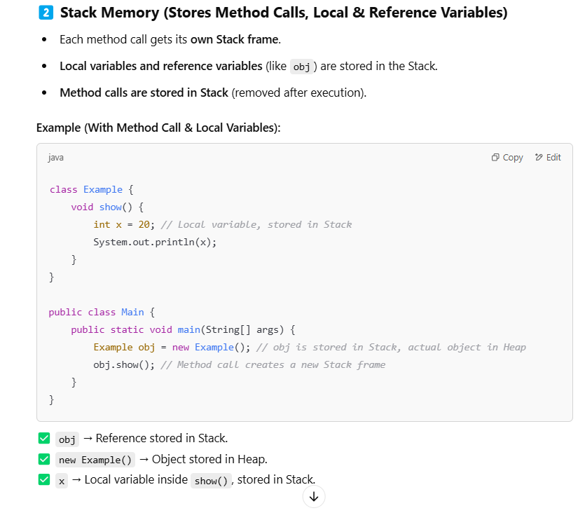

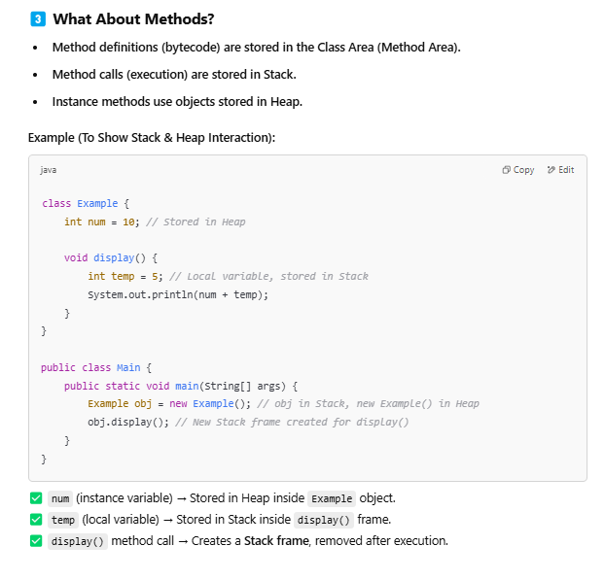

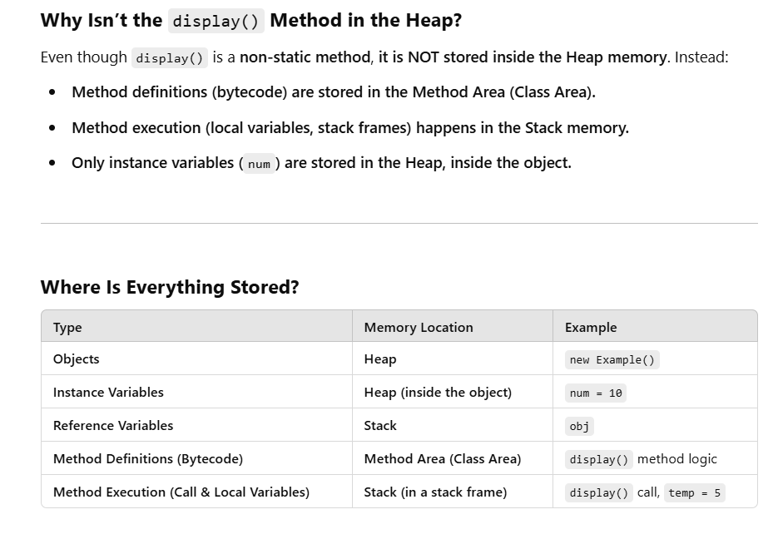
Both static and non-static method definitions are stored in the Method Area (also called Class Area), which is part of the JVM memory.

Q2. If I write int x will java automatically initialize it to 0?
A2. It depends on where we declare int x. If x is an Instance or Static Variable (Declared inside a class but outside methods)
✅ Yes, Java will automatically initialize it to 0.
