**Nginx, Prometheus, Alertmanager monitoring stack**

**Task:-**

Docker is a technology that is often used within the DevOps area, and Docker Compose is

a usefultool to allow the running on many different docker containers locally as a single solution.

Please create a docker compose configuration which will run 'AT LEAST' the following containers.

**Prometheus**

**Alertmanager**

**NGINX**

A frontend should be available for each of these services on the localhost.

Configure the above system in such a way so as when the NGINX container is down, this isregistered in the Prometheus system, which will then send an alert to Alertmanager. This alertshould be displayed on the Alertmanager UI. You do not need to configure any routes from theAlertmanager to any other systems such as email or slack.

**Solution:-**

**Step 1:**

First I’ve created a folder in the D drive of my local machine and created the following folders & files as below.

**docker-project**

|---docker-compose.yml

|---**prometheus**

|---alert.yml

|---prometheus.yml

|---**alertmanager**

|---alertmanager.yml

**Step 2:**

To run the docker containers, run the following command:

**docker-compose up -d**

PFA screenshots of the docker containers and UIs in the localhost.

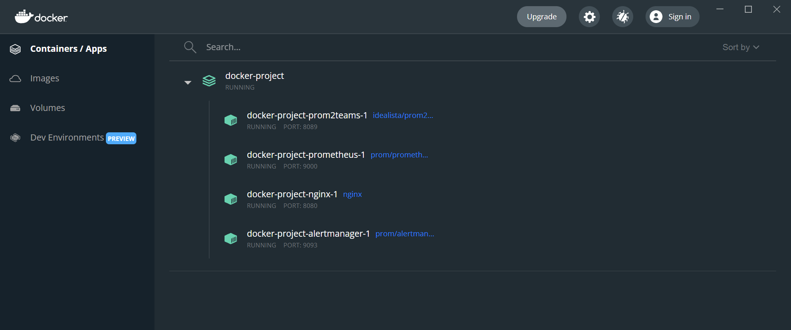

Figure 1 **Docker containers**



Figure 2 **Nginx frontend in localhost:80**

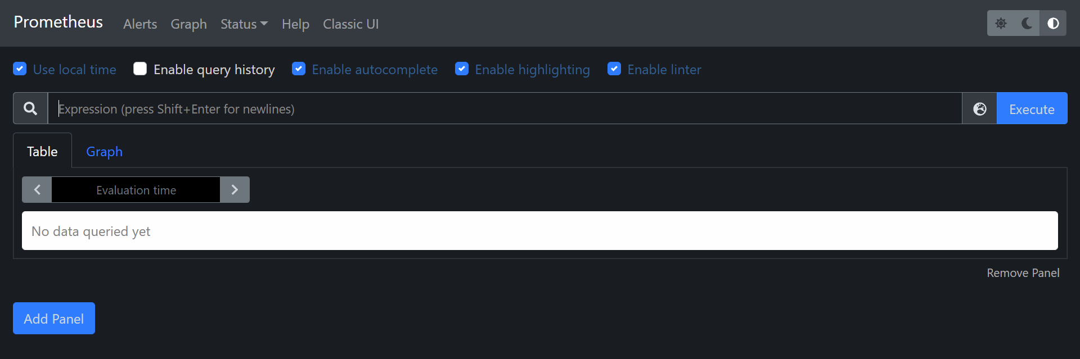

Figure 3 **Prometheus UI in localhost:9000**

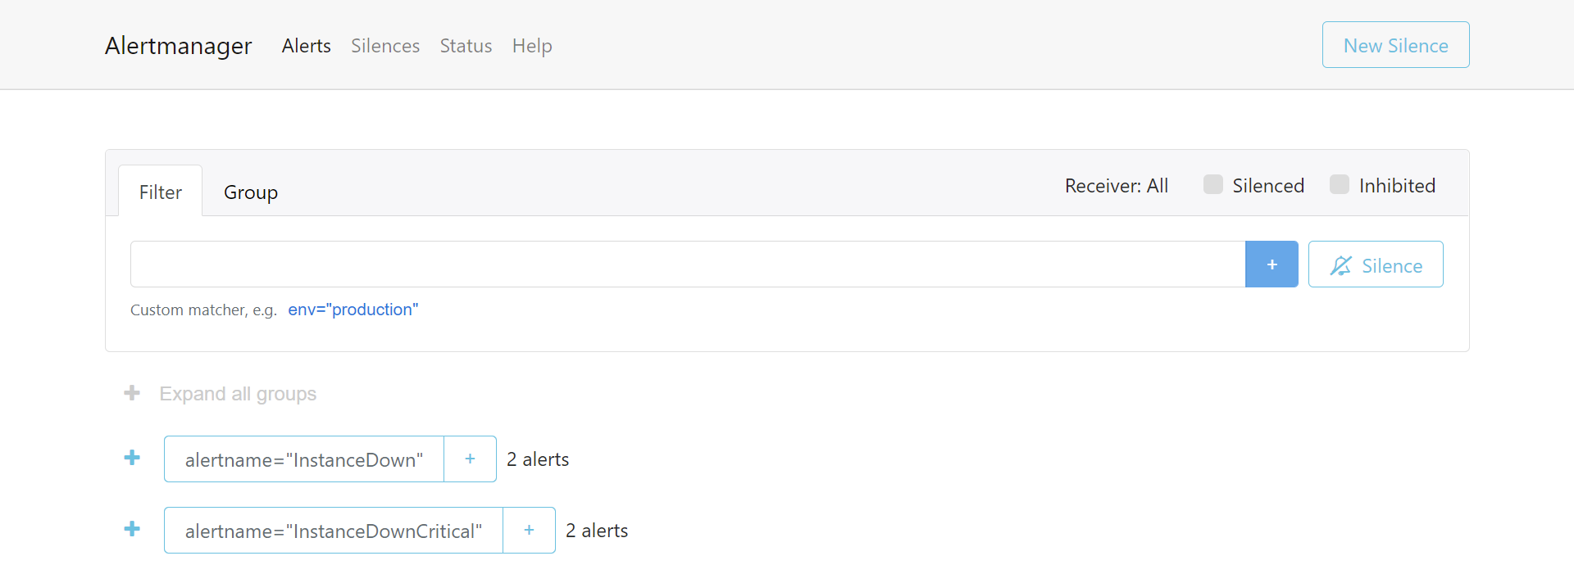

Figure 4 **Alertmanager UI in localhost:9093**

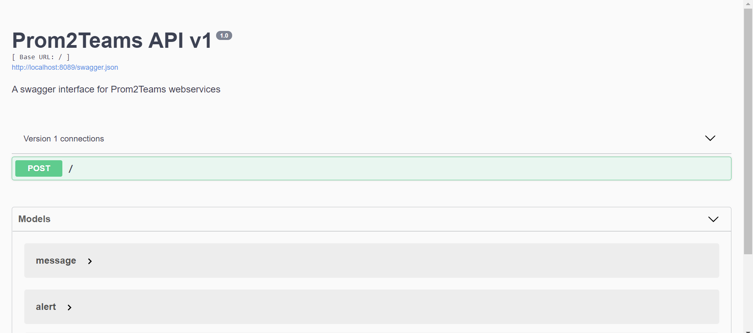

Figure 5 **Prom2Teams API in localhost:8089**

**Reference:**

**I’ve taken reference from the following to implement this project.**

[**https://github.com/ablx/monitoring_stack**](https://github.com/ablx/monitoring_stack)

[**https://dev.to/ablx/series/12839**](https://dev.to/ablx/series/12839)

[**https://docs.docker.com/compose/**](https://docs.docker.com/compose/)

[**https://prometheus.io/docs/alerting/latest/alertmanager/**](https://prometheus.io/docs/alerting/latest/alertmanager/)