* To show the name of the restaurant in jsx we have to create a state variable and store the data in the state variable which we are fetching from swiggy’s api.
* So after we put our data into the state variable, then we will have the ability to update the UI on every render based on any data changes.
* import {useState, useEffect} from “react”;
* const [resInfo, setResInfo] = useState(null);

1. What are various ways to add images into our App? Explain with code examples
   1. Importing images using ES6 Modules:
      1. Code Example:
         1. We can import images directly using ES6 modules. This is acommon approach for small to medium-sized apps, and it’s straightforward. Firstly, we have to place our image in the project directory (e.g., in the src folder or a subfolder).
         2. A screenshot of a computer code

            AI-generated content may be incorrect.
   2. Using public folder: If we want to reference images in the public folder, we can do so without importing them explicitly. This method is useful for handling large image assets or for dynamic image URLs. Place your image in the public directory.
      1. First we need to place the place in a public directory such as public/my_image.jpg and then we can reference it.
         1. A screen shot of a computer code

            AI-generated content may be incorrect.
   3. Loading images from a remote source: We can load images from a remote source, such as an external URL or a backend API, by specifying the image URL directly in our img tag.
      1. A screen shot of a computer code

         AI-generated content may be incorrect.
   4. Using image assets within CSS: We can also use images as background images or in other CSS styling. In this case, we can reference the image in your CSS file.
      1. 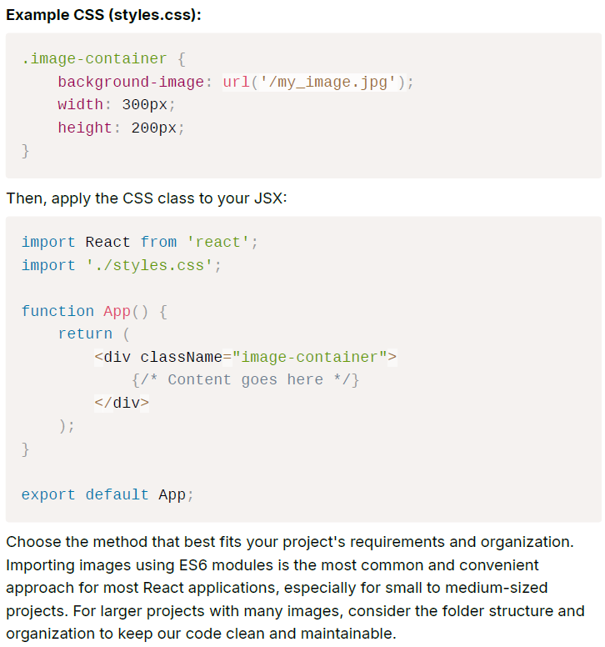
2. What would happen if we do console.log(useState())?
   1. If you write useState() in a functional component and then try console logging it will display the result in the browser’s developer console with [undefined, f], where undefined is the state variable and the f is the setter function of the state variable. The hook which is basically a function useState() returns an array with two elements, the current state value and a function to update that state value.
   2. const [count, setCount] = useState(0); In this example, count is the state variable and setCount is the function to update the state variable. If we try to do console.log(useState()), we will see something like this in the console: [0, function]
3. How will useEffect behave if we don’t add a dependency array?
   1. If we don’t provide a dependency array to the useEffect hook in React, it will run on every re-render of the component. If we pass a dependency array containing a variable, the effect will run once when the component first loads, and then again whenever that variable (or state variable) changes—triggering both a re-render of the component and the useEffect execution. If we pass an empty dependency array ([]), the effect will only run once during the initial load of the component. It will not run again on subsequent re-renders unless the page is refreshed or the component is re-mounted.
4. What is SPA?
   1. A single page application is an application where we don’t have to refresh the page and we stay on the same page. What happens instead is we interchange components and the common headers or footers or whatever the developer wants to have common will stay there.
   2. Google AI’s definition of SPA is that it is a type of web application that interacts with the user by dynamically rewriting the current web page with new data from the web server instead of the default method of loading entire new pages.
5. What is the difference between Client-Side Routing and Server-Side Routing?
   1. Server Side routing: Basically in server side routing the client makes a network call to the server, the server responds to this call and sends back the data in the form of html and makes the whole page reload.
   2. Client-side routing: In client-side routing the page doesn’t reload. It does make a network call but it is only for the initial load of the page and then all the files are downloaded in the browsers cache. Now if you go a different link using a link tag the page just changes the UI and the rest of the UI like the header or the footer stays there without a page reload.