Methodology for Introgression Aware Rooted Tree Inference
Conference manuscript methods and results | Executed design 5310 simulations | Reproducibility seed 20260828

3 Methodology
We evaluated a rooted species tree inference pipeline under incomplete lineage sorting and one introgression edge. The pipeline generated rooted binary backbones, simulated gene trees on the corresponding phylogenetic networks, summarized each taxon triplet, estimated its rooted topology with a three-class classifier, assembled a complete tree from weighted triplets, and evaluated that tree against the generating backbone. The candidate simulation grid contained 191,160 cells. The reported experiment used a deterministic, factor-balanced subset of 5,310 cells selected before any gene trees or model outcomes were observed. All analyses described below refer to this selected subset.

3.1 Inference target
For a taxon set V and each unordered triplet {a, b, c}, the prediction target was the rooted topology induced by the generating backbone. After sorting the taxon labels, the three classes were topology 0, ((a,b),c); topology 1, ((a,c),b); and topology 2, ((b,c),a). Predictor variables were computed only from the simulated gene trees. Introgression strength, ILS level, donor, recipient, pair class, backbone identifier, and the generating tree were retained as metadata and were excluded from the classifier input. The complete tree reconstructed for each simulation was the unit of biological evaluation.

3.2 Simulation design
The design covered every integer taxon count from 4 through 180. For each of the 177 sizes, we generated 10 unique rooted binary backbones, giving 1,770 backbones in total. A seeded random generator attempted to collect 200 unique candidate topologies within 4,000 draws per size. The finite topology spaces at four and five taxa supplied 15 and 105 candidates, respectively. Candidates were ranked by the normalized Colless index and divided into four imbalance strata. Ten backbones were then sampled across those strata, with three selected from each of the first two strata and two from each of the remaining strata. This procedure represented balanced and imbalanced shapes without making tree shape a classifier feature.
Each backbone defined a candidate factorial design with three internal branch lengths, three introgression strengths, four gene tree counts, and three donor and recipient distance classes. The internal branch lengths were 0.02, 0.10, and 0.50 coalescent units. Positive introgression strengths were 0.25 and 0.50. The null level was gamma equal to zero. Gene tree counts were 500, 1,000, 2,000, and 2,500. For each positive condition, unordered tip pairs were ranked by their number of backbone edges; the minimum, median, and maximum ranked pairs defined the close, intermediate, and distant classes. Donor direction within each selected pair was assigned by a deterministic seeded draw.
The gamma zero condition has no biological donor, recipient, direction, or pair distance. We therefore represented its three candidate pair slots as three independently seeded null replicates and recorded all four pair fields as none. The complete design contained 36 null runs and 72 positive runs per backbone, or 108 runs per backbone. This yielded 191,160 candidate simulations and 286,740,000 candidate gene trees.
Table 1. Simulation design and executed sampling plan
Design element | Specification
Taxon counts | Every integer from 4 through 180, 177 sizes
Backbones | 10 per size, 1,770 total
Backbone shape control | Seeded sampling across four normalized Colless strata
ILS internal length | 0.02, 0.10, 0.50 coalescent units
Introgression strength | Gamma 0, 0.25, 0.50
Positive pair class | Close, intermediate, distant
Gene tree count | 500, 1,000, 2,000, 2,500
Full candidate grid | 191,160 simulations; 286,740,000 gene trees
Executed design | 3 cells per backbone; 5,310 simulations
Executed gene trees | 7,976,000
Maximum feature rows | 4,975,320 after triplet sampling

The executed design selected three cells per backbone from the candidate grid. Every backbone contributed one run at each gamma level and one run at each ILS level. Within each taxon count, the four gene tree counts and the three positive pair classes differed in frequency by at most one. The selection was deterministic and independent of the simulated outcomes. It retained all 177 taxon sizes and all 1,770 backbones while reducing the workload to 5,310 simulations, 7,976,000 gene trees, and at most 4,975,320 triplet rows.

3.3 Backbone parameterization and gene tree simulation
Backbone taxa were labeled A1 through An. All internal edges of a simulation received the selected ILS length. A base terminal length of 1.0 was used, and terminal edges on shallower parts of the topology were extended to produce an ultrametric tree. For positive conditions, one reticulation edge was inserted from the donor lineage to the recipient lineage at height 0.25 above the tips. Its minor inheritance probability equaled gamma. The null condition used the backbone without a reticulation edge.
Gene trees were generated in Julia with PhyloCoalSimulations through simulatecoalescent, using one sampled lineage per taxon. Each simulation had a seed derived from the fixed base seed 20260828 and its condition key. A completed raw tree file had to contain exactly the requested number of nonempty Newick records. Partial files and count mismatches were rejected. No sequence evolution or gene tree estimation step was included; the experiment therefore measures inference from coalescent gene trees rather than from estimated gene trees with sequence error.

3.4 Triplet sampling and feature construction
All unordered triplets were analyzed when their count did not exceed 1,000. This rule is exhaustive through 19 taxa because C(19,3) equals 969. For 20 or more taxa, the pipeline selected 1,000 unique triplets with a deterministic seed derived from the simulation seed. The sampler first constructed a taxon-covering set, then added unique random triplets until the cap was reached. Every taxon appeared in at least one analyzed triplet. The same sampled triplet identifiers were used for feature extraction, prediction, and assembly within a simulation.
For a sampled triplet, n subscript k denoted the number of gene trees supporting topology k, and G denoted the requested gene tree count. The topology frequency was defined as follows.
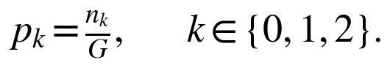
For each topology, we also calculated the mean, median, and population standard deviation of the induced internal branch length among gene trees supporting that topology. If no gene tree supported a topology, its branch summaries were missing and were handled within the fitted preprocessing pipeline. The alternative topology asymmetry associated with candidate k compared the other two frequency coordinates.
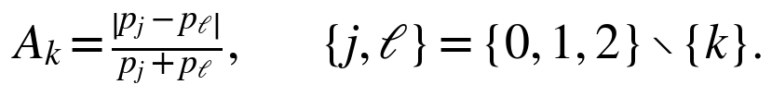
The denominator zero case was assigned an asymmetry of zero. The primary Enhanced17 representation contained 17 variables. Table 2 lists the feature families. Gamma, ILS, pair class, and gene tree count were not supplied directly, although the natural logarithm of the observed gene tree count was included as an observable sample size descriptor.
Table 2. Enhanced17 triplet feature representation
Feature family | Variables | Definition
Topology frequency | p0, p1, p2 | Fraction of gene trees supporting each rooted topology
Majority asymmetry | g_asym_major | Alternative frequency asymmetry for the observed majority topology
Branch length | mean, median, std for topology 0, 1, and 2 | Conditional summaries of the induced internal branch length, nine variables
Candidate asymmetry | g_asym0, g_asym1, g_asym2 | Alternative frequency asymmetry calculated for each candidate topology
Sample size | log_gene_tree_count | Natural logarithm of the observed gene tree count

3.5 Classifier training and probability calibration
The triplet classifier was a scikit-learn HistGradientBoostingClassifier preceded by median imputation with missingness indicators. Its fixed settings were learning rate 0.06, 250 maximum iterations, 31 maximum leaf nodes, L2 regularization 1.0, early stopping enabled, and random state 20260828. Hyperparameters were not selected on the held-out test backbones. Each model fit used at most 20 sampled triplet rows per simulation to bound memory use. Prediction was then performed for every held-out triplet row, not only for the training subsample.
We used five outer folds grouped by backbone identifier and stratified by taxon count. All scenarios from one backbone remained in one fold. Because each taxon count had 10 backbones, every fold held out exactly two backbones at each of the 177 sizes. Each outer test fold therefore contained 354 unseen backbones and 1,062 simulations. This grouping prevents triplets or scenarios derived from the same generating topology from appearing in both training and test data.
Topology coordinate augmentation was applied only to the outer training data. Each training row produced three rows through cyclic permutation of the topology indexed frequencies, branch summaries, asymmetries, and class label. Calibration used three grouped inner folds within the outer training partition. One temperature parameter was selected from 161 logarithmically spaced values between 0.25 and 4.0 by minimizing multiclass log loss on inner out of fold probabilities. The fitted temperature was then applied to the corresponding outer fold predictions. Test fold labels were never used to fit the classifier or its calibration parameter.
Classifier performance was recorded with triplet accuracy, multiclass log loss, multiclass Brier score, and 10-bin top-label expected calibration error. Complete-tree results used only the calibrated outer-fold probabilities. A separate model fitted to all sampled training rows was stored for later prediction, but it was not used to construct the trees reported in the cross-validated comparison.

3.6 Weighted recursive tree assembly
For each taxon triplet, the assembler created three weighted rooted topologies. At a candidate bipartition L given R, a topology contributed its positive weight when its paired taxa occurred on the same side, its negative weight when the pair was separated, and zero when all three taxa remained on one side. Only triplets crossing the candidate split entered the objective. The corrected split score was the signed contribution sum divided by the number of unique crossing triplet identifiers. This mean signed support prevents a split from receiving a larger score solely because it resolves more triplets.
The Fiduccia Mattheyses style search initialized a bipartition from a low-support seed pair and assigned the remaining taxa by average pair affinity. During one pass, it moved the unlocked taxon producing the largest corrected split score and locked that taxon for the rest of the pass. The numerator and crossing-triplet denominator were updated after each move. The best intermediate partition was retained only if it improved the starting normalized score by more than 10 to the power of negative 12. Passes continued until no improvement remained. The selected bipartition was applied recursively to each side until every terminal subset contained one taxon. Tie breaking and Newick child order were deterministic.
An initial implementation used the unnormalized signed sum. A post-run oracle diagnostic showed that this objective could favor partitions resolving more triplets even when the available triplet labels were correct. The objective was corrected before the final assembly and evaluation reported below. Pre-correction complete-tree outputs were excluded from the final comparisons.
Table 3. Internal assembly methods compared on identical simulations
Method | Triplet weights | Purpose
Enhanced17-ML-soft-FM | Three calibrated outer-fold probabilities | Primary calibrated-probability method
Enhanced17-ML-hard-FM | Weight 1 for the predicted class and 0 otherwise | Tests hard classification
Enhanced17-ML-confidence-FM | Winning class receives its maximum calibrated probability | Tests winner confidence weighting
Frequency-FM | Observed frequencies p0, p1, and p2 | Nonparametric soft control
Majority-FM | Weight 1 for the most frequent gene-tree topology | Nonparametric hard control

3.7 Rooted evaluation and paired statistical analysis
The inferred and generating trees were parsed as rooted trees with identical taxon labels. We represented each tree by its nontrivial rooted clades. Rooted RF distance was the size of the symmetric difference between the two clade sets. The normalized rooted RF distance divided that value by the total number of clades in both trees.
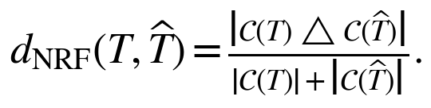
Rooted exact match was true when the two clade sets were identical. The evaluator also recorded whether the inferred tree was fully resolved, whether its taxon set matched the reference, and whether parsing or evaluation failed. Exact match accuracy used all requested simulations in its denominator, so failed evaluations could not count as correct. Mean and median normalized rooted RF were calculated over successfully evaluated trees. Results were additionally summarized by taxon count, triplet count, gamma, ILS length, gene tree count, pair class, backbone, and backbone imbalance stratum.
Every assembly method was evaluated on the same simulation identifiers. For each baseline, exact gain was the primary method exact indicator minus the baseline indicator. Normalized RF reduction was the baseline distance minus the primary method distance. Differences were first averaged within scenario group. The reported estimate was the mean scenario group difference. A 95 percent percentile interval was obtained from 10,000 bootstrap resamples clustered by the 1,770 backbones, using seed 20260909. A one sided Wilcoxon signed rank test used each backbone mean paired difference as one observation and tested whether the primary method had a positive gain or reduction. Holm correction covered the eight tests formed by four internal baselines and two metrics.

3.8 Computational execution and scope of inference
Simulation and feature extraction were executed in deterministic batches of five simulations. Two feature extraction workers were used. Each per simulation feature table was written as a compressed shard, read back for verification, and retained before its raw gene tree file was removed. Atomic partial files prevented an interrupted write from being accepted as complete. The runner enforced an 11 GB experiment budget and preserved at least 2 GB of free disk space. Verified shards and completed later stage outputs were reused after interruption.
The reduced design preserves the complete range of taxon counts and the complete backbone sample, but it does not execute every combination of gamma, ILS, gene tree count, and pair class on every backbone. It therefore supports paired method comparisons across the selected condition set and descriptive stratification by represented factors. It does not support a complete within-backbone factorial interaction analysis. STELAR, MP-EST, and Triplet MaxCut did not produce complete outputs for all 5,310 selected simulations within the execution window. Their partial runs were excluded. Existing six-taxon external benchmarks constitute a separate experiment and were not pooled with this analysis.

3.9 Oracle assembly diagnostic
We used a post-run oracle diagnostic to separate triplet classification error from limitations of assembly and sampled-triplet coverage. For every selected feature row, the stored true rooted topology label was converted to a one-hot weight vector and passed to the same assembler used for the model predictions. The diagnostic retained the same sampled triplet identifiers, taxon sets, and generating backbones. It did not simulate new gene trees, retrain the classifier, or provide unobserved triplets to the assembler.
The oracle result is therefore a conditional ceiling for the implemented assembler under the selected triplet set. It is not the theoretical accuracy obtainable from all possible triplets. Oracle and out-of-fold model trees were compared simulation by simulation across the complete 4 through 180 taxon design.

4 Results
The final analysis evaluated five internal assembly methods on the same 5,310 out-of-fold simulation predictions. Every method returned a fully resolved tree for every simulation. No evaluation failed, no inferred tree had a taxon-set mismatch, and exact match was equivalent to normalized rooted RF equal to zero in every row.

4.1 Triplet classification
Across 4,975,320 held-out triplet rows, Enhanced17 achieved 94.93% classification accuracy, multiclass log loss 0.1248, multiclass Brier score 0.0705, and 10-bin top-label expected calibration error 0.0021. These values were calculated exclusively from outer-fold predictions. The high triplet-level accuracy did not imply high complete-tree accuracy because a complete tree requires consistent information across many related splits.

4.2 Assembly correction and oracle validation
With the initial unnormalized assembly score, true triplet labels recovered 166 of 300 trees from 11 through 20 taxa, giving 55.33% exact accuracy and mean normalized rooted RF 0.0438. After normalizing the split score by the number of crossing triplets, the same diagnostic recovered 290 of 300 trees, giving 96.67% exact accuracy and mean normalized rooted RF 0.0022. The corrected oracle recovered all 30 trees at every individual size from 11 through 19 taxa.
At 20 taxa, the oracle recovered 20 of 30 trees. The sampler retained 1,000 of 1,140 possible triplets, or 87.72%, while every taxon pair appeared in at least one selected triplet. The remaining errors therefore reflect missing triplet combinations rather than missing taxa or a failure of the corrected objective on an exhaustive set.

4.3 Internal comparison from 4 through 20 taxa
The 4 through 20 taxon accuracy-focused stratum contained 510 simulations from 170 held-out backbones. This stratum was defined during post-run diagnosis and is reported as an exploratory description rather than a prespecified confirmatory analysis.
Table 4. Internal method performance from 4 through 20 taxa
Method | Exact trees | Exact accuracy | Mean nRF | Median nRF
Enhanced17 ML soft FM | 273/510 | 53.53% | 0.1781 | 0.0000
Enhanced17 ML hard FM | 273/510 | 53.53% | 0.1781 | 0.0000
Enhanced17 ML confidence FM | 268/510 | 52.55% | 0.1803 | 0.0000
Frequency FM | 203/510 | 39.80% | 0.2480 | 0.1250
Majority FM | 217/510 | 42.55% | 0.2325 | 0.1111

Enhanced17 ML-soft FM recovered 273 of 510 trees exactly, or 53.53%, with mean normalized rooted RF 0.1781. Relative to Frequency FM, the paired exact-accuracy gain was 0.1373, with a 95% clustered bootstrap interval from 0.1078 to 0.1667 and Holm-adjusted p = 8.59e-13. The corresponding normalized RF reduction was 0.0700, interval 0.0537 to 0.0870, adjusted p = 9.92e-14.
Relative to Majority FM, the exact-accuracy gain was 0.1098, interval 0.0804 to 0.1392, adjusted p = 4.62e-10. The normalized RF reduction was 0.0544, interval 0.0373 to 0.0723, adjusted p = 9.39e-08. ML-soft and ML-hard both recovered 273 trees, and their exact gain was 0.0000, adjusted p = 1.000. The ML-soft gain over ML-confidence was 0.0098, adjusted p = 0.675. Thus calibrated soft probabilities improved upon the two nonparametric controls, while the three ML weighting variants were not distinguishable in this stratum.

4.4 Performance across taxon counts
Complete-tree performance changed sharply with taxon count. Exact accuracy remained substantial through 20 taxa, declined between 21 and 40 taxa, and was zero above 40 taxa under the fixed 1,000-triplet budget. Mean normalized rooted RF showed the same scaling pattern and approached one at the largest sizes.
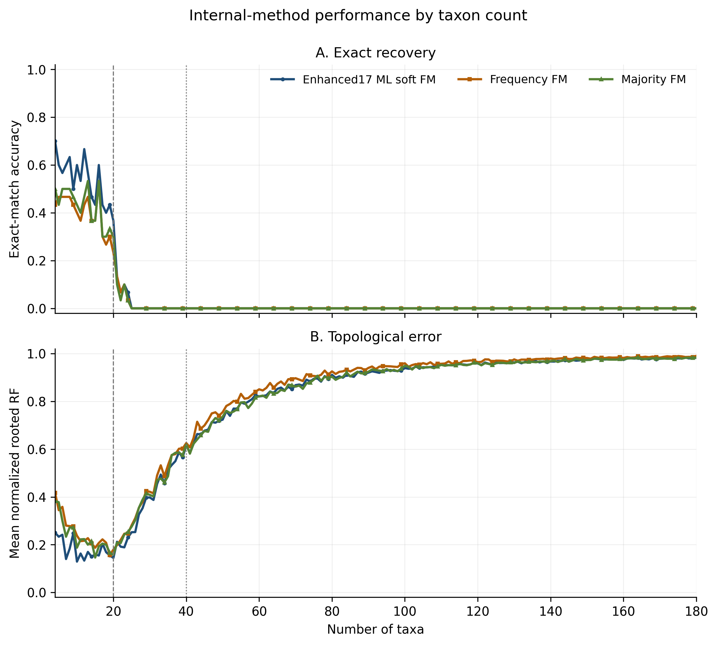
Figure 1. Internal method performance by taxon count. Dashed reference lines mark 20 and 40 taxa. Exact accuracy is shown above and mean normalized rooted RF below.
Table 5. ML-soft performance and conditional oracle ceiling by taxon-count stratum
Taxa | Simulations | Model exact | Oracle exact | Model mean nRF | Oracle mean nRF
4-10 | 210 | 60.00% | 100.00% | 0.2036 | 0.0000
11-20 | 300 | 49.00% | 96.67% | 0.1602 | 0.0022
21-40 | 600 | 1.83% | 4.00% | 0.3981 | 0.2914
41-80 | 1,200 | 0.00% | 0.00% | 0.7998 | 0.7472
81-120 | 1,200 | 0.00% | 0.00% | 0.9344 | 0.9168
121-180 | 1,800 | 0.00% | 0.00% | 0.9722 | 0.9636

The oracle recovered all 210 trees from 4 through 10 taxa and 290 of 300 trees from 11 through 20 taxa. It recovered only 24 of 600 trees from 21 through 40 taxa and none above 40 taxa. Because the oracle received correct labels for every selected triplet, this decline identifies sampled-triplet coverage and the resulting assembly information as the main constraint at larger taxon counts.
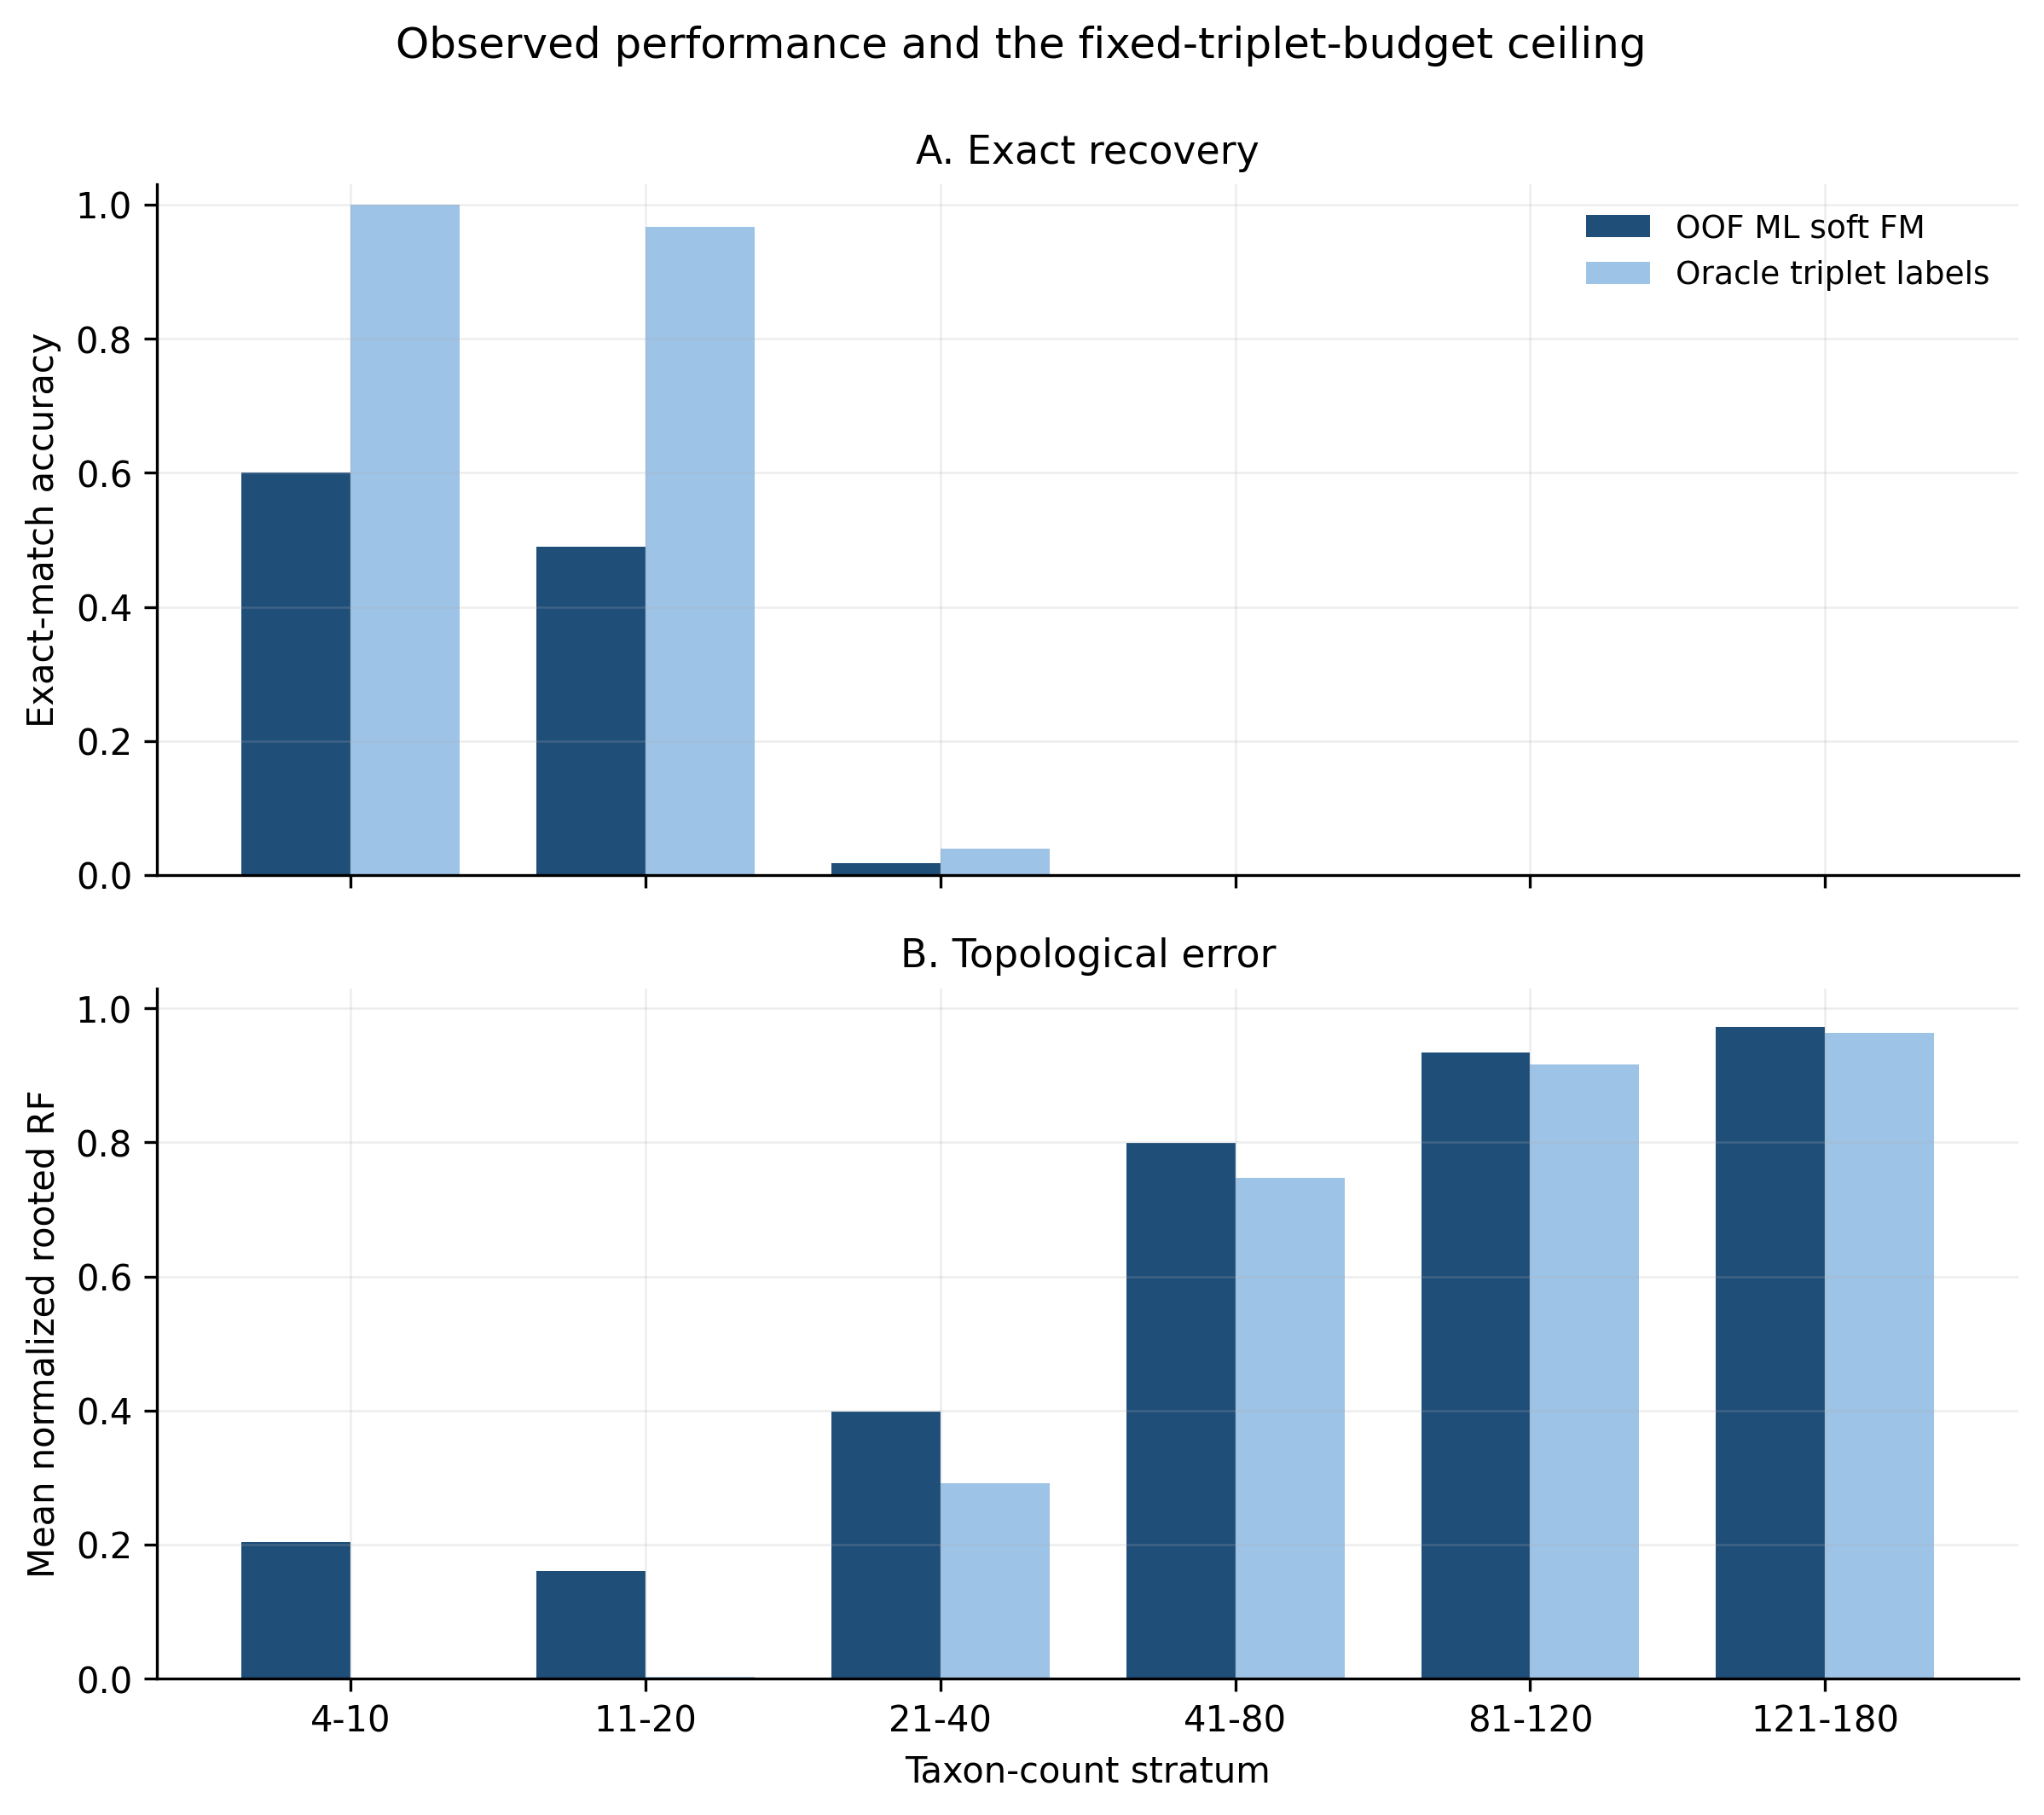
Figure 2. Out-of-fold ML-soft performance and the oracle ceiling conditional on the same sampled triplets. The oracle uses true triplet labels but does not receive unselected triplets.

4.5 Full-scope summary and runtime
Table 6 reports the complete 4 through 180 taxon evaluation. These pooled values are dominated by the 4,200 simulations above 40 taxa and should be interpreted together with the taxon-stratified results.
Table 6. Internal method summary across all 5,310 simulations
Method | Exact trees | Exact accuracy | Mean nRF | Mean assembly seconds
Enhanced17 ML soft FM | 284 | 5.35% | 0.7836 | 0.123
Enhanced17 ML hard FM | 282 | 5.31% | 0.7830 | 0.101
Enhanced17 ML confidence FM | 281 | 5.29% | 0.7840 | 0.123
Frequency FM | 213 | 4.01% | 0.8057 | 0.169
Majority FM | 225 | 4.24% | 0.7902 | 0.114

Across the complete scope, ML-soft recovered 284 trees exactly and had mean normalized rooted RF 0.7836. Model training required 573.4 recorded wall seconds. Mean assembly time ranged from 0.101 seconds per tree for ML-hard to 0.169 seconds for Frequency FM. These assembly measurements exclude simulation, feature extraction, and model training.

5 Discussion

5.1 Interpretation of the internal comparison
Within 4 through 20 taxa, Enhanced17 with calibrated soft weighting produced higher exact-tree accuracy and lower normalized rooted RF than Frequency FM and Majority FM. The lack of a measurable difference among ML-soft, ML-hard, and ML-confidence indicates that the main improvement arose from the learned triplet decision rule, not from the choice among the three probability-weighting variants. ML-soft remains the primary representation because it retains the complete calibrated probability vector and achieved the highest exact count across the full scope, but the data do not show that it outperforms ML-hard or ML-confidence.
The 94.93% held-out triplet accuracy and 53.53% exact-tree accuracy in the 4 through 20 stratum measure different targets. Triplet accuracy averages local decisions, whereas exact-tree accuracy requires every nontrivial rooted clade to match. Local errors can therefore accumulate even when the average triplet decision is accurate.

5.2 Fixed triplet budget and scaling
The fixed cap becomes increasingly sparse as the number of taxa grows. At 20 taxa, 1,000 selected triplets cover 87.72% of the 1,140 possible triplets. At 180 taxa, the same cap covers 0.1046% of the 955,860 possible triplets. Moreover, 1,000 triplets contain at most 3,000 taxon-pair incidences, whereas 180 taxa contain 16,110 distinct pairs. Even before duplicated pairs are considered, the maximum possible pair coverage is therefore 18.62%. A complete rooted tree cannot be expected to remain identifiable from this fixed information budget across the entire size range.
The oracle analysis supports this explanation. Correct labels nearly eliminated assembly error when the triplet set was exhaustive, but they did not recover large trees from the sparse selected sets. The results above 40 taxa therefore characterize computational behavior under a fixed 1,000-triplet budget. They do not establish the accuracy achievable with a taxon-dependent or coverage-aware sampling budget.

5.3 Study limitations
The executed design retained every taxon count and backbone but selected three of 108 candidate condition cells per backbone. It cannot estimate all factorial interactions within a backbone. The simulation used one introgression edge, common internal branch lengths within each simulation, and known gene trees without sequence evolution or gene-tree estimation error. These choices isolate the inference mechanism but limit biological generalization.
Training used at most 20 sampled rows per simulation, while prediction covered every retained triplet. Enhanced17 included the logarithm of observed gene-tree count but did not include taxon count or retained-triplet proportion. The diagnostic taxon strata and the normalized assembly correction were developed after inspection of the initial results. The stratified p values should therefore be treated as exploratory evidence requiring independent replication. No complete external benchmark was available for this 5,310-simulation design.

5.4 Required follow-up evaluation
The next evaluation should select triplets with deterministic coverage constraints on both taxa and taxon pairs, and should increase the cap with taxon count. A sensitivity experiment should compare the current 1,000-triplet cap with larger budgets on independent backbones before another full simulation. The corrected assembler and any size-aware classifier should then be evaluated without further tuning on a newly generated test set. Complete STELAR, MP-EST, and Triplet MaxCut runs should be reported only when all compared methods share the same simulation identifiers.

6 Conclusion
The corrected pipeline completed 5,310 out-of-fold evaluations across 1,770 rooted backbones and 177 taxon counts. From 4 through 20 taxa, Enhanced17 ML-soft FM recovered 53.53% of complete trees and outperformed Frequency FM and Majority FM on exact accuracy and normalized rooted RF. The three ML weighting variants were statistically indistinguishable. Oracle recovery of 98.04% across the same 510 low-taxon simulations confirmed that the normalized assembler was effective when triplet coverage was dense. Above 40 taxa, both model and oracle recovery failed under the fixed 1,000-triplet cap. The principal technical requirement for larger trees is therefore a taxon-dependent, coverage-aware triplet selection strategy followed by independent validation.

