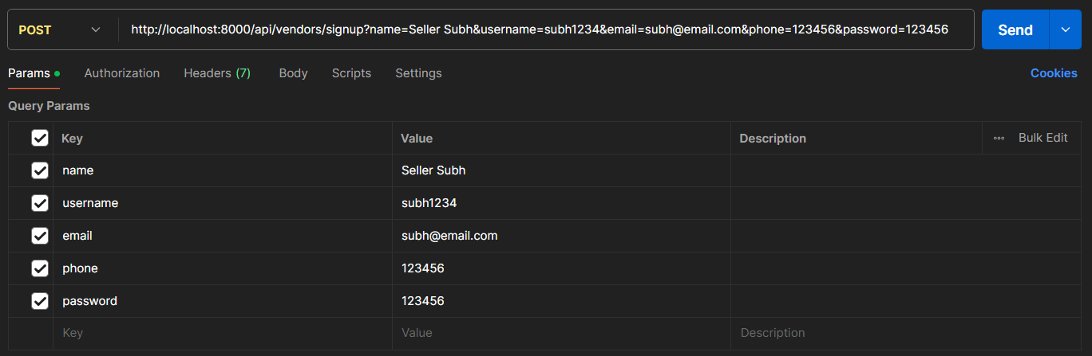

Creating a Seller account ↑.

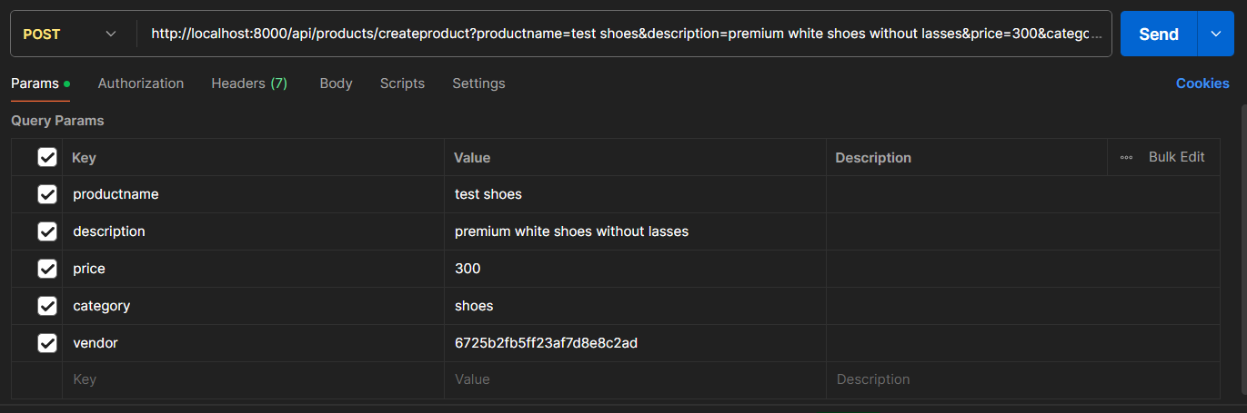

Creating a product ↑.

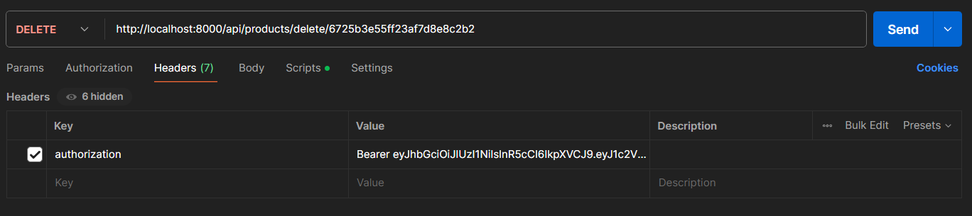

Deleting a product followed by the users token ↑.