KERALA SAMAJAM MODEL SCHOOL
PRE ICSE EXAMINATION 2025-26
SCIENCE PAPER 3 (BIOLOGY)

Maximum marks :- 80 marks
Time :- 15 mins + 2 hours
Answers to this paper must be written on the paper provided separately. You will not be allowed to write during first 15 minutes.
This time is to be spent in reading the questions papers.
The time given at the head of this paper is the time allowed for writing the answers.
_______________________________________________________

Section A is compulsory. Attempt any four questions from Section B. The intended marks for the questions are given in brackets( ).
SECTION A
(Attempt all questions from this section)

Question 1.
Select the correct answers to the questions from the given options. (Do not copy the questions. Write the correct answers only) :
i) Convex lens is used instead of concave lens to correct the eye defect hypermetropia. Which of the following reasons make it a correct choice?
P. Convex lens converges the light rays.
Q. With the use of convex lens image is formed on the retina.
R. Concave lens converges the light.
a) Only P b) P and Q c) P and R d) Only R

ii) Nuclear membrane reappears during:

a) Metaphase b) Telophase c) Anaphase d) Prophase

iii) Charles Darwin gave example of this species to explain Industrial Melanism.
a) Giraffe b) Butterfly c) Peppered moth d) Spider

iv) The outermost layer of meninges is:

a) Piamater b) Duramater c) Grey matter d) Arachnoid

v) Ahmed tried to match the hormones with their effect on human body. He tabulated the pairs as follows:

Hormone | Effect on the body
P | Stimulates the cells to utilize glucose
Q | Prepares the body for emergency situations.

a) P- Insulin, Q- Glucagon b) P- Adrenaline, Q- Insulin
c) P- Insulin, Q- Adrenaline d) P- Thyroxine, Q- Vasopressin

vi) Lata was pregnant with her first child. Her mother in law was asking her to take healthy diet for the nourishment of the developing baby. Which of the following is/are responsible for nourishment from mother to foetus.
a) Oviduct. b) Ovary. c) Placenta. d)Cervix.

vii) Uma placed a plant near the window in her kitchen.She observed that the stem started growing to the side from where sunlight was coming. What term/terms would you associate with it?
1) Tropic movement 2) Geotropism
3)Phototropism 4)Thigmotropism
a) Only 1 b) Only 1 and 3 c) Only 1, 3 and 4 d) Only 1, 2 and 4

viii) A cell has 5 pairs of chromosomes. After mitotic division, the number of chromosome in daughter cell will be
a) 5 b)10 c)20 d)40

ix) The chief radiation pollutant which raises the risk of thyroid cancer:
a) Iodine 113 b)Iodine 133 c)Iodine 131 d)Iodine 311

x) A condition in which adults become sluggish with swelling of the face
a)Cretinism b)Myxoedema c) Goitre d) Exophthalmic goitre

xi) This male accessory gland whose secretion neutralizes the acidity of vagina is :-
a) Prostate gland b) Seminal vesicle c) Seminiferous tubule d) Bulbo urethral gland

xii) Compressed natural gas is proposed to be a better alternative to fossil fuel. Which of the following reasons makes it a better alternative ?
P: Combustion leaves little or no residue.
Q: Absence of carbon in CNG.
R: Easily available.
a) Only P and R. b) Only Q and R. c) Only Q. d) Only P.

xiii) The part of the brain that acts as a thermoregulatory centre of the body:
a) Thalamus. b) Hypothalamus. c) Diencephalon. d) Pons.

xiv) Identify the diagram given below:
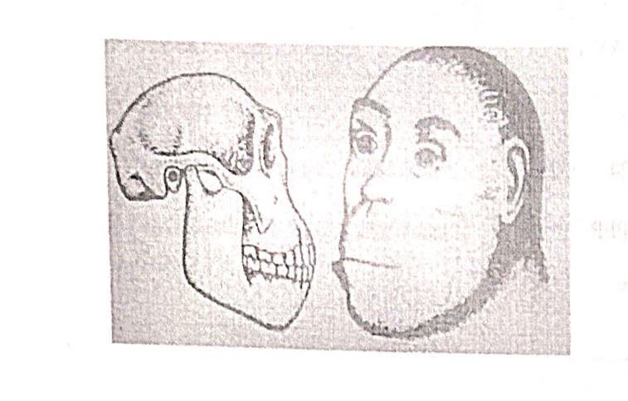

a) Homo erectus. b) Cro-magnon.
c) Australopithecus. d) Neanderthal.

xv) Assertion : Rods and cones are the photoreceptors present in the retina of eye.
Reason: Cones are sensitive to dim light.
a) Both A and R are true. b) Both A and R are false.
c) A is true and R is false. d) A is false and R is true.

Question 2.
(i) Give technical term for the following : (5)

(a)The site where the sperm and ovum unite and fuse.
(b) The molecule through which genetic information is transferred from one generation to other.
(c) The phenomenon of gradual increase in the average temperature of the surface of the earth.
(d)The hormone that controls the basal metabolic rate.
(e) The respiratory pigment in Erythrocytes. [Analysis]

(ii) Read the information below the diagram and fill in the blanks (5)
Spinal cord forms the posterior part of the CNS , running mid dorsally in the neural canal of the vertebral column . In an adult,the spinal cord is 42-45 cm long. Its diameter varies at different stages of growth.
Spinal cord serves as a vital communication pathway between the (a)______ and the rest of the body. It has two roots (b)______ attached to the receptor and (c) _____attached to the effector . The spinal cord is the center of (d)_______. The (e)_______are the membrane that protects the spinal cord. [Recall]

(iii) Arrange the following terms in logical sequence: (5)
(a) Australopithecus, Homo erectus, Homo habilis, Cro- magnon.
(b) Conjunctiva, Retina, Vitreous humour, Cornea.
(c) Embryo, Blastocytes, Foetus, Morula.
(d) Fertilization, Ovulation, Implantation, Gestation.
(e) Endodermis, Cortex, Xylem, Epidermis. [Understanding]

(iv) Choose the odd one out and name the category to which others belong: (5)
(i) Methane, Nitrogen, CFC, CO2
(ii) Axon, Dendron, Photon, Cyton.
(iii) Uterus, Urethra, Urinary bladder, Ureter.
(iv) Phosphate, RNA, Sugar, Nitrogen bases.
(v) Pons, Cyton, Axon, Dendrons. [Analysis ]

(v) Read the explanation given below and name the structures: (5)
(a) Serves as a link between sensory neuron and motor neuron.
(b) It is a heterocrine gland that lies in the loop of duodenum.
(c) The part of the plant that shows positive geotropism.
(d) The instrument which is used to measure blood pressure in human beings.
(e) Chromosome that is carried by the sperm to the male child.
[Understanding]

(vi) Match the column A with appropriate ones in column B: (5)
COLUMN A COLUMN B
(a) Rod cell (i) x-factor.
(b) Menarch (ii) Vasectomy.
(c) Clotting of blood (iii) Dim light sensitive
(d) Oviduct. (iv) Bright light sensitive.
(e) Vas deferens. (v) Menstrual cycle.
(vi) Tubectomy.
[Understanding and Recall]
SECTION B (40 MARKS)
Question 3
(i) Find the birth rate if there is 880 live birth in a population of 11000. [Analysis] (1)
(ii) Give reason: (2)
(a) It is better to have a colour blind father than a carrier mother.
(b) Excess fertilizer kills crop after watering. [Understanding]
(iii) Differentiate between transpiration and guttation. [Recall] (2)
(iv) Rohan’s grandfather can’t see nearer objects clearly. Name the eye defect and its correction. [Analysis] (2)
(v) By means of a neat labelled diagram show Metaphase stage with 3 chromosomes. [Analysis]. (3)

Question 4.
(i) Expand IUD. [Recall] (1)
(ii) Differentiate between the following on given criteria : (2)
(a) Dark adaptation and Light adaptation (pigments regenerated)
(b) Menstrual phase and Luteal phase (number of days) [Understanding]
(iii) What are the parts diencephalon consists? What roles do they perform? [Recall] (2)
(iv) When Swachh Bharat Abhiyan was launched? State its two objectives. [Recall] (2)
(v) Study the diagram given below and answer the following questions:
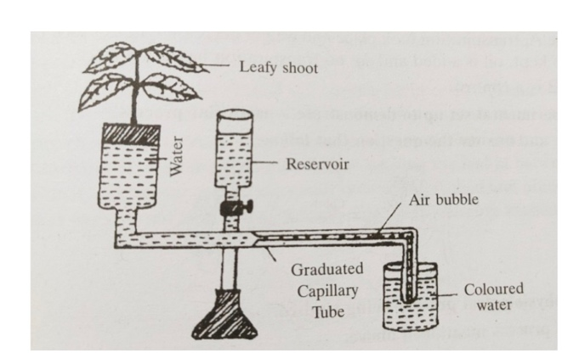

(a) Identify the instrument. (1)
(b) What is the above instrument used for? (1)
(c) Mention any two drawbacks of using this instrument. (1)
[Understanding and Recall]

Question 5.
(i) What is Parthenocarpy? [Recall] (1)
(ii) State the difference between Micturition and Parturition. (2)
[Recall]
(iii) What is the significance of Testes being placed in Scrotal sacs?
[Recall] (2)
(iv) Mention the significance of the following minerals: (2)
(a) Calcium in blood.
(b) Magnesium for green plants. [Understanding]
(v) Draw a neat labelled diagram of a Malpighian capsule. (3)
[Understanding and Recall]

Question 6.
(i) Write the overall chemical equation for photosynthesis. [Recall] (1)
(ii) Mention the two pairs of nitrogenous bases that are present in a DNA strand and pair with each other by hydrogen bonds. [Recall] (2)
(iii) What is ozone depletion? State any one harmful effect of it. (2) [Recall]
(iv) Ronita is an expert gymnast on the balance beam. She has been continuously practicing for the games. After sometime she has been experiencing dizziness and losing her balance. (2)
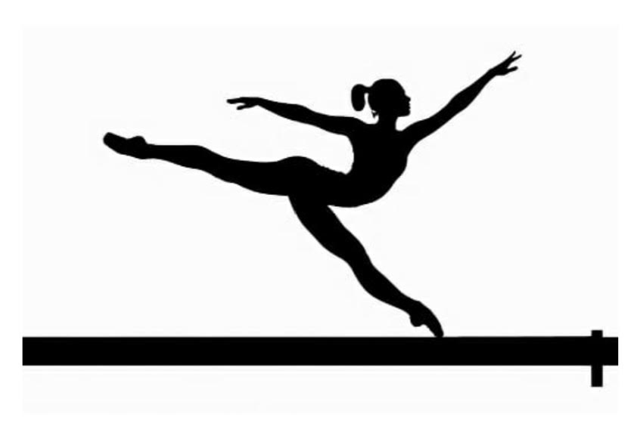
(a) Which type of balance is maintained by the structure ?
(b) Name the sensory cells that help in hearing. [Analysis and Recall]
(v) Study the diagram and answer the following questions: (3)

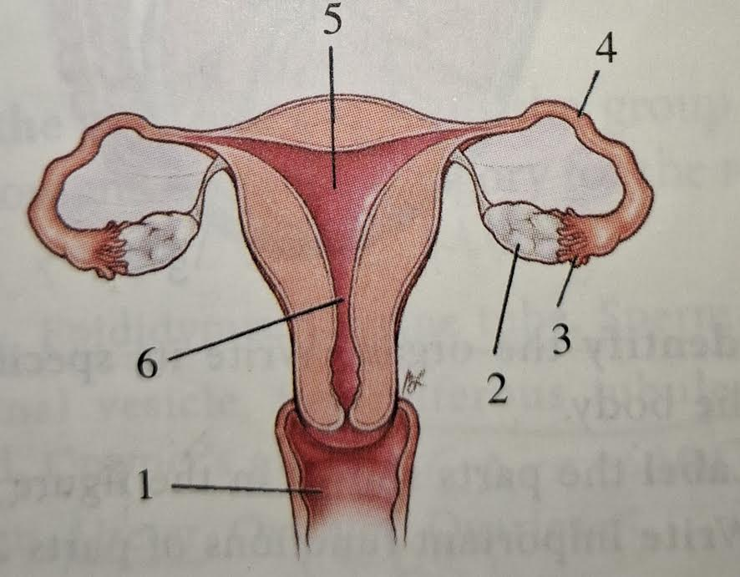

(i) Name any two extra embryonic membranes.
(ii) Mention the technical term for the fixing of developing zygote to the uterine wall. [Understanding and Recall]

Question 7.
(i) Why is ABA called stress hormone? [Understanding] (1)
(ii) Note the relationship between the first two words and suggest a suitable word for the fourth place: [Recall] (2)
(a) Chest pain : Angina pectoris :: Heart attack : _________
(b) __________ : Heart :: Hepatic artery : Liver.
(iii) Soham’s father is not keeping well . Due to some infection in urinary tract , he is passing urine with some traces of blood. (2)
(a) Name the disease he is suffering with.
(b) What could be the other cause for the above mentioned disease. [Analysis]
(iv) Name and state the law which explains the dihybrid phenotypic ratio. [Recall]. (2)
(v) Study the picture given below and answer the questions that follow: (3)

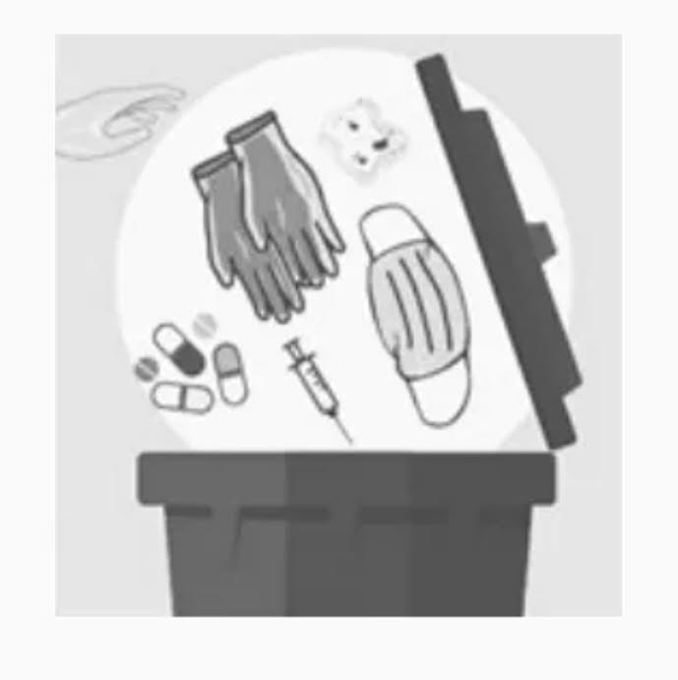
(a) Name the category of waste that is being disposed.
(b) Give an example of such a waste.
(c) Are they hazardous to human and animal ? Give a suitable reason. [Understanding ]

Question 8.
(i) The gene of red hair is recessive to the gene of black hair. What will be the hair colour of a person if he inherits a gene for red hair from his mother and a gene for black hair from his father? (1) [Analysis]
(ii) What are the two hormones secreted by Corpus luteum? (2)
[Recall]
(iii) Write the exact location of each of the following : (2)
(a) Loop of Henle. (b) Pituitary. [Recall]
(iv) What is MTP? In what circumstances is it recommended ? (2)[Recall and Understanding]
(v) Aryan is an intelligent student. He is writing a composition on ‘Significance Of Education’. (3)
(i) Which part of the brain helps the child for writing composition?
(ii) Is it a voluntary or involuntary action?
(iii)Arrange the following terms in a sequence:
Sensory neuron, Finger tips, Motor neurons, Effector muscle.
[Understanding]

