**Batch: A-3**

**Roll No.: 16010123066**

**Experiment / assignment / tutorial No. 6**

**Grade: AA / AB / BB / BC / CC / CD /DD**

**Signature of the Staff In-charge with date**

**Title: Queries based on Procedure,Function and Cursor**

**Objective:** To be able to functions and procedures on the table.

# Expected Outcome of Experiment:

CO 3 : Use SQL for Relational database creation, maintenance and query processing

# Books/ Journals/ Websites referred:

1. Dr. P.S. Deshpande, SQL and PL/SQL for Oracle 10g.Black book, Dreamtech Press
2. [www.db-book.com](http://www.db-book.com/)
3. Korth, Slberchatz, Sudarshan : “Database Systems Concept”, 5th Edition , McGraw Hill
4. Elmasri and Navathe,”Fundamentals of database Systems”, 4th Edition,PEARSON Education.

**Resources used:** Postgresql

# Theory Procedures:

A stored procedure is a set of Structured Query Language (SQL) statements with an assigned name, which are stored in a relational database management system as a group, so it can be reused and shared by multiple programs.

Stored procedures can access or modify data in a database, but it is not tied to a specific database or object, which offers a number of advantages.

# Benefits of using stored procedures

A stored procedure provides an important layer of security between the user interface and the database. It supports security through data access controls because end users may enter or change data, but do not write procedures. A stored procedure preserves

data integrity because information is entered in a consistent manner. It improves productivity because statements in a stored procedure only must be written once.

Use of stored procedures can reduce network traffic between clients and servers, because the commands are executed as a single batch of code. This means only the call to execute the procedure is sent over a network, instead of every single line of code being sent individually.

Syntax:

CREATE [ OR REPLACE ] PROCEDURE

***name*** ( [ [ ***argmode*** ] [ ***argname*** ] ***argtype*** [ { DEFAULT | = }

***default_expr*** ] [, ...] ] )

{ LANGUAGE ***lang_name***

| TRANSFORM { FOR TYPE ***type_name*** } [, ... ]

| [ EXTERNAL ] SECURITY INVOKER | [ EXTERNAL ] SECURITY DEFINER

| SET ***configuration_parameter*** { TO ***value*** | = ***value*** | FROM CURRENT }

| AS '***definition***'

| AS '***obj_file***', '***link_symbol***'

} ...

Parameters

**Name:** The name (optionally schema-qualified) of the procedure to create.

**Argmode:** The mode of an argument: IN, INOUT, or VARIADIC. If omitted, the default is IN. (OUT arguments are currently not supported for procedures. Use INOUT instead.)

**Argname:** The name of an argument.

**Argtype:** The data type(s) of the procedure's arguments (optionally schema-qualified), if any. The argument types can be base, composite, or domain types, or can reference the type of a table column.

Depending on the implementation language it might also be allowed to specify “pseudo-types” such as cstring. Pseudo-types indicate that the actual argument type is either incompletely specified, or outside the set of ordinary SQL data types.

The type of a column is referenced by writing table_name.column_name%TYPE. Using this feature can sometimes help make a procedure independent of changes to the definition of a table.

**default_expr:** An expression to be used as default value if the parameter is not specified. The expression has to be coercible to the argument type of the parameter. All input parameters following a parameter with a default value must have default values as well.

**lang_name** :The name of the language that the procedure is implemented in. It can be sql, c, internal, or the name of a user-defined procedural language, e.g. plpgsql. Enclosing the name in single quotes is deprecated and requires matching case.

# TRANSFORM { FOR TYPE type_name } [, ... ] }

Lists which transforms a call to the procedure should apply. Transforms convert between SQL types and language-specific data types; see CREATE TRANSFORM. Procedural language implementations usually have hardcoded knowledge of the built-in types, so those don't need to be listed here. If a procedural language implementation does not know how to handle a type and no transform is supplied, it will fall back to a default behavior for converting data types, but this depends on the implementation.

# [EXTERNAL] SECURITY INVOKER [EXTERNAL] SECURITY DEFINER

**SECURITY INVOKER** indicates that the procedure is to be executed with the privileges of the user that calls it. That is the default. SECURITY DEFINER specifies that the procedure is to be executed with the privileges of the user that owns it.

The key word EXTERNAL is allowed for SQL conformance, but it is optional since, unlike in SQL, this feature applies to all procedures not only external ones.

A SECURITY DEFINER procedure cannot execute transaction control statements (for example, COMMIT and ROLLBACK, depending on the language).

# configuration_parameter

**value:** The SET clause causes the specified configuration parameter to be set to the specified value when the procedure is entered, and then restored to its prior value when the procedure exits. SET FROM CURRENT saves the value of the parameter that is current when CREATE PROCEDURE is executed as the value to be applied when the procedure is entered.

If a SET clause is attached to a procedure, then the effects of a SET LOCAL command executed inside the procedure for the same variable are restricted to the procedure: the configuration parameter's prior value is still restored at procedure exit. However, an ordinary SET command (without LOCAL) overrides the SET clause, much as it would do for a previous SET LOCAL command: the effects of such a command will persist after procedure exit, unless the current transaction is rolled back.

If a SET clause is attached to a procedure, then that procedure cannot execute transaction control statements (for example, COMMIT and ROLLBACK, depending on the language).

# Definition

A string constant defining the procedure; the meaning depends on the language. It can be an internal procedure name, the path to an object file, an SQL command, or text in a procedural language.

It is often helpful to use dollar quoting to write the procedure definition string, rather than the normal single quote syntax. Without dollar quoting, any single quotes or backslashes in the procedure definition must be escaped by doubling them.

# obj_file, link_symbol

This form of the AS clause is used for dynamically loadable C language procedures when the procedure name in the C language source code is not the same as the name of the SQL procedure. The string obj_file is the name of the shared library file containing the compiled C procedure, and is interpreted as for the LOAD command. The string link_symbol is the procedure's link symbol, that is, the name of the procedure in the C language source code. If the link symbol is omitted, it is assumed to be the same as the name of the SQL procedure being defined.

When repeated CREATE PROCEDURE calls refer to the same object file, the file is only loaded once per session. To unload and reload the file (perhaps during development), start a new session.

# Example:

We will use the following accounts table for the demonstration:

CREATE TABLE accounts (

id INT GENERATED BY DEFAULT AS IDENTITY, name VARCHAR(100) NOT NULL,

balance DEC(15,2) NOT NULL, PRIMARY KEY(id)

);

INSERT INTO accounts(name,balance)

VALUES('Bob',10000);

INSERT INTO accounts(name,balance)

VALUES('Alice',10000);

The following example creates stored procedure named transfer that transfer specific amount of money from one account to another.

CREATE OR REPLACE PROCEDURE transfer(INT, INT, DEC)

LANGUAGE plpgsql AS $$

BEGIN

-- subtracting the amount from the sender's account UPDATE accounts

SET balance = balance - $3

WHERE id = $1;

-- adding the amount to the receiver's account UPDATE accounts

SET balance = balance + $3

WHERE id = $2;

COMMIT; END;

$$;

CALL stored_procedure_name(parameter_list); CALL transfer(1,2,1000);

# Functions

The basic syntax to create a function is as follows −

CREATE [OR REPLACE] FUNCTION function_name (arguments)

RETURNS return_datatype language plpgsql

AS

$variable_name$ declare

begin end; $$

-- variable declaration

-- stored procedure body

# Explanation:

**function-name** specifies the name of the function.

[OR REPLACE] option allows modifying an existing function. The function must contain a return statement.

**RETURN** clause specifies that data type you are going to return from the function. The return_datatype can be a base, composite, or domain type, or can reference the type of a table column.

**function-body** contains the executable part.

**The AS keyword** is used for creating a standalone function.

**plpgsql** is the name of the language that the function is implemented in. Here, we use this option for PostgreSQL,it Can be SQL, C, internal, or the name of a user-defined procedural language. For backward compatibility, the name can be enclosed by single quotes.

Example

CREATE TABLE employee ( id SERIAL PRIMARY KEY, name VARCHAR(100),

date_of_joining DATE, salary DECIMAL(10, 2)

);

INSERT INTO employee (name, dateofjoining, salary) VALUES ('John Doe', '2022-01-01', 50000),

('Jane Smith', '2022-02-15', 60000),

('Michael Johnson', '2022-03-20', 70000),

('Emily Davis', '2022-04-10', 45000),

('Christopher Wilson', '2022-05-05', 80000);

create a function named get_employee_count to calculate the number of records in the employee table:

CREATE OR REPLACE FUNCTION get_employee_count() RETURNS INTEGER AS $$

DECLARE

total_records INTEGER; BEGIN

-- Execute a SQL query to count the number of records in the employee table SELECT COUNT(*) INTO total_records FROM employee;

-- Return the total number of records RETURN total_records;

END;

$$ LANGUAGE plpgsql;

**calling the function using query:**

SELECT get_employee_count();

# Cursors

Rather than executing a whole query at once, it is possible to set up a cursor that encapsulates the query, and then read the query result a few rows at a time. One reason for doing this is to avoid memory overrun when the result contains a large number of rows. (However, PL/pgSQL users do not normally need to worry about that, since FOR loops automatically use a cursor internally to avoid memory problems.) A more interesting usage is to return a reference to a cursor that a function has created, allowing the caller to read the rows. This provides an efficient way to return large row sets from functions.

Before a cursor can be used to retrieve rows, it must be opened. (This is the equivalent action to the SQL command DECLARE CURSOR.) PL/pgSQL has three forms of the OPEN statement, two of which use unbound cursor variables while the third uses a bound cursor variable.

# OPEN FOR query

Syntax: OPEN unbound_cursorvar [ [ NO ] SCROLL ] FOR query; example:

OPEN curs1 FOR SELECT * FROM foo WHERE key = mykey;

# OPEN FOR EXECUTE

Syntax: OPEN unbound_cursorvar [ [ NO ] SCROLL ] FOR EXECUTE query_string [ USING expression [, ... ] ];

example:

OPEN curs1 FOR EXECUTE 'SELECT * FROM ' || quote_ident(tabname)

|| ' WHERE col1 = $1' USING keyvalue;

# Opening a Bound Cursor

Syntax: OPEN bound_cursorvar [ ( [ argument_name := ] argument_value [, ...] ) ];

Examples (these use the cursor declaration examples above): OPEN curs2;

OPEN curs3(42);

OPEN curs3(key := 42);

Because variable substitution is done on a bound cursor's query, there are really two ways to pass values into the cursor: either with an explicit argument to OPEN, or implicitly by referencing a PL/pgSQL variable in the query. However, only variables declared before the bound cursor was declared will be substituted into it. In either case the value to be passed is determined at the time of the OPEN. For example, another way to get the same effect as the curs3 example above is

DECLARE

key integer;

curs4 CURSOR FOR SELECT * FROM tenk1 WHERE unique1 = key; BEGIN

key := 42; OPEN curs4;

# Using Cursors FETCH

Synatx: FETCH [ direction { FROM | IN } ] cursor INTO target; Examples:

FETCH curs1 INTO rowvar; FETCH curs2 INTO foo, bar, baz;

FETCH LAST FROM curs3 INTO x, y; FETCH RELATIVE -2 FROM curs4 INTO x; **MOVE**

MOVE [ direction { FROM | IN } ] cursor;

MOVE repositions a cursor without retrieving any data. MOVE works exactly like the FETCH command, except it only repositions the cursor and does not return the row moved to. As with SELECT INTO, the special variable FOUND can be checked to see whether there was a next row to move to.

Examples:

MOVE curs1;

MOVE LAST FROM curs3;

MOVE RELATIVE -2 FROM curs4; MOVE FORWARD 2 FROM curs4;

# UPDATE/DELETE WHERE CURRENT OF

UPDATE table SET ... WHERE CURRENT OF cursor;

DELETE FROM table WHERE CURRENT OF cursor;

When a cursor is positioned on a table row, that row can be updated or deleted using the cursor to identify the row. There are restrictions on what the cursor's query can be (in particular, no grouping) and it's best to use FOR UPDATE in the cursor. For more information see the DECLARE reference page.

An example:

UPDATE foo SET dataval = myval WHERE CURRENT OF curs1;

# CLOSE

CLOSE cursor;

CLOSE closes the portal underlying an open cursor. This can be used to release resources earlier than end of transaction, or to free up the cursor variable to be opened again.

An example: CLOSE curs1;

# Example:

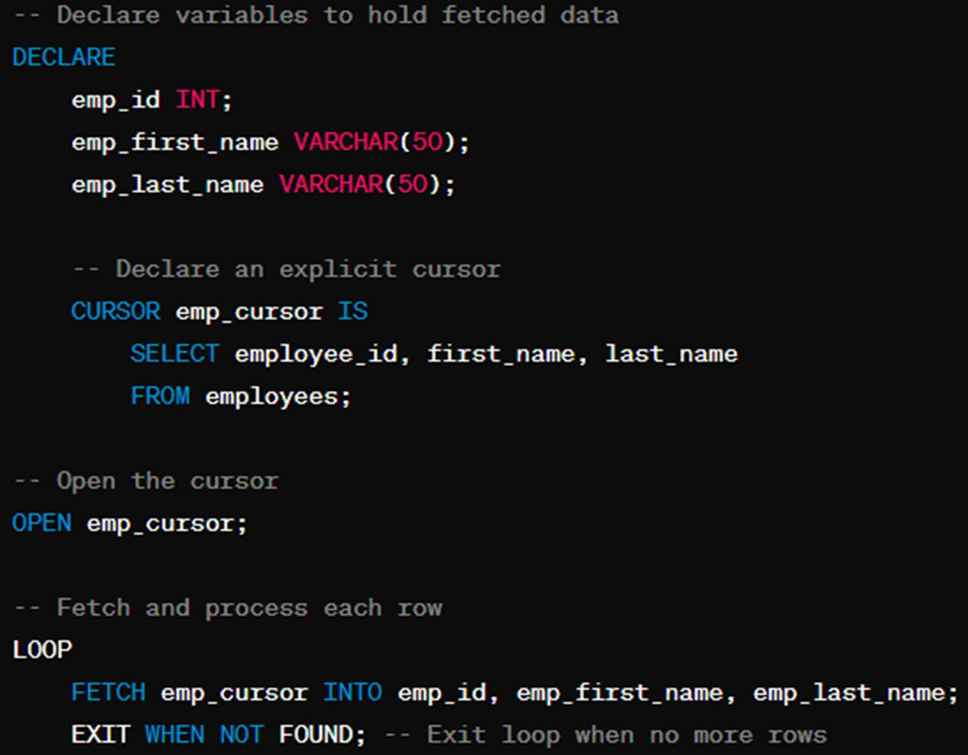

END LOOP;

CLOSE cur_emp; -- Close Cursor END $$;

# Implementation Screenshots (Problem Statement, Query and Screenshots of Results):

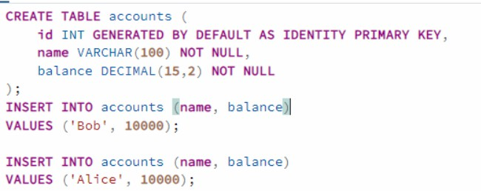

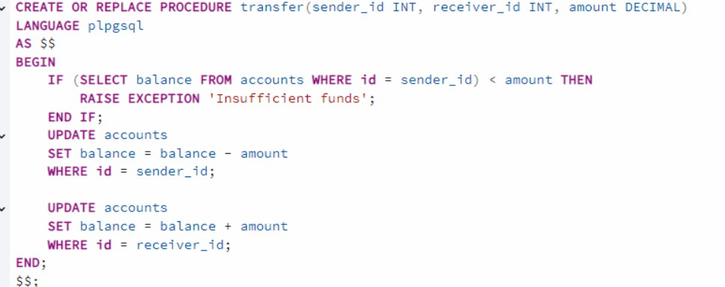

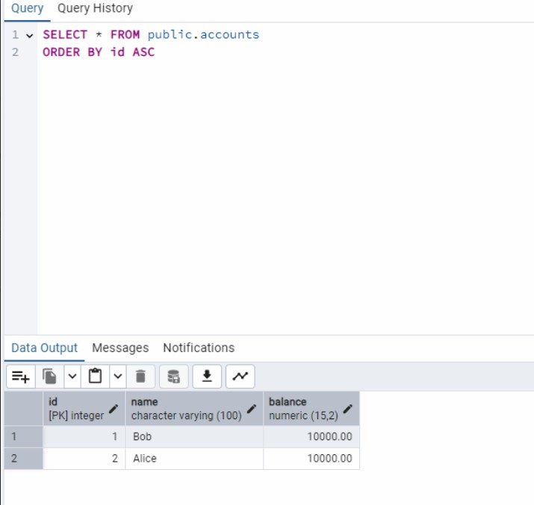

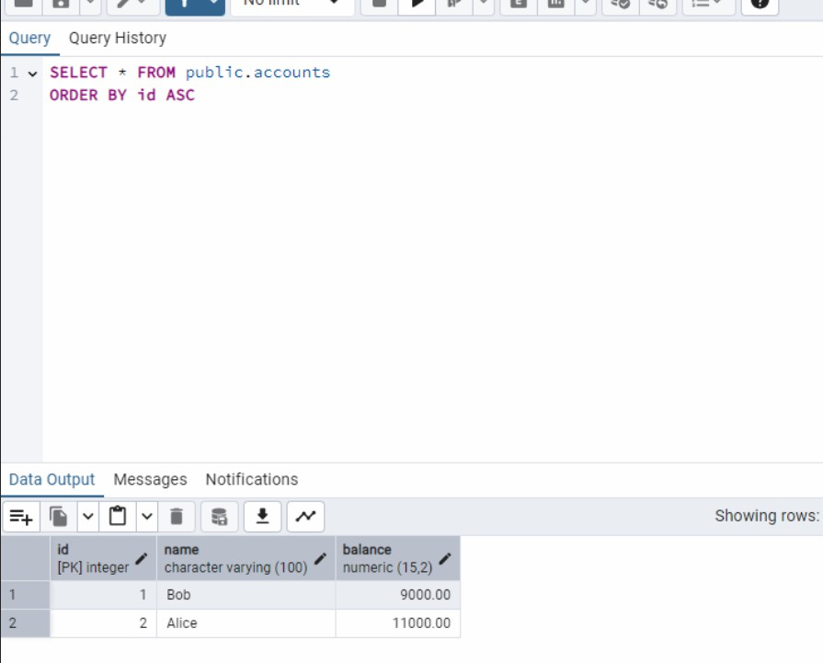

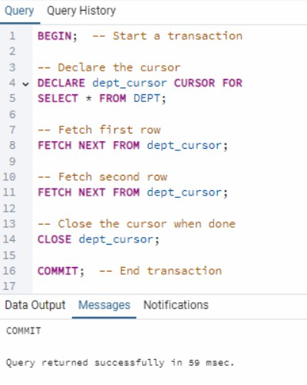

**Conclusion:**

This experiment demonstrated the use of **stored procedures**, **functions**, and **cursors** in PostgreSQL, highlighting their roles in modularizing database logic, improving performance, and handling result sets efficiently. Stored procedures excel in transactional operations, while functions integrate seamlessly into queries. Cursors enable row-by-row processing for large datasets. Understanding these concepts is crucial for advanced database management and application development.

# Post Lab Questions:

1. **Does Storing Of Data In Stored Procedures Increase The Access Time? Explain?**

Storing data in stored procedures does not inherently increase access time. In fact, stored procedures can improve performance in several ways:

* + **Precompilation**: Stored procedures are precompiled and stored in the database, reducing the overhead of parsing and optimizing the SQL queries each time they are executed.
  + **Reduced Network Traffic**: Since only the procedure call is sent over the network (rather than multiple SQL statements), latency is minimized.
  + **Execution Plan Reuse**: The database engine caches the execution plan of stored procedures, further speeding up subsequent calls.

However, poorly written procedures (e.g., those with complex logic or excessive data processing) can degrade performance. Proper indexing and query optimization within the procedure are essential to maintain efficiency.

# Explain the FETCH statement in SQL cursors.

The FETCH statement retrieves rows from a cursor (a pointer to a result set) one at a time or in batches.

# Syntax:

FETCH [direction] FROM cursor_name INTO target_variables;

Directions include NEXT, PRIOR, FIRST, LAST, ABSOLUTE n, or RELATIVE n.

# Usage:

Moves the cursor position and retrieves the row at that position into specified variables (e.g., FETCH cur_emp INTO emp_id, emp_name).

If no row is found, the FOUND variable is set to FALSE.

1. **What is the difference between a function and a stored procedure in PostgreSQL?**

**Feature**

**Function**

**Stored Procedure**

**Return**

**Value**

Must return a value (specified

in RETURNS).

Can return zero, one, or multiple values

via INOUT parameters or no value.

**Usage in**

**Queries**

Can be used in SQL queries

(e.g., SELECT func()).

Called with CALL and cannot be

embedded in queries.

**Transaction**

**Control**

Cannot execute transaction commands

(e.g., COMMIT/ROLLBACK).

Can execute transaction commands.

**Error**

Typically used for computations.

Better suited for complex operations

**Handling**

with error handling.

**Example**

CREATE PROCEDURE transfer(amount

CREATE FUNCTION add(a INT, b INT)

DEC) AS $$ BEGIN UPDATE accounts SET

RETURNS INT AS $$ BEGIN RETURN a +

balance = balance - amount; COMMIT;

b; END; $$ LANGUAGE plpgsql;

END; $$ LANGUAGE plpgsql;