**Batch: A_3 Roll No.: 16010123066**

**Experiment / assignment / tutorial No. 8**

**Grade: AA / AB / BB / BC / CC / CD /DD**

**Signature of the Staff In-charge with date**

Title: Implementing TCL/DCL

Objective: To be able to Implement TCL and DCL.

Expected Outcome of Experiment:

CO 3: Utilize SQL for Relational Database Operations

CO 5: Apply Transaction Management, Concurrency Control, and Recovery Techniques

Books/ Journals/ Websites referred:

1. Dr. P.S. Deshpande, SQL and PL/SQL for Oracle 10g.Black book, Dreamtech Press
2. [www.db-book.com](http://www.db-book.com/)
3. Korth, Slberchatz, Sudarshan : “Database Systems Concept”, 5th Edition , McGraw Hill
4. Elmasri and Navathe,”Fundamentals of database Systems”, 4th Edition,PEARSON Education.

Resources used: PostgreSQL

Theory

DCL stands for Data Control Language.

DCL is used to control user access in a database.

This command is related to the security issues.

Using DCL command, it allows or restricts the user from accessing data in database schema.

DCL commands are as follows, GRANT

REVOKE

It is used to grant or revoke access permissions from any database user. GRANT command gives user's access privileges to the database.

This command allows specified users to perform specific tasks. Syntax:

GRANT { { SELECT | INSERT | UPDATE | DELETE | TRUNCATE | REFERENCES | TRIGGER }

[, ...] | ALL [ PRIVILEGES ] }

ON { [ TABLE ] table_name [, ...]

| ALL TABLES IN SCHEMA schema_name [, ...] }

TO { [ GROUP ] role_name | PUBLIC } [, ...] [ WITH GRANT OPTION ]

GRANT { { SELECT | INSERT | UPDATE | REFERENCES } ( column_name

[, ...] )

[, ...] | ALL [ PRIVILEGES ] ( column_name [, ...] ) }

ON [ TABLE ] table_name [, ...]

TO { [ GROUP ] role_name | PUBLIC } [, ...] [ WITH GRANT OPTION ]

Example

GRANT INSERT ON films TO PUBLIC; GRANT ALL PRIVILEGES ON kinds TO ram;

GRANT admins TO krishna;

REVOKE command is used to cancel previously granted or denied permissions. This command withdraw access privileges given with the GRANT command.

It takes back permissions from user.

Syntax:



Example

REVOKE [ GRANT OPTION FOR ]

{ { SELECT | INSERT | UPDATE | DELETE | TRUNCATE | REFERENCES | TRIGGER }

[, ...] | ALL [ PRIVILEGES ] }

ON { [ TABLE ] table_name [, ...]

| ALL TABLES IN SCHEMA schema_name [, ...] } FROM { [ GROUP ] role_name | PUBLIC } [, ...]

[ CASCADE | RESTRICT ]

REVOKE [ GRANT OPTION FOR ]

{ { SELECT | INSERT | UPDATE | REFERENCES } ( column_name [,

...] )

[, ...] | ALL [ PRIVILEGES ] ( column_name [, ...] ) }

ON [ TABLE ] table_name [, ...]

FROM { [ GROUP ] role_name | PUBLIC } [, ...] [ CASCADE | RESTRICT ]

REVOKE [ GRANT OPTION FOR ]

{ { USAGE | SELECT | UPDATE } [, ...] | ALL [ PRIVILEGES ] }

ON { SEQUENCE sequence_name [, ...]

| ALL SEQUENCES IN SCHEMA schema_name [, ...] } FROM { [ GROUP ] role_name | PUBLIC } [, ...]

[ CASCADE | RESTRICT ]

REVOKE INSERT ON films FROM PUBLIC; REVOKE ALL PRIVILEGES ON kinds FROM Madhav;

REVOKE admins FROM Keshav;

TCL stands for Transaction Control Language.

This command is used to manage the changes made by DML statements. TCL allows the statements to be grouped together into logical transactions. TCL commands are as follows:

1. COMMIT
2. SAVEPOINT
3. ROLLBACK
4. SET TRANSACTION

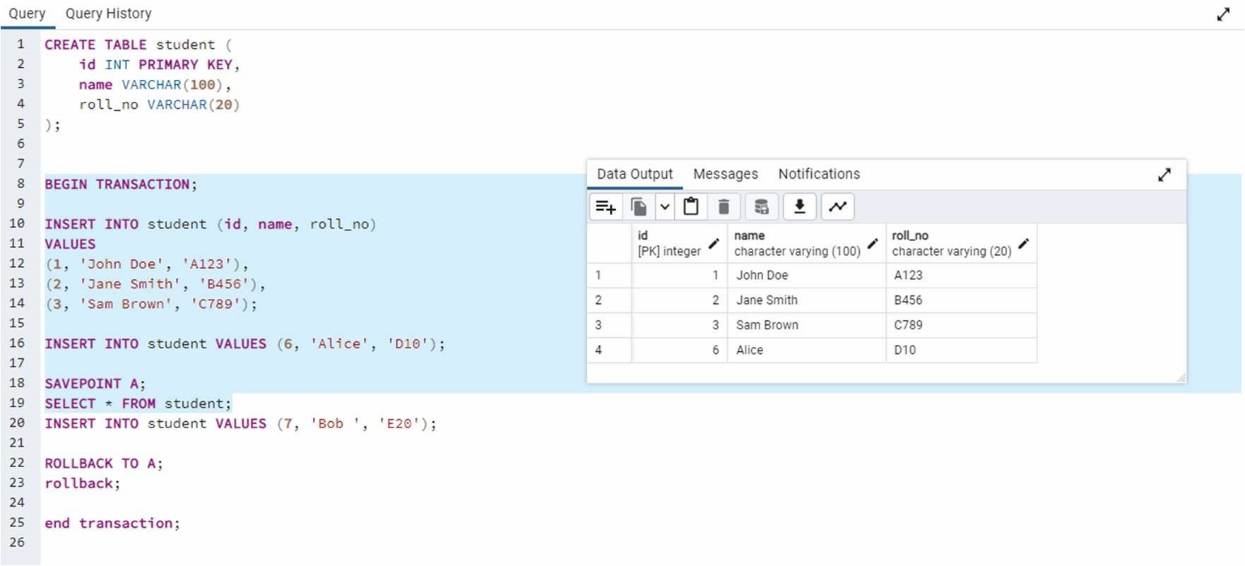

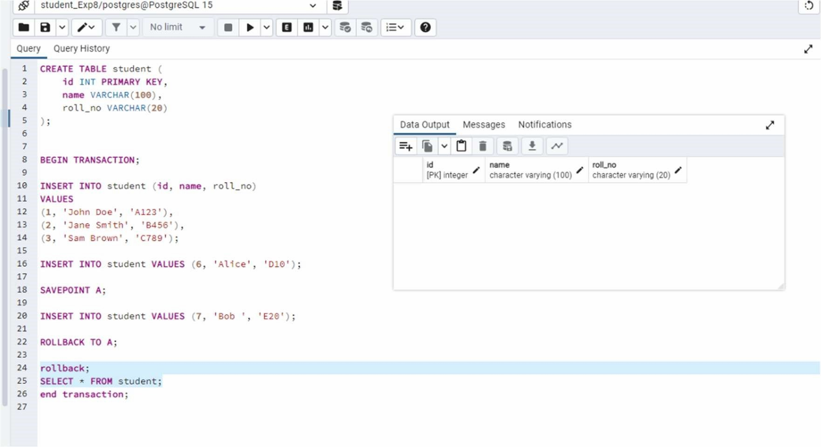

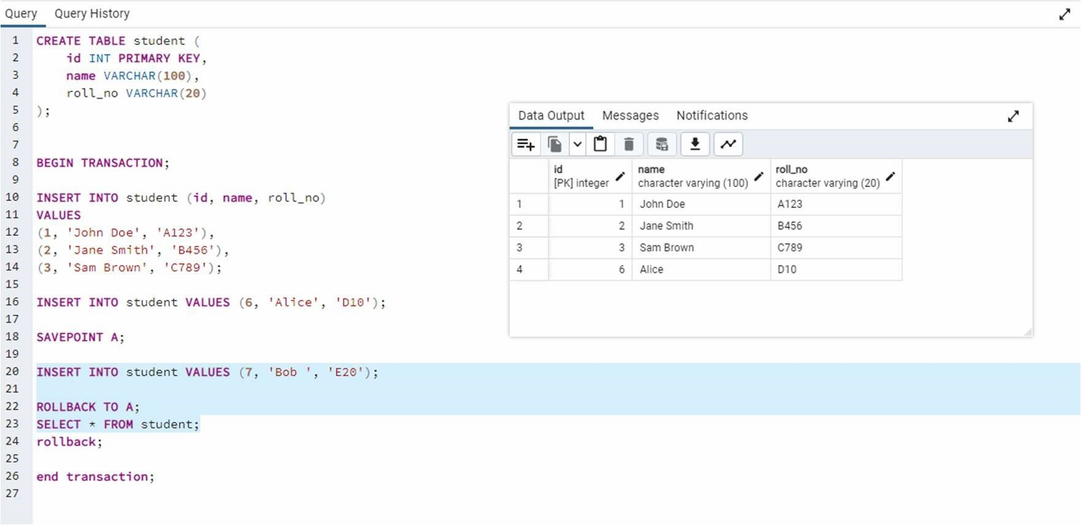

COMMIT command saves all the work done. It ends the current transaction and makes permanent changes during the transaction

Syntax: commit;

SAVEPOINT command is used for saving all the current point in the processing of a transaction. It marks and saves the current point in the processing of a transaction. It

is used to temporarily save a transaction, so that you can rollback to that point whenever necessary. Syntax

SAVEPOINT savepoint_name

ROLLBACK command restores database to original since the last COMMIT. It is used to restores the database to last committed state.

Syntax:

ROLLBACK [ WORK | TRANSACTION ] TO [ SAVEPOINT ] savepoint_name

Example

BEGIN;

INSERT INTO table1 VALUES (1);

SAVEPOINT my_savepoint;

INSERT INTO table1 VALUES (2);

ROLLBACK TO SAVEPOINT my_savepoint; INSERT INTO table1 VALUES (3);

COMMIT;

The above transaction will insert the values 1 and 3, but not 2.

SET TRANSACTION is used for placing a name on a transaction. You can specify a transaction to be read only or read write. This command is used to initiate a database transaction.

Syntax:

SET TRANSACTION [Read Write | Read Only];

The SET TRANSACTION command sets the characteristics of the current transaction. It has no effect on any subsequent transactions. SET SESSION CHARACTERISTICS sets the default transaction characteristics for subsequent transactions of a session. These defaults can be overridden by SET TRANSACTION for an individual transaction. The available transaction characteristics are the transaction isolation level, the transaction access mode (read/write or read-only), and the deferrable mode. In addition, a snapshot can be selected, though only for the current transaction, not as a session default.

The isolation level of a transaction determines what data the transaction can see when other transactions are running concurrently:

READ COMMITTED

A statement can only see rows committed before it began. This is the default.

REPEATABLE READ

All statements of the current transaction can only see rows committed before the first query or data-modification statement was executed in this transaction.

SERIALIZABLE

All statements of the current transaction can only see rows committed before the first query or data-modification statement was executed in this transaction. If a pattern of reads and writes among concurrent serializable transactions would create a situation which could not have occurred for any serial (one-at-a-time) execution of those transactions, one of them will be rolled back with a serialization_failure error. Examples

With the default read committed isolation level.

process A: BEGIN; -- the default is READ COMMITED process A: SELECT sum(value) FROM purchases;

--- process A sees that the sum is 1600

process B: INSERT INTO purchases (value) VALUES (400)

--- process B inserts a new row into the table while

--- process A's transaction is in progress

process A: SELECT sum(value) FROM purchases;

--- process A sees that the sum is 2000 process A: COMMIT;

If we want to avoid the changing sum value in process A during the lifespan of the transaction, we can use the repeatable read transaction mode.

process A: BEGIN TRANSACTION ISOLATION LEVEL REPEATABLE READ;

process A: SELECT sum(value) FROM purchases;

--- process A sees that the sum is 1600

process B: INSERT INTO purchases (value) VALUES (400)

--- process B inserts a new row into the table while

--- process A's transaction is in progress

process A: SELECT sum(value) FROM purchases;

--- process A still sees that the sum is 1600

process A: COMMIT;

The transaction in process A fill freeze its snapshot of the data and offer consistent values during the life of the transaction.

Repeatable reads are not more expensive than the default read commit transaction. There is no need to worry about performance penalties. However, applications must be prepared to retry transactions due to serialization failures.

Let’s observe an issue that can occur while using the repeatable read isolation level — the

could

|  |  |  |
| --- | --- | --- |
|  | not serialize access due to concurrent update | error. |
| process A: BEGIN TRANSACTION ISOLATION LEVEL REPEATABLE READ;  process B: BEGIN;  process B: UPDATE purchases SET value = 500 WHERE id = 1; process A: UPDATE purchases SET value = 600 WHERE id = 1;  -- process A wants to update the value while process B is changing it -- process A is blocked until process B commits  process B: COMMIT;  process A: ERROR: could not serialize access due to concurrent update  -- process A immidiatly errors out when process B commits | | |

If process B would rolls back, then its changes are negated and repeatable read can proceed without issues. However, if process B commits the changes then the repeatable read transaction will be rolled back with the error message because it can not modify or lock the rows changed by other processes after the repeatable read transaction has began. demonstrate the differences between the two isolation modes.

process A: BEGIN TRANSACTION ISOLATION LEVEL REPEATABLE READ;

process A: SELECT sum(value) FROM purchases; process A: INSERT INTO purchases (value) VALUES (100); process B: BEGIN TRANSACTION ISOLATION LEVEL

REPEATABLE READ; process B: SELECT sum(value) FROM purchases; process B: INSERT INTO purchases (id, value); process B: COMMIT; process A: COMMIT;

With Repeatable Reads everything works, but if we run the same thing with a Serializable isolation mode, process A will error out.

process A: BEGIN TRANSACTION ISOLATION LEVEL SERIALIZABLE;

process A: SELECT sum(value) FROM purchases; process A: INSERT INTO purchases (value) VALUES (100); process B: BEGIN TRANSACTION ISOLATION LEVEL SERIALIZABLE; process B: SELECT sum(value) FROM purchases;

process B: INSERT INTO purchases (id, value); process B: COMMIT; process A:

COMMIT;

ERROR: could not serialize access due to read/write dependencies among transactions DETAIL: Reason code: Canceled on identification as

a pivot, during commit attempt.

HINT: The transaction might succeed if retried.

Both transactions have modified what the other transaction would have read in the select statements. If both would allow to commit this would violate the Serializable behaviour, because if they were run one at a time, one of the transactions would have seen the new record inserted by the other transaction.

Implementation Screenshots (Problem Statement, Query and Screenshots of Results): Demonstrate DCL and TCL language commands on your database.

TCL commands are as follows:

1. COMMIT
2. SAVEPOINT
3. ROLLBACK
4. SET TRANSACTION

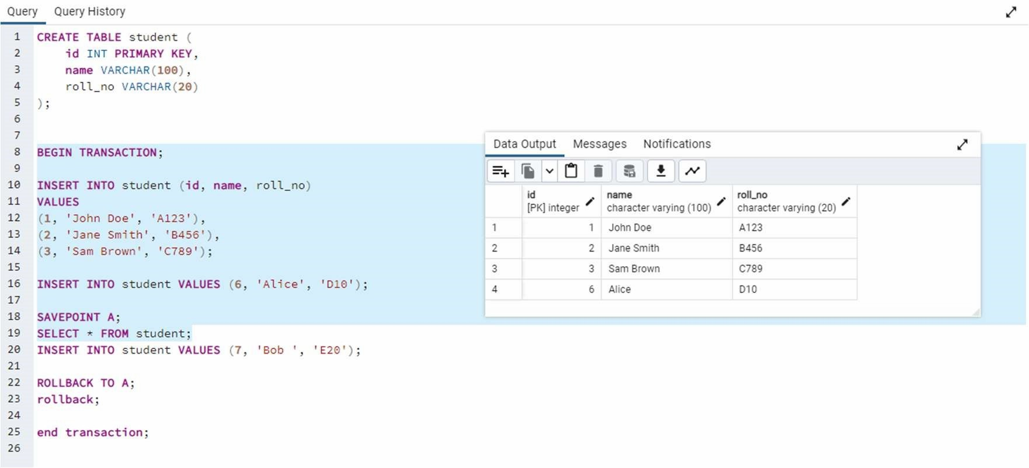





Conclusion:

Post Lab question:

* 1. Discuss ACID properties of transaction with suitable example

Ans;-

ACID ensures reliable transactions:

Atomicity: All steps complete or none. Example: Transfer $100 (Alice → Bob). If Alice’s account is debited but Bob’s isn’t credited, the entire transaction is canceled.

Consistency: Data stays valid. Example: Total money ($800) before/after transfer remains the same.

Isolation: Concurrent transactions don’t interfere. Example: A transfer won’t see halfway changes from another transfer.

Durability: Once done, changes survive crashes. Example: After success, $100 stays in Bob’s account even if the system restarts.

* 1. What is the purpose of the SAVEPOINT command in SQL?

Ans;- It creates a "checkpoint" within a transaction. If an error occurs later, you can roll back to the savepoint instead of undoing the entire transaction.

Example: Updating 3 tables in a transaction. After each successful update, set a savepoint. If the third update fails, roll back to the second savepoint, keeping the first two updates intact.