**Batch: H24 Roll No.:16010122257**

**Experiment 08**

|  |
| --- |
| **Title: To create an effective Story.** |

# Objective:

# *Search/locate and download any Data of Your Choice (Use same dataset if it contains location information)*

# *To learn how to create Story*

# *Include the dashboard/s and worksheet/s into story*

# *Apply best practices to create Story(Colour, font, caption, title).*

# Course Outcome:

# CO1: Learn how to locate and download datasets, extract insights from that data and present their findings in a variety of different formats

# CO3: Apply data visualization best practices

# CO4: Design static charts, interactive Dashboards and data storiesBooks/ Journals/

# Websites referred:

<https://ori.hhs.gov/education/products/n_illinois_u/datamanagement/dctopic.html>

<file:///C:/Users/DELL/Downloads/visual-data-storytelling-with-tableau_LindyRyan.pdf>

# Resources used:

# <https://data.world/mandalravi/sample-superstore>

# Theory:

# A story in data visualization is a sequence of visuals that collaborate to convey information. It serves various purposes such as explaining a data narrative, providing context, illustrating the relationship between decisions and outcomes, or making a persuasive argument. Similar to worksheets and dashboards, a story is essentially a sheet, and the methods used for creating, naming, and managing them apply to stories. However, a story is unique in that it is a compilation of sheets arranged in a specific order, where each individual sheet is referred to as a story point.

# In the digital age, where vast amounts of information are readily accessible, storytelling becomes a potent tool. It allows for the effective communication of messages, leveraging the wealth of insights available. A well-constructed data story integrates three crucial elements: data, narrative, and visuals.

# The data component is fundamental; accurate and reliable data is essential for deriving correct insights. The visual component, on the other hand, enables the identification of trends and patterns within datasets, which might be challenging to discern when looking at raw data in spreadsheets.

# Data storytelling revolves around the art of conveying insights effectively, essentially giving a voice to the data. The narrative component involves using simple language to describe the data, providing a voice to each data point, making them protagonists in the story, each with its own unique tale. When combined harmoniously, narrative, data, and visuals create compelling data stories that have the power to instigate transformative change within businesses and organizations.

# Describe content related to story:

(Theory related to experiment needed to perform - Students should write)

# The theory section covered the fundamentals of effective storytelling, emphasizing the significance of understanding the target audience, structuring the narrative coherently, and using visuals to augment the message’s impact. Additionally, principles of data visualization, such as avoiding clutter, choosing appropriate chart types, and ensuring accessibility, were explored in depth.Explored concepts related to effective data visualization, storytelling techniques, and dashboard design to ensure a comprehensive understanding of the topic.

# Following points should be written by students

# Create Story workspace

# Best practices for telling best stories.

# Use stories to make your case more compelling by showing how facts are connected,

# and how decisions relate to outcomes. You can then publish your story to the web, or

# present it to an audience.

# Each story point can be based on a different view or dashboard, or the entire story can

# be based on the same visualization seen at different stages, with different filters and

# annotations. A good data story brings data and facts to life. Some of the best practices

# have been mentioned below.

# 1. Understand your story’s purpose: Before you start to build your story, take some

# time to think about the purpose of your story and what you want your viewers'

# journey to be. you're presenting a case, decide whether you want to present data

# points that lead up to a conclusion at the end, or start with a conclusion then

# show the supporting data points.

# 2. Keep it simple: A common error is trying to cram too many views and

# dashboards into a single story. The result is too many points for your viewers to

# take in.The clarity of each story point is also important. Take a step back and

# consider your story from the perspective of someone who's never seen it. Every

# element should serve a purpose. If captions, titles, legends, or grid lines aren't

# necessary, get rid of them!

# 3. Use ‘Fit’ in dashboards: Dashboards are a common ingredient in Tableau stories.

# For dashboards that you plan to include in your story, you can use the Fit to

# option under Size on the Dashboard pane. It will resize your dashboard so that

# it's the right size for the story you're creating.

# Integrate the Dashboard and multiple sheets in story.

# Present the story as per the points considered.

# Interpret the each slide of story in detail.

# Note: Detail observation needed along screenshots wherever required

# 

This image is a dashboard that shows the overall profits across the United States for different categories and manufacturers.Useful as a storyboard for a business presentation.

* The most profitable category is technology, followed by furniture and office supplies.
* The most profitable state is California, followed by New York and Texas.
* The most profitable manufacturer is HP, followed by Dell and Apple.
* There is a lot of variation in the profits across the states, with some states having negative or zero profits.(Avg. variation:-12,720 to 15)

Central:

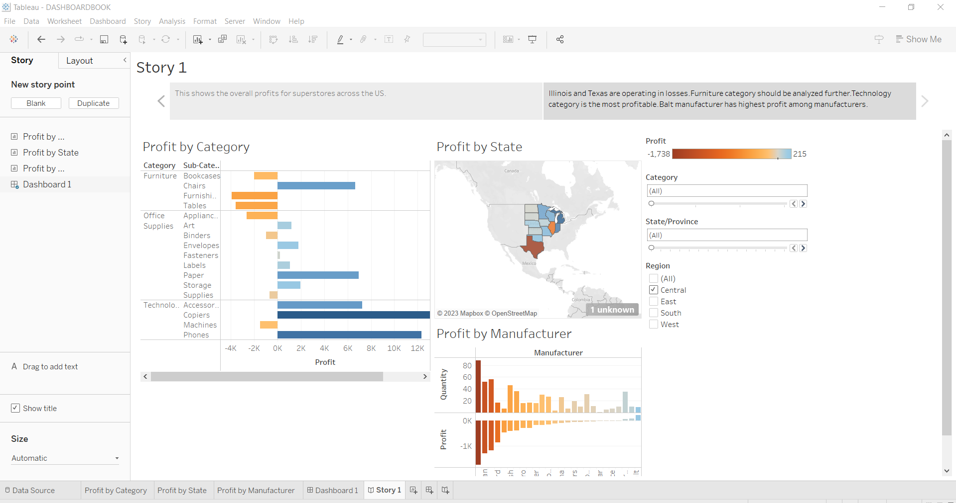

This represents for Central region.Profit varies from -1,738 to 215.Lowest:Illionois,Texas. Highest:Michigan.

# West:

# 

# This representation is for West region.Profit varies from -880 to 670.Oregon,Colorado and Arizona are operating in losses(lowest) while California has highest profits.The profit by manufacturer is balanced state-wise,50-50.Half of the manufacturers have losses,while half have profits.Some are in between,low profit/low loss.

# East:

# 

# This representation is for Eastern region.Ohio and Pennsylvania have low profits(i.e.losses) while New York has highest profits.An interesting observation to note is that,Manufacturer profits are low here.Variation:-9240-237.

# South:

# 

# This representation is for South region.Here too,profits are mostly low,except for a few states.Tennessee and North Carolina,Florida are operating in losses,while Georgia and Virginia are at the upper end of the spectrum.

# AN OVERALL OBSERVATION-Furniture category has lowest profits,while Technology category is most profitable.

# OVERALL:

# 

# This shows the overall profits for superstores across the US.Furniture category has least profit,while Technology category has high profits..Cubify manufacturer has highest loss.California state has highest profits,followed by New York.

# Profit variation:-12,720 to 15.

# 2)STORYBOARD:

# 

# Here,in this storyboard,I’ve added the option of filters to make it flexible for the user to check for each state,region etc. and all.

# GRAPHS USED:BAR GRAPH/DOUBLE BAR GRAPH,MAP.

# Conclusion (Students should write in their own words, comparative conclusion needed): This experiment has taught us the concept of storytelling and how to proficiently articulate the information conveyed by our dashboards. It allowed us to present our subject matter, "Adult Income," while also illustrating the influence of various other factors on it.

**Date: _____________ Signature of faculty in-charge**

# Post Lab Question:

# Explain the need of story in your words.

The need for a story lies in its ability to transform raw data into meaningful insights. While data itself might be overwhelming, a story provides context, guiding the audience through the data's intricacies. It simplifies complex information, making it relatable and understandable. A well-crafted story not only informs but also engages, leaving a lasting impact on the audience. Through storytelling, data transcends mere numbers, becoming a powerful tool for decision-making and understanding real-world phenomena.

Effective data storytelling has become increasingly crucial, especially in the midst of the Covid-19 crisis. Communicating the significance of data has never been more essential. During the pandemic, the public has relied on individuals who can convey both findings and uncertainties in clear and understandable ways as we seek answers and evaluations of the threats posed by the virus.

Skilled data storytellers have simplified complex concepts like exponential curves and logarithmic axes. The media has adeptly transformed data into narratives about trends, movements, and the impacts of changing lockdown measures. More recently, the focus has shifted from data about the disease to its effects on our economy.

Data serves as a tool for discovering and sharing insights, persuading, informing, and driving change. However, having a complete set of tools for data collection, storage, processing, and analysis is pointless if you and your employees don't know how to utilize that data for meaningful conversations and decision-making. Data storytelling transforms raw data in databases into opinions, arguments, and insights.

By promoting a data-driven culture and enhancing digital literacy across various domains, we can empower individuals to engage in more compelling and meaningful data storytelling. This, in turn, leads to a higher return on investment.