DIGITAL ELECTRONICS LAB (ESC392)
Assignment 1: AI-Assisted Boolean Expression Simplifier

1. GenAI Model Name
AI tool: ChatGPT
Model: GPT-6
Purpose: Boolean expression simplification and digital logic circuit design.

2. Prompt
Given the four-variable Boolean function below, simplify it using a Karnaugh Map (K-map) and Boolean algebra techniques. List all minterms, draw the K-map, identify the grouping of cells, derive the simplified Sum of Products (SOP) expression, and explain each simplification step clearly.
Boolean Function:
$$F\left(A , B , C , D\right)=Σm\left(1 , 3 , 4 , 6 , 9 , 11 , 12 , 14\right)$$
After obtaining the simplified expression, explain how it can be implemented in Logisim using NOT, AND, and OR gates. Also provide the expected truth table and describe the procedure for verifying the circuit.

3. AI Response

3.1 Given Boolean Function
F(A,B,C,D) = Σm(1,3,4,6,9,11,12,14)
The function outputs 1 for minterms 1, 3, 4, 6, 9, 11, 12, and 14.

3.2 Karnaugh Map
Rows and columns use Gray-code order: 00, 01, 11, 10.
AB \ CD | 00 | 01 | 11 | 10
00 | 0 | 1 | 1 | 0
01 | 1 | 0 | 0 | 1
11 | 1 | 0 | 0 | 1
10 | 0 | 1 | 1 | 0

3.3 Grouping and Simplification
Group 1: Minterms 1, 3, 9, 11. In these cells, B = 0 and D = 1, while A and C vary. The resulting term is B′D.
Group 2: Minterms 4, 6, 12, 14. In these cells, B = 1 and D = 0, while A and C vary. The resulting term is BD′.
F = B′D + BD′ = B XOR D

4. Verification by Logisim Evolution

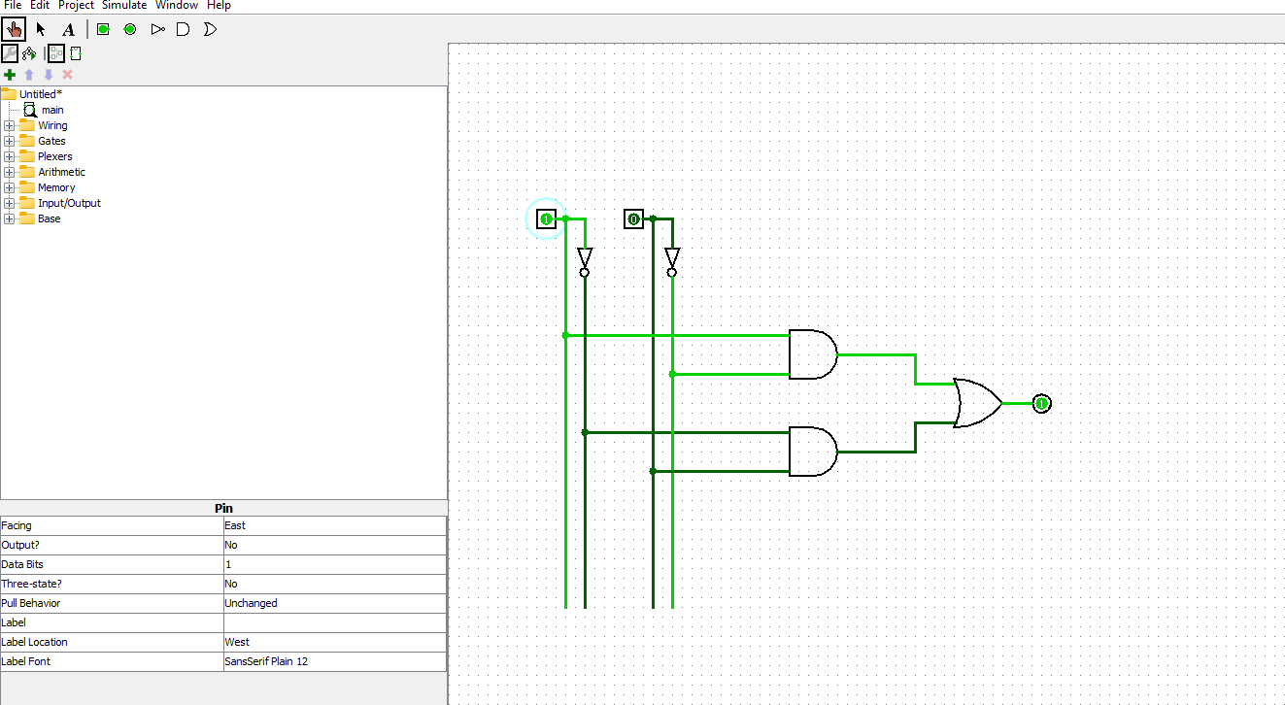

5. Circuit Diagram
Implement the following connections in Logisim Evolution:
- AND gate 1: B′ and D → output B′D.
- AND gate 2: B and D′ → output BD′.
- OR gate: combine B′D and BD′ to produce F.
The circuit uses two NOT gates, two 2-input AND gates, and one 2-input OR gate. Label the input pins B and D and the output pin F. Inputs A and C are not required in the simplified implementation.

6. Output
B | D | Expected F
0 | 0 | 0
0 | 1 | 1
1 | 0 | 1
1 | 1 | 0
Expected verification: output F = 1 when B and D differ, and F = 0 when B and D are equal. For the complete four-variable truth table, each B,D combination occurs four times as A and C vary. The expected number of matching outputs between the original function and its simplified implementation is 16 out of 16, with zero mismatches.
Insert screenshots of the completed Logisim circuit and its tested outputs here.

7. Discussion
The Boolean function was simplified using a Karnaugh map. Grouping minterms 1, 3, 9, and 11 produces B′D, while grouping minterms 4, 6, 12, and 14 produces BD′. Combining the terms gives F = B′D + BD′, which is the XOR function.
The simplified circuit uses two NOT gates, two AND gates, and one OR gate. Its output is HIGH when the inputs differ and LOW when they are equal. The circuit should be verified in Logisim Evolution by testing all input combinations and capturing screenshots for the report.
Assignment 2: Natural Language to Logic Circuit Generator – Automatic Room Lighting System

1. GenAI Model Name
AI Tool: ChatGPT
Model: GPT-6
Purpose: Natural language based digital logic circuit design and verification.
2. Prompt
Design a digital logic circuit for an automatic room-lighting system. The light should be turned ON only when the room is dark and a person is detected inside the room. Define the input and output Boolean variables, derive the Boolean expression, prepare the truth table, and explain how the circuit can be implemented and tested in Logisim.
3. AI Response
3.1 Problem Definition
The room light should turn ON only when:
- The room is dark.
- A person is present in the room.
3.2 Variable Definition
Variable | Meaning
D | Room is Dark
P | Person Present
L | Light Output

3.3 Boolean Expression
The light turns ON only when both conditions are true.
$$L=D⋅P$$
where "." represents the AND operation.

3.4 Truth Table
Dark (D) | Person Present (P) | Light Output (L)
0 | 0 | 0
0 | 1 | 0
1 | 0 | 0
1 | 1 | 1
0 = OFF/FALSE
1 = ON/TRUE

4. Verification by Logisim Evolution

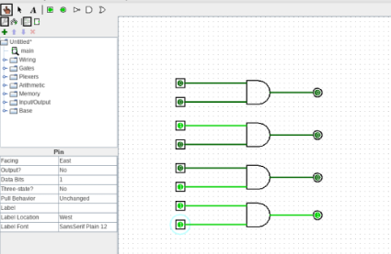
The circuit was implemented in Logisim Evolution using:
- Two input pins (D and P)
- One 2-input AND gate
- One output LED (L)

5. Circuit Diagram
Implementation Steps:
- Place two input pins labeled D and P.
- Connect both inputs to a 2-input AND gate.
- Connect the output of the AND gate to an LED labeled L.
- Simulate all four input combinations.
Hardware Required:
- One 2-input AND gate
- Two input switches
- One LED output

6. Output
D | P | Expected L
0 | 0 | 0
0 | 1 | 0
1 | 0 | 0
1 | 1 | 1
Expected Verification
The LED turns ON only when both D and P are HIGH.
The observed outputs should exactly match the truth table with zero mismatches.

7. Discussion
The automatic room lighting system was designed using a two-input AND gate. The Boolean expression L = D · P accurately represents the requirement that the room must be dark and a person must be present before the light turns ON. The circuit was simulated in Logisim Evolution and tested for all possible input combinations. The observed outputs matched the generated truth table, confirming the correctness of the design. This experiment demonstrates how a natural-language requirement can be translated into a digital logic circuit with the assistance of GenAI.

Assignment 3: FSM Design for Traffic Light Controller

1. GenAI Model Name
AI Tool: Claude Sonnet 5.5 (Anthropic)
Purpose: FSM generation, state table design, Boolean equation derivation, and digital circuit implementation.

2. Prompt
Design a Finite State Machine (FSM) based traffic light controller with Red, Yellow, and Green lights along with a pedestrian request button. Use Generative AI to create the state diagram, state table, binary state encoding, and simplified Boolean equations using Karnaugh Maps.
Implement the FSM using D flip-flops and logic gates, draw the complete circuit diagram, and simulate it in Logisim. Explain the state transitions, timing sequence, and outputs. Verify the operation of the design using suitable test cases.

3. AI Response
3.1 System Specification
Inputs:
- P (Pedestrian Button)
- CLK (1 Hz Clock)
- RST (Reset)
Outputs:
- R (Red Light)
- Y (Yellow Light)
- G (Green Light)
- WALK
- DONT_WALK
3.2 System Behavior
- Cars normally stay at GREEN.
- When a pedestrian presses the button, the controller changes:
Green → Yellow → Red (Walk) → Green
The design is a Moore FSM, where outputs depend only on the current state.

3.3 State Assignment
State | Binary Code
GREEN | 00
YELLOW | 01
RED | 10
State 11 is unused and treated as a don't-care condition.

3.4 State Diagram
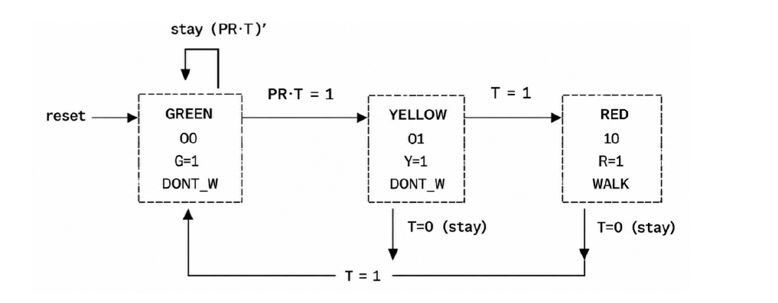
3.5 State Table
Present State | Condition | Next State
GREEN (00) | PR=1 and T=1 | YELLOW (01)
GREEN (00) | Otherwise | GREEN (00)
YELLOW (01) | T=1 | RED (10)
YELLOW (01) | T=0 | YELLOW (01)
RED (10) | T=1 | GREEN (00)
RED (10) | T=0 | RED (10)

3.6 Simplified Boolean Equations
Using Karnaugh Maps:
$$D_{1}=Q_{0}T+Q_{1}T^{'} \\ D_{0}=Q_{0}T^{'}+Q_{1}^{'}Q_{0}^{'}PRT$$
Output Equations:
$$G=Q_{1}^{'}Q_{0}^{'} \\ Y=Q_{1}^{'}Q_{0} \\ R=Q_{1} \\ WALK=Q_{1} \\ DONT_WALK=Q_{1}^{'}$$

4. Verification by Logisim
The FSM was implemented using:
- Two D flip-flops
- Logic gates for next-state generation
- Clock input
- Output indicators for traffic lights
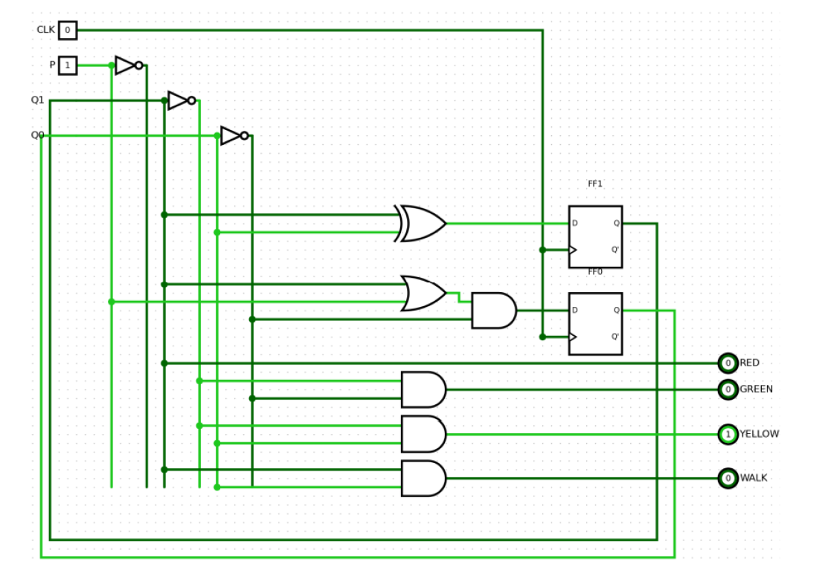
5. Circuit Diagram
Implementation Components:
- 2 D Flip-Flops
- AND Gates
- OR Gates
- NOT Gates
- Clock Source
- Input Button (P)
- Output LEDs
State transitions occur synchronously on each clock pulse.

6. Output
State | Green | Yellow | Red | Walk
GREEN (00) | 1 | 0 | 0 | 0
YELLOW (01) | 0 | 1 | 0 | 0
RED (10) | 0 | 0 | 1 | 1
Expected Verification
The simulated sequence should follow:
GREEN → YELLOW → RED → GREEN
Pedestrian crossing is enabled only during the RED state.
The FSM should transition correctly according to the generated state table with no invalid output combinations.

7. Discussion
The traffic light controller was designed as a Moore Finite State Machine and successfully implemented using D flip-flops and logic gates. Simplified Boolean equations obtained through Karnaugh-map minimization were used to generate the next-state logic. Simulation in Logisim Evolution confirmed that the traffic lights followed the intended sequence and pedestrian crossing was enabled only during the RED state. Because outputs depend solely on the FSM state, the design is free from output glitches and behaves predictably. The experiment demonstrates how GenAI can assist in FSM design, optimization, and digital circuit implementation.

Assignment 4: AI-Based Fault Detection in Half Adder Circuit

1. GenAI Model Name
AI Tool: ChatGPT
Model: GPT-6
Purpose: Fault diagnosis and correction in digital circuits using truth table analysis.

2. Prompt
Examine the truth table of a Half Adder having inputs A and B and outputs Sum and Carry. Compare the obtained outputs with the standard Half Adder truth table. Determine the incorrect Boolean expression, explain why the error occurs, and provide the corrected Boolean expressions based on the supplied image.
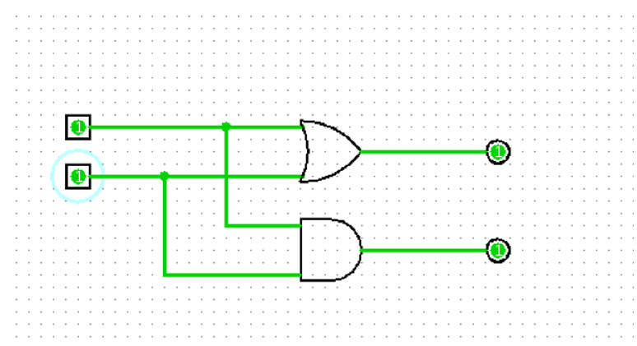

3. AI Response
3.1 Given Faulty Half Adder Circuit
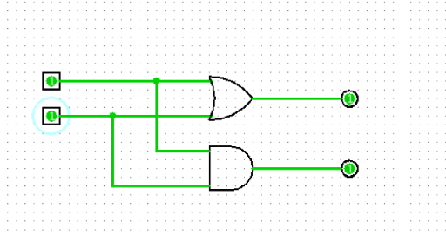

The truth table obtained from the faulty circuit is:
A | B | Faulty Sum (S) | Carry (C)
0 | 0 | 0 | 0
0 | 1 | 1 | 0
1 | 0 | 1 | 0
1 | 1 | 1 | 1

3.2 Fault Identification
For a correct Half Adder:
$$S=A⊕{B} \\ C=A⋅B$$
However, the observed Sum output behaves as:
$$S=A+B$$
which corresponds to an OR gate.
The fault occurs when:
A | B | Expected Sum | Faulty Sum
1 | 1 | 0 | 1
Thus, the XOR gate has been incorrectly replaced by an OR gate.

3.3 Corrected Boolean Expressions
Faulty Expression
$$S=A+B$$
Correct Expression
$$S=A⊕{B}$$
Carry Expression
$$C=A⋅B$$
(Remains unchanged)

4. Verification by Logisim
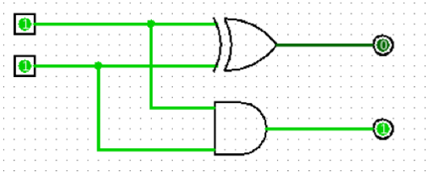
The OR gate was replaced with an XOR gate. After correction, the circuit produced the correct outputs for all input combinations.

5. Circuit Diagram
Implementation Steps:
Place two input pins A and B.
Connect A and B to an XOR gate for Sum.
Connect A and B to an AND gate for Carry.
Connect outputs to LEDs labeled S and C.
Simulate all input combinations.
Components Used:
One XOR gate
One AND gate
Two input switches
Two LEDs

6. Output
Corrected Truth Table
A | B | Sum (S) | Carry (C)
0 | 0 | 0 | 0
0 | 1 | 1 | 0
1 | 0 | 1 | 0
1 | 1 | 0 | 1
Expected Verification
All outputs should match the standard Half Adder truth table with zero mismatches.

7. Discussion
The experiment demonstrates the use of Generative AI for fault diagnosis in digital circuits. A deliberate fault was introduced by replacing the XOR gate with an OR gate in the Sum path of a Half Adder. By comparing the observed truth table with the expected Half Adder truth table, GenAI correctly identified the fault and recommended replacing the OR gate with an XOR gate. After modification, the circuit produced the correct Sum and Carry outputs for all input combinations. Thus, AI-assisted fault detection proved effective in identifying and correcting design errors.

Assignment 5: Digital Clock FSM Design with GenAI

1. GenAI Model Name
AI Tool: Claude Sonnet 5.5 (Anthropic)
Purpose: FSM design, state analysis, counter implementation, and digital clock simulation.

2. Prompt
- Design a 24-hour digital clock (HH:MM:SS) driven by a 1 Hz clock signal. Describe the FSM states for the seconds, minutes, and hours counters. Determine the number of flip-flops required and explain the enable and rollover conditions used to connect the three counters.

3. AI Response
3.1 System Overview
The digital clock consists of three cascaded synchronous counters:
Seconds Counter (00–59)
Minutes Counter (00–59)
Hours Counter (00–23)
All counters operate using the same 1 Hz clock signal.

3.2 Counter Requirements
Counter | Range | States | Minimum FFs
Seconds | 00–59 | 60 | 6
Minutes | 00–59 | 60 | 6
Hours | 00–23 | 24 | 5
Total | - | 86,400 | 17

3.3 FSM Operation
Seconds FSM
$$S_{0}→S_{1}→⋯→S_{59}→S_{0}$$
Advances every second.
Minutes FSM
$$M_{0}→M_{1}→⋯→M_{59}→M_{0}$$
Advances only when Seconds = 59.
Hours FSM
$$H_{0}→H_{1}→⋯→H_{23}→H_{0}$$
Advances only when Minutes = 59 and Seconds = 59.

3.4 Next-State Equations
$$sec_{next}=\left(sec==59\right)?0:sec+1 \\ min_{next}=EN_{min}?\left(\left(min==59\right)?0:min+1\right):min \\ hr_{next}=EN_{hr}?\left(\left(hr==23\right)?0:hr+1\right):hr$$

4. Verification by Logisim
The clock was verified using cascaded counters with common clock inputs and rollover enable signals.
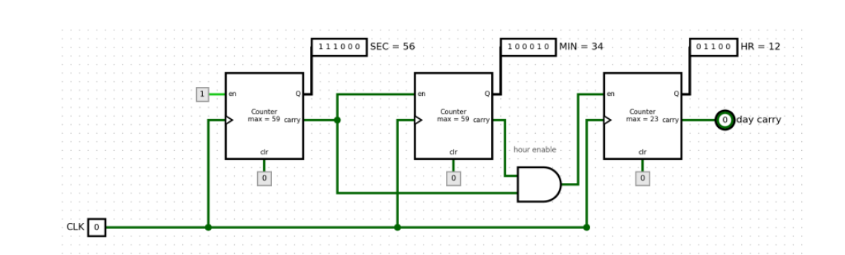

5. Circuit Diagram

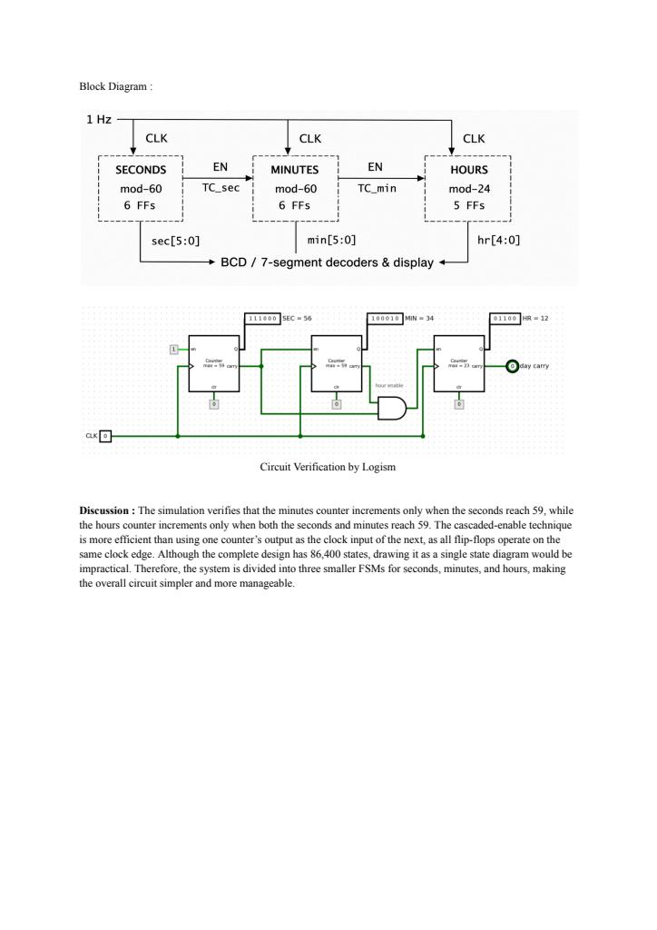
Components Used:
6 Flip-Flops for Seconds Counter
6 Flip-Flops for Minutes Counter
5 Flip-Flops for Hours Counter
Clock Generator (1 Hz)
Enable Logic
Displays

6. Output
Current Time | Next Time
12:34:58 | 12:34:59
12:34:59 | 12:35:00
12:59:59 | 13:00:00
23:59:59 | 00:00:00
Expected Verification
Seconds count from 00 to 59.
Minutes increment after seconds roll over.
Hours increment after minutes and seconds roll over.
Clock resets from 23:59:59 to 00:00:00.

7. Discussion
The digital clock was implemented using three cascaded synchronous modulo counters. Enable signals were used instead of cascading clocks, ensuring all flip-flops operate within a single clock domain and avoiding ripple-counter delays. Simulation confirmed correct second, minute, and hour transitions, including rollover at 23:59:59. The design demonstrates the practical implementation of FSMs and counters in real-time digital systems.

Assignment 6: Application Mapping of Sequential Building Blocks

1. GenAI Model Name
AI Tool: Claude Sonnet 5.5 (Anthropic)
Purpose: Analysis of practical applications of flip-flops, counters, and shift registers.

2. Prompt
For each of the following digital components, identify one real-world application and explain its function and operation:
- D Flip-Flop
- Mod-N Counter
- SIPO/PISO Shift Registers
Justify why each component is suitable for the chosen application. Also propose a simple Logisim Evolution simulation of a Mod-60 counter that counts from 0 to 59 and then resets to 0. Include the circuit diagram, expected outputs, and conclusions.

3. AI Response
3.1 D Flip-Flop Application
System
Microcontroller Input Synchronizer
Role
Used to synchronize asynchronous push-button inputs with the system clock.
Working
At every rising clock edge:
$$Q←D$$
The flip-flop stores one bit and acts as a one-clock-cycle delay element.
CLK | D | Q(next)
↑ | 0 | 0
↑ | 1 | 1
Justification
A D flip-flop eliminates invalid states and provides reliable synchronization.

3.2 Mod-N Counter Application
System
Digital Clock / Wristwatch
Role
Counts seconds, minutes, and hours.
Working
A Mod-N counter cycles through:
$$0→1→...→N-1→0$$
Mod-60 requires:
$$\left\lceil \log_{2}60\right\rceil =6$$
flip-flops.
Justification
Time naturally follows modular counting patterns.
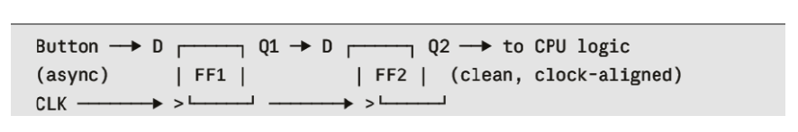
3.3 SIPO/PISO Shift Register Application
System
UART Communication
PISO Operation
Loads parallel data.
Shifts one bit at a time onto TX line.
SIPO Operation
Receives serial bits.
Converts them into parallel form.
Justification
Reduces wire count and communication cost.

4. Verification by Logisim Evolution
Mod-60 Counter Circuit
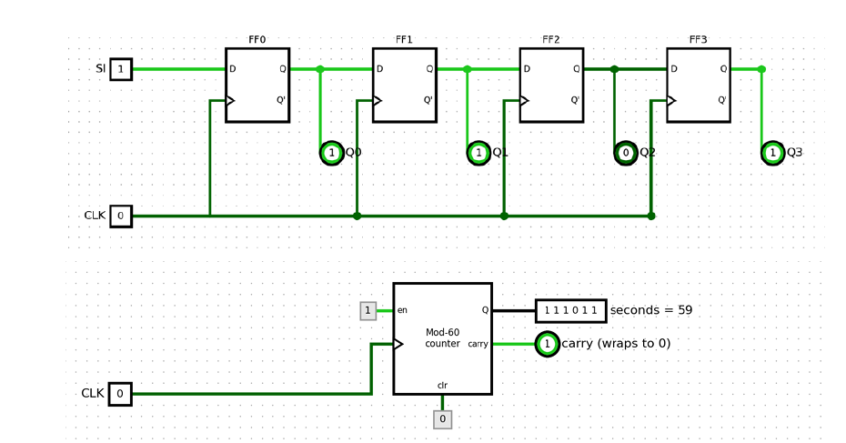
The design consists of:
Mod-10 Units Counter
Mod-6 Tens Counter
Common Clock
Reset Button
Two Hex Displays

5. Circuit Diagram
Implementation Steps:
Connect a Clock source.
Configure Units Counter as Mod-10.
Configure Tens Counter as Mod-6.
Connect Units Carry to Tens Enable.
Connect Reset button to both counters.
Connect outputs to displays.

6. Output
Clock Pulse | Display
0 | 00
1 | 01
... | ...
9 | 09
10 | 10
... | ...
58 | 58
59 | 59
60 | 00
Timing Behaviour
$$CLK:_∣\text{‾}∣_∣\text{‾}∣_ \\ UNITS:0,1,2,...,9,0 \\ TENS:0,0,...,0,1$$
Verification Checklist
Counts from 00 to 59 correctly.
No skipped values.
Rolls over to 00 after 59.
Reset clears display immediately.

7. Discussion
This experiment examined practical applications of sequential building blocks. The D flip-flop was used as a synchronizer for asynchronous inputs, the Mod-N counter was applied to digital timekeeping, and SIPO/PISO shift registers were used in UART communication. A Mod-60 counter was successfully implemented and simulated in Logisim Evolution. The design counted correctly from 00 to 59, reset properly, and demonstrated the importance of sequential logic components in modern digital systems.

Assignment 7: Design a Mini Automation System – Automatic Parking Barrier Control System

1. GenAI Model Name
AI Tool: ChatGPT
Model: GPT-6
Purpose: FSM design, state encoding, state transition analysis, and automation system implementation.

2. Prompt
Design a mini automation system for an automatic parking barrier. Specify the inputs, outputs, and design constraints. Develop a Finite State Machine (FSM), state transition table, state encoding scheme, and output table for the following states:
- IDLE
- WAIT_PAY
- OPEN
- LOWER
Use the inputs CAR_ARRIVED, PAYMENT_VALID, VEHICLE_PASSED, and RESET.
Clearly describe how the system can be implemented and tested in Logisim . State all assumptions made and keep the design suitable for a digital electronics laboratory assignment.

3. AI Response
3.1 Objective and System Description
The system models an automatic parking barrier control system. When a vehicle arrives, the controller waits for payment verification. After successful payment, the barrier opens to allow entry. Once the vehicle passes, the barrier lowers and the controller returns to the IDLE state.

3.2 Inputs and Outputs
Signal | Type | Meaning
CAR_ARRIVED | Input | Detects vehicle arrival
PAYMENT_VALID | Input | Indicates successful payment
VEHICLE_PASSED | Input | Indicates vehicle has crossed gate
RESET | Input | Resets FSM to IDLE
BARRIER | Output | Controls barrier opening
GREEN_LIGHT | Output | Allows vehicle entry
RED_LIGHT | Output | Entry restricted

3.3 State Encoding
State | Q1 Q0
IDLE | 00
WAIT_PAY | 01
OPEN | 10
LOWER | 11

3.4 State Transition Table
Current State | Condition | Next State
IDLE | CAR_ARRIVED = 1 | WAIT_PAY
WAIT_PAY | PAYMENT_VALID = 1 | OPEN
OPEN | VEHICLE_PASSED = 1 | LOWER
LOWER | Automatic transition | IDLE
RESET returns any state to IDLE.

3.5 Output Table (Moore FSM)
State | BARRIER | GREEN_LIGHT | RED_LIGHT
IDLE | 0 | 0 | 1
WAIT_PAY | 0 | 0 | 1
OPEN | 1 | 1 | 0
LOWER | 0 | 0 | 1

4. Verification by Logisim Evolution

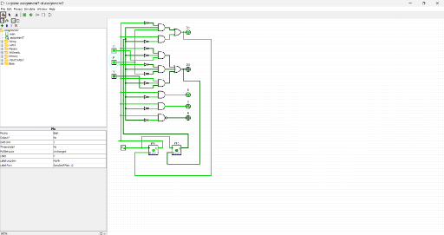

The FSM was implemented using two D flip-flops, next-state combinational logic, input controls, and output decoder logic. Testing confirmed correct transitions between all states.

5. Circuit Diagram
The circuit contains:
Two D Flip-Flops (Q1 and Q0)
Next-State Logic Block
Output Decoder
Clock Input
Reset Input
Input switches for CAR_ARRIVED, PAYMENT_VALID, and VEHICLE_PASSED
The outputs are generated according to the current state of the FSM.

6. Output
Expected state sequence:
IDLE → WAIT_PAY → OPEN → LOWER → IDLE
Expected behavior:
BARRIER = 1 only in OPEN state.
GREEN_LIGHT = 1 only in OPEN state.
RED_LIGHT = 1 during IDLE, WAIT_PAY, and LOWER states.
RESET immediately returns to IDLE.

7. Discussion
The parking barrier controller was implemented as a Moore Finite State Machine using four states. The controller changes state according to vehicle arrival, payment verification, and vehicle passage signals. Outputs depend only on the present state, making the system easy to design and verify. Logisim simulation confirmed proper state transitions and correct barrier operation. This assignment demonstrates a practical application of FSMs in automation and access-control systems.

Assignment 8: From Code to Circuit – Building a 4-bit Mini ALU and Program Counter

1. GenAI Model Name
AI Tool: ChatGPT
Model: GPT-6
Purpose: Code-to-hardware mapping, ALU design, program counter implementation, and circuit verification.

2. Prompt
Construct a 4-bit ALU capable of addition and subtraction using a mode-select multiplexer for choosing between the two operations. Also design a simple 4-bit Program Counter using flip-flops with enable and reset controls. Identify which block performs arithmetic operations, which block stores operands, and which block represents instruction sequencing. Describe the design and explain how it can be verified in Logisim

3. AI Response
3.1 Given Code Snippet
a = 5;
b = 3;
c = a + b;
The code assigns values 5 and 3 to variables a and b and calculates the result c = 8.

3.2 4-bit ALU Design
The ALU receives two 4-bit inputs A and B and a select signal S.
S = 0 → Addition
S = 1 → Subtraction
For:
A = 0101 (5)
B = 0011 (3)
Output:
Y = 1000 (8)
The ALU uses an Adder, Subtractor, and MUX to select the desired operation.

3.3 Operand Registers
Registers store operand values before execution.
Register | Stored Value
A | 0101
B | 0011
These values are provided to the ALU inputs.

3.4 Program Counter
The 4-bit Program Counter performs:
Reset → 0000
Hold when ENABLE = 0
Increment when ENABLE = 1
Wrap from 1111 to 0000
The PC models instruction sequencing inside a processor.

3.5 Code-to-Hardware Mapping
Code Action | Hardware Block | Function
a = 5 | Register A | Stores operand
b = 3 | Register B | Stores operand
c = a + b | ALU | Performs addition
Store c | Result Register | Stores output
Next Instruction | Program Counter | Updates instruction address

4. Verification by Logisim Evolution
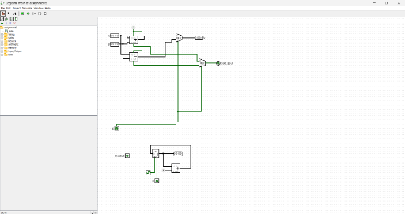
The ALU and Program Counter were simulated in Logisim Evolution and tested using different input combinations.

5. Circuit Diagram
ALU Components
4-bit Adder
4-bit Subtractor
2:1 Multiplexer
Input buses A and B
Output bus Y
Program Counter Components
Four D Flip-Flops / 4-bit Register
Incrementer (PC + 1)
Enable Control
Reset Logic
Clock Input

6. Output
ALU Test Case
A | B | S | Operation | Output Y
0101 | 0011 | 0 | Add | 1000

Program Counter Test Case
RESET | ENABLE | Current PC | Next PC
1 | X | 1010 | 0000
0 | 0 | 0101 | 0101
0 | 1 | 0101 | 0110

7. Discussion
This experiment demonstrated how software instructions can be mapped to digital hardware. Registers store operands, the ALU performs arithmetic operations, and the Program Counter manages instruction sequencing. The ALU correctly produced addition and subtraction results using a MUX-based design, while the Program Counter successfully implemented reset, hold, and increment functions. Simulation results confirmed proper circuit operation.

Assignment 9: AI-Assisted Code-to-Gate Explainer

1. GenAI Model Name
AI Tool: ChatGPT
Model: GPT-6
Purpose: Code-to-logic conversion, gate implementation, and circuit verification.

2. Prompt
Implement the following C code snippet using its equivalent Logisim circuit:
c = a ^ b;
Explain the logic gate implementation, truth table, and verification process.

3. AI Response
3.1 Given Code Snippet
c = a ^ b;
The symbol (^) represents the XOR (Exclusive-OR) operation. Therefore, the code can be implemented using a single XOR gate.

3.2 Boolean Expression
$$C=A⊕{B}$$
The output becomes HIGH only when the inputs are different.

3.3 Truth Table
A | B | C = A ⊕ B
0 | 0 | 0
0 | 1 | 1
1 | 0 | 1
1 | 1 | 0

4. Verification by Logisim Evolution
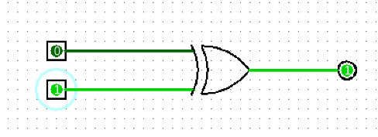
The circuit was tested using all four input combinations and the outputs matched the XOR truth table exactly.

5. Circuit Diagram
Implementation Steps:
Place two input pins labeled A and B.
Insert one XOR gate.
Connect A and B to the XOR gate inputs.
Connect the XOR gate output to output pin C.
Simulate all input combinations.
Components Used:
One XOR Gate
Two Input Switches
One Output LED

6. Output
A | B | Expected C
0 | 0 | 0
0 | 1 | 1
1 | 0 | 1
1 | 1 | 0

Expected Verification
The XOR gate generates HIGH output when the inputs differ and LOW output when they are equal. All outputs should match the truth table without error.

7. Discussion
The GenAI tool correctly identified that the XOR operation in the code corresponds to an XOR gate in digital electronics. A simple circuit containing one XOR gate was sufficient to implement the logic. The truth table confirmed the correctness of the Boolean expression, and Logisim simulation verified all possible input combinations. This experiment demonstrates how programming statements can be translated directly into digital logic circuits using GenAI-assisted design.

DIGITAL ELECTRONICS LAB (ESC392)

ASSIGNMNENTS

NAME- SOUMILI DAS

SECTION- F

ROLL NUMBER- 393

ENROLLMENT NUMBER- 12025052002407

SEMESTER- III

YEAR- 2ND

