**Exercise 1: Implementing the Singleton Pattern**

**Code**

using System;

namespace SingletonPatternExample

{

public class Logger

{

private static Logger instance;

private Logger()

{

Console.WriteLine("Logger instance created.");

}

public static Logger GetInstance()

{

if (instance == null)

{

Console.WriteLine("Creating first instance");

instance = new Logger();

}

Console.WriteLine("Fetching instance");

return instance;

}

}

class Test

{

static void Main(string[] args)

{

Logger logger1 = Logger.GetInstance();

Logger logger2 = Logger.GetInstance();

Console.WriteLine("Are both the instances same?" +(logger1==logger2));

}

}

}

**Output**

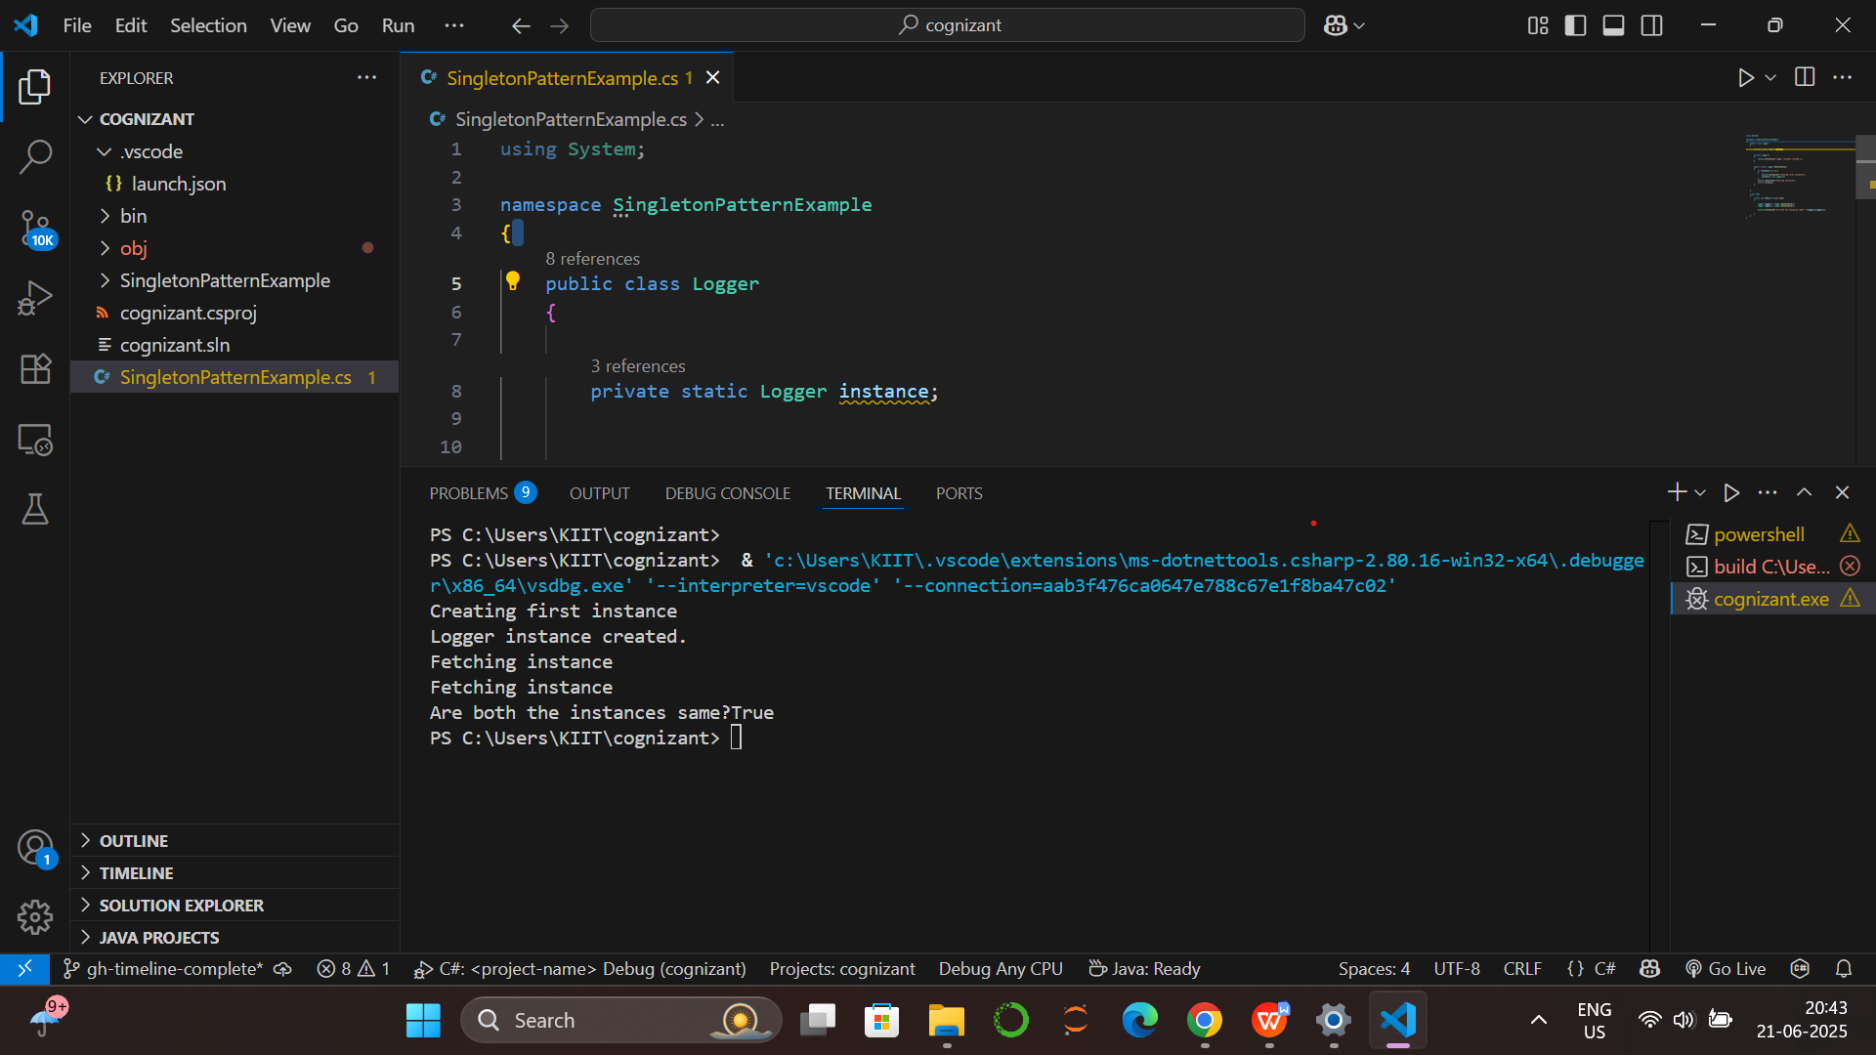

**Exercise 2: Implementing the Factory Method Pattern**

**Code**

using System;

namespace FactoryMethodPatternExample

{

public interface Documenttypes

{

void Open();

}

public class WordDocument : Documenttypes

{

public void Open()

{

Console.WriteLine("Opening Word document.");

}

}

public class PdfDocument : Documenttypes

{

public void Open()

{

Console.WriteLine("Opening PDF document.");

}

}

public class ExcelDocument : Documenttypes

{

public void Open()

{

Console.WriteLine("Opening Excel document.");

}

}

public abstract class DocumentFactory

{

public abstract Documenttypes CreateDocument();

}

public class WordFactory : DocumentFactory

{

public override Documenttypes CreateDocument()

{

return new WordDocument();

}

}

public class PdfFactory : DocumentFactory

{

public override Documenttypes CreateDocument()

{

return new PdfDocument();

}

}

public class ExcelFactory : DocumentFactory

{

public override Documenttypes CreateDocument()

{

return new ExcelDocument();

}

}

class Test

{

static void Main(string[] args)

{

DocumentFactory wordFactory = new WordFactory();

Documenttypes wordDoc = wordFactory.CreateDocument();

wordDoc.Open();

DocumentFactory pdfFactory = new PdfFactory();

Documenttypes pdfDoc = pdfFactory.CreateDocument();

pdfDoc.Open();

DocumentFactory excelFactory = new ExcelFactory();

Documenttypes excelDoc = excelFactory.CreateDocument();

excelDoc.Open();

}

}

}

**Output**

