Week 7
9. ReactJS-HOL
Code:
App.js
import React from 'react';

function App() {
const flag = false; // can change to true for different output
const players = [
{ name: "Jack", score: 101 },
{ name: "Michael", score: 70 },
{ name: "John", score: 40 },
{ name: "Ann", score: 61 },
{ name: "Elisabeth", score: 61 },
{ name: "Sachin", score: 95 },
{ name: "Dhoni", score: 100 },
{ name: "Virat", score: 84 },
{ name: "Jadeja", score: 64 },
{ name: "Raina", score: 75 },
{ name: "Rohit", score: 80 }
];

const T20Players = ["First Player", "Second Player", "Third Player"];
const RanjiTrophyPlayers = ["Fourth Player", "Fifth Player", "Sixth Player"];
const IndianPlayers = [...T20Players, ...RanjiTrophyPlayers];

const IndianTeam = ["Sachin1", "Dhoni2", "Virat3", "Rohit4", "Yuvaraj5", "Raina6"];

const OddPlayers = ([first, , third, , fifth]) => (
<div>
<li>First: {first}</li>
<li>Third: {third}</li>
<li>Fifth: {fifth}</li>
</div>
);

const EvenPlayers = ([, second, , fourth, , sixth]) => (
<div>
<li>Second: {second}</li>
<li>Fourth: {fourth}</li>
<li>Sixth: {sixth}</li>
</div>
);

if (flag) {
const below70 = [];
players.forEach(item => {
if (item.score <= 70) below70.push(item);
});

return (
<div>
<h1>List of Players</h1>
{players.map((item, index) => (
<div key={index}>
<li>Mr. {item.name} <span>{item.score}</span></li>
</div>
))}

<hr />

<h1>List of Players having Scores Less than 70</h1>
{below70.map((item, index) => (
<div key={index}>
<li>Mr. {item.name} <span>{item.score}</span></li>
</div>
))}
</div>
);
} else {
return (
<div>
<h1>Indian Team</h1>
<h2>Odd Players</h2>
{OddPlayers(IndianTeam)}
<hr />
<h2>Even Players</h2>
{EvenPlayers(IndianTeam)}
<hr />
<h2>List of Indian Players Merged:</h2>
{IndianPlayers.map((player, index) => (
<li key={index}>Mr. {player}</li>
))}
</div>
);
}
}
export default App;

Screenshot:

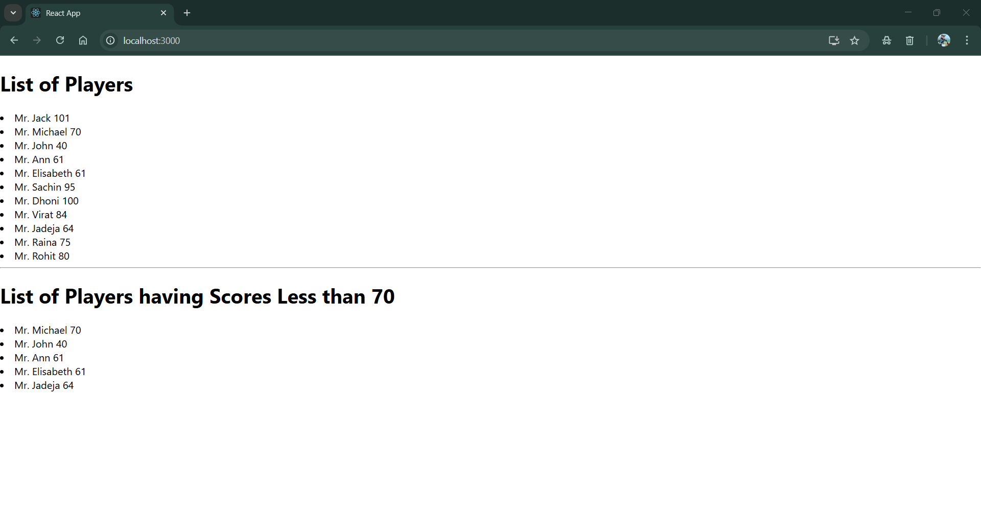
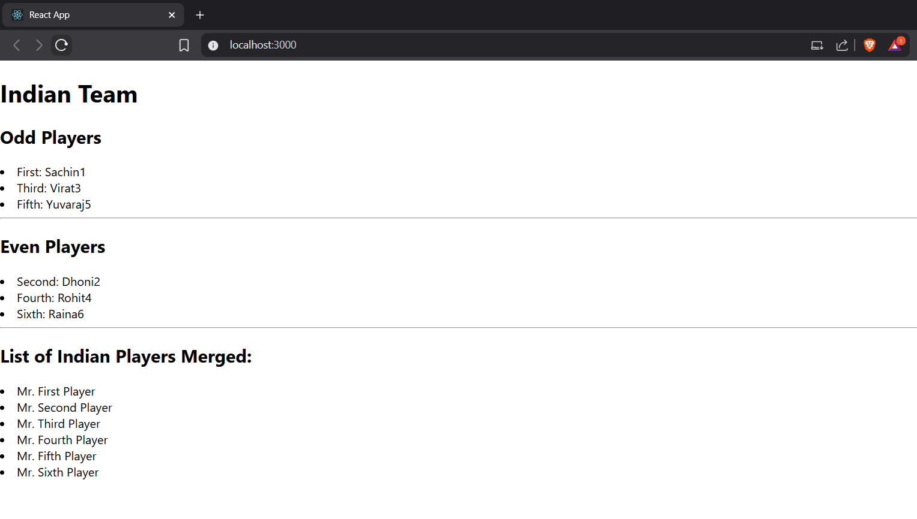

10. ReactJS-HOL
Code:
App.js
import React from 'react';

function App() {
const heading = "Office Space";

const officeList = [
{ Name: "DBS", Rent: 50000, Address: "Chennai" },
{ Name: "SmartWorks", Rent: 58000, Address: "Hyderabad" },
{ Name: "WeWork", Rent: 90000, Address: "Mumbai" }
];
const getColor = (rent) => {
return {
color: rent <= 60000 ? 'red' : 'green'
};
};

return (
<div style={{ padding: ”10px” }}>
<h1 style={{ fontWeight: "bold" }}>
{heading}, at Affordable Range
</h1>

<img src="office.webp" width="25%" height="25%" alt="Office Space" />

<br /><br />

{officeList.map((item, index) => (
<div key={index} style={{ marginBottom: "30px" }}>
<h2>Name: {item.Name}</h2>
<h3 style={getColor(item.Rent)}>Rent: Rs. {item.Rent}</h3>
<h3>Address: {item.Address}</h3>
</div>
))}
</div>
);
}

export default App;

Screenshot:

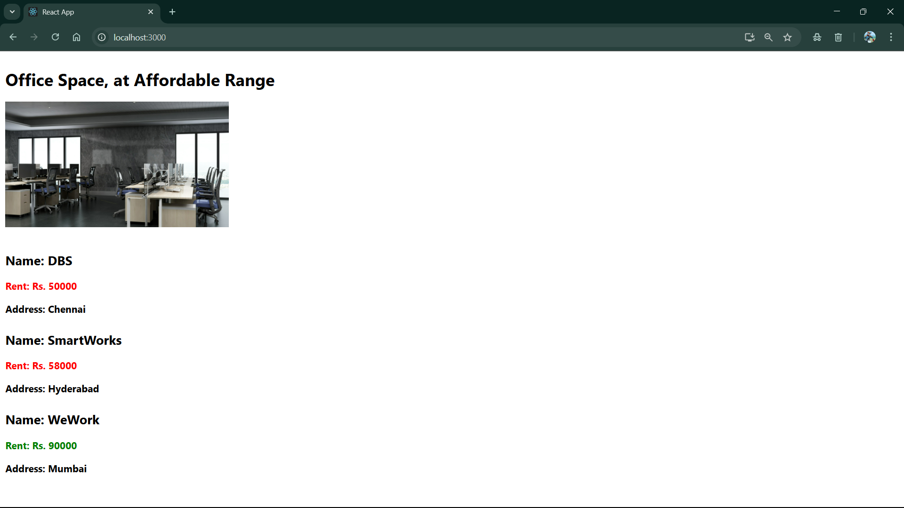

11. ReactJS-HOL
Code:
App.js
import React from 'react';
import CurrencyConverter from './CurrencyConverter';

class App extends React.Component {
constructor(props) {
super(props);
this.state = {
count: 0,
message: ''
};

this.increment = this.increment.bind(this);
this.sayHello = this.sayHello.bind(this);
this.handleMultiple = this.handleMultiple.bind(this);
this.sayWelcome = this.sayWelcome.bind(this);
this.onPress = this.onPress.bind(this);
}

increment() {
this.setState({ count: this.state.count + 1 });
}

sayHello() {
alert("Hello! This is a static message.");
}

handleMultiple() {
this.increment();
this.sayHello();
}

decrement = () => {
this.setState({ count: this.state.count - 1 });
};

sayWelcome(message) {
alert(`Welcome Message: ${message}`);
}

onPress(e) {
e.preventDefault();
this.setState({ message: "I was clicked" });
}

render() {
return (
<div style={{ padding: "10px" }}>
<h2>Counter: {this.state.count}</h2>
<button onClick={this.handleMultiple}>Increment</button>
<br />
<button onClick={this.decrement}>Decrement</button>
<br />
<button onClick={() => this.sayWelcome("Welcome to React Events!")}>
Say Welcome
</button>
<br />
<button onClick={this.onPress}>Click Me</button>
<p>{this.state.message}</p>

<CurrencyConverter />
</div>
);
}
}

export default App;

CurrencyConverter.js

import React, { useState } from 'react';

const CurrencyConverter = () => {
const [rupees, setRupees] = useState('');
const [euros, setEuros] = useState('');

const handleSubmit = (e) => {
e.preventDefault();
const converted = (parseFloat(rupees) / 90).toFixed(2);
setEuros(converted);
};

return (
<div style={{ marginTop: "40px" }}>
<h2>Currency Converter (INR to EURO)</h2>
<form onSubmit={handleSubmit}>
<input
type="number"
placeholder="Enter amount in Rupees"
value={rupees}
onChange={(e) => setRupees(e.target.value)}
/>
<button type="submit">Convert</button>
</form>
{euros && <p>Converted Euro: € {euros}</p>}
</div>
);
};

export default CurrencyConverter;

Screenshot:

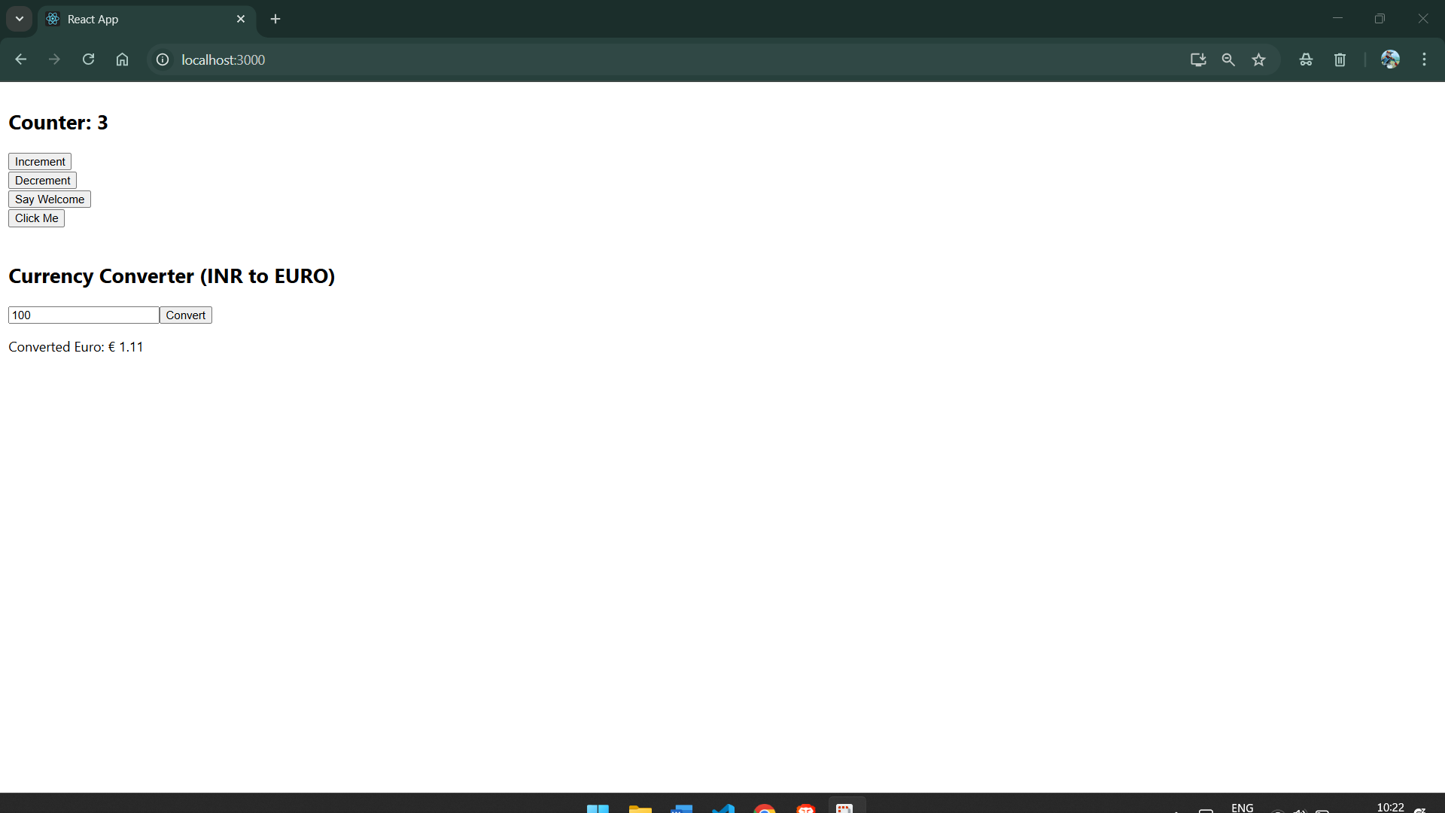

12. ReactJS-HOL
Code:
App.js
import React from 'react';
function GuestGreeting() {
return (
<div>
<h2>Please Sign Up...</h2>
<p>Click the Login Button</p>
</div>
);
}
function UserGreeting() {
return (
<div>
<h2>Welcome Back, Soumili Pal!</h2>
</div>
);
}

function Greeting(props) {
const isLoggedIn = props.isLoggedIn;
if (isLoggedIn) {
return <UserGreeting />;
}
return <GuestGreeting />;
}
function LoginButton(props) {
return <button onClick={props.onClick}>Login</button>;
}
function LogoutButton(props) {
return <button onClick={props.onClick}>Logout</button>;
}
class App extends React.Component {
constructor(props) {
super(props);
this.state = { isLoggedIn: false };
this.handleLoginClick = this.handleLoginClick.bind(this);
this.handleLogoutClick = this.handleLogoutClick.bind(this);
}
handleLoginClick() {
this.setState({ isLoggedIn: true });
}
handleLogoutClick() {
this.setState({ isLoggedIn: false });
}
render() {
const isLoggedIn = this.state.isLoggedIn;
let button;

if (isLoggedIn) {
button = <LogoutButton onClick={this.handleLogoutClick} />;
} else {
button = <LoginButton onClick={this.handleLoginClick} />;
}
return (
<div style={{ padding: '40px', fontFamily: 'Arial' }}>
<Greeting isLoggedIn={isLoggedIn} />
<br />
{button}
</div>
);
}
}

export default App;

Screenshot:
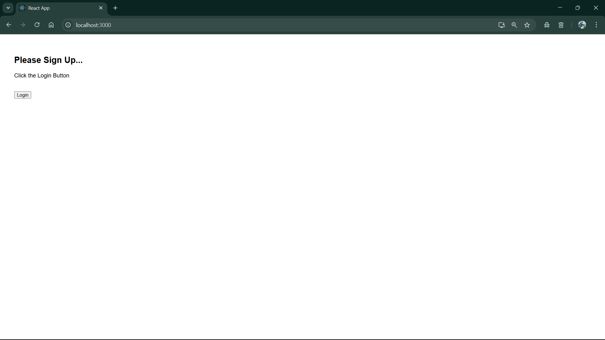

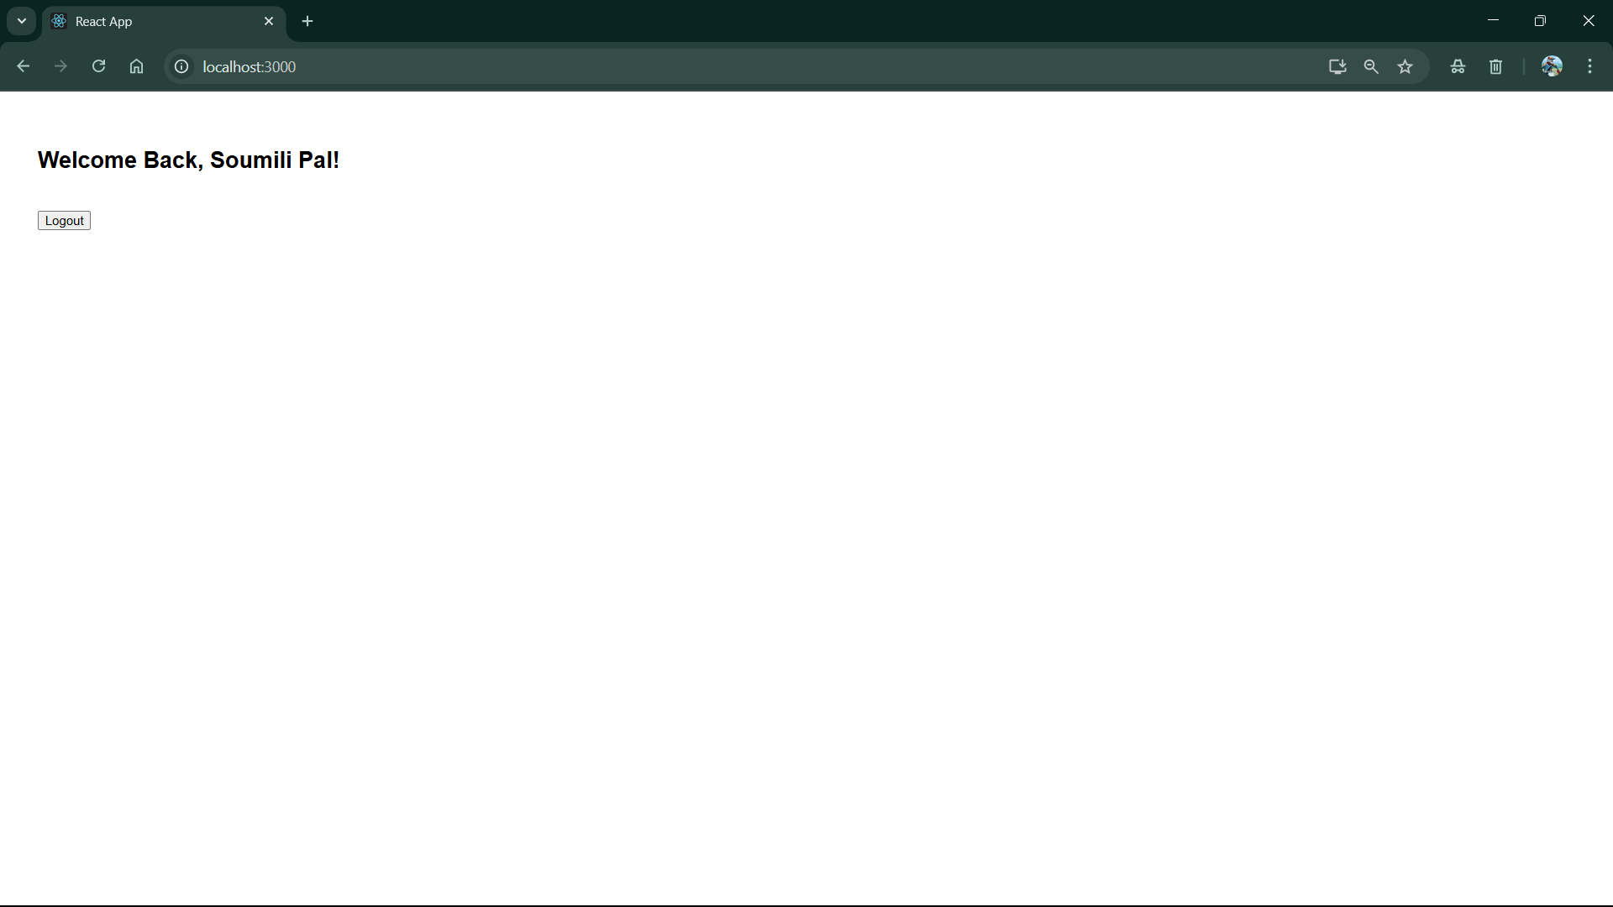

13. ReactJS-HOL
Code
App.js
import React from 'react';
import BookDetails from './BookDetails';
import BlogDetails from './BlogDetails';
import CourseDetails from './CourseDetails';
import './App.css'; // Import CSS

function App() {
return (
<div className="app-container">
<CourseDetails />
<BookDetails />
<BlogDetails />
</div>
);
}

export default App;

BlogDetails.js
import React from 'react';

const BlogDetails = () => {
const blogs = [
{
id: 1,
title: 'Machine Learning',
author: 'Stephen Biz ',
description: 'Welcome to the learning React!'
},
{
id: 2,
title: 'Installation',
author: 'Soumili Pal',
description: 'You can install React from npm.'
}
];

return (
<div className="column blog">
<h2>Blog Details</h2>
{blogs.map((blog) => (
<div key={blog.id}>
<h3>{blog.title}</h3>
<p><strong>{blog.author}</strong></p>
<p>{blog.description}</p>
</div>
))}
</div>
);
};

export default BlogDetails;

BookDetails.js
import React from 'react';

const BookDetails = () => {
const books = [
{ id: 101, bname: 'Master React', price: 670 },
{ id: 102, bname: 'Deep Dive into Angular 11', price: 800 },
{ id: 103, bname: 'Mongo Essentials', price: 450 }
];

return (
<div className="column book">
<h2>Book Details</h2>
{books.map((book) => (
<div key={book.id}>
<h3>{book.bname}</h3>
<p>{book.price}</p>
</div>
))}
</div>
);
};

export default BookDetails;

CourseDetails.js
import React from 'react';

const CourseDetails = () => {
const courses = [
{ id: 1, cname: 'Angular', date: '4/5/2021' },
{ id: 2, cname: 'React', date: '6/3/2021' }
];

return (
<div className="column course">
<h2>Course Details</h2>
{courses.map((course) => (
<div key={course.id}>
<h3>{course.cname}</h3>
<p>{course.date}</p>
</div>
))}
</div>
);
};

export default CourseDetails;

Screenshot:

