SCALABLE THREAD MANAGEMENT LIBRARY

This is Submitted By:
SAMARTH CHANDEL
12416232
SOUMI MAITI
12415421
G GURUVEERA KARTHIKEYA
12415223

Section-3E041

Under the Guidance of
Dr. Deepak Thakur(33989)
Associate Professor
School of Computing and AI
LPU



School of Computing & Artificial Intelligence
Lovely Professional University, Phagwara

1. Project Overview
ThreadVerse is an interactive, visually immersive web-based platform designed to demonstrate modern energy-aware thread scheduling and CPU telemetry.
Unlike traditional simulators that only focus on task execution, ThreadVerse highlights the dynamic relationship between workload density, CPU frequency scaling, and real-time power consumption. The system models how modern processors manage performance and energy using concepts like Dynamic Voltage and Frequency Scaling (DVFS).
The primary objective of this project is educational: to simplify complex operating system and hardware-level concepts such as thread scheduling, synchronization, and energy optimization into an intuitive and visual experience. Through real-time graphs, interactive controls, and live telemetry, users can clearly observe how system resources behave under different workloads.

2. Module-Wise Breakdown
The project is divided into three major layers:

a) User Interface Layer (HTML + CSS)
- Dashboard Layout:
A responsive “Bento-Box” grid design representing 28 logical threads, inspired by modern multi-core processors.
- Telemetry HUD (Head-Up Display):
Displays real-time system metrics:
  - Power Consumption (Wattage)
  - CPU Frequency
  - System Mode (Performance / Balanced / Deep Sleep)
- Visual Design:
  - Dark “Obsidian” theme
  - Glassmorphism effects
  - Color-coded thread states:
    - Green → Running
    - Orange → Waiting
    - Red → Idle

b) Animation & Telemetry Layer (GSAP)
- Smooth animations for thread transitions using GSAP.
- Dynamic visual feedback:
  - Pulsing effects for active threads
  - Energy rings indicating load intensity
- Real-time graph animations reacting to:
  - Thread activity
  - Frequency scaling
  - Power spikes

c) Simulation Logic Layer (JavaScript)
- Custom Scheduler Engine:
Simulates OS-level thread scheduling behavior based on workload.
- Energy-Aware Model:
Power is calculated using:
P ≈ V² × f × C
Where:
V = Voltage
f = Frequency
C = Load/Capacitance
- Signal Processing:
Includes smoothing (low-pass filtering) to simulate realistic power fluctuations and noise.

3. Functionalities
- Interactive Power Modes:
  - Max Performance: Forces high CPU frequency → increases power usage
  - Deep Sleep: Reduces activity → minimizes energy consumption
- Dynamic Thread Injection:
  - Users can add threads to simulate workload bursts
- Real-Time Telemetry:
  - Live graphs showing:
    - Power usage
    - Thread activity
    - Frequency changes
- Thread State Visualization:
  - Running, Waiting, and Idle states clearly distinguishable
- Live System Feedback:
  - Immediate response to user actions in the simulation

4. Technology Used

• Programming Languages:
- HTML5
- CSS3
- JavaScript

• Libraries and Tools:
- GSAP (GreenSock Animation Platform)
- HTML5 Canvas (for graphs and rendering)

• Other Tools:
- GitHub (Version Control)
- VS Code (Development Environment)

5. Flow Diagram

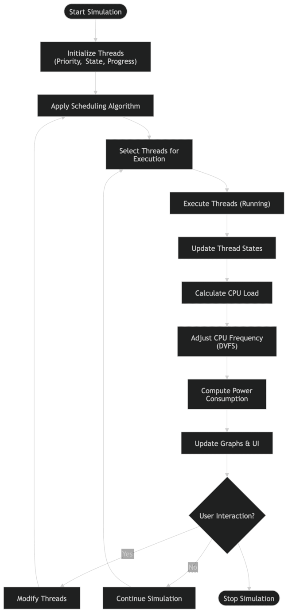
Step-wise Flow:
- User interacts (Start / Add Threads / Mode Change)
- Scheduler processes workload
- Thread states updated
- Power calculation applied
- Data sent to graph engine
- UI updates in real-time

6. Revision Tracking on GitHub
- Repository Name: Thread-Verse
- GitHub Link:
https://github.com/SAMARTH-19-CSE/THREAD-VERSE.git

7. Conclusion and Future Scope

Conclusion
ThreadVerse successfully demonstrates the relationship between thread scheduling and energy consumption in modern computing systems. It transforms abstract theoretical concepts into a visual and interactive simulation, making it easier to understand how operating systems balance performance and efficiency.
The project reflects real-world principles like DVFS and energy-aware scheduling while maintaining a clean and responsive user interface.

Future Scope
- Advanced telemetry controls (temperature, priority sliders)
- Performance analytics (latency, energy per task)
- Hybrid CPU simulation (P-cores & E-cores)
- Comparative scheduling models
- Exportable simulation data (CSV/JSON)
- Hardware integration using WebUSB/WebHID

8. References
- Operating System Concepts – Abraham Silberschatz
- Modern Processor Architecture (Intel Documentation)
- GSAP Official Documentation
- MDN Web Docs (JavaScript, HTML, CSS)

Appendix

A. AI-Generated Project Elaboration/Breakdown Report
ThreadVerse is designed as a high-performance educational simulator that bridges the gap between operating system theory and practical visualization. It models how threads interact with CPU scheduling mechanisms while incorporating energy-awareness into execution logic.
The system emphasizes real-time feedback and interactive learning, enabling users to experiment with workloads and immediately observe the effects on performance and power consumption.

B. Problem Statement
Modern operating systems manage hundreds of threads simultaneously, balancing performance and energy efficiency. However, these processes are difficult to visualize and understand due to their abstract nature.
There is a need for a system that can visually demonstrate how thread scheduling, CPU frequency scaling, and power consumption interact in real time.

C. Solution / Code:

