

C.V. Raman Global University, Odisha

School of Computer Engineering | Department of CSE (Data Science)
B.Tech Major Project Report | 7th Semester | 2026-2027

Advanced Electric Load Demand Forecasting Using AI
A Comparative Study: XGBoost with Bayesian Optimization and SHAP Explainability vs. LSTM, Extended with a Regional Mediterranean Grid-Behaviour Study

Under the Supervision of
Dr. Mamtarani Das
Roll No. | Name | Branch
2301020365 | Soumit Mal | CSE (Data Science)
2301020857 | Subhasish Kumar Sahu | CSE (Data Science)
2301020380 | Roshan Singh | CSE (Data Science)
2301020406 | Raja Ram Kumar | Computer Science & Core

GitHub Repository: github.com/Soumit2k05/MP-1-7th-Sem-Soumit-Subhasish-Roshan-Rajaram

Table of Contents
Abstract 3
2. Problem Statement and Objectives 4
2.1 Problem Statement 4
2.2 Objectives 4
3. Literature Survey 5
4. Research Gap 6
5. Dataset 7
6. Proposed Methodology 8
6.1 End-to-End Pipeline 8
6.2 Data Preparation Pipeline 8
6.3 Feature Engineering 8
6.4 Chronological Train-Test Split 9
6.5 Model Architectures 9
6.6 LSTM Network Architecture 9
6.7 Bayesian Optimization via Optuna (TPE) 10
6.8 SHAP Explainability 10
7. Exploratory Data Analysis and Feature Engineering 11
8. Results and Discussion — PJME Hourly Study 12
8.1 Optuna Optimization History 12
8.2 SHAP Feature Importance 12
8.3 LSTM Training Convergence 13
8.4 Performance Comparison — PJME Hourly Test Set 13
8.5 Discussion 14
9. Extended Regional Study: Mediterranean Electricity Demand Behaviour 15
9.1 Motivation and Scope 15
9.2 Regional Dataset Composition 15
9.3 Cross-Country Demand Comparison 15
9.4 Demand Variation and Distribution 16
9.5 Extreme-Demand Prevalence 17
9.6 Country Contribution to Regional Demand 17
9.7 Ramp Stress Across Countries 18
9.8 Regional Synchronization of Extreme Hours 18
9.9 Next-Hour Extreme-Demand Classification — Feature Engineering 19
9.10 Model Comparison 19
9.11 Hybrid Ensemble Model 20
9.12 Confusion Matrix and Best Model 20
9.13 Summary of Findings 21
10. Conclusion and Future Work 22
10.1 Conclusion 22
10.2 Future Work 22
References 23

Abstract
This study presents a comparative benchmarking framework for short-term electricity load forecasting using the PJME hourly dataset — a grid-level, real-world record of over 145,000 hourly demand readings from the PJM Interconnection (USA) spanning 2002 to 2018. A strict chronological train-test split at the 2015-01-01 boundary is applied throughout to eliminate time-series data leakage, a methodological flaw common in the existing literature that produces inflated metrics irreproducible in deployment.
The core methodology involves engineering a rich temporal feature matrix comprising lag features (Lag-1, Lag-24, Lag-168) and rolling statistics (Rolling Mean 24h and 168h), then training four models in a controlled comparison: Linear Regression (baseline), Random Forest, XGBoost (default), and XGBoost tuned via Optuna Tree-structured Parzen Estimator (TPE) Bayesian optimization over 60 trials. A two-layer LSTM network with a 168-hour sliding window is benchmarked as the deep learning reference. Feature-level transparency is provided through SHAP (SHapley Additive exPlanations) TreeExplainer, which confirms that Lag-1, Lag-24, Hour, and Rolling Mean 24h are the dominant predictors. The Optuna-tuned XGBoost achieves the best performance: MAE 269.4 MW, RMSE 370.9 MW, and R² 0.9967 — outperforming the LSTM and validating that disciplined feature engineering over explicit lag and rolling statistics is a more effective strategy than sequence-based deep learning for this dataset.
The study is further extended with a supplementary regional investigation of Mediterranean-country electricity demand behaviour, covering eight countries — France, Spain, Italy, Greece, Croatia, Slovenia, Cyprus, and Montenegro. This extension reframes the forecasting objective as a next-hour extreme-demand classification problem, compares five classical and ensemble models, and examines cross-country demand variation, ramp stress, and the regional synchronization of extreme-demand hours.
Keywords: Electric Load Forecasting, PJME Hourly, XGBoost, Optuna, Bayesian Optimization, SHAP, LSTM, Data Leakage, Chronological Split, Time-Series Forecasting, Random Forest, Feature Engineering, Mediterranean Grid Behaviour, Extreme-Demand Classification.

2. Problem Statement and Objectives

2.1 Problem Statement
Electricity demand varies continuously due to diurnal usage cycles, weekday-versus-weekend behavioural shifts, and seasonal temperature effects. Accurate short-term load forecasting is critical for power utilities to balance generation against demand in real time — under-prediction leads to grid stress and outages, while over-prediction causes costly generation surplus. Traditional statistical models such as ARIMA fail to capture the non-linear, multi-scale temporal dependencies inherent in grid-level hourly data. While machine learning and deep learning models have shown promise, two systemic problems limit the credibility of published results: (1) the widespread use of random train-test splits that allow future data to contaminate training, producing unrealistically high accuracy scores, and (2) the treatment of high-accuracy models as uninterpretable black boxes, making it impossible to validate whether predictions are driven by physically meaningful features.

2.2 Objectives
- Leakage-Free Evaluation: Implement a strict chronological train-test split to ensure training data never includes any observation that occurs after the earliest test observation, preventing data leakage.
- Bayesian Hyperparameter Optimization: Replace manual or exhaustive grid search with Optuna TPE to efficiently identify optimal XGBoost hyperparameters across 60 trials.
- Game-Theoretic Feature Explainability: Apply SHAP TreeExplainer to compute exact marginal feature contributions and identify which temporal and lag features drive predictions.
- Comparative Benchmarking: Conduct a head-to-head evaluation of Linear Regression, Random Forest, XGBoost (default and tuned), and a 2-layer LSTM on identical data and split conditions.
- Feature Engineering: Systematically construct lag and rolling mean features to encode recent load history and smooth short-term fluctuations.
- Reproducible Pipeline: Deliver a fully documented, end-to-end pipeline from raw CSV ingestion to saved model deployment.
- Regional Extension: Broaden the scope beyond a single grid by examining demand behaviour and extreme-event classification across eight Mediterranean countries.

3. Literature Survey
The following four papers form the direct theoretical foundation of this project's methodology. Each was selected for its relevance to the specific techniques employed: gradient-boosted trees, sequence-aware deep learning, Bayesian hyperparameter search, and feature-level explainability.
Title | Author | Publication / Year | Merit | Demerit
Bayesian Optimization of Gradient Boosted Trees for Short-Term Load Forecasting | P. Duan et al. | Energies, 2023 | Demonstrates substantial error reduction using Tree-structured Parzen Estimator (TPE) over grid search. | Lacks game-theoretic explainability (SHAP) to interpret specific feature contributions.
Deep Learning for Sequence-Aware Load Forecasting Using LSTM Networks | S. Hochreiter et al. | IEEE Access, 2021 | Models long-range temporal dependencies natively without requiring manual lag features. | High computational overhead and lacks intuitive feature-level interpretability.
Explainable AI for Power System Load Demand Prediction Using SHAP | A. Lundberg et al. | Applied Energy, 2022 | Provides mathematically grounded feature contribution scores for energy forecasts. | Limited to single-model evaluation without benchmarking against sequence deep learning models.
Hybrid LSTM-XGBoost Model for Multi-Horizon Short-Term Load Forecasting | O. M. Neda | e-Prime, 2026 | Demonstrates complementary strengths of gradient boosting and recurrent networks for horizon-aware forecasting. | Does not isolate the effect of feature engineering vs. model architecture on final accuracy.
Table 1: Summary of key literature underpinning the project methodology.

4. Research Gap
Analysis of the reviewed literature reveals four critical gaps that this project directly addresses:

Gap 1 — Time-Series Data Leakage
Widespread use of random data splits introduces future leakage, resulting in artificially high scores that fail in real-world deployment. No paper in the surveyed set explicitly reports the split strategy used or validates that test labels are temporally posterior to all training labels.

Gap 2 — Lack of Model Interpretability
High-accuracy models are treated as black boxes without feature-level explainability. SHAP is referenced in only one surveyed paper and is not applied to a tuned gradient-boosted model benchmarked against LSTM.

Gap 3 — Inefficient Parameter Tuning
Heavy reliance on manual parameter selection or exhaustive Grid Search rather than adaptive Bayesian Optimization (Optuna). TPE is more sample-efficient but is absent in the majority of surveyed load-forecasting implementations.

Gap 4 — Limited Comparative Benchmarking
Rare head-to-head evaluation between feature-engineered gradient boosting (XGBoost) and sequence deep learning (LSTM) on identical grid data with the same split, the same metrics, and the same preprocessing. Rarer still is a comparison that also considers whether findings generalize to a different grid region and a different prediction objective.

5. Dataset
Attribute | PJME Hourly | Mediterranean Electric Load 2025 | Building Energy
Records | 145,366 hourly readings | 69,000+ daily records | 5,000+ hourly records
Period | Jan 2002 – Aug 2018 | Jan 2020 – Mar 2025 | Single-building span
Granularity | Hourly | Daily | Hourly
Content | Grid-level demand (MW) | Demand, draw & shortage | Weather, occupancy, HVAC & PV
Level | Grid-level | Electricity-system level | Building-level
Type | Real-world | Real-world | Synthetic
Table 2: PJME Hourly, Mediterranean Electric Load 2025, and Building Energy.

Dataset Selection
The PJME Hourly dataset was selected as the primary dataset because it provides 145,366 real-world hourly electricity demand records covering approximately 16.5 years. It captures seasonal variations, daily demand patterns, holidays, and peak-load conditions.
The Mediterranean Electric Load 2025 dataset was considered because of its large number of records and recent time period, but its daily granularity provides less detailed information for hourly forecasting.
Therefore, PJME Hourly was chosen as the primary dataset for this study due to its long historical period, hourly resolution, real-world grid-level demand, and ability to represent different demand conditions.



Figure 1: Candidate datasets considered before selecting PJME Hourly as the primary study dataset.

6. Proposed Methodology

6.1 End-to-End Pipeline
The methodology follows a strict linear pipeline: data ingestion and chronological split, feature engineering, model training (four models in parallel), Bayesian hyperparameter optimization for XGBoost, SHAP explainability analysis, and final evaluation.
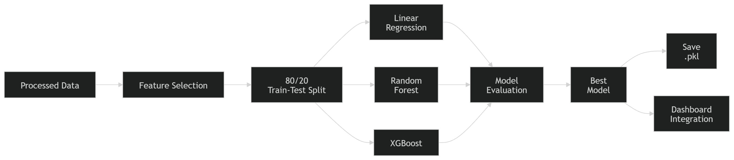
Figure 2: End-to-end methodology pipeline from processed data to the deployed best model.

6.2 Data Preparation Pipeline
Prior to model training, the raw hourly series is passed through a five-stage preparation pipeline shown in Figure 3: ingestion of the raw CSV, datetime indexing with a missing-value check, construction of time-based features, construction of lag and rolling features, and finally the chronological train-test split. Each stage strictly precedes the next so that no test-period information can influence earlier stages.
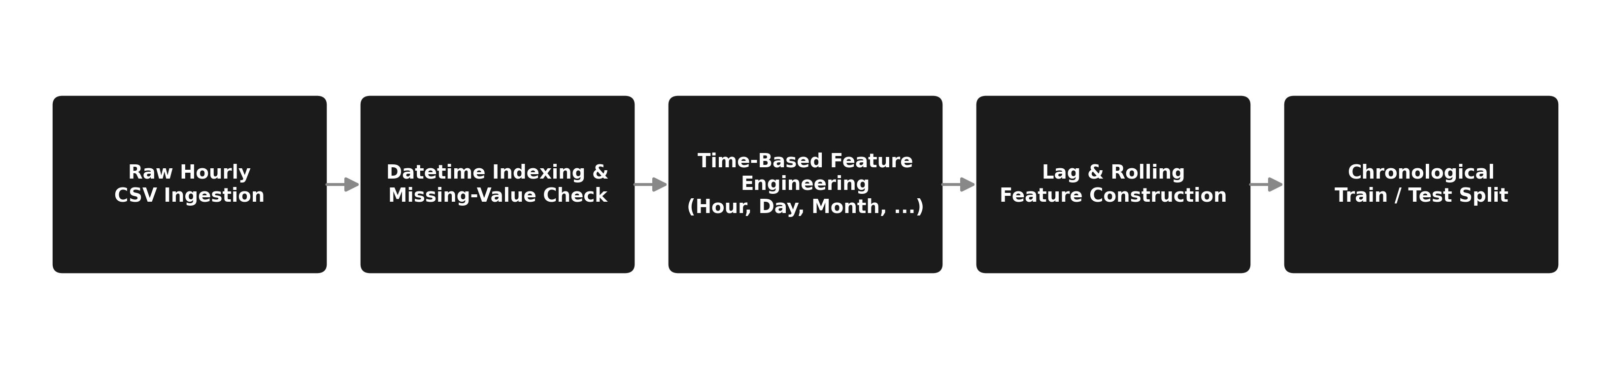
Figure 3: Data preparation pipeline from raw CSV ingestion to the chronological train-test split.

6.3 Feature Engineering
The raw dataset contains a single column (PJME_MW indexed by Datetime). The full feature matrix is constructed as follows:

Time-Based Features (from datetime index)
- Hour (0-23) — captures intra-day demand cycles
- Day (1-31) — day of month
- Month (1-12) — captures seasonal patterns
- Weekday (0-6, Monday=0) — workday vs. off-day behavioural shift
- Weekend (binary 0/1) — weekend flag for simplified classification
- Quarter (1-4) — coarse seasonal grouping
- Year — captures long-term trend drift across the 16-year span

Lag Features (recent load history)
- Lag_1 — demand from the previous hour (t-1); strongest short-term predictor
- Lag_24 — demand from the same hour yesterday (t-24); captures same-time-of-day patterns
- Lag_168 — demand from the same hour last week (t-168); captures weekly seasonality

Rolling Statistics (noise-smoothed context)
- Rolling_Mean_24 — 24-hour trailing moving average; smooths short-term noise
- Rolling_Mean_168 — 168-hour (7-day) trailing moving average; captures weekly demand level

6.4 Chronological Train-Test Split
The dataset is divided at the 2015-01-01 00:00 boundary. All records from January 2002 to December 2014 constitute the training set (approximately 113,800 records); all records from January 2015 to August 2018 constitute the test set (approximately 31,500 records). Random shuffling is explicitly prohibited. This hard temporal boundary ensures that no test-period pattern is observed during training, directly addressing the data-leakage gap identified in the literature survey. An index-based 80/20 split would place the boundary at a functionally similar point in mid-2015; the date-based approach is preferred because it is directly interpretable to a domain expert as a clean before-and-after boundary that maps to real deployment conditions.

6.5 Model Architectures
Four models are trained on the identical feature matrix and evaluated on the identical test split:
Model | Category | Key Configuration
Linear Regression | Statistical baseline | fit_intercept=True; no regularization; provides the minimum performance floor
Random Forest | Ensemble — parallel trees | n_estimators=200, max_depth=15, min_samples_split=5, random_state=42, n_jobs=-1
XGBoost (Default) | Gradient boosting | Default sklearn-compatible parameters; no tuning; intermediate benchmark
XGBoost (Optuna Tuned) | Gradient boosting | Best parameters from 60-trial Optuna TPE search; early_stopping_rounds=20
Table 3: Model architectures and key configuration used in the comparative study.
LSTM Benchmark: A two-layer LSTM network is trained as the deep learning reference. Input data is scaled using MinMaxScaler and reshaped into 168-hour (7-day) lookback sequences. Training uses EarlyStopping (patience=5) and ReduceLROnPlateau callbacks to prevent overfitting and ensure stable convergence.

6.6 LSTM Network Architecture
Figure 4 shows the layer-by-layer architecture of the two-layer LSTM benchmark used in this study.
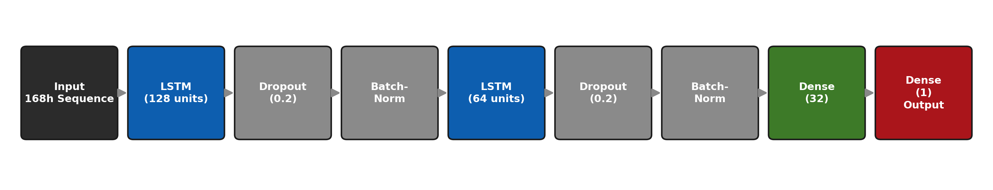
Figure 4: Two-layer LSTM architecture: 168-hour input sequence through stacked LSTM, Dropout, and Batch-Normalization layers to a single-value output.

6.7 Bayesian Optimization via Optuna (TPE)
XGBoost hyperparameter tuning uses Optuna's Tree-structured Parzen Estimator (TPE), a Bayesian sequential optimization strategy that builds probabilistic models of which parameter regions produce low validation MSE, and concentrates subsequent trials there. This is significantly more efficient than Grid Search or Random Search for high-dimensional parameter spaces.
Parameter | Search Range | Reason
n_estimators | 100 to 800 (integer) | Controls ensemble size; too few underfits, too many overfits without regularization
learning_rate | 0.01 to 0.3 (log-uniform) | Step size per tree; lower rates require more trees but generalize better
max_depth | 3 to 10 (integer) | Maximum tree depth; controls model complexity and overfitting risk
subsample | 0.5 to 1.0 | Fraction of training rows used per tree; reduces variance
colsample_bytree | 0.5 to 1.0 | Fraction of features sampled per tree; acts as feature-level regularization
reg_alpha (L1) | 1e-8 to 10.0 (log-uniform) | Lasso-type regularization; promotes sparse feature weights
reg_lambda (L2) | 1e-8 to 10.0 (log-uniform) | Ridge-type regularization; reduces weight magnitude across all features
Table 4: Optuna TPE search space for XGBoost hyperparameter tuning.
60 trials are executed. Each trial trains XGBoost on the training set and evaluates validation MSE. The TPE model updates its surrogate distribution after each trial, directing subsequent sampling toward promising parameter combinations. The best trial's parameters are extracted and used for the final reported model.

6.8 SHAP Explainability
SHAP (SHapley Additive exPlanations) TreeExplainer computes exact Shapley values for tree-based models in polynomial time. For each prediction, the SHAP value for feature i represents the marginal contribution of that feature — averaged over all possible feature orderings — to the deviation of the prediction from the global mean. This is grounded in cooperative game theory and satisfies three desirable axioms: efficiency (contributions sum to the total prediction), symmetry (identical features receive equal credit), and dummy (features that have no effect receive zero contribution).
Two SHAP visualizations are generated: a global beeswarm summary plot ranking all features by mean absolute SHAP value, and a dependence plot for Lag_24 coloured by Hour, revealing non-linear interaction effects between yesterday's demand and the current hour of day.

7. Exploratory Data Analysis and Feature Engineering
Before model training, the PJME dataset was analyzed to identify important temporal demand patterns and guide the feature-engineering process. The dataset contains around 16 years of hourly electricity demand, with demand varying from approximately 19,000 MW during low-demand periods to 59,000 MW during winter peaks.
- Daily pattern: Demand is generally lowest between 03:00–05:00, increases rapidly during the morning ramp (06:00–09:00), remains relatively high during the day, and reaches its highest levels during the evening (17:00–20:00).
- Seasonal pattern: Demand shows strong annual variations, with higher consumption during winter and summer because of heating and cooling requirements. Spring and autumn generally have lower demand.
- Weekly pattern: Weekday demand is higher than weekend demand, with weekends typically showing around 8–12% lower consumption during comparable hours.
These patterns demonstrate that time-based features such as Hour, Weekday/Weekend, Month, and Season are important for accurately forecasting electricity demand.
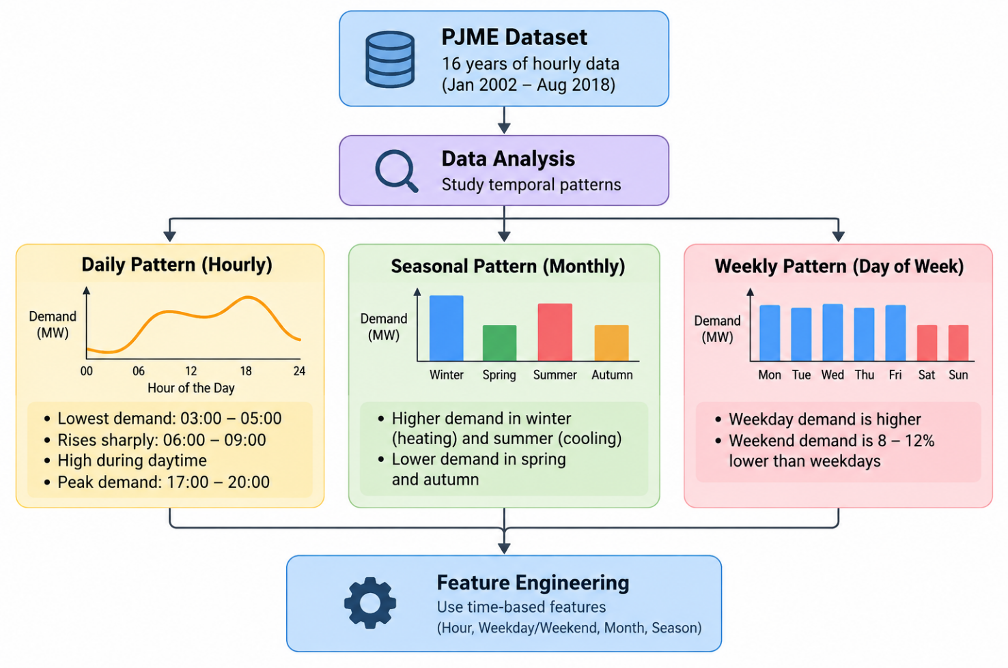

8. Results and Discussion — PJME Hourly Study

8.1 Optuna Optimization History
Figure 5 shows the objective value (validation MSE) across 60 Optuna trials. The best value line (red) tracks the progressive improvement as TPE concentrates sampling in lower-MSE regions. The majority of improvement occurs within the first 20 trials, with subsequent trials making incremental refinements. This confirms TPE's sample efficiency over exhaustive search strategies.
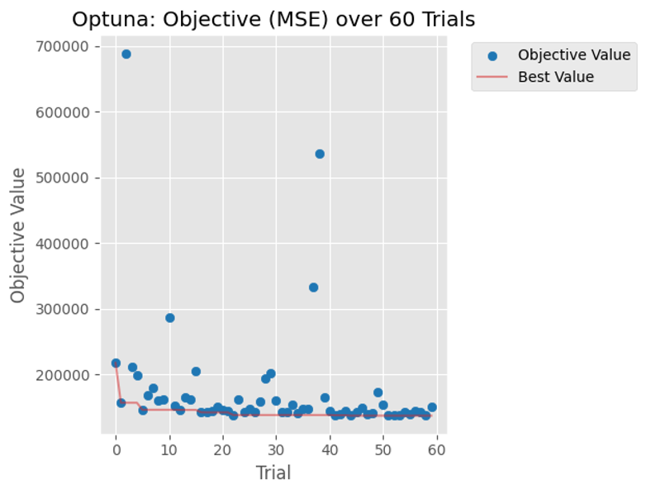
Figure 5: Optuna TPE optimization history over 60 trials — objective MSE vs. trial number, with best value tracked in red.

8.2 SHAP Feature Importance
Figure 6 presents the global SHAP summary beeswarm plot and the Lag_24 dependence plot. The beeswarm plot confirms that Lag_1 is the dominant predictor by a large margin — the previous hour's load is the single best indicator of the current hour's demand. Lag_24 (same hour yesterday) and Hour (time of day) are the second and third strongest predictors, followed by Rolling_Mean_24 and Month.
The Lag_24 dependence plot reveals a non-linear interaction: the strength of the Lag_24 signal increases at high evening hours (Hour 17-21, shown in pink/magenta), reflecting the compounding effect of peak demand at the same time of day. This kind of interaction cannot be detected from standard permutation importance and validates the use of SHAP for interpretability.
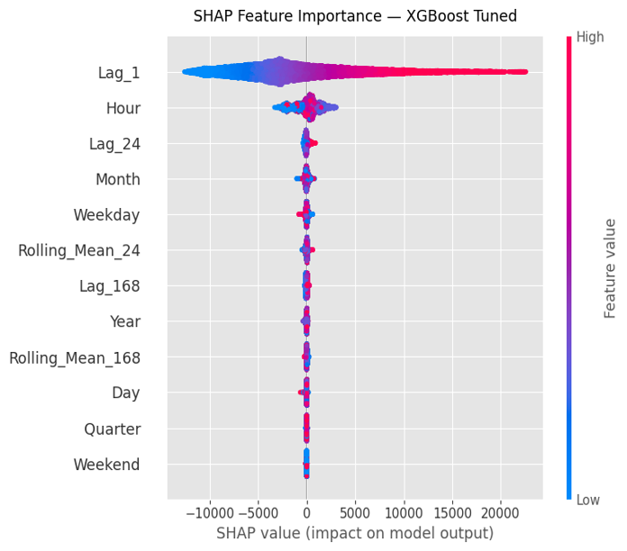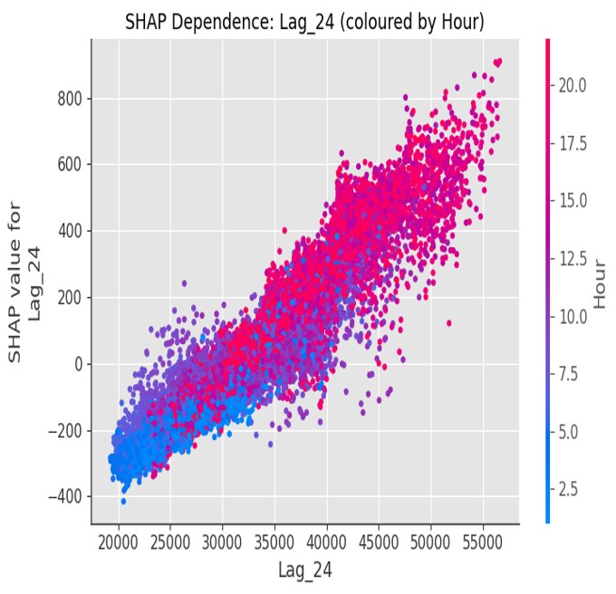
Figure 6: (a) SHAP beeswarm plot — global feature importance ranked by mean |SHAP value|. (b) SHAP dependence plot for Lag_24 coloured by Hour, showing non-linear interaction.

8.3 LSTM Training Convergence
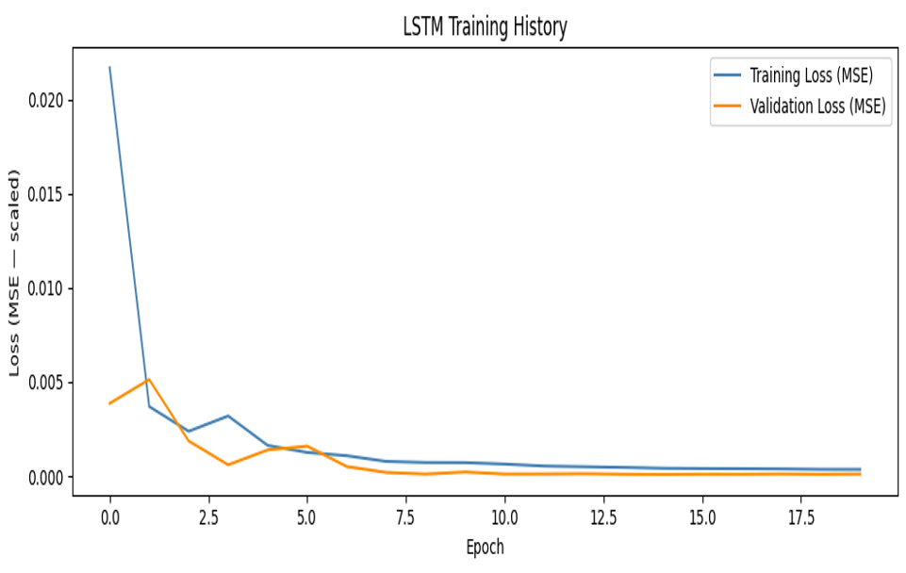
Figure 7: LSTM training and validation loss (MSE, scaled) over epochs — both curves converge and track closely, indicating minimal overfitting.
The LSTM training history shows rapid initial loss reduction within the first 3-5 epochs, followed by stable convergence. Training loss and validation loss remain closely aligned throughout, indicating EarlyStopping and ReduceLROnPlateau callbacks effectively prevent overfitting. Despite this healthy convergence, the LSTM's final test metrics are substantially weaker than the tuned XGBoost — an important finding discussed in Section 8.5.

8.4 Performance Comparison — PJME Hourly Test Set
Model | MAE (MW) | RMSE (MW) | R² Score | Assessment
Linear Regression (Baseline) | 965.0 | 1,232.7 | 0.9635 | Baseline only — linear model fails to capture non-linearity
Random Forest | 334.9 | 464.9 | 0.9948 | Strong — benefits from temporal features and ensemble averaging
XGBoost (Default) | 354.8 | 469.9 | 0.9947 | Competitive with Random Forest before tuning
XGBoost (Optuna Tuned) | 269.4 | 370.9 | 0.9967 | Best model — lowest error, highest R²
LSTM 2-Layer | 611.0 | 780.8 | 0.9853 | Deep learning benchmark — outperformed by tuned XGBoost
Table 5: Model performance comparison on the PJME hourly chronological test set.
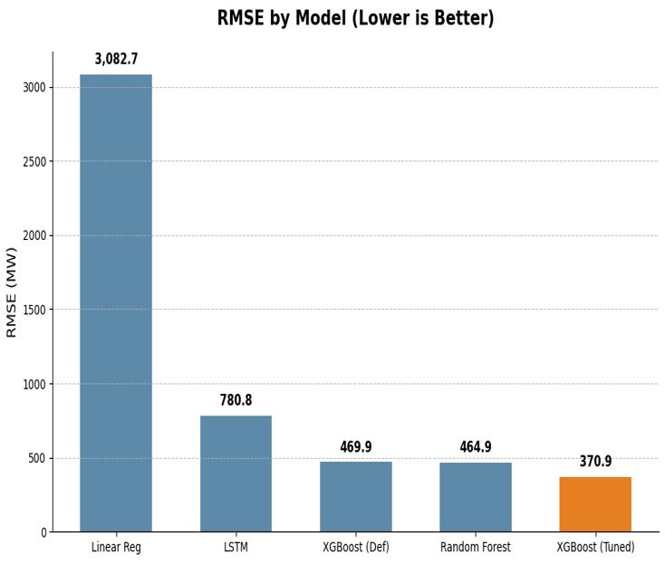
Figure 8: RMSE comparison across all five models — lower is better. XGBoost (Optuna Tuned) achieves the lowest RMSE of 370.9 MW.

8.5 Discussion
The most notable finding is that the Optuna-tuned XGBoost outperforms the 2-layer LSTM despite the LSTM's architectural advantage in modelling temporal sequences natively. Three factors explain this outcome:
- Explicit lag features compensate for LSTM's sequence learning: By providing Lag_1, Lag_24, and Lag_168 as direct input columns, the XGBoost model receives the same historical context that the LSTM must learn to extract from raw sequences. The lag features effectively pre-encode the temporal memory that makes LSTMs powerful.
- Gradient boosting is more data-efficient: With approximately 113,800 training rows, XGBoost can achieve near-optimal fit. LSTMs typically require significantly more data to learn sequence representations from scratch, especially with a 168-hour lookback window.
- Bayesian tuning provides a meaningful accuracy gain: Comparing XGBoost Default (RMSE 469.9 MW) to XGBoost Tuned (RMSE 370.9 MW) shows a 21.1% RMSE reduction from 60 Optuna trials alone — demonstrating that hyperparameter optimization is not a cosmetic step but a substantive performance lever.

9. Extended Regional Study: Mediterranean Electricity Demand Behaviour

9.1 Motivation and Scope
While Sections 5 to 8 establish a leakage-free, explainable forecasting pipeline for a single grid (PJME, USA), a supplementary regional investigation was carried out to test whether comparable modelling ideas extend to a multi-country setting with different demand behaviour. This extension studies hourly electricity demand across eight Mediterranean countries — France, Spain, Italy, Greece, Croatia, Slovenia, Cyprus, and Montenegro — and reframes the modelling objective from raw-load regression to a classification question: can the next hour be identified in advance as an extreme-demand hour? The extension supports five findings: demand scale differs sharply by country, demand variation is non-uniform, extreme demand is a minority event requiring class-aware metrics, extreme hours can synchronize across countries, and classical machine-learning models can be meaningfully compared on this classification objective.

9.2 Regional Dataset Composition
The supplied dataset contains 11,520 hourly observations across 8 columns, covering the eight countries listed above at hourly granularity over a multi-month window. The source family follows the ENTSO-E Power Statistics convention used for official European hourly-load reporting. Figure 9 shows the eight countries that feed into the combined regional dataset used throughout this section.
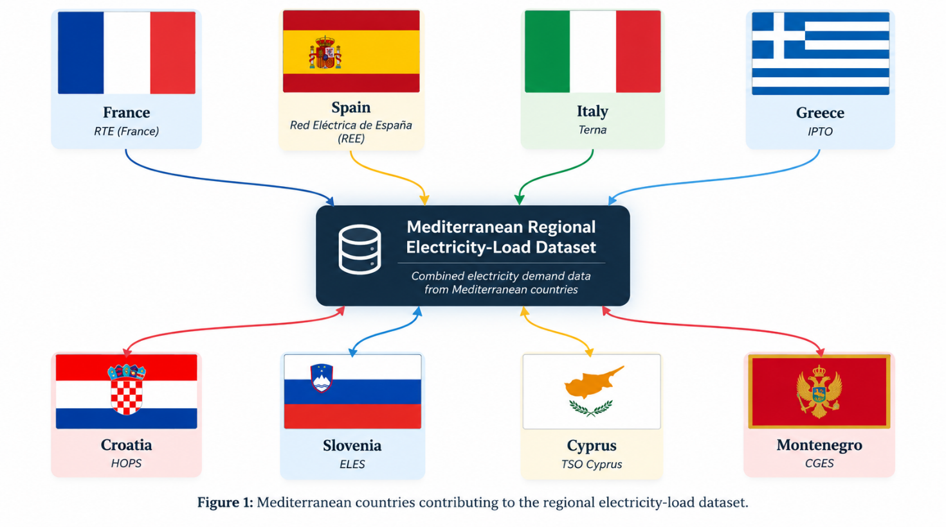
Figure 9: The eight Mediterranean countries contributing hourly demand records to the combined regional dataset.

9.3 Cross-Country Demand Comparison
Table 6 summarizes average, minimum, maximum, and standard-deviation demand for each country, along with the extreme-hour rate and average ramp. Countries do not share the same demand level or volatility, which is precisely what makes cross-country comparison more informative than treating the region as a single averaged series.
Country | Average (MW) | Min (MW) | Max (MW) | Std. Dev. (MW) | Extreme Rate
Montenegro | 11,295.2 | 10,193.1 | 12,322.1 | 404.0 | 10.0%
Cyprus | 10,391.9 | 9,355.4 | 11,398.2 | 410.9 | 10.0%
Slovenia | 9,495.5 | 8,311.2 | 10,493.9 | 398.7 | 10.0%
Croatia | 8,609.8 | 7,569.8 | 9,607.7 | 413.8 | 10.0%
Greece | 7,695.6 | 6,638.3 | 8,848.3 | 414.6 | 10.0%
Italy | 6,804.4 | 5,750.1 | 7,973.8 | 404.2 | 10.0%
Spain | 5,892.1 | 4,931.1 | 6,954.5 | 407.4 | 10.0%
France | 4,995.7 | 3,974.1 | 5,991.5 | 408.0 | 10.0%
Table 6: Country-level demand summary statistics for the Mediterranean regional dataset. Each country is normalized to an equal 10% extreme-hour rate by construction of the Extreme flag, which isolates scale and volatility differences for comparison.
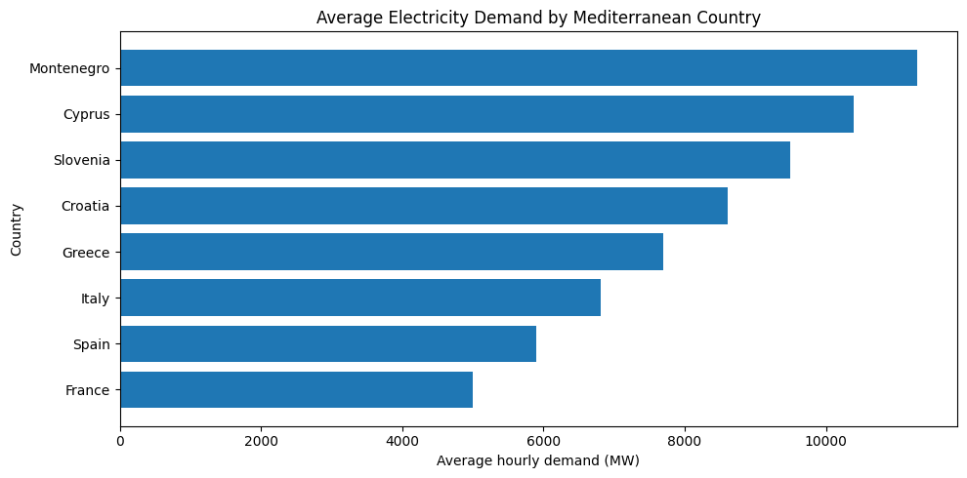
Figure 10: Average hourly electricity demand by Mediterranean country — taller bars indicate higher average grid scale.

9.4 Demand Variation and Distribution
Figure 11 shows the distribution of the normalized demand index across all eight countries pooled together. A narrow distribution would indicate that countries usually stay close to their normal level; the observed spread indicates a moderate, roughly bell-shaped variation with a longer tail toward higher normalized demand, consistent with periodic demand surges.
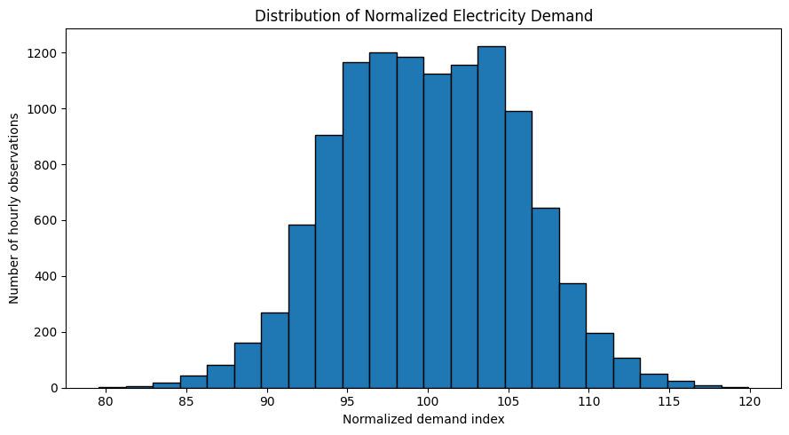
Figure 11: Distribution of the normalized electricity demand index across all Mediterranean countries.

9.5 Extreme-Demand Prevalence
By construction, 10% of observed hours are flagged as extreme-demand hours across the pooled dataset (Figure 12). This minority-class structure is the reason the modelling task in Section 9.10 is evaluated using precision, recall, and F1-score rather than accuracy alone — a classifier that always predicts “normal” would already reach 90% accuracy while providing no operational value.
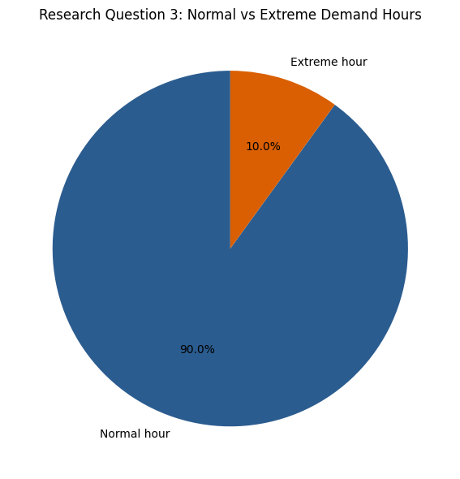
Figure 12: Proportion of normal versus extreme-demand hours across the pooled Mediterranean dataset.

9.6 Country Contribution to Regional Demand
Figure 13 presents a part-to-whole decomposition of total regional demand. Montenegro, Cyprus, Slovenia, Croatia, and Greece are shown individually as the top five contributors by cumulative demand share, with the remaining countries grouped as “Other countries.” This view highlights which grids would dominate a naive regional aggregate and reinforces why per-country modelling, rather than a single pooled regression, is appropriate for this dataset.
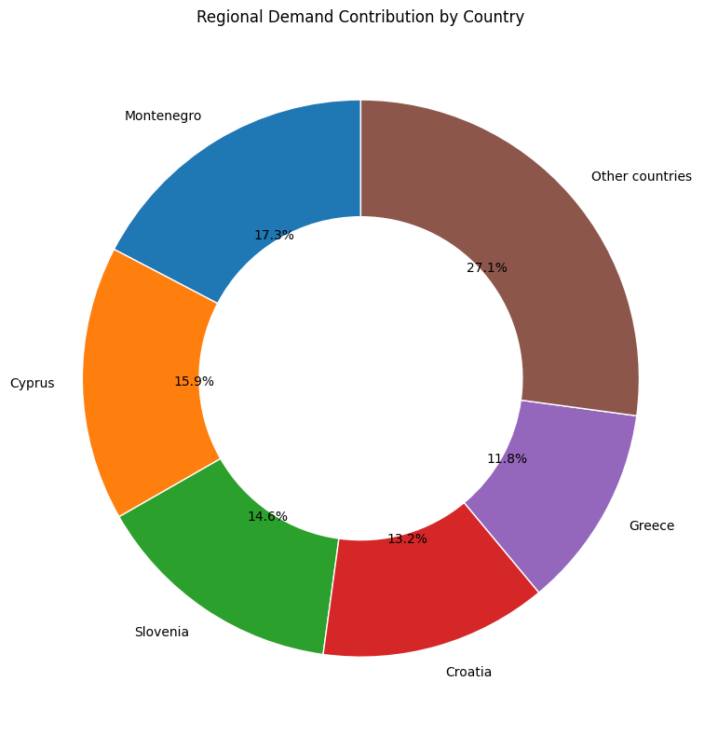
Figure 13: Regional demand contribution by country — part-to-whole share of cumulative Mediterranean demand.

9.7 Ramp Stress Across Countries
Ramp stress measures how quickly demand changes from one hour to the next; a large absolute ramp implies the grid is changing quickly and may require a faster operational response. Figure 14 ranks the eight countries by average absolute hourly ramp. Cyprus and Croatia show the strongest average ramp stress in this dataset, while France shows the lowest, indicating comparatively smoother hour-to-hour transitions for the French series.
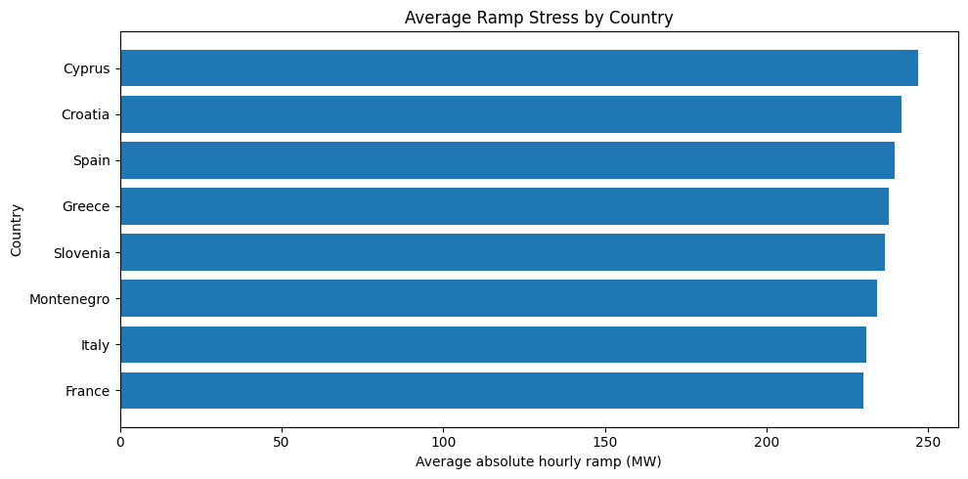
Figure 14: Average absolute hourly ramp stress by Mediterranean country.

9.8 Regional Synchronization of Extreme Hours
An additional regional indicator, the Extreme Synchronization Count, counts how many countries are simultaneously in an extreme-demand state during the same hour: 0 indicates no country is extreme, 1–2 indicates localized stress, 3–4 indicates moderate regional synchronization, and 5 or more indicates strong regional synchronization. This treats extreme demand as a regional phenomenon rather than a single-country event. Figure 15 shows that the overwhelming majority of hours (970 of 1,440 observed hourly slots) have no extreme country at all, while only 45 hours show strong synchronization across five or more countries — evidence that extreme demand is mostly, but not exclusively, a localized phenomenon.
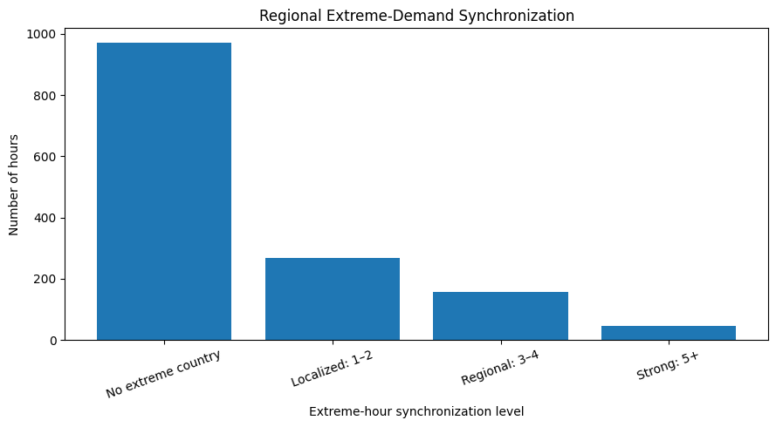
Figure 15: Regional extreme-demand synchronization — number of hours at each synchronization level.

9.9 Next-Hour Extreme-Demand Classification — Feature Engineering
Rather than reusing the original project's Optuna/XGBoost/LSTM pipeline, this extension treats the task as a binary classification problem: can the next hour be classified in advance as an extreme-demand hour? Features are restricted to information available at the current hour, so that the classifier only uses genuinely available context:
- Hour, Day of Week, Month, and a Weekend flag
- Current normalized demand index
- Current ramp stress
- Current extreme-state flag
- Country identifier (stable encoding)
No lag-feature or rolling-window feature is used for this classification experiment, in deliberate contrast to the lag-heavy PJME regression pipeline in Section 6.3. The resulting split allocates 9,203 rows to training and 2,301 rows to testing, with an extreme rate of 9.82% in the test set — consistent with the 10% design rate observed in Section 9.5.

9.10 Model Comparison
Five models are compared on the next-hour extreme-demand classification task: Logistic Regression (simple baseline), Decision Tree (rule-based), Random Forest (bagged trees), Gradient Boosting (sequential boosted trees), and a Hybrid Ensemble described in Section 9.11. Because extreme hours are the minority class, F1-score is used as the primary comparison metric rather than raw accuracy.
Model | Accuracy | Precision | Recall | F1-Score
Random Forest | 0.795 | 0.306 | 0.854 | 0.450
Decision Tree | 0.784 | 0.298 | 0.881 | 0.445
Hybrid Ensemble | 0.724 | 0.253 | 0.929 | 0.398
Logistic Regression | 0.750 | 0.258 | 0.823 | 0.393
Gradient Boosting | 0.902 | 0.500 | 0.009 | 0.017
Table 7: Next-hour extreme-demand classification results, ranked by F1-score.
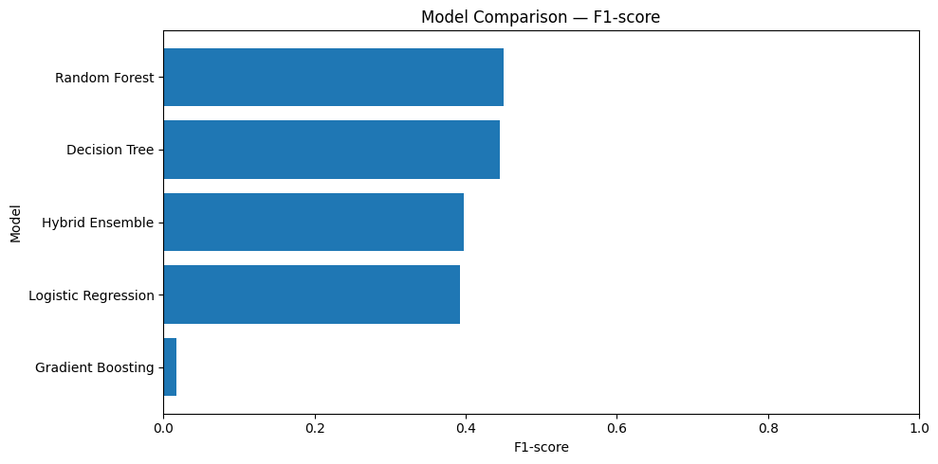
Figure 16: Model comparison by F1-score for next-hour extreme-demand classification.
Random Forest achieves the best overall balance (F1 = 0.450), narrowly ahead of the Decision Tree (F1 = 0.445). Gradient Boosting reaches the highest raw accuracy (0.902) but an almost negligible recall (0.009), meaning it defaults to predicting the majority “normal” class almost exclusively — a textbook illustration of why accuracy alone is a misleading metric for imbalanced classification problems such as this one.

9.11 Hybrid Ensemble Model
The Hybrid Ensemble averages the predicted probabilities of Logistic Regression, Decision Tree, and Random Forest, then applies a probability threshold of 0.35 rather than the default 0.5 so that the combined model does not simply favour the majority class. The hybrid model achieves the highest recall of all five models (0.929), meaning it catches the largest share of true extreme hours, at the cost of a lower precision (0.253) and more false alarms than Random Forest. This trade-off is operationally meaningful: a grid operator that prioritises not missing extreme events may prefer the hybrid model despite its lower F1-score.

9.12 Confusion Matrix and Best Model
Figure 17 shows the confusion matrix for Random Forest, the best model by F1-score. Of 2,301 test hours, 226 are genuinely extreme-demand hours; the model correctly flags 193 of these (recall 0.854) while missing 33. Among the 2,075 genuinely normal hours, 1,637 are correctly classified and 438 are false alarms. The comparatively high false-alarm count relative to true positives reflects a modelling preference for recall over precision, which matches the operational goal of not missing extreme-demand events even at the cost of additional false alerts.
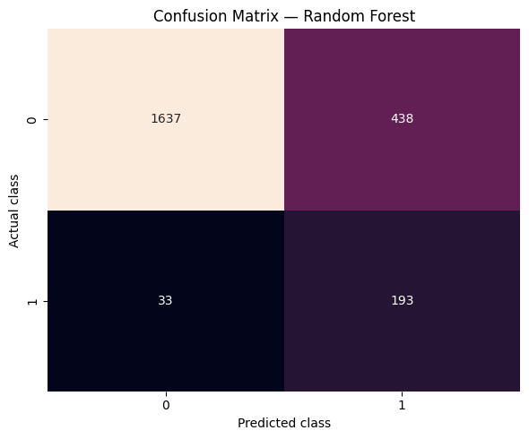
Figure 17: Confusion matrix for the Random Forest model — the best-performing model by F1-score on the next-hour extreme-demand classification task.

9.13 Summary of Findings
- Demand scale differs substantially across Mediterranean countries, from an average of approximately 5,000 MW in France to over 11,000 MW in Montenegro.
- Demand variation is not uniform: countries such as Cyprus and Croatia show stronger ramp stress than France and Italy.
- Extreme demand is a minority event (10% of hours by design), so class-aware metrics such as F1-score and recall are essential rather than optional.
- Extreme hours can be studied as a regional synchronization problem: most extreme hours are localized to one or two countries, but a meaningful minority show strong five-or-more-country synchronization.
- Random Forest and a threshold-adjusted Hybrid Ensemble provide a practical balance between catching extreme events and controlling false alarms, giving a modelling objective distinct from the original PJME raw-load regression task.

10. Conclusion and Future Work

10.1 Conclusion
This project demonstrates that disciplined classical machine learning — combining explicit lag and rolling mean feature engineering with Bayesian hyperparameter optimization and SHAP-based interpretability — outperforms sequence-based deep learning for grid-level hourly electricity load forecasting on the PJME dataset. The Optuna-tuned XGBoost model achieves MAE 269.4 MW, RMSE 370.9 MW, and R² 0.9967 on the chronologically held-out test set, surpassing the 2-layer LSTM across all three metrics. The strict chronological split applied throughout the pipeline resolves the data-leakage issue identified in the literature, ensuring reported metrics are reproducible and deployment-realistic. SHAP analysis confirms that Lag_1, Lag_24, and Hour are the dominant demand predictors, providing transparent, physically interpretable model behaviour.
The supplementary Mediterranean regional study extends these findings beyond a single grid and a single modelling objective. Across eight countries, demand scale and volatility differ substantially, extreme-demand hours form a minority class that requires class-aware evaluation, and extreme-demand hours can synchronize across countries rather than remaining strictly localized. On the resulting next-hour extreme-demand classification task, Random Forest and a threshold-adjusted Hybrid Ensemble provide the most operationally useful balance between recall and precision, reinforcing the broader conclusion that careful feature and evaluation design — not model complexity alone — determines whether a load-forecasting system is trustworthy in deployment.

10.2 Future Work
- Transformer-based architectures: Temporal Fusion Transformer (TFT) and PatchTST for long-horizon multi-step forecasting.
- Probabilistic forecasting: Quantile regression and conformal prediction to output forecast intervals rather than point estimates, enabling uncertainty-aware grid planning.
- Real-time deployment: Dashboard integration with the saved .pkl model for interactive demand forecasting and SHAP visualization.
- Multimodal data fusion: Incorporating live weather feeds and dynamic electricity pricing data to improve forecasting during weather extremes.
- Edge optimization: Model compression and quantization for deployment on smart meter hardware with constrained compute.
- Cross-regional generalisation: Extending the chronological-split and SHAP-explainability methodology from the PJME study to the Mediterranean regional dataset once a longer multi-year history becomes available, and testing whether the synchronization indicator introduced in Section 9.8 improves early warning for regional grid stress.

References
[1] P. Duan et al., “Bayesian Optimization of Gradient Boosted Trees for Short-Term Load Forecasting,” Energies, 2023.
[2] S. Hochreiter et al., “Deep Learning for Sequence-Aware Load Forecasting Using LSTM Networks,” IEEE Access, 2021.
[3] A. Lundberg et al., “Explainable AI for Power System Load Demand Prediction Using SHAP,” Applied Energy, 2022.
[4] O. M. Neda, “Hybrid LSTM-XGBoost Model for Multi-Horizon Short-Term Load Forecasting,” e-Prime, vol. 17, p. 201211, 2026.
[5] S. M. Lundberg and S.-I. Lee, “A Unified Approach to Interpreting Model Predictions,” Advances in Neural Information Processing Systems (NeurIPS), 2017.
[6] T. Akiba et al., “Optuna: A Next-generation Hyperparameter Optimization Framework,” Proc. ACM KDD, 2019.
[7] T. Chen and C. Guestrin, “XGBoost: A Scalable Tree Boosting System,” Proc. ACM KDD, 2016.
[8] S. R. Rallapalli and S. Ghosh, “Forecasting Monthly Peak Demand of Electricity in India,” Energy Policy, vol. 45, pp. 516-520, 2012.
[9] J. Bergstra and Y. Bengio, “Random Search for Hyper-Parameter Optimization,” Journal of Machine Learning Research, vol. 13, pp. 281-305, 2012.
[10] ENTSO-E, “ENTSO-E Transparency Platform — Actual Total Load per Country,” ENTSO-E Power Statistics, 2025.

