Product Listing with Search & Filter
Assignment 6 — Dynamic Product Listing with ListView.builder & setState
Name: Soumitra Deshpande
Roll No: 150096724035
Cohort: Elon Musk
Environment: Flutter 3.x / Dart 3.x
Code: https://github.com/SoumitraDeshpande11/assignments/tree/assignments_6

1. Objective
Build a dynamic product listing app in Flutter. Products must be described by a data model class, rendered with an efficient ListView.builder, and the user must be able to search by name and filter by category, with every change applied through setState.

2. Requirements Checklist
Requirement | Where it lives
Data model class | Product — an immutable class with name, category, price, rating, and emoji fields
ListView.builder | Builds one card per product in the filtered list, lazily, from itemCount: filtered.length
Search | TextField whose onChanged stores the query in state via setState
Filter | A horizontal row of ChoiceChips (All, Electronics, Clothing, Grocery, Books) selected via setState
setState | _onSearchChanged, _onCategorySelected, and _clearSearch all wrap their changes in setState

3. How the Data Model Works
Each product is a Product object:
class Product {
const Product({required this.name, required this.category,
required this.price, required this.rating, required this.emoji});
final String name;
final String category;
final double price;
final double rating;
final String emoji;
}
The catalog is a hard-coded list of 12 Product instances stored in the State class. Because the fields are final, products never change — only which products are shown changes.

4. How Search & Filter Work
Two pieces of state drive the UI:
- _searchQuery — the current text in the search box.
- _selectedCategory — the currently selected chip ('All' by default).
Both are combined in a getter that recomputes the visible list on every rebuild:
List<Product> get _filteredProducts {
final query = _searchQuery.toLowerCase();
return _products.where((p) {
final matchesSearch =
query.isEmpty || p.name.toLowerCase().contains(query);
final matchesCategory =
_selectedCategory == 'All' || p.category == _selectedCategory;
return matchesSearch && matchesCategory;
}).toList();
}
Typing in the search box or tapping a chip calls setState, Flutter rebuilds the widget tree, the getter runs again, and ListView.builder shows only the matching products. A live counter above the list shows "X of 12 products", and a friendly message appears when nothing matches.

5. Widget Map
MaterialApp
└── Scaffold
├── AppBar ('Product Catalog')
└── Column
├── TextField ← search box (with clear button)
├── ListView.separated ← horizontal row of ChoiceChips
├── Text ← "X of 12 products" counter
└── Expanded
└── ListView.builder
└── Card per product
└── ListTile[ emoji avatar, name, rating · category, price ]

6. Source Code
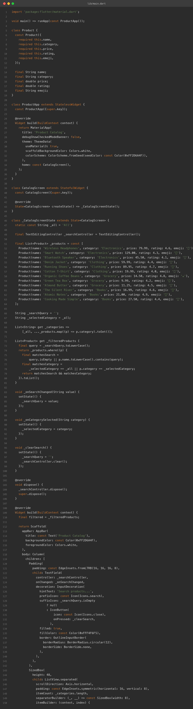

7. App Screenshots
The app was built for the web (flutter build web) and captured in Chrome at two window sizes.
Phone width (500px):
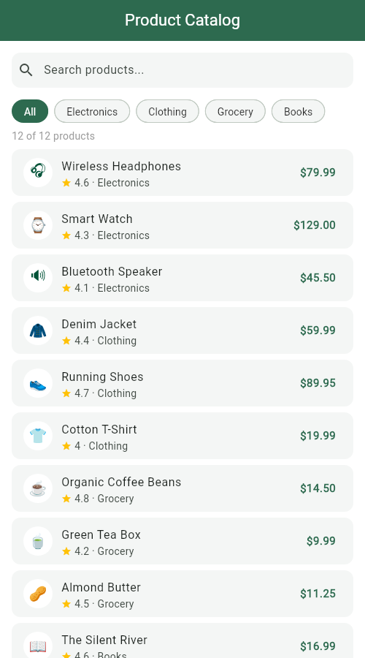
Desktop width (1280px):
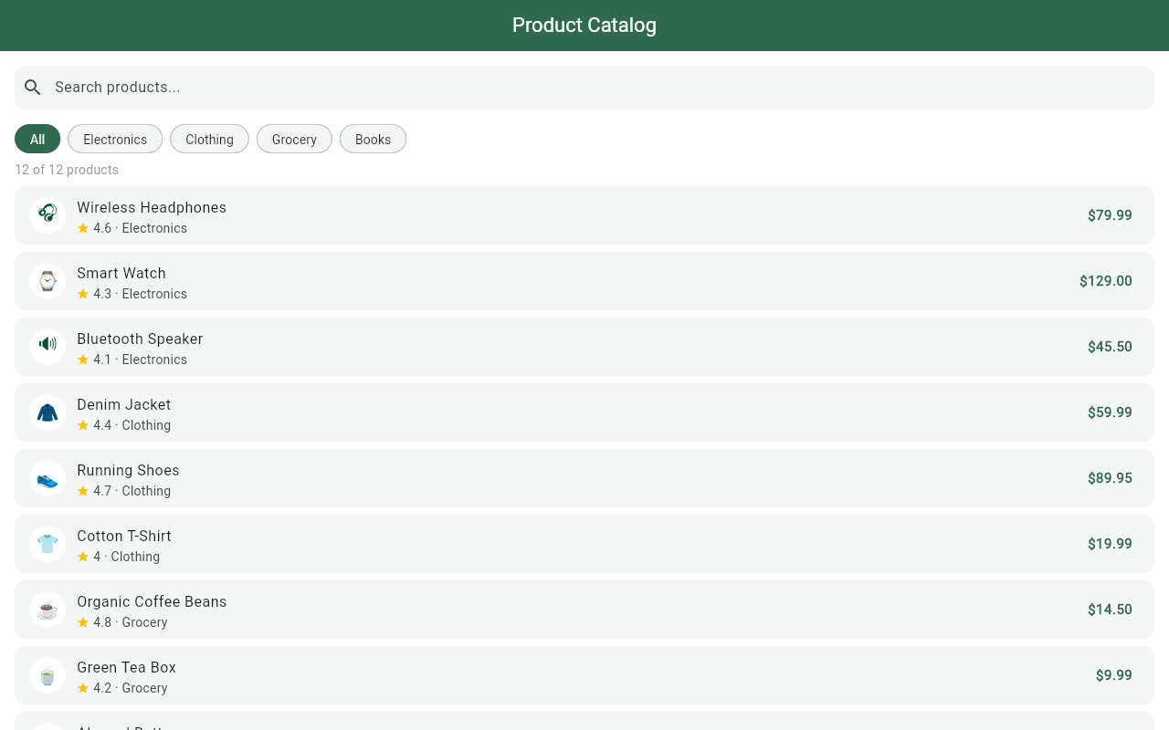

8. Terminal
Real build-and-run session: flutter pub get, flutter analyze (no issues), flutter build web, then flutter run -d web-server to serve the app locally.
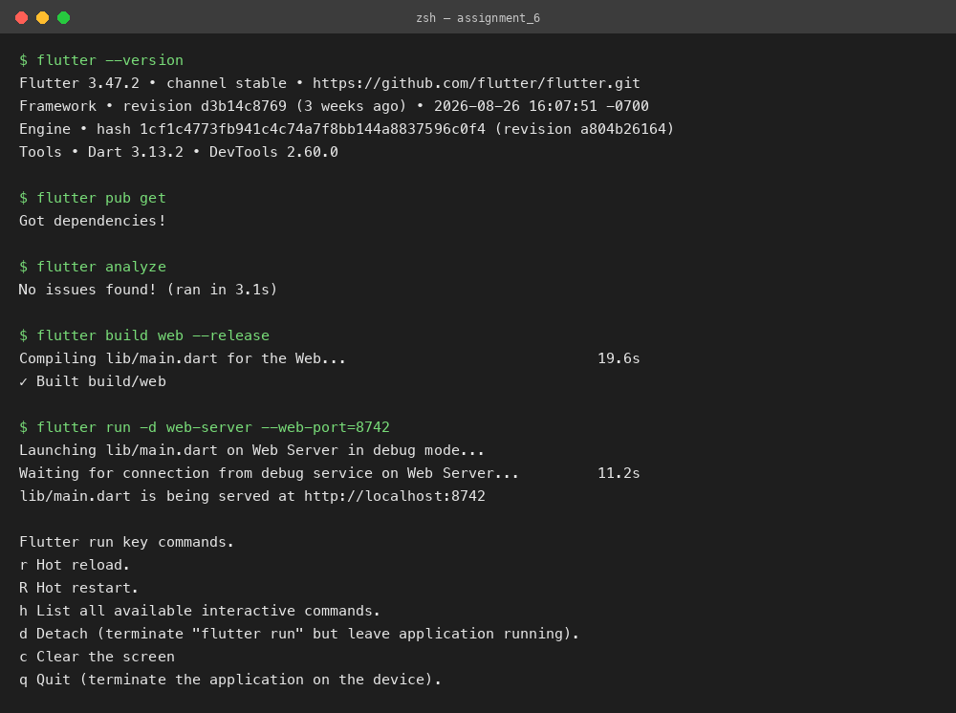

9. Run Instructions
flutter pub get
flutter run # pick a device, or use flutter run -d chrome
Type in the search box to narrow products by name, tap a category chip to filter, and tap the × in the search box to clear. Both filters combine — searching "tea" with the Grocery chip selected shows only grocery items matching "tea".

10. Possible Extensions
- Sort the list by price or rating with a dropdown.
- Load products from a JSON file or a real REST API instead of a hard-coded list.
- Add a detail page that opens when a product card is tapped.
Built by Soumitra Deshpande · Roll No. 150096724035 · Cohort: Elon Musk

