Responsive Store Dashboard
Assignment 3 — Responsive Flutter Layouts
Name: Soumitra Deshpande
Roll No: 150096724035
Cohort: Elon Musk
Environment: Flutter 3.x / Dart 3.x

1. Objective
Build a multi-section store dashboard that adapts to the screen size. The required widgets are ListView, GridView, MediaQuery, and Flexible/Expanded. The visual design is kept deliberately minimal — white background, one green accent, flat rounded cards.

2. Requirements Checklist
Requirement | Where it lives
MediaQuery | DashboardScreen.build reads MediaQuery.of(context).size.width
GridView | statsGrid — GridView.builder with 8 stat cards
ListView | activityList — ListView.separated with 7 activity rows
Expanded | Header Row of summary chips; grid/list slots in narrow layout
Flexible | Wide layout splits space 2:1 between grid and activity panel
Responsive behavior | 2/3/4 grid columns; side-by-side vs stacked sections

3. How the Layout Adapts
Breakpoints are derived from the screen width:
Width | Columns | Section arrangement
< 600 (phone) | 2 | Grid stacked above the activity list
600–899 (tablet) | 3 | Grid stacked above the activity list
>= 900 (desktop) | 4 | Grid and activity panel side by side (2:1 via Flexible)
The header row always uses three Expanded summary chips, so the chips stretch or shrink to share the full width evenly on any screen.

4. Widget Map
Scaffold
└── Column
├── Row ← 3 × Expanded(SummaryChip)
├── SectionTitle('Overview')
└── Expanded ← fills all remaining space
├── width >= 900: Row[ Flexible(2, GridView), Flexible(1, ActivityPanel(ListView)) ]
└── width < 900: Column[ Expanded(3, GridView), Expanded(2, ListView) ]
- StatCard — flat grey card with an icon, a large value, and a small label.
- SummaryChip — green header chip (today / week / month totals).
- ActivityPanel — wraps the ListView in a titled card on wide screens.

5. Preview
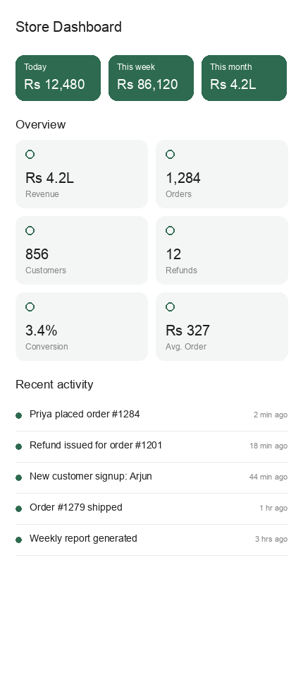
The preview shows the narrow layout: summary chips on top (via Expanded), a 2-column GridView of stat cards, and the ListView activity feed below.

6. Run Instructions
flutter pub get
flutter run # pick a device, or use flutter run -d chrome
Resize the window (or rotate the device) to watch the column count and section arrangement change.

7. Possible Extensions
- Replace the breakpoint math with LayoutBuilder constraints.
- Add pull-to-refresh on the activity ListView.
- Animate the layout switch with AnimatedSwitcher.
Built by Soumitra Deshpande · Roll No. 150096724035 · Cohort: Elon Musk

