3-Screen App with Named Routes & Form Validation
Assignment 7 — Named Routes (Home, Form, Detail) + Registration Form Validation
Name: Soumitra Deshpande
Roll No: 150096724035
Cohort: Elon Musk
Environment: Flutter 3.x / Dart 3.x
Code: https://github.com/SoumitraDeshpande11/assignments/tree/assignments_7

1. Objective
Build a Flutter app with three screens — Home, Form, and Detail — connected with named routes. The Form screen is a registration form with real validation: required fields, an email format check, and a minimum-length password rule. On successful validation, the user's data is passed to the Detail screen as route arguments.

2. Requirements Checklist
Requirement | Where it lives
3 screens | HomeScreen, RegisterScreen, DetailScreen
Named routes | MaterialApp(routes: {'/', '/register', '/detail'}) with initialRoute: '/'
Navigation | Navigator.pushNamed(context, '/register') etc.
Data model class | User — immutable class with name and email
Passing data between screens | Navigator.pushNamed(..., arguments: User(...)) read back with ModalRoute.of(context)!.settings.arguments
Required fields | _validateName, _validateEmail, _validatePassword all reject empty input
Email validation | Regex ^[\w.+-]+@[\w-]+\.[\w.]+$ checked in _validateEmail
Password validation | Minimum 8 characters, obscured text with a show/hide toggle

3. How Named Routes Work
Instead of building each screen's widget at the call site, the app registers a route table in MaterialApp:
MaterialApp(
initialRoute: '/',
routes: {
'/': (_) => const HomeScreen(),
'/register': (_) => const RegisterScreen(),
'/detail': (_) => const DetailScreen(),
},
)
Any screen can then navigate by name: Navigator.pushNamed(context, '/register'). On the web this also maps each screen to a URL (/#/register), so screens are deep-linkable.
To send data forward, pushNamed accepts arguments. The form passes a User object, and the Detail screen pulls it out of the route settings:
final user = ModalRoute.of(context)!.settings.arguments as User? ?? _sample;
If the screen is opened without arguments (deep link or the "View Sample Detail" button), it falls back to a sample user instead of crashing.

4. How Form Validation Works
The form is a Form widget holding a GlobalKey<FormState>. Each input is a TextFormField with a validator function that returns an error string (shown under the field) or null (valid):
- Name — required (non-empty after trimming).
- Email — required, and must match an email regex (name@domain.tld).
- Password — required, minimum 8 characters, with an eye-icon toggle to show/hide.
Pressing Register calls _formKey.currentState!.validate(), which runs every validator. Only if all pass does the app navigate to /detail with the entered data. The password is never sent to the Detail screen — only name and email.

5. Widget Map
MaterialApp (routes table)
├── '/' → HomeScreen ← welcome + 2 navigation buttons
├── '/register' → RegisterScreen ← Form[ name, email, password ] + Register button
└── '/detail' → DetailScreen ← profile card (avatar initial, name, email)

6. Source Code
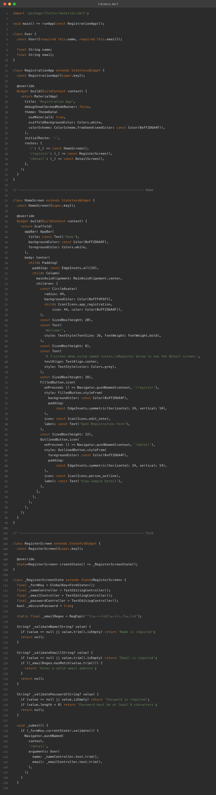

7. App Screenshots
The app was built for the web (flutter build web) and captured in Chrome. Each screen was captured at phone width (500px) via its route URL; the Home screen is also shown at desktop width (1280px).
Home (phone width):
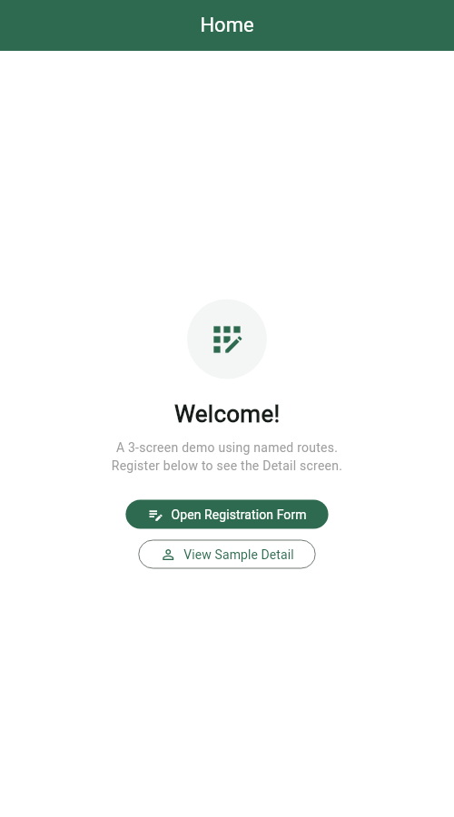
Registration form (phone width):
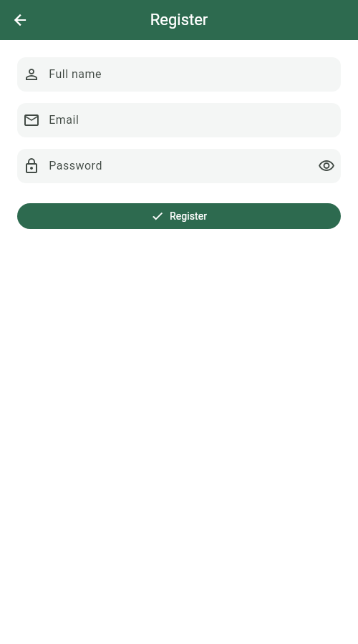
Detail screen (phone width):
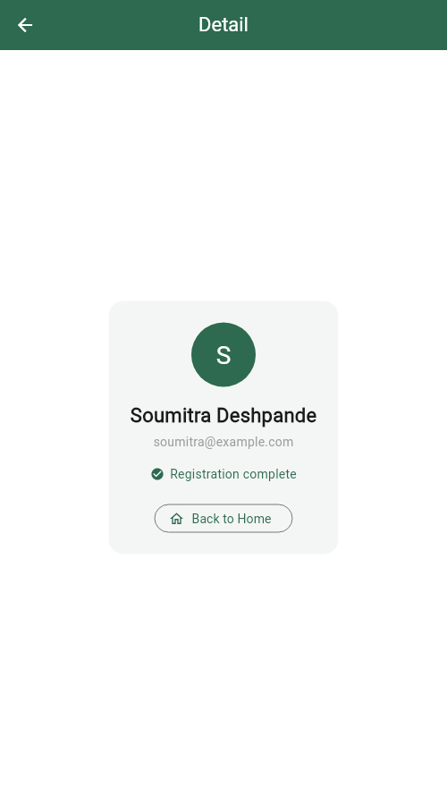
Home (desktop width):
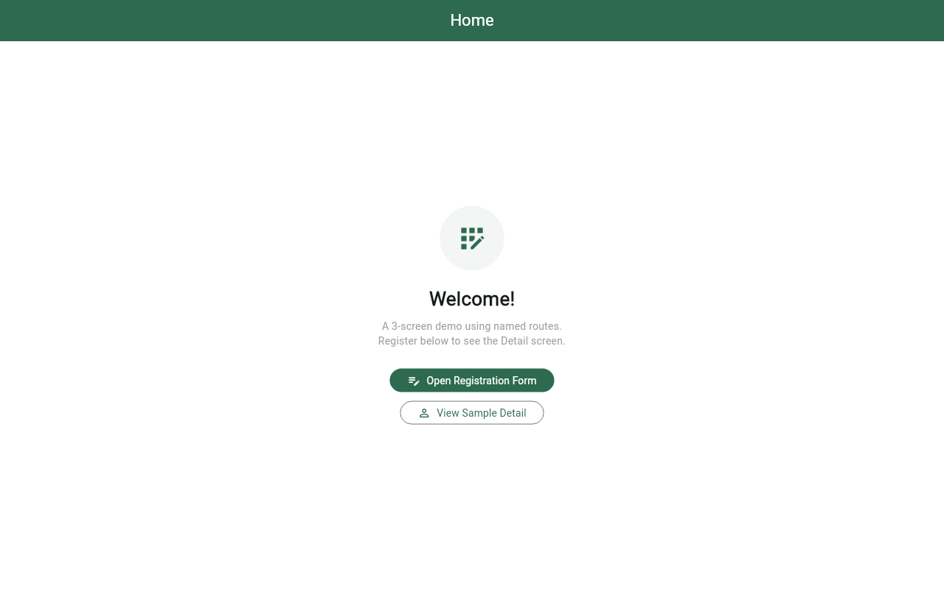

8. Terminal
Real build-and-run session: flutter pub get, flutter analyze (no issues), flutter build web, then flutter run -d web-server to serve the app locally.
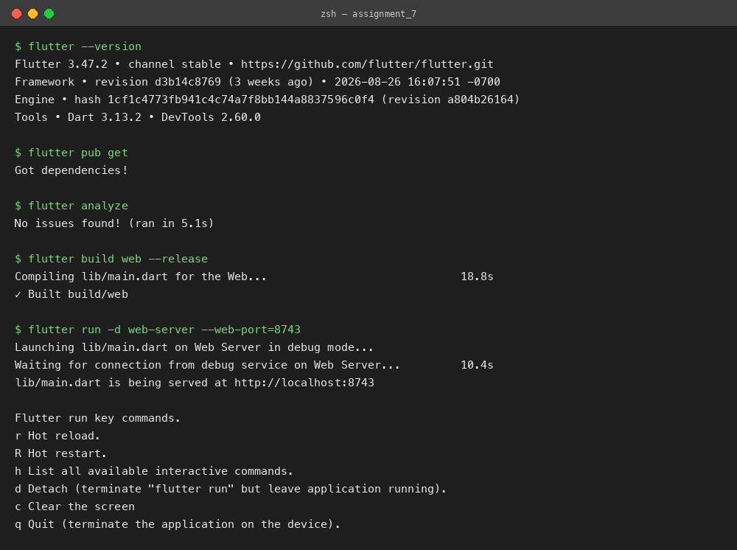

9. Run Instructions
flutter pub get
flutter run # pick a device, or use flutter run -d chrome
From Home, tap Open Registration Form, fill in name, email, and password, and press Register. Try submitting empty fields or a short password to see the inline validation errors. On success, the Detail screen shows the registered user; Back to Home pops the whole navigation stack.

10. Possible Extensions
- Add a confirm-password field that must match the password.
- Replace the routes table with onGenerateRoute for typed route arguments.
- Show a loading spinner and a success SnackBar before navigating.
Built by Soumitra Deshpande · Roll No. 150096724035 · Cohort: Elon Musk

