EXOPLANET CATALOG
FETCHER
Async Dart & Null Safety
Name: Soumitra Deshpande
Roll No: 150096724035
Environment: Dart SDK 3.x
August 2026

Assignment 2 — Async Dart & Null Safety
Name: Soumitra Deshpande
Roll No: 150096724035
Environment: Dart SDK 3.x

1. Mission Briefing
This program queries a mock exoplanet catalog API and displays whatever comes back — or explains, politely, why nothing came back.
The API is simulated in-process. Some records are complete, some have missing fields, one response is a `null` payload, and one request fails outright. The program has to survive all four outcomes without crashing, which is the entire point of the assignment: null safety, `Future`, `async`/`await`, and error handling.

2. Launch Checklist
Requirement | Evidence
Null safety | `Exoplanet.discoveryYear` and `massEarths` are nullable; display uses null-aware fallbacks
`Future` | `MockApiClient.fetchRawRecord()` and `ExoplanetService.fetchExoplanet()` both return `Future`
`async`/`await` | `main()` is `async`; every API call is awaited inside a loop
Mock API data | `MockApiClient` returns JSON-shaped maps after a simulated network delay
Null payload handling | `kepler-22b` returns `null`; the service converts it to `null`, the caller prints a message
Error handling | `hd-40307g` throws `ApiException`; caught with `on ApiException` in `main()`

3. Payload Specification
File | Role
`lib/exoplanet.dart` | `Exoplanet` model with nullable fields and a `fromJson` factory
`lib/mock_api.dart` | `MockApiClient` (fake HTTP) and `ApiException`
`lib/exoplanet_service.dart` | `ExoplanetService` — turns raw maps into typed models, including a parallel `fetchMany()`
`lib/main.dart` | Async driver that walks four scenarios
The pipeline is one-way:
main.dart
→ ExoplanetService.fetchExoplanet(id)
→ MockApiClient.fetchRawRecord(id) [300ms delay, then map / null / exception]
→ Exoplanet.fromJson(raw) [only when raw is non-null]

4. Anomaly Report
Four records are requested. Four different outcomes are handled:
Request | Outcome | Handling
`proxima-b` | Complete record | Parsed and displayed
`trappist-1e` | Missing `discoveryYear` and `massEarths` | Nullable fields stay null; display falls back to `unknown` / `not measured`
`kepler-22b` | `null` payload | Service returns `null`; caller prints "nothing to display"
`hd-40307g` | HTTP 504 exception | Caught by `on ApiException`; status code and message are printed
Two safety patterns do the heavy lifting:
- Null-aware model: `discoveryYear != null ? '$discoveryYear' : 'unknown'` — no nullable value ever reaches `print` unguarded.
- Typed catch: `on ApiException catch (e)` handles known API failures, while a general `catch (e)` catches anything unexpected.

5. Mission Log
Actual run output:
=== FETCHING EXOPLANET RECORDS ===
[proxima-b] Proxima Centauri b (orbits Proxima Centauri)
Discovery year: 2016
Mass: 1.27 Earth masses
Orbital period: 11.2 days
[trappist-1e] TRAPPIST-1e (orbits TRAPPIST-1)
Discovery year: unknown
Mass: not measured
Orbital period: 6.1 days
[kepler-22b] API returned a null payload — nothing to display.
[hd-40307g] API error: gateway timeout (HTTP 504)
=== PARALLEL BATCH FETCH ===
Fetched 2 valid records:
• Proxima Centauri b — discovery: 2016
• TRAPPIST-1e — discovery: unknown
The batch fetch at the end uses `Future.wait` to run three requests concurrently, then drops the null result with `whereType<Exoplanet>()`.

6. Telemetry
Terminal execution screenshot
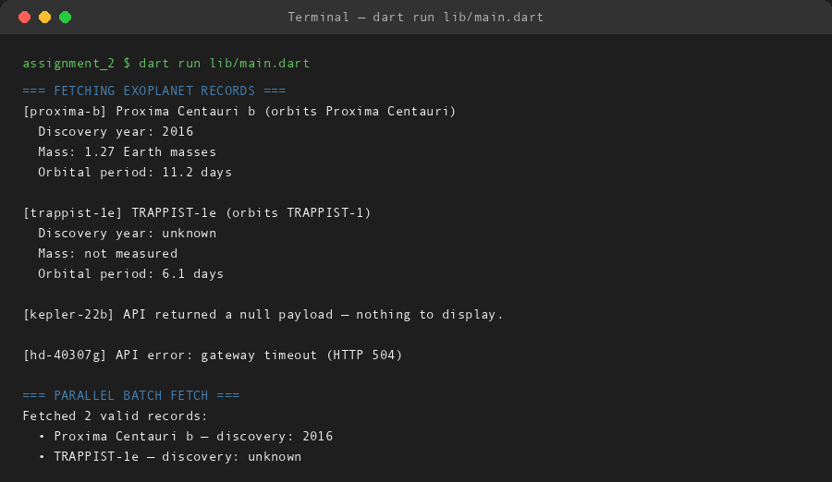

7. Decommission Notes
If this were a real service, the next changes would be:
- Swap `MockApiClient` for `package:http` against a live endpoint.
- Retry failed requests with exponential backoff.
- Cache successful records so repeated lookups skip the network.
- Add a timeout wrapper around `fetchRawRecord()` using `Future.timeout()`.
Built by Soumitra Deshpande · Roll No. 150096724035

