API Data Fetcher with Local Cache
Assignment 8 — REST API + FutureBuilder + SharedPreferences Cache
Name: Soumitra Deshpande
Roll No: 150096724035
Cohort: Elon Musk
Environment: Flutter 3.x / Dart 3.x
Code: https://github.com/SoumitraDeshpande11/assignments/tree/assignments_8

1. Objective
Fetch data from a public REST API (JSONPlaceholder), display it with FutureBuilder, and cache the last successful result using SharedPreferences so the app still shows content when the network is unavailable.

2. Requirements Checklist
Requirement | Where it lives
Public REST API | https://jsonplaceholder.typicode.com/posts?_limit=12 via the http package
FutureBuilder | PostsScreen builds loading / error / data states from a Future<FetchResult>
SharedPreferences cache | PostsRepository._saveCache / _readCache store posts + timestamp as JSON
Data model class | Post with fromJson / toJson for API parsing and cache serialization
Refresh | App-bar refresh icon and a Retry button both re-run the future via setState

3. How Fetching Works
The Post class models one JSONPlaceholder post (id, title, body) with fromJson/toJson converters. PostsRepository.loadPosts() does the work:
1. http.get the JSONPlaceholder /posts endpoint.
2. On HTTP 200, decode the JSON array into Post objects, save them to the cache, and return them marked as live data.
3. On any failure — non-200 status, timeout, no network — it falls back to the cache: if a previous result was saved, it returns those posts marked fromCache with the original fetch time.
4. Only if there is no cache at all does the error reach the UI.

4. How the Cache Works
SharedPreferences stores simple key-value data that survives app restarts (on the web it uses localStorage):
await prefs.setString('posts_cache', jsonEncode(posts.map((p) => p.toJson()).toList()));
await prefs.setString('posts_cache_time', DateTime.now().toIso8601String());
Reading reverses it: decode the JSON string back into Post objects and parse the saved timestamp. A banner at the top tells the user what they're looking at — "Live data · fetched at HH:MM:SS" in green, or "Offline — cached data from HH:MM:SS" in amber.

5. How FutureBuilder Works
FutureBuilder takes the future and rebuilds as it moves through states:
- waiting → spinner + "Fetching posts..."
- error → offline icon, the error message, and a Retry button
- hasData → the source banner plus a ListView.builder of post cards
The future is created once in initState; pressing Refresh or Retry calls setState with a brand-new future, which re-runs the fetch.

6. Widget Map
MaterialApp
└── Scaffold
├── AppBar ('JSONPlaceholder Posts' + refresh IconButton)
└── FutureBuilder<FetchResult>
├── waiting → CircularProgressIndicator
├── error → offline icon + message + Retry button
└── data → Column
├── Container ← live/cached banner with timestamp
└── Expanded
└── ListView.builder
└── Card per post (id avatar, title, body preview)

7. Source Code
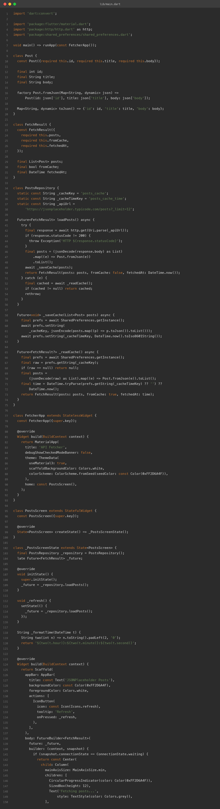

8. App Screenshots
The app was built for the web (flutter build web) and captured in Chrome at two window sizes. Both show a live fetch from JSONPlaceholder — the green "Live data · fetched at …" banner is visible above the post list.
Phone width (500px):
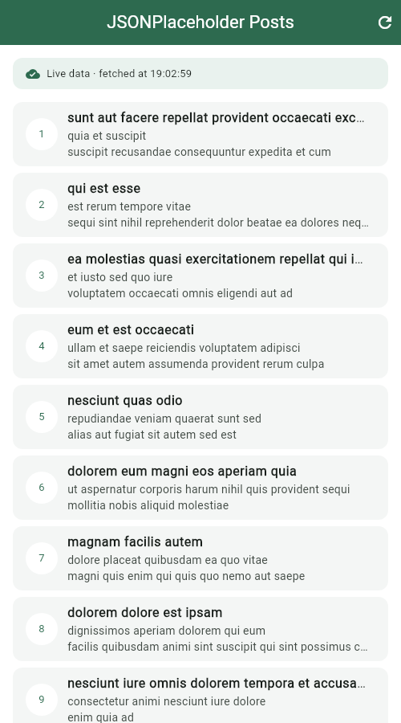
Desktop width (1280px):
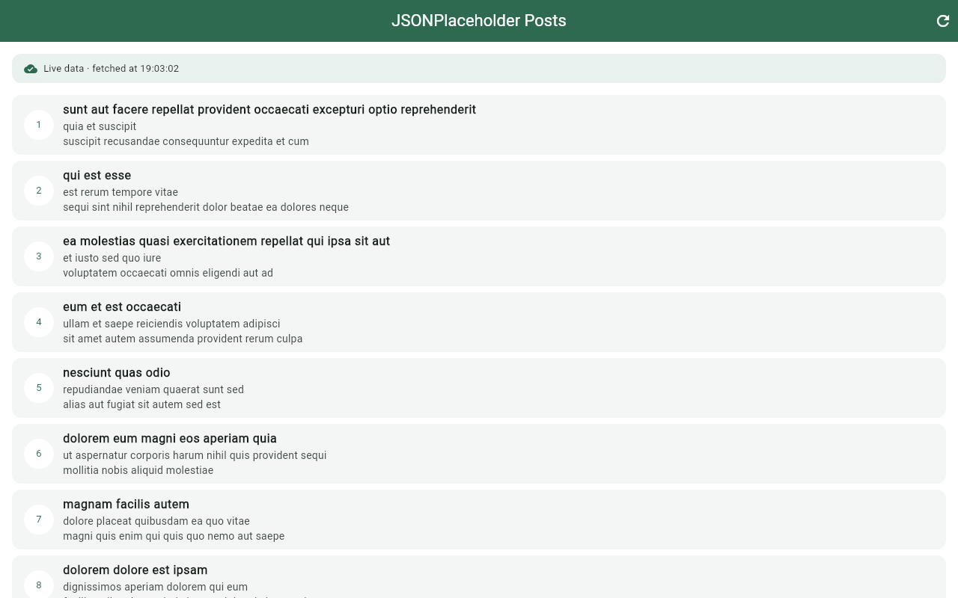

9. Terminal
Real build-and-run session: flutter pub get, flutter analyze (no issues), flutter build web, then flutter run -d web-server to serve the app locally.
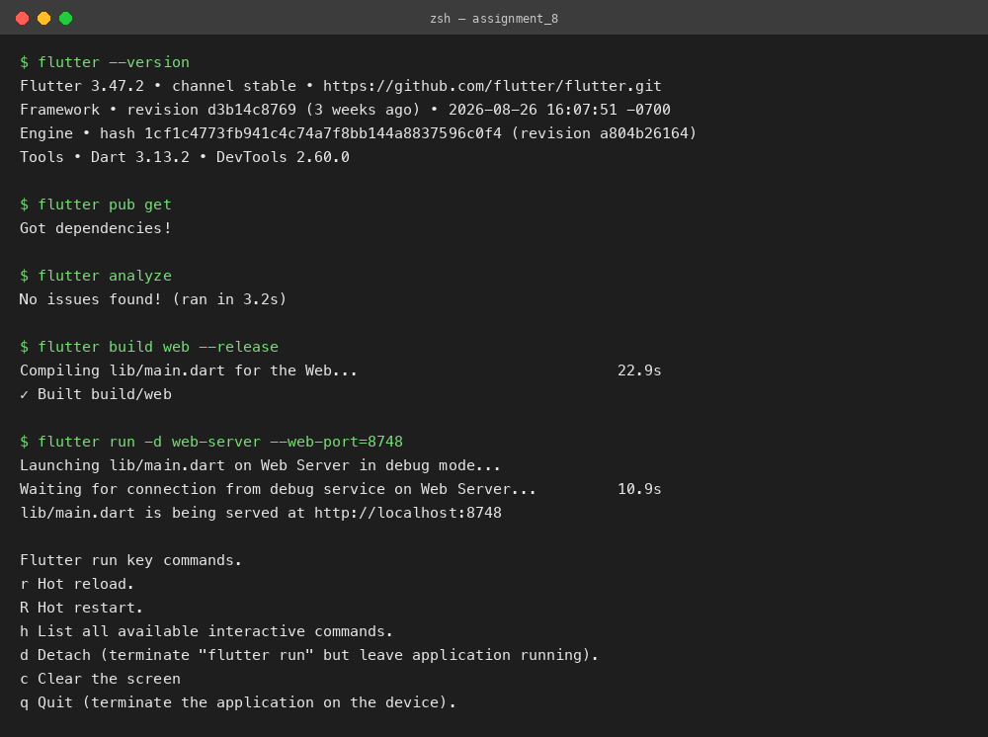

10. Run Instructions
flutter pub get
flutter run # pick a device, or use flutter run -d chrome
The app fetches 12 posts on launch. Tap the refresh icon to fetch again. To see the cache in action, load the app once, go offline (or block the network), and relaunch — the posts reappear from the cache with the amber offline banner.

11. Possible Extensions
- Add a "stale after N minutes" rule so old cache entries trigger a background refresh.
- Cache images too, using cached_network_image.
- Paginate with /posts?_page=N and cache each page.
Built by Soumitra Deshpande · Roll No. 150096724035 · Cohort: Elon Musk

