Profile Card UI
Assignment 3 (Brief) — Profile Card with Column, Row, Container, CircleAvatar & Custom Theme Colors
Name: Soumitra Deshpande
Roll No: 150096724035
Cohort: Elon Musk
Environment: Flutter 3.x / Dart 3.x
Code: https://github.com/SoumitraDeshpande11/assignments/tree/assignments_4

1. Objective
Build a Flutter profile card screen using the core layout widgets — Column, Row, Container, CircleAvatar, Text, and Icon — styled with custom theme colors.

2. Requirements Checklist
Requirement | Where it lives
Column | Main card layout — avatar, name, stats, contacts stacked vertically
Row | Location line, the three stat boxes, contact rows, and the action buttons
Container | The card itself, each stat box, and the icon chips — all with custom padding, color, and rounded corners
CircleAvatar | Profile picture placeholder with initials "SD"
Text | Name, role, stats, and contact details in varying sizes/weights
Icon | Location, email, phone, website, and button icons
Custom theme colors | kPrimary, kAccent, kSurface constants feeding ColorScheme.fromSeed and the card styling

3. How the Layout Works
The screen is a single centered card built from nested layout widgets:
1. A Container with a light surface color and 20px rounded corners forms the card.
2. Inside it, one Column stacks everything top to bottom.
3. Rows handle the horizontal pieces: three equal stat boxes (Expanded inside a Row), contact lines (icon chip + text), and the Follow/Message buttons.
4. Small reusable widgets — _StatBox and _ContactRow — keep the build method short and consistent.
Custom colors are defined once as constants (kPrimary green, kAccent light green, kSurface off-white) and reused everywhere, so the whole card recolors by changing three lines.

4. Widget Map
MaterialApp (custom green theme)
└── Scaffold
├── AppBar ('Profile')
└── Center
└── Container ← the card (rounded, kSurface)
└── Column
├── CircleAvatar ← "SD" initials
├── Text ← name / role / location (Row with Icon)
├── Row ← _StatBox × 3 (Projects, Followers, Following)
├── Divider
├── _ContactRow ← email / phone / GitHub (Icon in Container + Text)
└── Row ← Follow (FilledButton) + Message (OutlinedButton)

5. Source Code
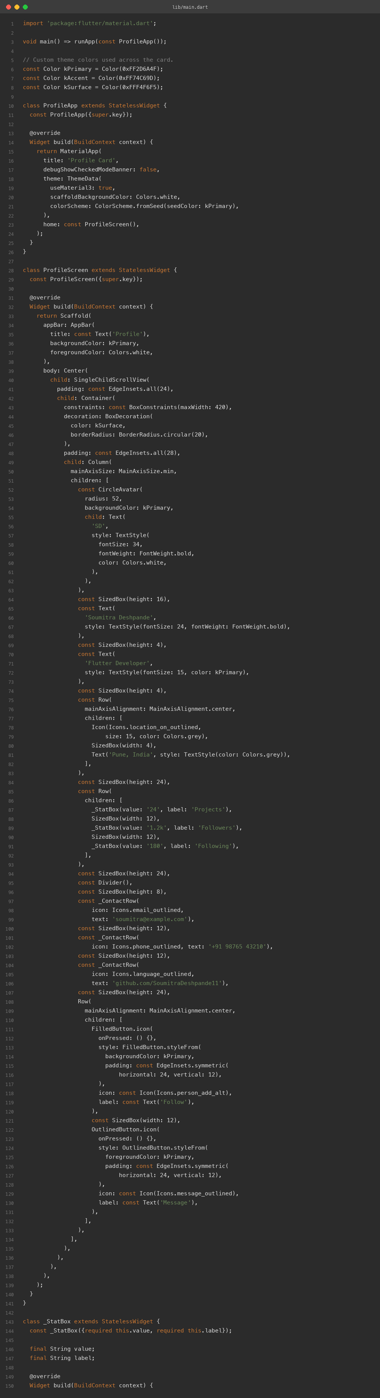

6. App Screenshots
The app was built for the web (flutter build web) and captured in Chrome at two window sizes.
Phone width (500px):
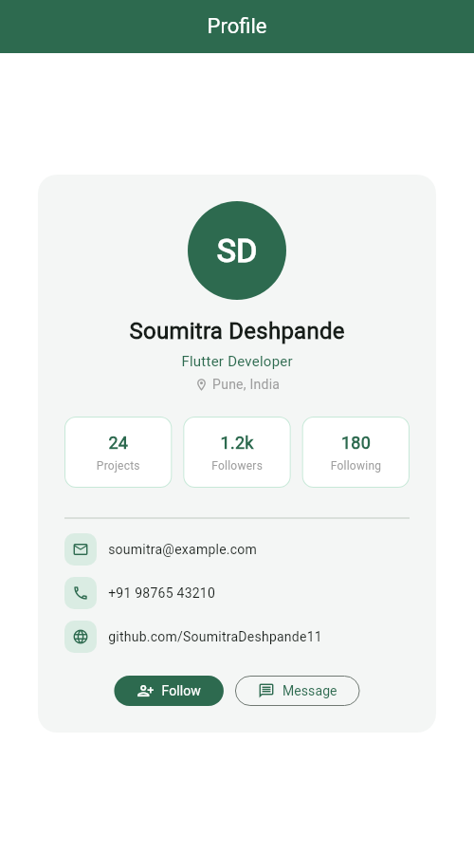
Desktop width (1280px):
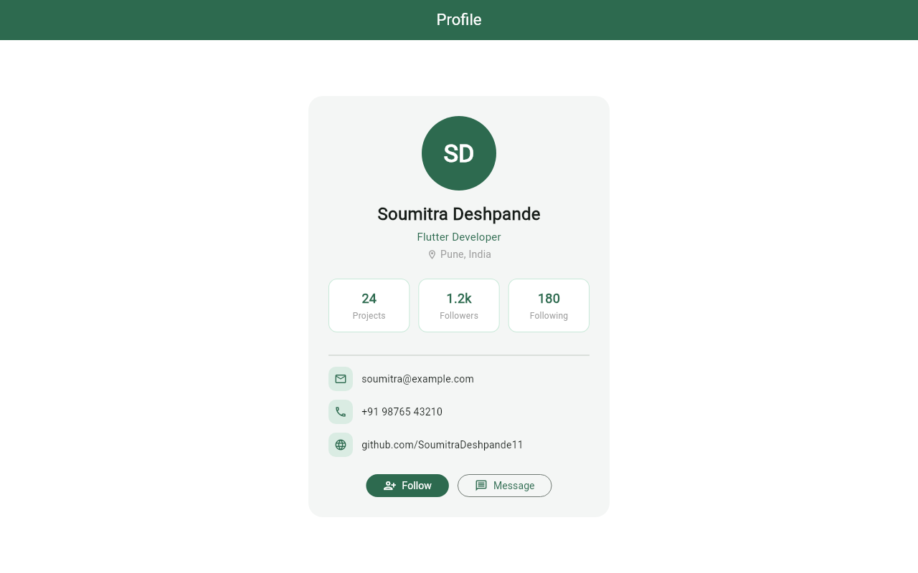

7. Terminal
Real build-and-run session: flutter pub get, flutter analyze (no issues), flutter build web, then flutter run -d web-server to serve the app locally.
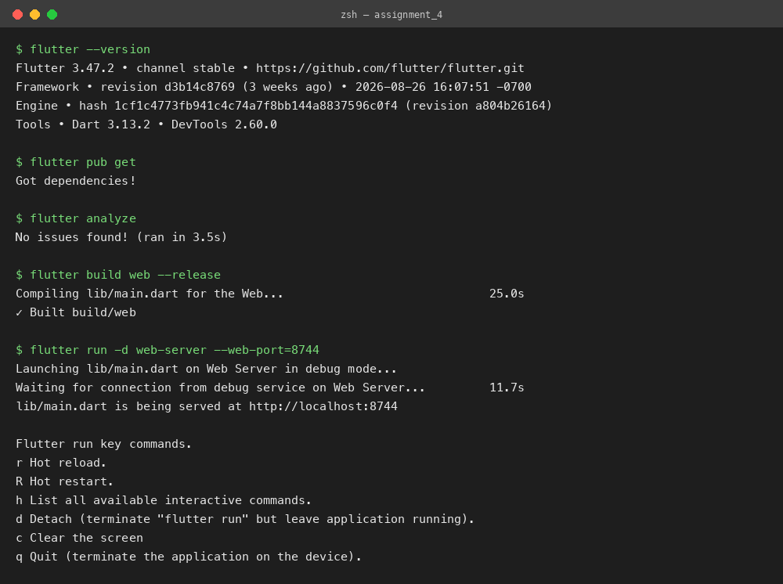

8. Run Instructions
flutter pub get
flutter run # pick a device, or use flutter run -d chrome

9. Possible Extensions
- Load the avatar from a network image with CircleAvatar(backgroundImage: ...).
- Make Follow/Message functional with state (setState toggling "Following").
- Animate the card entrance with a fade/slide transition.
Built by Soumitra Deshpande · Roll No. 150096724035 · Cohort: Elon Musk

