COMMUNITY BOARD GAME
LENDING LIBRARY
Dart Console Application
Name: Soumitra Deshpande
Roll No: 150096724035
Environment: Dart SDK 3.x
August 2026

Assignment 1 — Dart Console Application
Name: Soumitra Deshpande
Roll No: 150096724035
Environment: Dart SDK 3.x

1. The Pitch
Most first-year console apps model a book library. This one models something far more interesting: a community board game lending library. Instead of tracking paperbacks and e-books, it tracks tabletop games — board games, card games, and RPG manuals — and helps members find the right game for the right group.
The app is built in Dart and demonstrates variables, control flow, loops, functions, and object-oriented inheritance without copying the usual physical/digital media split.

2. A Shift at the Library
Here is what happens when the program runs:
1. The librarian opens the catalog. Four games are listed: two board games, one card game, and one RPG manual.
2. Soumitra Deshpande borrows *Wingspan*. Alex Chen borrows *Love Letter*.
3. A group of three friends walks in. The librarian runs a recommendation check and suggests *Catan* because it supports exactly three players.
4. Soumitra returns *Wingspan*.
5. The system prints each member's current borrow record.
6. The late-fee calculator shows what happens if games come back overdue.
This single workflow exercises every required Dart concept.

3. What's Under the Hood
The system is built around three ideas:
- A shared base type. Every item in the catalog is a `Game`. The exact kind of game is handled by subclasses.
- A member registry. Members are stored in a `Map<String, Member>` for fast lookup by ID.
- A librarian. `GameLibrary` holds the catalog, registers members, handles checkout/return, and recommends games.
classDiagram
direction TB
class Game {
<<abstract>>
+String id
+String title
+String publisher
+int releaseYear
+String genre
+bool isAvailable
+describe()* void
}
class BoardGame {
+int playerCountMin
+int playerCountMax
+int playTimeMinutes
+double complexityRating
}
class CardGame {
+int deckSize
+int avgPlayTimeMinutes
}
class RPGManual {
+String edition
+int pageCount
}
class Member {
+String memberId
+String name
+List~Game~ borrowedGames
}
class GameLibrary {
+List~Game~ catalog
+Map~String,Member~ members
+borrowGame() bool
+returnGame() bool
+recommendForPlayers() void
}
Game <|-- BoardGame
Game <|-- CardGame
Game <|-- RPGManual
GameLibrary --> Game
GameLibrary --> Member

4. Dart Concepts in Action
Requirement | Where It Lives
Variables (`String`, `int`, `double`, `bool`) | `Game` fields, `BoardGame.playerCountMin`, `RPGManual.pageCount`
Collections (`List`, `Map`) | `GameLibrary.catalog`, `Member.borrowedGames`, `GameLibrary.members`
Named parameters & defaults | `calculateLateFee({required int overdueDays, double dailyRate = 1.5})`
Typed return values | `borrowGame()` returns `bool`, `findGameById()` returns `Game?`
`for` loop | Indexed catalog listing in `GameLibrary.listCatalog()`
`while` loop | Player-count recommendation search in `recommendForPlayers()`
`for-in` loop | Iterating member borrows in `Member.showBorrowedGames()`
Abstract class | `Game` with abstract `describe()`
Inheritance | `BoardGame`, `CardGame`, `RPGManual` extend `Game`
Polymorphism | Each subclass `@override` of `describe()`
Encapsulation | Borrow/return logic controlled by `GameLibrary`

5. File Guide
File | Responsibility
`lib/game.dart` | Abstract `Game` base class
`lib/board_game.dart` | Board-game subclass with player counts and complexity
`lib/card_game.dart` | Card-game subclass with deck size
`lib/rpg_manual.dart` | RPG manual subclass with edition and page count
`lib/member.dart` | Member record and active borrow list
`lib/game_library.dart` | Central controller for catalog and transactions
`lib/late_fee_calculator.dart` | Pure function for overdue fees
`lib/main.dart` | Demo script that runs the workflow

6. Design Notes
Why inheritance? Board games, card games, and RPG manuals share common fields — title, publisher, year, genre, availability — but each has unique data. An abstract `Game` class lets the rest of the system treat every item uniformly while subclasses store their own details.
Why a `while` loop for recommendations? The assignment required multiple loop types. The recommendation search is a natural fit for `while` because it scans until the catalog ends and conditionally collects matches.
Why named parameters everywhere? Dart's `{required ...}` syntax removes ambiguity. `borrowGame(memberId: 'M001', gameId: 'BG002')` is clearer than positional arguments.

7. Edge Cases That Don't Break It
Situation | Behavior
Invalid member ID | `Map` lookup returns `null`; transaction is rejected
Invalid game ID | Search returns `null`; transaction is rejected
Borrowing an already-borrowed game | Blocked by `isAvailable` check
Returning a game you never borrowed | Rejected after checking `borrowedGames`
Zero or negative overdue days | `calculateLateFee` returns `$0.00`
No games match the player count | Prints a clear message instead of crashing

8. Run It Yourself
cd assignment_1
dart pub get
dart run lib/main.dart
Expected output:
=== GAME CATALOG ===
1.
[BG001] Catan — Board Game
Publisher: Kosmos | Year: 1995 | Genre: Strategy
Players: 3-4 | Playtime: 90m | Complexity: 2.3/5
Status: Available
2.
[BG002] Wingspan — Board Game
Publisher: Stonemaier Games | Year: 2019 | Genre: Strategy
Players: 1-5 | Playtime: 70m | Complexity: 2.4/5
Status: Available
3.
[CG001] Love Letter — Card Game
Publisher: Z-Man Games | Year: 2012 | Genre: Bluffing
Deck size: 16 cards | Avg playtime: 20m
Status: Available
4.
[RPG001] D&D Player's Handbook — RPG Manual
Publisher: Wizards of the Coast | Year: 2014 | Genre: RPG
Edition: 5th Edition | Pages: 320
Status: Available
Soumitra Deshpande borrowed Wingspan.
Alex Chen borrowed Love Letter.
=== RECOMMENDATIONS FOR 3 PLAYERS ===
• Catan (3-4 players, 90m)
Soumitra Deshpande returned Wingspan.
=== MEMBER BORROWS ===
Soumitra Deshpande has no borrowed games.
Alex Chen has borrowed:
• Love Letter
=== LATE FEE EXAMPLES ===
Card game 5 days late: $7.50
RPG manual 3 days late: $9.00

9. Terminal Proof
Terminal execution screenshot
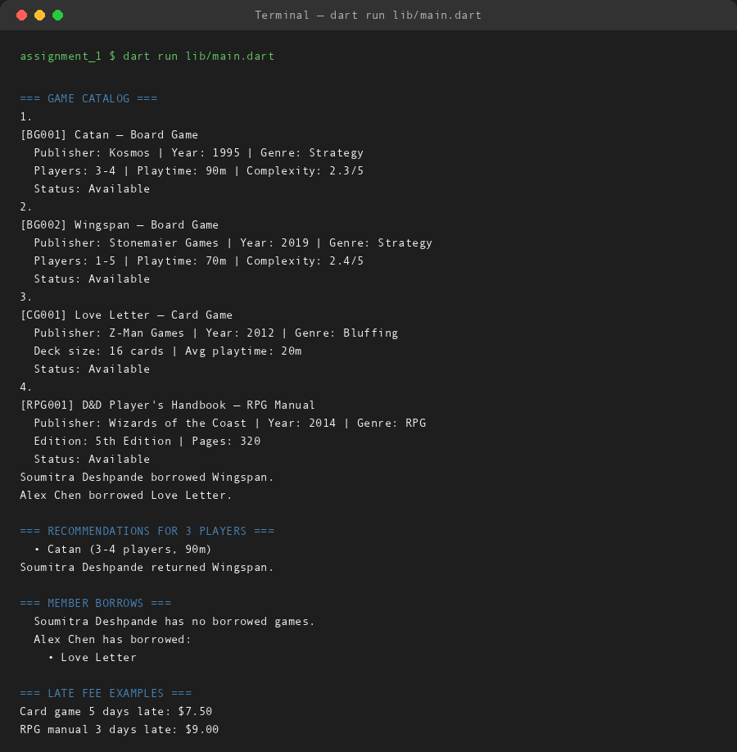

10. What Could Come Next
- Add a `Reservation` class for holds on borrowed games.
- Persist the catalog and member list to JSON.
- Add due dates and automatic overdue reminders.
- Build an interactive CLI menu instead of a fixed demo.

11. Closing
This assignment shows the same core Dart skills as a traditional library app, but applied to a different domain. A board game library needs the same inheritance, collections, and control flow — it just happens to be more fun to demo.

