Todo List App with State
Assignment 5 — Todo List with StatefulWidget & setState
Name: Soumitra Deshpande
Roll No: 150096724035
Cohort: Elon Musk
Environment: Flutter 3.x / Dart 3.x
Code: https://github.com/SoumitraDeshpande11/assignments/tree/assignments_5

1. Objective
Build a fully functional todo list app in Flutter. The app must use a StatefulWidget and setState to manage its data, and it must support three operations: adding a task, deleting a task, and marking a task as complete.

2. Requirements Checklist
Requirement | Where it lives
StatefulWidget | TodoScreen — its state class is _TodoScreenState
setState | _addTodo, _toggleTodo, and _deleteTodo all wrap their changes in setState
Add a task | Text field + green + button at the top (pressing Enter also works)
Delete a task | Red trash icon on each task card
Mark complete | Checkbox (or tapping the card) flips the task's done flag and strikes the text through

3. How the State Works
A stateless widget cannot change anything on screen by itself, so the todo list needs a stateful one. The idea is simple:
1. The task list (_todos) is stored inside the State class, not in the widget.
2. Every time the user adds, deletes, or checks off a task, the code changes that list inside a `setState()` call.
3. setState tells Flutter "the data changed, please rebuild the screen". Flutter calls build again, and the new list shows up.
Each task is a small Todo object with two fields: a title (the text) and done (true or false).

4. The Three Operations
- Add — _addTodo() reads the text field, ignores empty input, puts a new Todo at the end of the list, and clears the field so the user can type the next one.
- Delete — _deleteTodo(index) removes the task at that position with removeAt.
- Mark complete — _toggleTodo(index) flips done between true and false. Done tasks get a line through the text and turn grey. The counter above the list ("1 of 3 done") updates on its own because it is counted fresh on every rebuild.

5. Widget Map
MaterialApp
└── Scaffold
├── AppBar ('My Tasks')
└── Column
├── Row ← Expanded(TextField) + FilledButton(+)
├── Text ← "X of Y done" counter
└── Expanded
└── ListView.builder
└── Card per task
└── ListTile[ Checkbox, title, delete IconButton ]
When the list is empty, the ListView is swapped for a friendly "No tasks yet" message.

6. Source Code
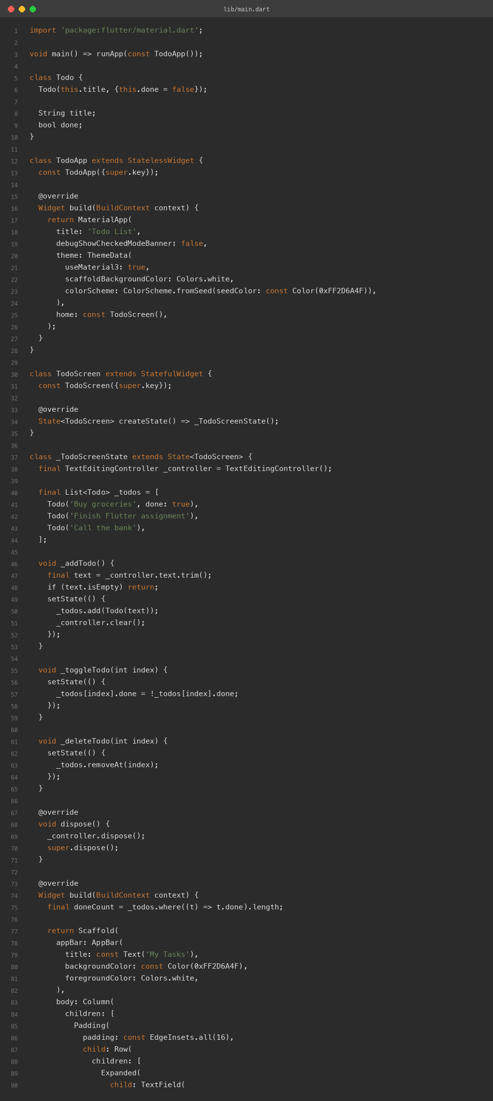

7. App Screenshots
The app was built for the web (flutter build web) and captured in Chrome at two window sizes. The first task is checked off, so the strikethrough, the grey text, and the "1 of 3 done" counter are all visible.
Phone width (500px):
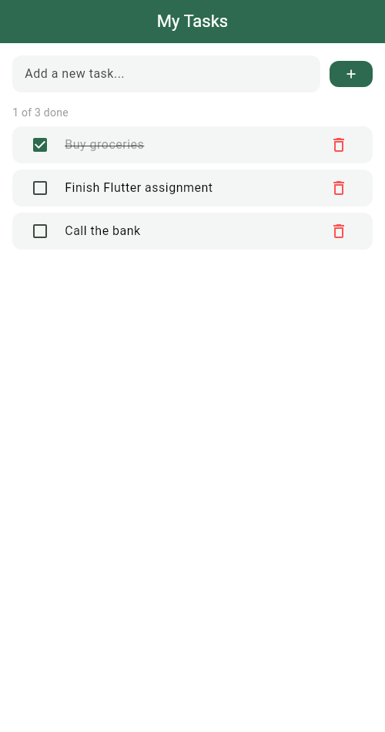
Desktop width (1280px):
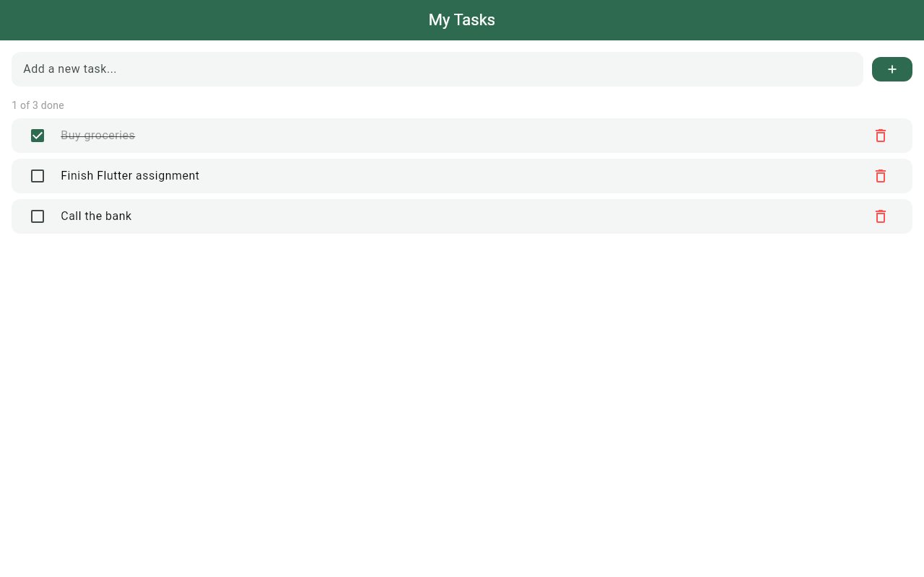

8. Terminal
Real build-and-run session: flutter pub get, flutter analyze (no issues), flutter build web, then flutter run -d web-server to serve the app locally.
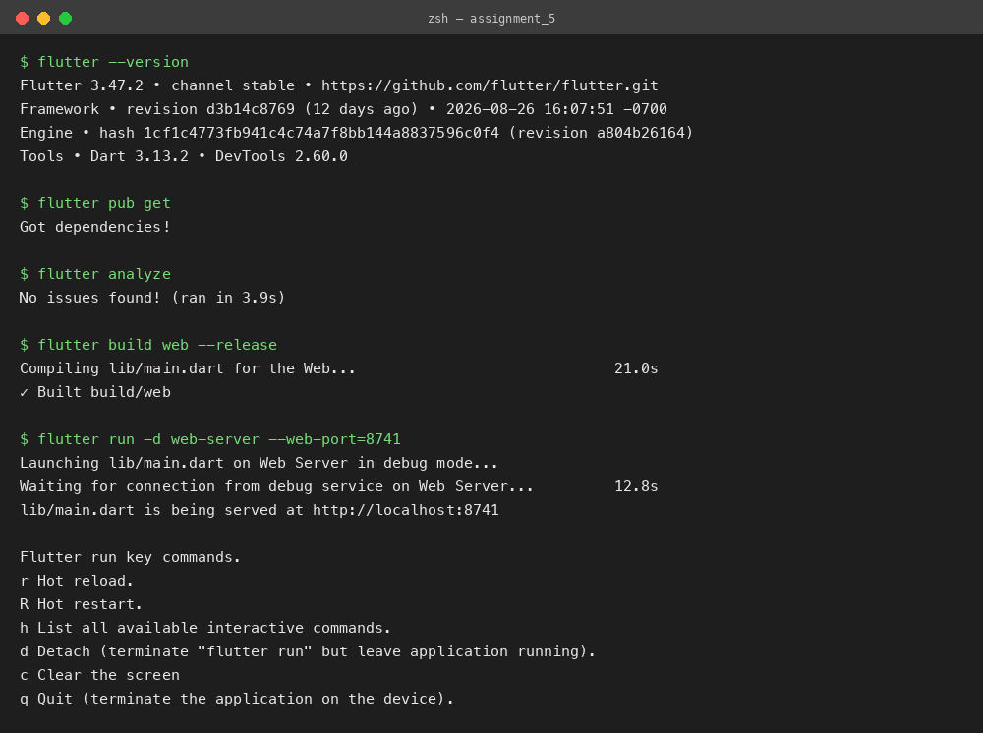

9. Run Instructions
flutter pub get
flutter run # pick a device, or use flutter run -d chrome
Type a task and press the + button (or Enter) to add it, tap the checkbox or the card to mark it done, and tap the trash icon to delete it.

10. Possible Extensions
- Save the list to device storage with shared_preferences so tasks survive a restart.
- Add an edit button to rename an existing task.
- Show a swipe-to-dismiss gesture with Dismissible instead of the delete icon.
Built by Soumitra Deshpande · Roll No. 150096724035 · Cohort: Elon Musk

