Automation for <http://www.mapsynq.com> site.

Set up used: **Selenium with Java + TestNg + Maven (POM structure)**

Please see the below structure for details:-

Here I have captured all **Xpath** for Home page and declare some reusable function (**Set Location**, **GetDirection**, **Select checkboxes, Unselect Chk Boxes**, **ZoomIn/Out**

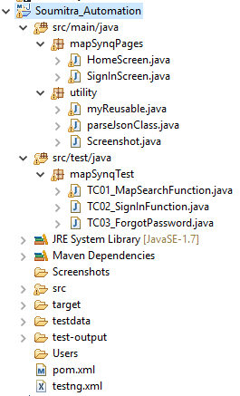s

Here created Function for Chk the **OS** and based on that set the **Web Browser** driver. Last functn I tried for **Android** mobile OS also.

Test Data here as json file

Pom.xml => we can configure the Maven dependencies

3rd Test Case to validate Forgot Password feature

2nd **Test Case** to validate sign In.

First **Test Case** to check some functionality in Home screen to validate- Direction with/without chkbox, zoom etc

**Get Data** from Json file and pass the data as Argument

Capture **Screenshot** of the page function

Captured **Xpath** for Sign page

TestNg.xml => here we can run/comment-out the TCs. Also in below line, we can modify the **Thread-count and parallel execution** accordingly:-

<suite name="Suite" thread-count="1" parallel="false">