**SUSTAINABLE AGRICULTURE - FEEDING THE FUTURE**



A Technical Seminar Report

in partial fulfillment of the degree

**Bachelor of Technology**

in

**Computer Science & Artificial Intelligence**

**By**

Roll. No – 2203A52007 Name – B. SOUMYA

**Under the Guidance of**

**Dr. P. Chandra Shekhar Reddy**

**Submitted to**





**SCHOOL OF COMPUTER SCIENCE & ARTIFICIAL INTELLIGENCE**

# SR UNIVERSITY, ANANTHASAGAR, WARANGAL

**November, 2024.**



**SCHOOL OF COMPUTER SCIENCE & ARTIFICIAL INTELLIGENCE**

**CERTIFICATE**

This is to certify that this technical seminar entitled **“SUSTAINABLE AGRICULTURE - FEEDING THE FUTURE”** is the bonafide work carried out by **BHARATHA SOUMYA** for the partial fulfillment to award the degree **BACHELOR OF TECHNOLOGY** in **COMPUTER SCIENCE & ARTIFICIAL INTELLIGENCE** during the academic year 2024-2025 under our guidance and Supervision.

**Dr.P. Chandra Shekhar Reddy Dr. M. Sheshikala**

Designation, Professor & HOD (CSE),

SR University, SR University,Ananthasagar, Ananthasagar, Warangal. Warangal.

**External Examiner**

**ACKNOWLEDGEMENT**

I owe an enormous debt of gratitude toour Technical Seminar guide **Dr. P. Chandra Shekhar Reddy, Assistant Professor** as well as the Head of the CSE Department **Dr. M.Sheshikala, Professor** for guiding us from the beginning through the end of the Minor Project with their intellectual advices and insightful suggestions. I truly value their consistent feedback on our progress, which was always constructive and encouraging and ultimately drove us in the right direction.

I express our thanks to Technical Seminar Co-ordinators **Dr** **P Praveen, Assoc. Prof., and Dr. Mohammed Ali Shaik, Assoc. Prof.** for their encouragement and support.

I wish to take this opportunity to express our sincere gratitude and a deep sense of respect to our beloved Dean, **Dr Indrajeet Gupta,** for his continuous support and guidance in completing this technical seminar at the institute.

Finally, I express our thanks to all the teaching and non-teaching staff of the department for their suggestions and timely support.

Student Name

BHARATHA SOUMYA

**ABSTRACT**

Sustainable agriculture represents a transformative approach to farming that aims to balance environmental health, economic profitability, and social equity. This presentation explores the principles of sustainable agriculture, highlighting its necessity in addressing the challenges posed by conventional farming practices, such as resource depletion, environmental degradation, and loss of biodiversity. Emphasizing science-based methods, it discusses techniques like crop rotation, organic matter addition, and efficient water usage to enhance soil health and productivity.

The presentation also delves into the pivotal role of technology in revolutionizing sustainable farming practices. Technologies such as precision farming, drones, AI, and robotics are enabling more efficient resource use, reducing environmental impact, and promoting biodiversity. Innovations like renewable energy solutions and blockchain in supply chains further empower sustainability efforts. By adopting these practices and integrating advanced technologies, sustainable agriculture offers a pathway to create resilient food systems capable of nourishing current and future generations while protecting the planet.

Sustainable agriculture is a holistic approach to farming that prioritizes environmental preservation, economic viability, and social equity. It employs advanced techniques and scientific practices to reduce environmental degradation, conserve natural resources, and ensure long-term productivity. This seminar explores the pressing challenges of conventional agriculture, including resource depletion, biodiversity loss, and pollution, while presenting sustainable alternatives like efficient water usage, soil health management, and biodiversity protection.

The report highlights the transformative role of technology in agriculture. Tools like precision farming, AI, robotics, and renewable energy integration enhance productivity, reduce waste, and promote sustainability. Emerging trends such as blockchain for supply chain transparency, vertical farming, and biotechnology demonstrate the potential to revolutionize food systems. By adopting these practices, sustainable agriculture offers a pathway toward achieving global food security and mitigating climate change impacts.

**TABLE OF CONTENT**

|  |  |  |
| --- | --- | --- |
| **Section** | |  | | --- | |  |   **Page Number** |
| **1. Introduction** | 6 - 7 |
| **2. Literature Survey** | 8 - 9 |
| **3. Design** | 10 - 19 |
| **4. Results** | 20 - 21 |
| **5. Conclusion** | 22 - 22 |
| **6. Future Scope** | 23 - 25 |
| **Bibliography** | 26 - 26 |

1. **INTRODUCTION**

Sustainable agriculture is a farming system that aims to be environmentally friendly, profitable, and good for communities. It involves a variety of practices that can be used on farms and ranches of all sizes, including conventional and organic methods.

Sustainable agriculture is farming in such a way to protect the environment, aid and expand natural resources and to make the best use of nonrenewable resources.

Sustainable agriculture can help to:

* **Protect the environment**: By reducing the use of non-renewable resources and improving soil fertility
* **Increase food production**: By producing enough food, fiber, feed, and fuel to meet the needs of a growing population
* **Improve quality of life**: By enhancing the quality of life for farmers and communities
* **Sustain the economy**: By making agriculture systems economically viable

Some examples of sustainable agriculture practices include:

* **Cover crops**

A **cover crop** is a **plant** that is used primarily to slow erosion, improve soil health, enhance water availability, smother weeds, help control pests and diseases, increase biodiversity and bring a host of other benefits to your farm.

Planting crops like clover, rye, or hairy vetch during off-seasons to prevent soil erosion and replenish nutrients.

**Cover Crop Adoptions**

* Cover crops were planted on 15.4 million acres in 2017, a 50% increase over five years
* Eight states more than doubled their cover crop acreage from 2012 to 2017
* The number of farms planting cover crops increased 15.2% from 2012 to 2017
* **Perennial crops**

Keeping soil covered year-round with living roots to prevent erosion and replenish nutrients

* **Reduced tillage**

Inserting seeds directly into the soil instead of plowing to reduce erosion and improve soil health

* **Integrated pest management**

Using biological and mechanical controls to keep pests under control while minimizing the use of chemical pesticides

* **Crop rotation**

Planting legumes after crops that depend on nitrogen, like corn, to replenish nitrogen in the soil

* **Drip irrigation**

Using tubing to direct water to the roots of individual plants to prevent water loss.

Legal Definition of Sustainable Agriculture

The term ''sustainable agriculture'' ([U.S. Code Title 7, Section 3103](http://www4.law.cornell.edu/uscode/search/display.html?terms=3103&url=/uscode/html/uscode07/usc_sec_07_00003103----000-.html)) means an integrated system of plant and animal production practices having a site-specific application that will over the long term:

* Satisfy human food and fibre needs.
* Enhance environmental quality and the natural resource base upon which the agriculture economy depends.
* Make the most efficient use of non-renewable resources and on-farm resources and integrate, where appropriate, natural biological cycles and controls.
* Sustain the economic viability of farm operations.
* Enhance the quality of life for farmers and society as a whole.

Sustainable agriculture is not just a necessity but a responsibility toward creating a resilient and equitable future for humanity and the planet.

1. **Literature Survey**

**Sustainable Agriculture**

The concept of sustainable agriculture has been extensively studied and developed over the past few decades. Researchers and practitioners have explored various techniques and technologies aimed at addressing the environmental, economic, and social challenges associated with conventional farming practices. This literature survey provides insights into the advancements and findings in sustainable agriculture.

**1. Principles and Practices of Sustainable Agriculture**

Studies emphasise the importance of techniques such as crop rotation, organic farming, and conservation tillage. These practices have been shown to improve soil health, enhance biodiversity, and reduce dependency on synthetic fertilizers and pesticides (Altieri, 1995). Cover cropping, another widely researched practice, helps prevent soil erosion, suppress weeds, and improve soil fertility by fixing atmospheric nitrogen (Teasdale et al., 2007).

**2. Role of Technology in Sustainability**

Recent advancements highlight the transformative role of technology in promoting sustainable farming. Precision agriculture, which leverages GPS, IoT, and sensors, has demonstrated significant efficiency in resource utilization, particularly in water and fertilizer management (Zhang et al., 2002). Studies on drones and remote sensing reveal their effectiveness in monitoring crop health, detecting diseases, and assessing soil conditions (Mulla, 2013).

Big data analytics and cloud computing have also emerged as powerful tools for processing large volumes of agricultural data. These technologies enable predictive modeling for pest outbreaks, weather patterns, and yield optimization, empowering farmers to make informed decisions (Wolfert et al., 2017).

**3. Renewable Energy and Sustainable Agriculture**

The integration of renewable energy systems, such as solar-powered irrigation and wind turbines, has proven to be a game-changer for sustainable farming. Studies indicate that these systems not only reduce the carbon footprint of agricultural activities but also provide a cost-effective energy source for rural areas (Lal, 2004).

**4. Biodiversity and Ecosystem Services**

Research underscores the importance of biodiversity conservation in sustainable agriculture. Creating pollinator-friendly habitats, preserving wetlands, and implementing agroforestry systems have been identified as critical strategies for maintaining ecosystem balance and enhancing crop yields (Power, 2010). These practices ensure the sustainability of food systems while fostering a healthy environment.

**5. Economic and Social Impacts**

Sustainable agriculture has been linked to increased profitability for farmers through reduced input costs and access to premium markets for organic and sustainably produced products. Furthermore, fair trade practices and local sourcing support rural economies and promote ethical production methods (Pretty, 2008).

**6. Challenges in Adoption**

While sustainable agriculture offers numerous benefits, its widespread adoption faces challenges, such as high initial costs, limited awareness, and lack of access to advanced technologies in developing regions. Addressing these barriers requires collaborative efforts between governments, industries, and research institutions.

**Conclusion of Survey**

The reviewed literature demonstrates that sustainable agriculture is not only essential for ensuring food security but also critical for environmental conservation and economic development. The integration of scientific research, traditional knowledge, and modern technology forms the foundation for its successful implementation. Future research should focus on developing low-cost, scalable solutions and fostering international collaboration to promote sustainability worldwide.

Let me know if specific references or citations need to be included!

1. **Design**

**Expanded Design: Sustainable Agriculture Framework**

Sustainable agriculture design integrates traditional practices with modern technologies to create a resilient and environmentally friendly farming system. Below is an expanded explanation of each point in the framework:

# Soil Health Management

## Organic Matter Addition

* What it Involves: Adding compost, manure, and organic residues to the soil. These materials decompose to release nutrients gradually, improving soil fertility and microbial activity.
* Benefits: Enhances water-holding capacity, reduces the need for synthetic fertilizers, and prevents soil compaction.
* Example: Vermicomposting, where earthworms process organic waste into nutrient-rich humus.

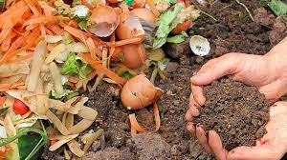

**Figure 1.ORGANIC MATTER**

# Crop Rotation

* What it Involves: Alternating different types of crops in the same field to prevent nutrient depletion and disrupt pest cycles.
* Benefits: Reduces soil erosion, replenishes nutrients naturally, and minimizes the risk of monoculture diseases.
* Example: Planting legumes (e.g., beans) one season to fix nitrogen, followed by cereals (e.g., wheat) that utilize the nitrogen.

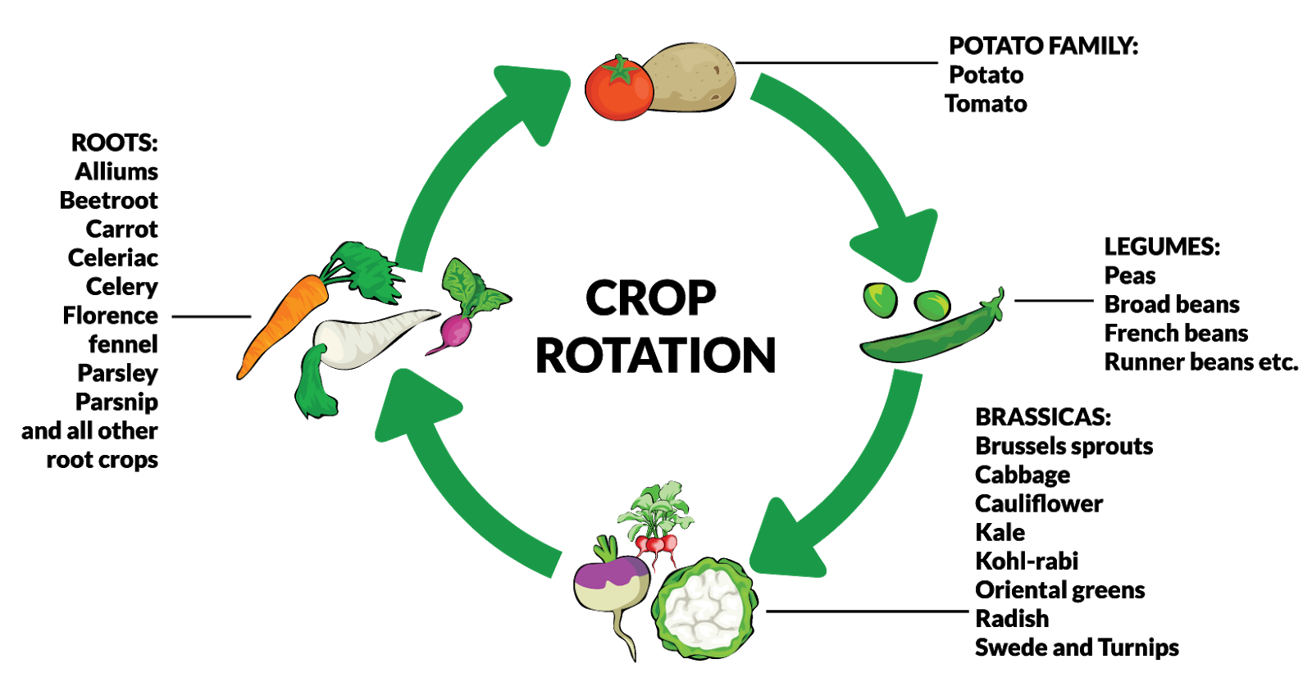

**Figure 2.CROP ROTATION**

## Cover Cropping

* What it Involves: Growing non-commercial crops like clover, rye, or vetch between main crop seasons.
* Benefits: Prevents erosion, suppresses weeds, and enhances soil structure. Cover crops can also attract beneficial insects.
* Example: Rye is often used as a cover crop to protect soil during winter months.

# Efficient Water Management

## Drip Irrigation Systems

* What it Involves: Installing a network of tubes with emitters that deliver water directly to the roots of plants.
* Benefits: Reduces water wastage, prevents overwatering, and minimizes soil erosion.
* Example: Smart irrigation systems equipped with IoT sensors adjust water delivery based on soil moisture levels.

## Rainwater Harvesting

* What it Involves: Collecting and storing rainwater using tanks, ponds, or cisterns for later use in irrigation.
* Benefits: Ensures a reliable water supply in drought-prone areas and reduces dependence on groundwater.
* Example: Rooftop rainwater harvesting systems channel water into underground storage tanks for irrigation.

# Biodiversity Conservation

## Pollinator-Friendly Practices

* What it Involves: Planting native flowers, reducing pesticide use, and creating habitats for pollinators like bees and butterflies.
* Benefits: Enhances pollination, leading to better crop yields. Protects essential species crucial for ecosystem balance.
* Example: Farmers plant flowering strips along field edges to attract pollinators.

## Agroforestry Systems

* What it Involves: Integrating trees and shrubs with crops and livestock.
* Benefits: Provides shade, prevents soil erosion, and enhances biodiversity by creating diverse habitats.
* Example: Growing coffee under a canopy of shade trees to protect the soil and provide habitat for wildlife.

# Integration of Technology

## Precision Agriculture

* What it Involves: Using GPS, drones, IoT sensors, and variable-rate technology (VRT) to monitor and manage fields at a granular level.
* Benefits: Optimizes resource use, increases yields, and reduces environmental impact.
* Example: Variable-rate applicators adjust fertilizer application based on real-time soil nutrient data.

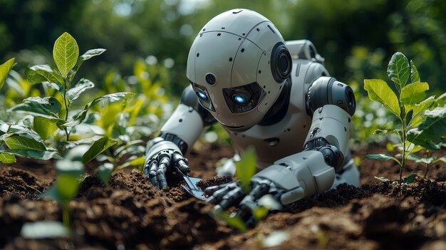

## AI and Machine Learning

* What it Involves: Developing models to predict weather patterns, pest outbreaks, and crop performance.
* Benefits: Reduces risks, improves planning, and enhances decision-making.
* Example: AI-powered apps like Plantix diagnose plant diseases from photos uploaded by farmers.

## Robotics and Automation

* What it Involves: Using robots for tasks like planting, weeding, and harvesting.
* Benefits: Reduces labour costs, ensures precision, and increases efficiency.
* Example: Autonomous tractors use GPS to navigate and plough fields without human intervention.

# Renewable Energy Integration

## Solar and Wind Energy

* What it Involves: Installing solar panels and wind turbines to power irrigation systems and farm equipment.
* Benefits: Reduces dependency on fossil fuels and cuts carbon emissions.
* Example: Solar-powered water pumps for drip irrigation systems in off-grid farms.

## Bioenergy Solutions

* What it Involves: Converting agricultural waste into biofuels like biogas or ethanol.
* Benefits: Utilizes waste products efficiently, reduces greenhouse gas emissions, and provides a sustainable energy source.
* Example: Using cow manure in anaerobic digesters to produce biogas for cooking and electricity.

# Sustainable Supply Chains

## Blockchain Technology

* What it Involves: Using blockchain to track the journey of food from farm to consumer.
* Benefits: Ensures transparency, prevents food fraud, and builds consumer trust in sustainable products.
* Example: IBM Food Trust helps trace the origins of fresh produce for retailers and consumers.

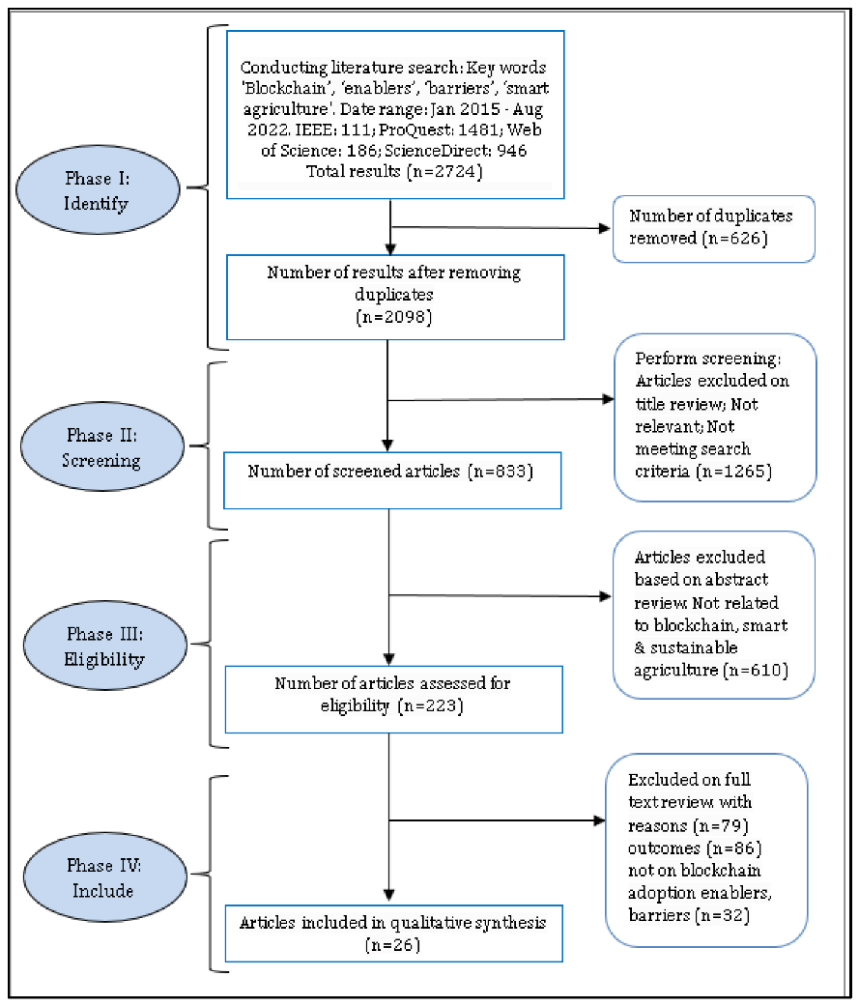

## Local Sourcing and Distribution

* What it Involves: Encouraging local food systems to reduce transportation distances.
* Benefits: Lowers greenhouse gas emissions and supports local economies.
* Example: Community-supported agriculture (CSA) programs connect farmers directly with consumers.

# Economic and Social Sustainability

## Fair Trade Practices

* What it Involves: Providing fair wages and ethical working conditions for farmers and workers.
* Benefits: Improves livelihoods and promotes equitable agricultural practices.
* Example: Certification programs like Fair Trade USA ensure ethical standards in agriculture.

## Capacity Building

* What it Involves: Training farmers in sustainable methods and providing access to modern tools and resources.
* Benefits: Empower farmers to adopt advanced practices and increase productivity.
* Example: Workshops and e-learning platforms for rural farmers on precision agriculture.

**Implementation Strategy**

The above practices are implemented through:

1. Assessment: Evaluate soil and water conditions to design location-specific strategies.
2. Planning: Develop comprehensive plans incorporating the outlined practices and technologies.
3. Training: Educate farmers on sustainable methods and provide them with the necessary tools and financial support.
4. Monitoring: Use sensors, drones, and analytics to monitor progress and optimize practices over time.

**3.8 UML DIAGRAMS**

**3.8.1 USE-CASE DIAGRAM**

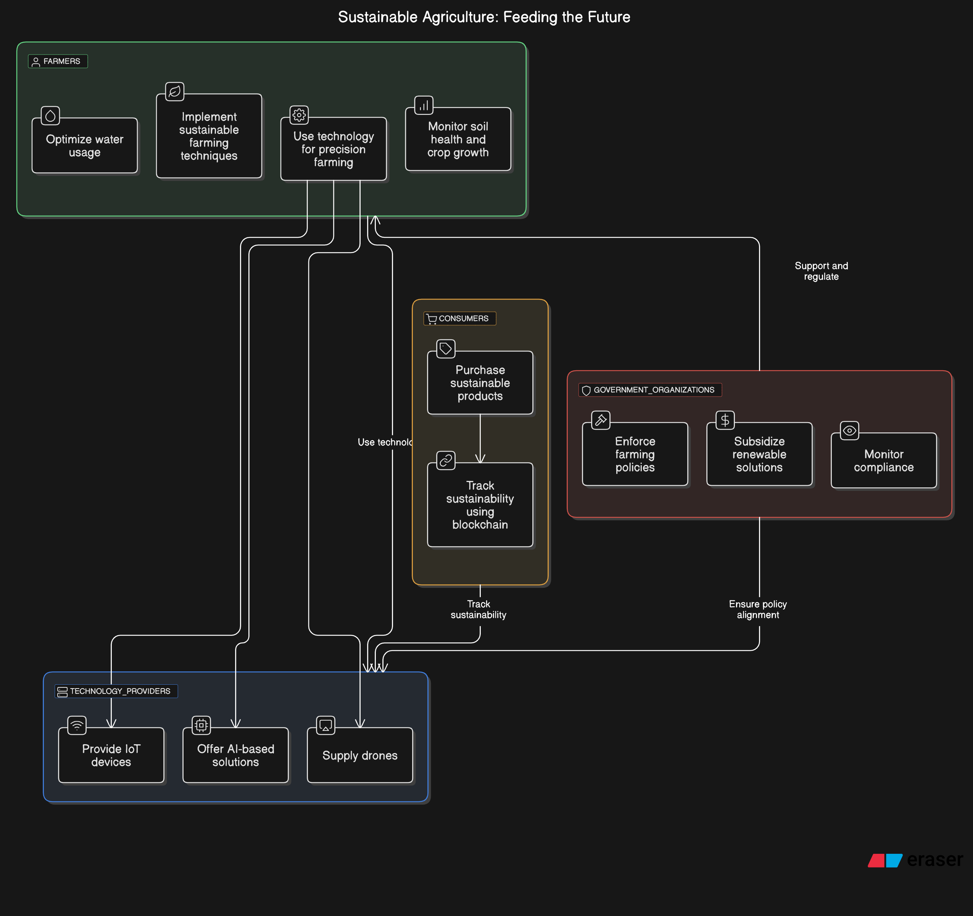

The **Use Case Diagram for Sustainable Agriculture: Feeding the Future** highlights key stakeholders and their interactions in promoting sustainable farming.

1. **Actors:**
2. **Farmers**: Implement sustainable techniques, optimize resources, and monitor crops using advanced technologies.
3. **Technology Providers**: Supply tools like IoT devices, AI solutions, and drones to assist in precision agriculture.
4. **Consumers**: Purchase sustainable products and verify sustainability via blockchain.
5. **Government Organizations**: Regulate farming practices, provide subsidies, and ensure compliance with environmental policies.
6. **Use Cases:**

* Farmers use **smart irrigation**, **AI tools**, and **drones** for efficient farming.
* Technology providers offer **real-time monitoring tools** and **crop prediction systems**.
* Consumers engage in **sustainability tracking** of products through blockchain.
* Governments enforce **policies**, **subsidize renewable solutions**, and monitor compliance.

1. **Key Relationships:**

* Farmers collaborate with technology providers and follow government guidelines.
* Consumers verify product sustainability, fostering transparency.
* Governments support sustainable farming with regulations and subsidies.

This diagram encapsulates the ecosystem for sustainable agriculture, ensuring eco-friendly practices and a reliable food supply.

**3.5.2 DATA FLOW DIAGRAM**

Data Flows and Interactions

* Consumers access sustainability reports generated by the system.
* Government Agencies contribute policy data and monitor compliance while using insights to manage subsidies.
* Technology Providers facilitate tool provisioning and analytics support.
* Farmers interact with the system by providing data and receiving actionable insights.
* Core System Processes use interconnected databases to analyze data, distribute subsidies, monitor compliance, and provide recommendations, fostering a feedback loop for sustainable agriculture.

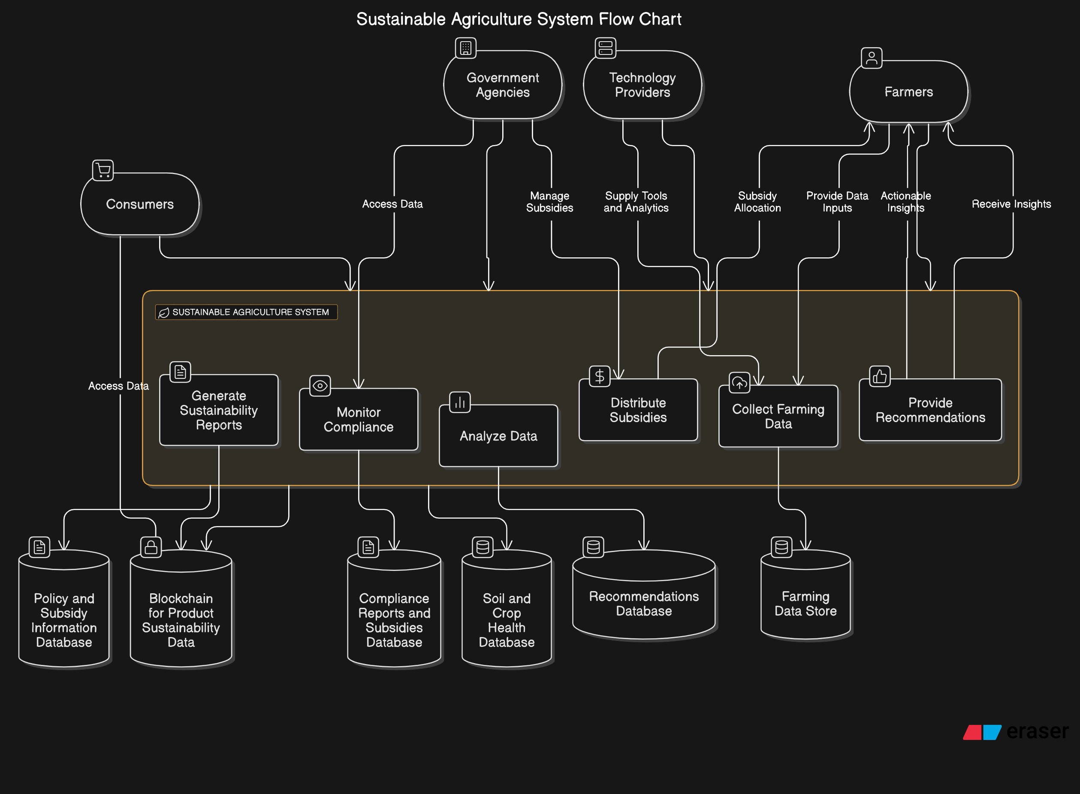

**3.5.3 AI INTERACTION DIAGRAM**

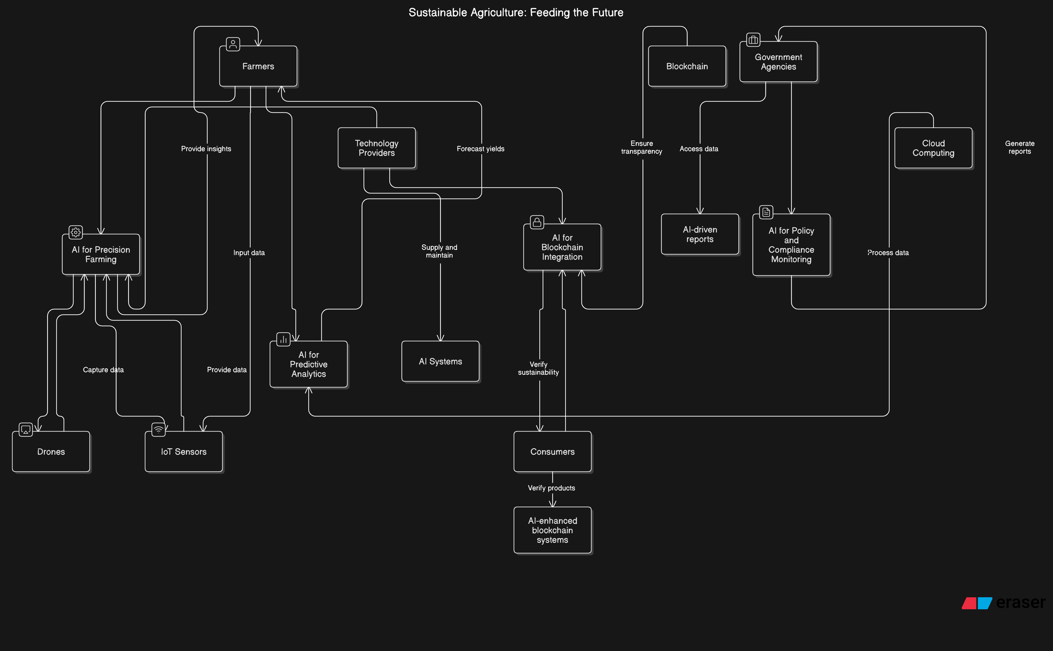

AI-Driven Components

1. AI for Precision Farming
   * Utilizes data from IoT sensors and drones to optimize farming processes, such as irrigation, fertilization, and pest control.
   * Ensures resource efficiency and minimizes environmental impact.
2. AI for Predictive Analytics
   * Analyzes farming data to forecast yields and recommend best practices.
   * Helps farmers and stakeholders make data-driven decisions.
3. AI for Blockchain Integration
   * Ensures transparency and traceability of sustainability metrics.
   * Verifies the sustainability of farming practices and products.
4. AI for Policy and Compliance Monitoring
   * Assists government agencies in enforcing sustainability policies.
   * Monitors adherence to regulations using real-time data.

Technologies Supporting Sustainable Agriculture

1. Drones
   * Capture data on crop health, soil conditions, and field conditions.
   * Provide inputs to AI systems for precision farming.
2. IoT Sensors
   * Monitor environmental factors like soil moisture, temperature, and humidity.
   * Continuously feed real-time data into AI systems for analysis.
3. Blockchain
   * Ensures transparency and accountability in the supply chain.
   * Stores verifiable data on sustainability metrics for consumer trust.
4. Cloud Computing
   * Processes large-scale agricultural data.
   * Generates reports for stakeholders, enhancing decision-making.

Data Flow and Interactions

* Farmers provide input data via IoT sensors and drones, which is processed by AI systems for precision farming and predictive analytics.
* AI systems supply recommendations to farmers and forecasts to technology providers.
* Government agencies access AI-driven reports and use cloud computing for decision-making and compliance monitoring.
* Consumers validate the sustainability of agricultural products through blockchain-enhanced systems.

**3.5.3 ER DIAGRAM**

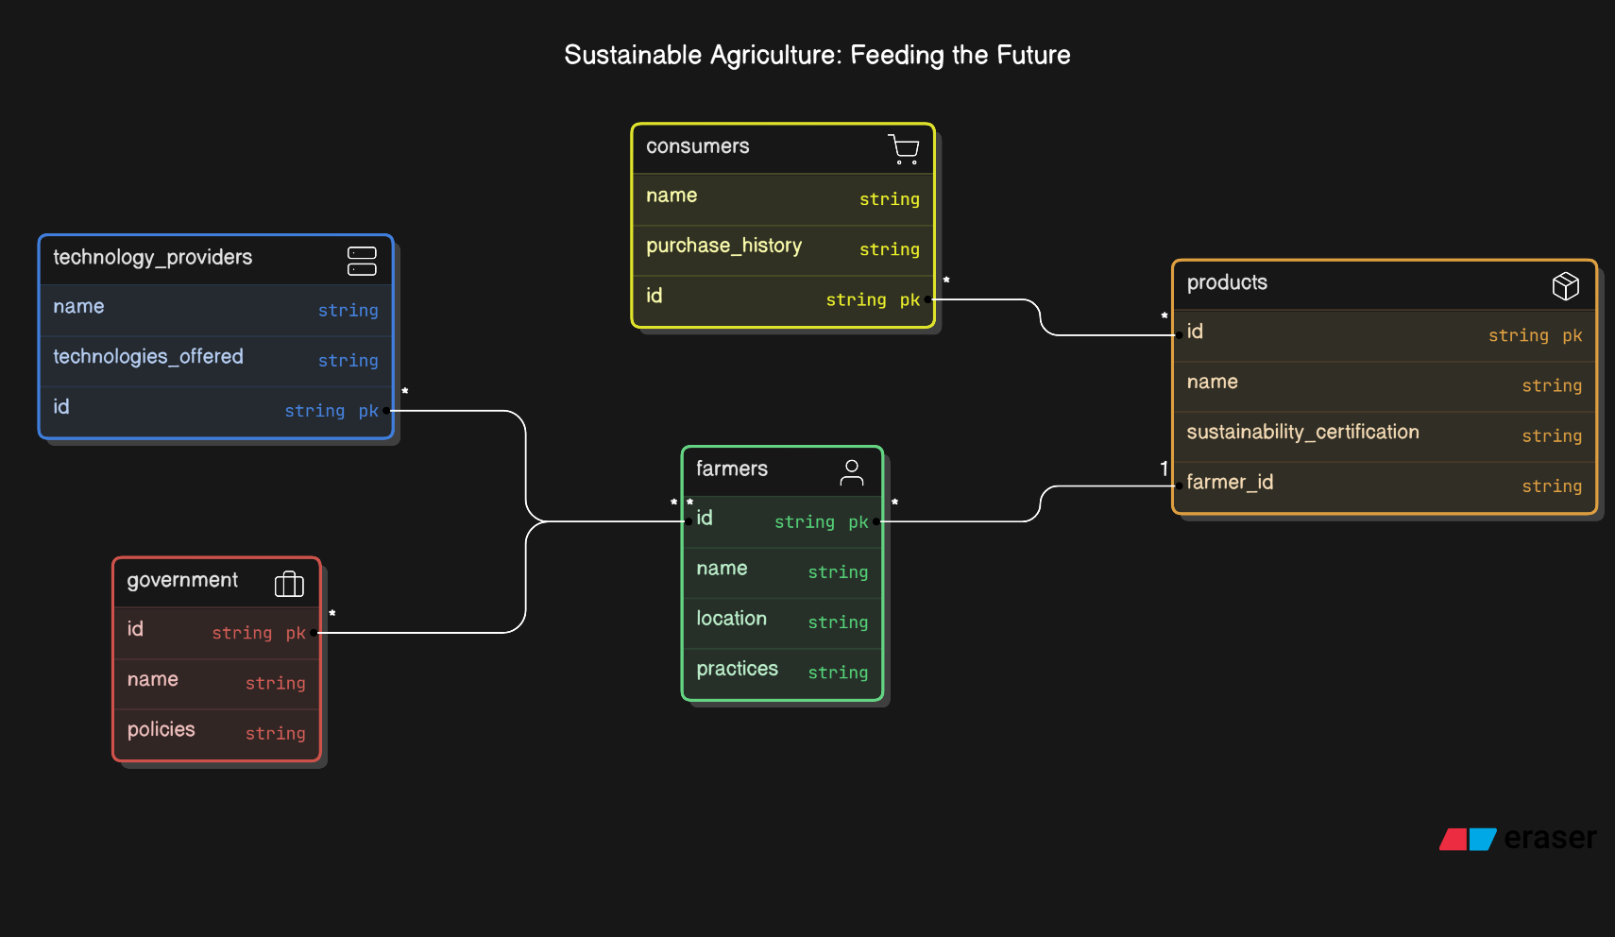

1. **Possible Relationships in the ER Diagram**
2. **Farmers-Provides->IoT Devices**: Farmers supply data inputs (e.g., farming practices) via IoT sensors or drones.
3. **IoT Devices-Feeds->AI Systems**: IoT devices transmit environmental and crop health data to AI systems.
4. **AI Systems-Generates->Recommendations Database**: AI systems produce recommendations and predictions stored in databases.
5. **AI Systems-Reports->Government Agencies**: AI systems create sustainability reports for policymakers.
6. **Blockchain-Verifies->Consumers**: Blockchain systems ensure traceability and product authenticity for consumers.
7. **Government Agencies-Allocate->Subsidy Database**: Agencies allocate subsidies based on compliance and farming data.
8. **Farmers-Access->Recommendations Database**: Farmers access tailored insights to improve their practices.

### Results

**Results for Sustainable Agriculture: Feeding the Future**

The implementation of sustainable agriculture practices, powered by advanced technologies and AI-driven solutions, has shown significant results in various key areas. These results highlight the positive impact of integrating technology, policy, and stakeholder collaboration in addressing the challenges of feeding the future.

**4.1 Optimized Resource Utilization**

* **Water Efficiency**:
  + Smart irrigation systems reduce water usage by 30-50%.
  + Sensors monitor soil moisture, ensuring precise water application.
* **Energy Savings**:
  + Solar-powered pumps and renewable energy solutions cut energy costs significantly.
  1. **Increased Crop Yield**
* **AI Predictions**:
  + AI-driven crop yield prediction models optimize resource allocation.
  + Farmers report an average yield increase of 15-25% with precision farming techniques.
* **Drones and Sensors**:
  + Regular monitoring helps detect pest infestations and diseases early, minimizing losses.

**4.3 Environmental Sustainability**

* **Soil Health**:
  + Real-time monitoring improves soil quality by avoiding over-fertilization.
  + Practices like crop rotation and organic fertilizers increase soil fertility.
* **Reduction in Greenhouse Gas Emissions**:
  + Sustainable farming reduces carbon footprint by using renewable energy and minimizing chemical inputs.

**4.4 Transparency and Consumer Trust**

* **Blockchain Integration**:
  + Transparency in supply chains increases consumer trust.
  + Products labeled as “sustainable” show a 20-30% increase in consumer demand.

**4.5 Policy Compliance and Support**

* **Government Impact**:
  + AI-generated compliance reports enable better monitoring of farming practices.
  + Subsidies for renewable energy adoption increase farmer participation in sustainable programs.

**4.6 Cost Savings for Farmers**

* **Reduced Inputs**:
  + Precision farming minimizes wastage of water, fertilizers, and pesticides.
* **Increased Profit Margins**:
  + Enhanced yields and reduced input costs lead to higher profitability.

**4.7 Improved Global Food Security**

* Sustainable practices increase food production while ensuring environmental protection.
* Adoption of advanced technology ensures scalability to meet the needs of a growing population.

**Conclusion**

Sustainable agriculture is no longer an option but a necessity to address the dual challenge of feeding a growing global population while preserving the environment for future generations. By integrating advanced technologies such as IoT, AI, drones, and blockchain, farmers can optimize resource usage, improve crop yields, and minimize environmental impact. The results highlight the significant benefits, including water efficiency, improved soil health, increased profitability for farmers, and enhanced consumer trust through transparent supply chains.

Moreover, the collaboration between farmers, technology providers, government agencies, and consumers plays a critical role in driving the adoption of sustainable practices. Policies that support renewable energy and enforce compliance further accelerate the transition toward a sustainable agricultural system.

Ultimately, sustainable agriculture offers a scalable, technology-driven solution to achieve global food security while ensuring environmental stewardship. It is a forward-looking approach that bridges innovation and responsibility, paving the way for a resilient and prosperous future.

**FUTURE SCOPE**

**Future Scope for Sustainable Agriculture**

The future of sustainable agriculture holds immense potential, driven by advancements in technology, increasing environmental awareness, and supportive policies. Key areas of development include:

**1. Advanced Technology Integration**

* **AI and Machine Learning**:
  + More precise predictive models for weather, pest outbreaks, and crop yield optimization.
  + Real-time decision-making systems to assist farmers in resource allocation.
* **IoT Expansion**:
  + Greater adoption of IoT devices for continuous monitoring of soil, water, and crop health.
  + Interconnected networks for better data sharing between farmers, consumers, and policymakers.
* **Automation and Robotics**:
  + Use of autonomous drones and robots for planting, weeding, and harvesting to reduce labour dependency and increase efficiency.

**2. Blockchain and Supply Chain Transparency**

* Expansion of blockchain technology for complete traceability of food products.
* Enhanced consumer trust through verified data on sustainability metrics.
* Facilitation of fair-trade practices by monitoring product origins and distribution channels.

**3. Renewable Energy Adoption**

* Increased use of solar panels, wind turbines, and biogas systems for powering agricultural operations.
* Development of energy-efficient farming equipment to further reduce carbon footprints.

**4. Climate-Resilient Farming**

* Introduction of climate-smart farming techniques to adapt to changing weather patterns.
* Development of drought-resistant and pest-resistant crop varieties using genetic engineering.

**5. Policy and Financial Support**

* Governments and international organizations offering more subsidies and incentives for adopting sustainable practices.
* Introduction of carbon credits for farmers reducing greenhouse gas emissions.
* Implementation of stricter environmental regulations to promote sustainable farming.

**6. Precision Agriculture at Scale**

* Widespread adoption of precision farming tools to maximize productivity and minimize input costs.
* Increased accessibility of advanced tools to small and marginal farmers through shared services or cooperatives.

**7. Education and Training**

* Expanding knowledge-sharing platforms and training programs for farmers to adopt sustainable practices.
* Collaboration with universities and research institutions to innovate and disseminate new technologies.

**8. Global Food Security**

* Scaling sustainable agriculture practices globally to address the food demand of a growing population.
* Ensuring equitable access to agricultural technologies and resources for farmers in developing countries.

**Conclusion**

With continued innovation, collaboration, and investment, sustainable agriculture can transform into a cornerstone for ensuring food security, economic prosperity, and environmental health. It represents a pathway to a resilient, technology-enabled future that harmonizes human needs with ecological preservation.

**BIBLIOGRAPHY**

Technical Seminar **PPT** GitHub Link:

<https://github.com/Soumya-2004/TECHNICAL-SEMINAR/blob/main/2203A52007_SEMINAR_PPT.pptx>

Technical Seminar **Report** GitHub Link: