CHAPTER 1
INTRODUCTION
1.1 Background
Brain tumors represent one of the most serious health challenges worldwide. According to medical research, early and accurate detection significantly improves treatment planning and patient survival rates. Magnetic Resonance Imaging (MRI) is the primary non-invasive diagnostic tool used by neurologists and radiologists to identify and classify brain abnormalities.
Traditional diagnosis relies heavily on manual examination of MRI scans by trained radiologists. This process is labor-intensive, time-consuming, and can be subject to inter-observer variability. As the volume of medical imaging data continues to grow, there is an increasing need for automated computer-aided diagnosis (CAD) systems that can assist medical professionals in rapid and consistent tumor classification.
Deep Learning, particularly Convolutional Neural Networks (CNNs), has revolutionized medical image analysis by automatically learning hierarchical visual features from images. However, training a full CNN classifier from scratch requires large annotated datasets and significant computational resources. An alternative hybrid approach combines CNN-based feature extraction with classical machine learning classifiers such as Support Vector Machines (SVM), offering strong performance with reduced training complexity.
This project develops a Brain Tumor MRI Detection System that classifies MRI scans into glioma, meningioma, pituitary tumor, or no tumor using ResNet50 for feature extraction, SVM for classification, Grad-CAM for visual explainability, and Flask for web-based deployment.
1.2 Objectives
The primary objectives of this project are:
- To design and implement an automated brain tumor classification system using MRI images.
- To extract deep visual features from MRI scans using a pre-trained ResNet50 CNN with ImageNet transfer learning.
- To train an SVM classifier with RBF kernel on extracted features for multi-class tumor classification.
- To implement Grad-CAM (Gradient-weighted Class Activation Mapping) for visual explainability of model predictions.
- To develop a Flask-based web application for real-time MRI upload, prediction, and result visualization.
- To evaluate the system on the Kaggle Brain Tumor MRI dataset with balanced training and testing splits.
- To demonstrate the integration of deep learning, classical ML, and Explainable AI in a single medical imaging pipeline.

1.3 Scope of the Project
The scope of this project encompasses the design, development, training, and deployment of a Brain Tumor MRI Detection System. The system classifies 2D MRI images into four categories: glioma, meningioma, pituitary tumor, and no tumor.
The project uses the Kaggle Brain Tumor MRI dataset containing 7,200 images organized in folder-based class labels — 5,600 images for training (1,400 per class) and 1,600 images for testing (400 per class). The dataset is perfectly balanced across all four classes.
The machine learning pipeline consists of three stages: (1) ResNet50 feature extraction producing 2048-dimensional vectors, (2) SVM training with StandardScaler normalization, and (3) CNN head training solely for Grad-CAM explainability. Data augmentation (horizontal flip, rotation, zoom, contrast) is applied during CNN training.
The deployment component is a Flask web application with a modern responsive UI that accepts MRI image uploads, displays predicted class, confidence percentage, per-class probability bars, original image, and Grad-CAM heatmap overlay.
The project is intended as an academic research and demonstration prototype. It is not designed for clinical deployment without further validation, regulatory approval, and integration with hospital Picture Archiving and Communication Systems (PACS).
1.4 Significance of the Study
The significance of this study lies in its contribution to the growing field of Artificial Intelligence (AI)-assisted medical image analysis and Explainable Artificial Intelligence (XAI) in healthcare.
Firstly, the proposed hybrid CNN-SVM approach demonstrates that transfer learning using pre-trained ResNet50 features can effectively classify brain tumors from MRI images without requiring the computational expense of fine-tuning an entire deep neural network. This makes the solution cost-effective and suitable for academic institutions and research environments with limited computational resources.
Secondly, the integration of Gradient-weighted Class Activation Mapping (Grad-CAM) addresses one of the major challenges in medical AI systems: explainability. Healthcare professionals need to understand not only the prediction but also the reasoning behind it. Grad-CAM provides visual heatmaps that highlight the regions of the MRI image that most influenced the model's decision, thereby increasing transparency, trust, and interpretability.
Thirdly, the deployment of the model through a Flask-based web application enhances the practical usability of the system. The web interface enables users to upload MRI images and obtain instant classification results without requiring technical knowledge or command-line interaction.
Finally, the project showcases the effective integration of various open-source technologies, including TensorFlow, Scikit-learn, Flask, and OpenCV, to develop a complete end-to-end medical AI solution. The system covers the entire workflow, from dataset preprocessing and feature extraction to model training, prediction, visualization, and web deployment.

CHAPTER 2
LITERATURE SURVEY
2.1 Kermany et al. (2018) – Identifying Medical Diagnoses and Treatable Diseases by Image-Based Deep Learning[1]
Kermany et al. (2018) conducted a landmark study demonstrating that deep learning models trained on medical images can achieve diagnostic performance comparable to expert physicians. The researchers utilized transfer learning with pre-trained Convolutional Neural Networks (CNNs) to classify retinal diseases from optical coherence tomography (OCT) images. Their findings showed that deep learning models can effectively extract meaningful features from medical images and assist in accurate disease diagnosis.
Key Contribution: The study established the feasibility of CNN-based medical diagnosis and highlighted the effectiveness of transfer learning in medical image classification tasks.
Limitation: The research focused primarily on retinal images rather than brain MRI images. Additionally, it required large, carefully curated datasets and relied on end-to-end CNN training, which demands significant computational resources.
Relation to the Present Work: The proposed project extends the concept of transfer learning to brain tumor classification using MRI images. Instead of training a complete deep neural network, ResNet50 is used as a feature extractor, and an SVM classifier is employed for classification. This approach reduces computational complexity while maintaining high classification performance.
2.2 Deepak and Ameer (2019) – Brain Tumor Classification Using Deep CNN Features and Machine Learning[2]
Deepak and Ameer proposed a hybrid framework for brain tumor classification that combines deep learning feature extraction with traditional machine learning algorithms. In their approach, CNN-generated features were used as inputs to classifiers such as Support Vector Machines (SVM) and Random Forest. The study demonstrated that hybrid models could achieve competitive classification accuracy while reducing training time compared to fully trained deep neural networks.
Key Contribution: The work showed that deep feature extraction combined with classical machine learning classifiers can effectively classify brain tumors from MRI images.
Limitation: The model lacked interpretability and did not provide any mechanism to explain the classification decisions. No visualization techniques were incorporated to highlight important regions in the MRI images.
Relation to the Present Work: The proposed project builds upon this hybrid CNN-SVM concept and enhances it by integrating Grad-CAM, which generates visual explanations and improves the transparency of the classification process.
2.3 Selvaraju et al. (2017) – Grad-CAM: Visual Explanations from Deep Networks via Gradient-Based Localization[3]
Selvaraju et al. introduced Gradient-weighted Class Activation Mapping (Grad-CAM), a technique that provides visual explanations for predictions made by convolutional neural networks. Grad-CAM works by computing gradients of the target class score with respect to convolutional feature maps and generating heatmaps that highlight the most influential image regions.
Key Contribution: The study introduced an effective and architecture-independent method for interpreting CNN decisions, making deep learning models more transparent and trustworthy.
Limitation: Grad-CAM itself does not improve classification accuracy; rather, it serves as a visualization and interpretability tool. Its effectiveness depends on the quality and architecture of the underlying CNN model.
Relation to the Present Work: The proposed project directly incorporates Grad-CAM to generate heatmaps on brain MRI images, enabling users and medical practitioners to understand which regions contributed most to the tumor classification decision.
2.4 Comparative Analysis of Reviewed Literature
The reviewed literature collectively establishes the foundation for the hybrid architecture. Table 2.1 summarises the key contributions and gaps addressed by the present work.
Paper | Approach | Limitation | Our Contribution
Kermany et al. (2018) | End-to-end CNN | Requires large data & GPU | Hybrid CNN+SVM reduces training cost
Deepak & Ameer (2019) | CNN features + ML | No explainability | Grad-CAM heatmap integration
Selvaraju et al. (2017) | Grad-CAM XAI | Needs spatial CNN maps | Dedicated CNN head for Grad-CAM
He et al. (2016) | ResNet50 backbone | General vision, not medical | Transfer learning on MRI data
Table 2.1: Comparative Analysis of Reviewed Literature

CHAPTER 3
SYSTEM ANALYSIS
3.1 Proposed System
The proposed system is a Brain Tumor MRI Detection System that accepts brain MRI images as input and classifies them into one of four categories: glioma, meningioma, pituitary tumor, or no tumor. The system uses a hybrid deep learning and machine learning pipeline combined with visual explainability and web-based deployment.
During training, MRI images are loaded from folder-structured datasets, preprocessed to 224×224 resolution, and passed through a frozen ResNet50 network to extract 2048-dimensional feature vectors. These features are normalized using StandardScaler and used to train an SVM classifier with RBF kernel. A separate CNN model with a softmax classification head is trained for Grad-CAM explainability.
During inference, a user uploads an MRI image through the Flask web interface. The image is preprocessed, features are extracted via ResNet50, the SVM predicts the tumor class with confidence scores, and Grad-CAM generates a heatmap overlay showing the influential brain regions.
3.1.1 System Workflow
The system operates through the following sequential workflow:
- Step 1: User opens the Flask web application and accesses the upload interface.
- Step 2: User uploads a brain MRI image (JPG/PNG) via the web form or drag-and-drop interface.
- Step 3: Server loads the image, converts to RGB, and resizes to 224×224 pixels.
- Step 4: Image is preprocessed using ResNet50-specific normalization (preprocess_input).
- Step 5: ResNet50 feature extractor converts the image to a 2048-dimensional feature vector.
- Step 6: SVM Pipeline (StandardScaler + SVC) predicts class probabilities for all four categories.
- Step 7: Argmax selects the predicted class; confidence score is displayed to the user.
- Step 8: Grad-CAM generates a heatmap on the parallel CNN model for the predicted class.
- Step 9: Heatmap is overlaid on the original MRI using JET colormap and alpha blending.
- Step 10: Results page displays prediction, confidence, probability bars, original image, and Grad-CAM overlay.

3.1.2 Comparison with Existing Systems
Traditional brain tumor diagnosis relies entirely on manual radiologist examination, which is slow and subjective. Pure deep learning approaches require extensive GPU resources and large annotated datasets for end-to-end training. The proposed hybrid approach offers a practical middle ground combining efficiency, accuracy, and explainability.
Primary Features:
- Hybrid ResNet50 + SVM architecture for efficient and accurate classification.
- Transfer learning from ImageNet — no need to train CNN from scratch.
- Grad-CAM visual explainability showing brain regions influencing predictions.
- Flask web application with drag-and-drop upload and real-time inference.
- Per-class probability display with confidence percentage and ranked results.
- Modular codebase: separate files for training, inference, utilities, and Grad-CAM.
- Saved model artifacts (svm.joblib, cnn_classifier.keras) for instant deployment.
- Balanced dataset handling with class_weight='balanced' in SVM training.

3.2 Software Requirements
Software | Version | Purpose
Python | 3.10 or higher | Primary programming language
TensorFlow / Keras | ≥ 2.15 | Deep learning — ResNet50, training, Grad-CAM
scikit-learn | ≥ 1.4 | SVM classifier, StandardScaler, Pipeline
NumPy | ≥ 1.26 | Numerical arrays for features and images
Pillow (PIL) | ≥ 10.2 | Image loading, resizing, PNG encoding
OpenCV | ≥ 4.9 | Heatmap resize, JET colormap, overlay blending
Flask | ≥ 3.0 | Web framework for deployment
joblib | ≥ 1.3 | SVM model serialization and loading
Table 3.1: Software Requirements
3.3 Hardware Requirements
Component | Minimum Requirement
Operating System | Windows 10/11 or Linux Ubuntu
Display | 1280×720 minimum for web interface
Processor | Intel i5 or higher (multi-core recommended)
RAM | 8 GB minimum (16 GB recommended for TensorFlow)
Storage | 10 GB free space for dataset, models, and dependencies
Table 3.2: Hardware Requirements
3.4 User Requirements
- Basic understanding of Python and running scripts in a terminal or IDE.
- Ability to navigate a web browser to access the Flask web application.
- Understanding of MRI brain scan images for interpreting the classification results.
- Familiarity with VS Code or any Python IDE for running and monitoring the application.
- Knowledge of virtual environment setup (python -m venv) for dependency management.

3.5 Product Requirements
- Pre-trained model artifacts: svm.joblib, class_names.json, cnn_classifier.keras.
- Modular codebase with separate files: train.py, app.py, ml_utils.py, gradcam.py.
- Kaggle Brain Tumor MRI dataset organized in dataset/Training and dataset/Testing folders.
- Flask web application with file upload interface and result rendering templates.
- Grad-CAM heatmap generation with JET colormap overlay on MRI images.
- requirements.txt for reproducible dependency installation.

CHAPTER 4
DESIGN
4.1 Purpose
The primary purpose of this project is to develop an intelligent Brain Tumor MRI Detection System that automates the classification of brain MRI scans into different tumor categories while providing confidence scores and visual explanations for the predictions. The system aims to assist in the rapid and accurate analysis of MRI images using Artificial Intelligence (AI) and Machine Learning (ML) techniques.
To achieve this objective, the proposed system employs a hybrid machine learning framework that combines the strengths of deep learning and traditional machine learning. A pre-trained ResNet50 Convolutional Neural Network (CNN) is utilized as a frozen feature extractor to generate high-level image representations, while a Support Vector Machine (SVM) classifier performs the final tumor classification. This approach improves classification efficiency and reduces computational requirements compared to training a deep neural network from scratch.
In addition, a parallel CNN model equipped with a softmax classification head is incorporated to support Gradient-weighted Class Activation Mapping (Grad-CAM). This enables the generation of visual heatmaps that highlight the regions of the MRI image that contribute most significantly to the prediction. Such visual explanations enhance the transparency and interpretability of the system, making the results easier to understand and trust.
Furthermore, the project includes a Flask-based web application that provides a user-friendly interface for MRI image analysis. Through this interface, users can upload MRI scans, obtain instant classification results, view prediction confidence scores, and visualize Grad-CAM heatmaps without requiring any command-line interaction. This makes the system accessible, practical, and suitable for demonstration and educational purposes.

4.2 Architecture Diagram
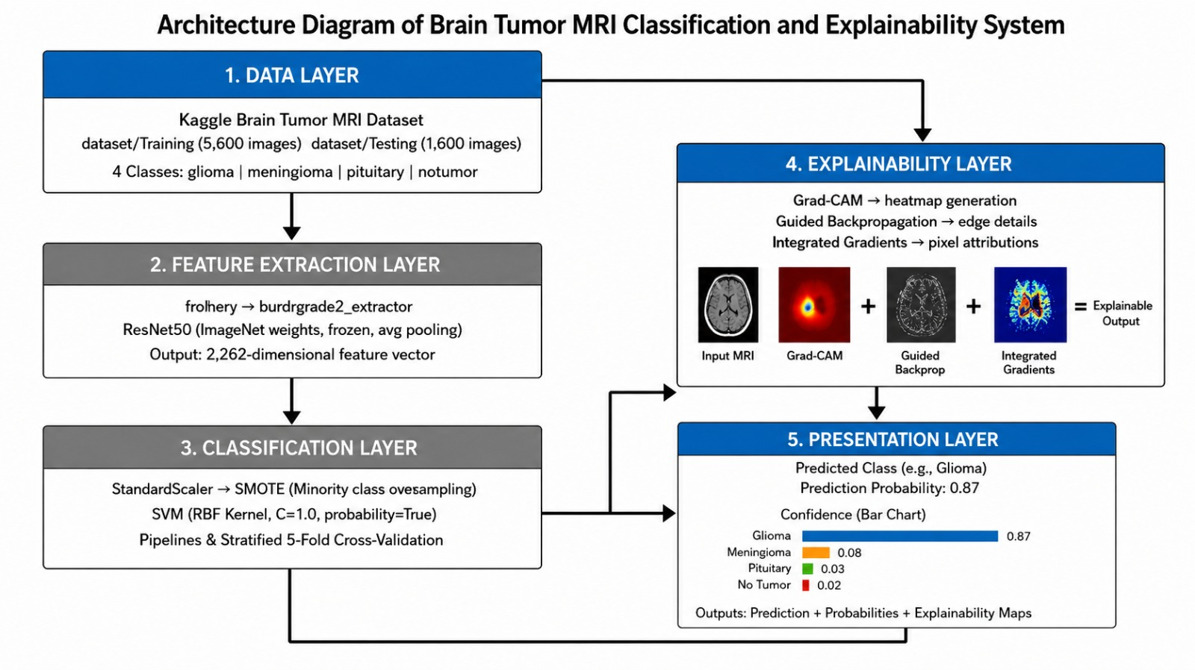

Figure 4.1 illustrates the overall architecture of the Brain Tumor Classification and Explainability System, organized into five interconnected layers:

Data Layer: Uses the Kaggle Brain Tumor MRI Dataset containing training and testing images from four classes: glioma, meningioma, pituitary tumor, and no tumor.
Feature Extraction Layer: A pre-trained ResNet50 model extracts 2048-dimensional feature vectors from MRI images.
Classification Layer: A StandardScaler and SVM classifier predict the tumor category and generate probability scores for all four classes.
Explainability Layer: Grad-CAM uses a dedicated ResNet50-based CNN model to generate heatmaps highlighting important regions in the MRI scan.
Presentation Layer: A Flask-based web interface allows users to upload MRI images and view predictions, confidence scores, and Grad-CAM visualizations. Together, these layers enable accurate and interpretable brain tumor classification.

4.3 Data Flow Diagram
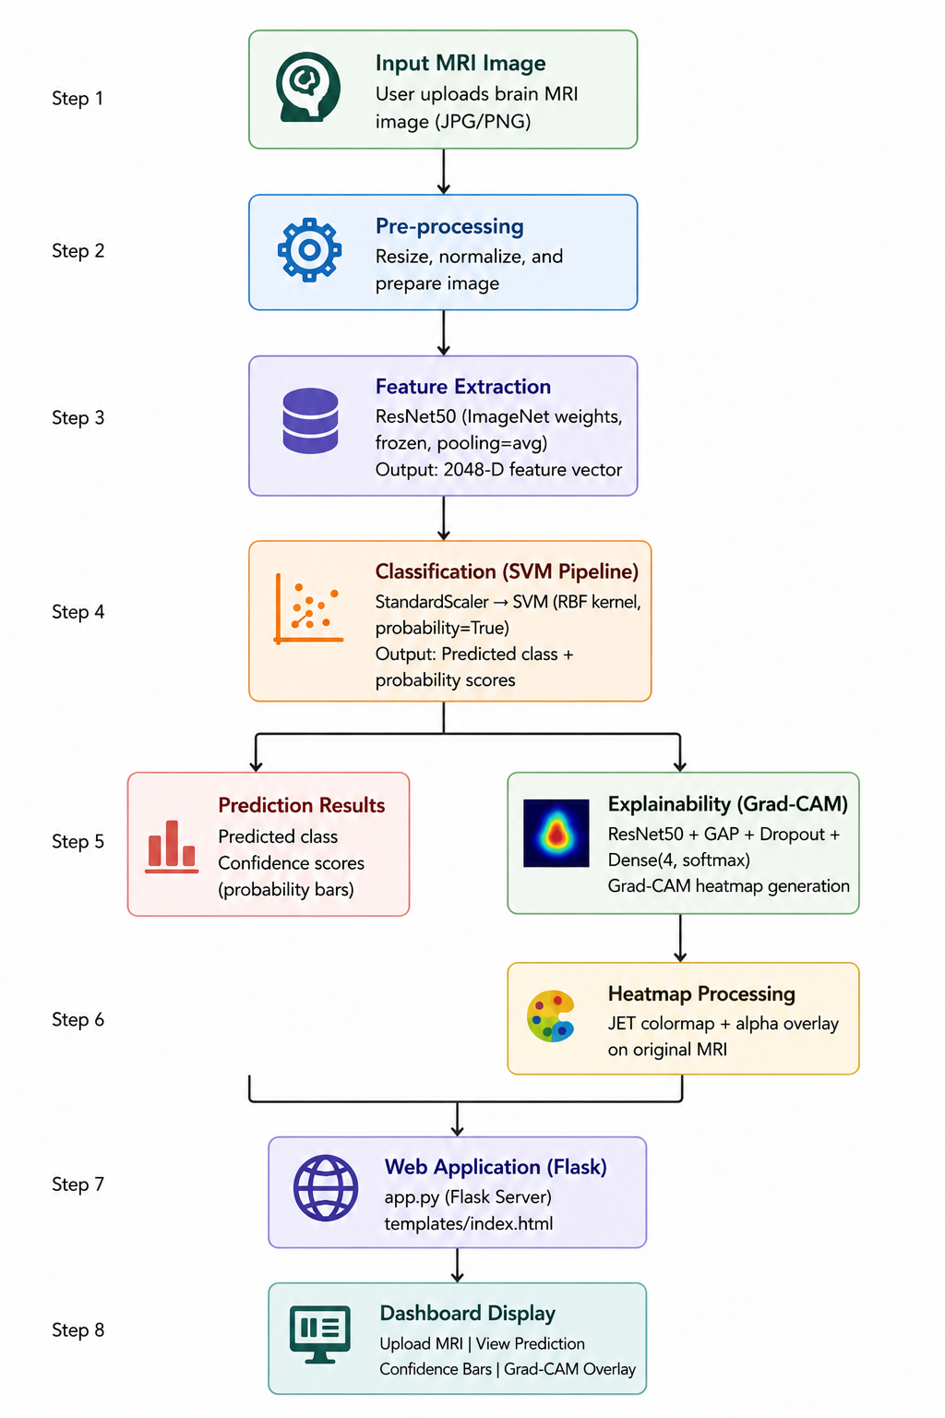
The data flow through the system follows a sequential pipeline from MRI image upload to classification result display:

Fig. 4.2: Data Flow Diagram of Attack Detection
4.4 Project File Structure
The project follows a clean modular structure with each file serving a specific purpose, as shown in Table 4.1 below:
File | Purpose
train_model.py | Trains ResNet50 feature extractor and SVM classifier on brain MRI dataset
app.py | Main Flask application with upload route and all result rendering endpoints
ml_utils.py | Utility functions for preprocessing, feature extraction, and SVM prediction
gradcam.py | Grad-CAM heatmap generation using dedicated CNN classification head
svm.joblib | Saved trained SVM pipeline (StandardScaler + SVC) model artifact
cnn_classifier.keras | Saved CNN model used exclusively for Grad-CAM explainability
class_names.json | JSON file mapping class indices to tumor category names
requirements.txt | Pip-installable dependency list for reproducible environment setup
templates/index.html | Home page of the Flask web application with drag-and-drop upload
templates/results.html | Results page rendering prediction, confidence, Grad-CAM heatmap overlay
Table 4.1: Project File Structure

CHAPTER 6
EXPECTED OUTCOMES
1. Functional Detection System
The primary expected outcome is a fully functional Brain Tumor MRI Detection System that classifies uploaded MRI images into glioma, meningioma, pituitary tumor, or no tumor with associated confidence scores. The system operates through a user-friendly Flask web interface requiring no command-line expertise.
2. Hybrid Deep Learning and Machine Learning Framework
The system is expected to demonstrate the effectiveness of combining deep learning feature extraction with classical machine learning classification. ResNet50 extracts rich visual features from MRI scans, while the SVM classifier provides efficient and interpretable multi-class decision boundaries in the 2048-dimensional feature space. This hybrid approach is expected to achieve accurate and reliable tumor classification performance.
3. Research Gap Resolution
Kermany et al. (2018) gap: High GPU and data requirements of end-to-end CNN models — resolved through a hybrid CNN+SVM architecture using frozen ResNet50 feature extraction.
Deepak & Ameer (2019) gap: Lack of visual explainability in tumor classification — resolved through Grad-CAM heatmap integration.
Selvaraju et al. (2017) gap: Requirement of spatial CNN feature maps for Grad-CAM generation — resolved through a dedicated CNN head model.
4. Explainable AI through Grad-CAM Visualization
The Grad-CAM explainability module is expected to generate heatmaps highlighting the brain regions that most influenced the model's prediction. This visual explanation mechanism improves transparency and trustworthiness in medical AI systems by allowing users and reviewers to verify whether the model focuses on clinically relevant tumor regions during classification.
5. Web-Based Deployment
The Flask web application is expected to provide:
- Drag-and-drop MRI image upload interface with instant feedback.
- Prediction with class label and confidence percentage.
- Per-class probability bars for all four tumor categories.
- Side-by-side display of the original MRI image and Grad-CAM heatmap overlay.
- Responsive dark-theme user interface compatible with desktop and mobile browsers.
- Clear error messages when uploads fail or required model artifacts are missing.
6. Academic and Practical Contribution
Beyond its practical utility, this project serves as a comprehensive case study on applying hybrid deep learning and machine learning techniques in medical image analysis. It demonstrates transfer learning using ResNet50, data augmentation techniques, SVM-based classification, Grad-CAM explainability, and Flask-based deployment within a single integrated framework. The project provides a valuable reference implementation for future research and real-world medical AI applications.
CHAPTER 7
SDG MAPPING
This project aligns with the United Nations Sustainable Development Goals (SDGs) by contributing to health innovation, responsible technology development, and accessible healthcare solutions.
SDG | Sustainable Development Goal | Core Project Contribution
SDG 3 | Good Health and Well-Being | Automated brain tumor detection from MRI scans supports early diagnosis and timely medical intervention, potentially improving patient outcomes and reducing diagnostic delays.
SDG 9 | Industry, Innovation and Infrastructure | Introduces a hybrid ML architecture combining ResNet50, SVM, and Grad-CAM — demonstrating innovation in medical AI using open-source technologies and transfer learning.
SDG 4 | Quality Education | Serves as a comprehensive academic project demonstrating deep learning, classical ML, Explainable AI, and web deployment — contributing to practical AI education in engineering curricula.
SDG 12 | Responsible Consumption and Production | Built entirely on open-source technologies (Python, TensorFlow, Flask, scikit-learn) — promoting responsible, cost-effective, and sustainable software development.

Table 6.1: Sustainable Development Goals (SDG) Alignment M

REFERENCES
[1] Kermany, D. S., Goldbaum, M., Cai, W., et al., "Identifying Medical Diagnoses and Treatable Diseases by Image-Based Deep Learning," Cell, vol. 172, no. 5, pp. 1122-1131, 2018.
[2] S. Deepak and P. M. Ameer, "Brain Tumor Classification Using Deep CNN Features via Logistic Classifier," Journal of Medical Systems, vol. 43, no. 9, 2019.
[3] R. R. Selvaraju, M. Cogswell, A. Das, R. Vedantam, D. Parikh, and D. Batra, "Grad-CAM: Visual Explanations from Deep Networks via Gradient-based Localization," ICCV, 2017.
[4] K. He, X. Zhang, S. Ren, and J. Sun, "Deep Residual Learning for Image Recognition," CVPR, pp. 770-778, 2016.
[5] Cortes, C. and Vapnik, V., "Support-Vector Networks," Machine Learning, vol. 20, no. 3, pp. 273-297, 1995.
[6] F. Chollet, "Xception: Deep Learning with Depthwise Separable Convolutions," CVPR, 2017.
[7] TensorFlow Documentation, "Keras Applications — ResNet50," https://keras.io/api/applications/resnet/, 2024.
[8] scikit-learn Documentation, "Support Vector Machines," https://scikit-learn.org/stable/modules/svm.html, 2024.
[9] Kaggle, "Brain Tumor MRI Dataset," https://www.kaggle.com/datasets, accessed 2025.
[10] S. J. Pan and Q. Yang, "A Survey on Transfer Learning," IEEE Transactions on Knowledge and Data Engineering, vol. 22, no. 10, pp. 1345-1359, 2010.

CONCLUSION
This project presents the design and development of an End-to-End Brain Tumor MRI Detection System that integrates transfer learning, classical machine learning, and Explainable AI into a single coherent framework. The system demonstrates how ResNet50-based feature extraction combined with SVM classification can achieve accurate, multi-class tumor recognition while remaining computationally efficient and suitable for academic and research environments.
The incorporation of Grad-CAM visualization addresses a critical need in medical AI: the ability to explain predictions in a human-understandable manner. By generating heatmaps that highlight the brain regions most responsible for each prediction, the system bridges the gap between black-box machine learning and clinical interpretability.
The Flask-based deployment ensures that the system is accessible to users without requiring specialized technical expertise. The web interface supports drag-and-drop upload, displays per-class probability scores, and provides side-by-side comparison of the original MRI and the Grad-CAM overlay, making the system suitable for demonstration, education, and prototype evaluation.
In conclusion, this project successfully integrates three complementary techniques — transfer learning, SVM classification, and Grad-CAM explainability — into a working medical AI prototype. It contributes to Sustainable Development Goals 3 (Good Health), 9 (Innovation), 4 (Quality Education), and 12 (Responsible Consumption), and provides a strong foundation for future enhancements such as 3D MRI classification, clinical dataset integration, and regulatory-compliant deployment.

