VISVESVARAYA TECHNOLOGICAL UNIVERSITY
"JNANA SANGAMA", MACHHE, BELAGAVI-590018

Project Phase-1 Report on

End-to-End Brain Tumor Detection using Deep Learning
Submitted in partial fulfillment of the requirements for the VI semester

Bachelor of Engineering
in

Computer Science and Engineering
of
Visvesvaraya Technological University, Belagavi.
By

Soumya (1CD23CS159)

Ankita Palled (1CD23CS016)

Soumya Suresh Marennavar (1CD23CS160)

Under the Guidance of Prof. Lokesh
Assistant Professor Dept. of CSE


Department of Computer Science and Engineering CAMBRIDGE INSTITUTE OF TECHNOLOGY
AN AUTONOMOUS INSTITUTION AFFILIATED TO VTU,

BANGALORE - 560 036

2025-2026

CAMBRIDGE INSTITUTE OF TECHNOLOGY

AN AUTONOMOUS INSTITUTION AFFILIATED TO VTU
K. R. Puram, Bangalore-560 036
DEPARTMENT OF COMPUTER SCIENCE & ENGINEERING

CERTIFICATE

Certified that Ms. Soumya , Ms. Soumya Suresh Marennavar and Ms. Ankitha Palled bearing USN: 1CD23CS159, 1CD23CS160,and 1CD23CS016 respectively, are bonafide students of Cambridge Institute of Technology, have successfully completed the project entitled “End-to-End Brain Tumor Detection using Deep Learning” in partial fulfillment of the requirements for VI semester Bachelor of Engineering in Computer Science and Engineering of Visvesvaraya Technological University, Belagavi during academic year 2026-2027. It is certified that all Corrections/Suggestions indicated for Internal Assessment have been incorporated in the report deposited in the departmental library. The project report has been approved as it satisfies the academic requirements in respect of project work prescribed for the Bachelor of Engineering degree.

-----------------------------  Project Guide | -----------------------------  Project Co-Ordinator | --------------------------  Head of the Dept.
Prof. Lokesh | Ms. Lakshmi Shree M S | Dr. Shreekanth M Prabhu
Dept. of CSE, CITech | Dept. of CSE. CITech | Dept. of CSE. CITech

DECLARATION
We, Ms. Soumya , Ms. Soumya Suresh Marennavar and Ms. Ankitha Palled bearing USN 1CD23CS159, 1CD23CS160 and 1CD23CS016 respectively, are the students of VI semester, Computer Science and Engineering, Cambridge Institute of Technology, hereby declare that the project entitled “End-to-End Brain Tumor Detection using Deep Learning” has been carried out by us and submitted in partial fulfillment of the course requirements of VI semester Bachelor of Engineering in Computer Science and Engineering as prescribed by Visvesvaraya Technological University, Belagavi, during the academic year 2026-2027.

We also declare that, to the best of our knowledge and belief, the work reported here does not form part of any other report on the basis of which a degree or award was conferred on an earlier occasion on this by any other student.

Date: Name USN Signature

Place: Bangalore Soumya 1CD23CS159 Ankitha Palled 1CD23CS016 Soumya Suresh Marennavar 1CD23CS160
ACKNOWLEDGEMENT

We would like to place on record our deep sense of gratitude to Shri. D. K. Mohan, Chairman, Cambridge Group of Institutions, Bangalore, India for providing excellent Infrastructure and Academic Environment at CITech without which this work would not have been possible.

We are extremely thankful to Prof. B V Ravishankar., Principal, CITech, Bangalore, for providing us the academic ambience and everlasting motivation to carry out this work and shaping our careers.

We express our sincere gratitude to Dr. Shreekanth Prabhu M, HOD, Dept. of Computer Science and Engineering, CITech, Bangalore, for his stimulating guidance, continuous encouragement and motivation throughout the course of present work.

We wish to extend our thanks to Prof. Lakshmi Shree M S, Project Coordinator, Dept. of CSE, CITech, Bangalore, for her critical, insightful comments, guidance and constructive suggestions to improve the quality of this work.

We also wish to extend our thanks to Prof. Lokesh Assistant Professor, Dept. of CSE, CITech for his guidance and impressive technical suggestions to complete our project.

Finally, to all our friends, classmates who always stood by us in difficult situations also helped us in some technical aspects and last but not the least we wish to express deepest sense of gratitude to our parents who were a constant source of encouragement and stood by us as pillar of strength for completing this work successfully.

Soumya (1CD23CS159)

Ankitha Palled(1CD23CS016)
Soumya Suresh Marennavar (1CD23CS160)

ABSTRACT
Brain tumors are among the most critical neurological conditions, and early detection through Magnetic Resonance Imaging (MRI) plays a vital role in improving patient outcomes. Manual analysis of MRI scans is time-consuming, subjective, and dependent on radiologist expertise. This project addresses these challenges by developing an intelligent Brain Tumor MRI Detection System that automatically classifies MRI scans into four categories: glioma, meningioma, pituitary tumor, and no tumor.

The system employs hybrid deep learning and machine learning architecture. A pre-trained ResNet50 Convolutional Neural Network (CNN) is used as a feature extractor to convert each MRI image into a 2048-dimensional feature vector. A Support Vector Machine (SVM) with Radial Basis Function (RBF) kernel then classifies these features. For explainability, Gradient-weighted Class Activation Mapping (Grad-CAM) is implemented on a parallel CNN model to generate visual heatmaps highlighting the brain regions that influenced the prediction.

The Kaggle Brain Tumor MRI dataset containing 7,200 images (5,600 training and 1,600 testing) is used for training and evaluation. The dataset is balanced across all four classes. The trained models are deployed through a Flask web application that allows users to upload MRI images and receive instant predictions with confidence scores and Grad-CAM visual explanations.

The proposed system demonstrates how transfer learning, classical machine learning, and Explainable AI (XAI) can be combined to build a practical medical image classification solution suitable for academic research

CONTENTS

Abstract Contents
List of Figures List of Table
i ii iii iv

Chapters Page No.
Chapter 1 Introduction 1
  - Background 1
  - Objectives 1-2
  - Scope of the Project 2
  - Significance of the study 3
Chapter 2 Literature Survey 4-6
Chapter 3 System Analysis 7
  - Proposed System 7
    - System workflow 7-8
3.1.2 Comparing with existing systems 8

 | 3.2 Software Requirements | 8
 | 3.3 Hardware Requirements | 9
 | 3.4 User Requirements | 9
 | 3.5 Product Requirements | 9
Chapter 4 | Design | 10
 | 4.1 Purpose | 10
 | 4.2Architecture Diagram | 11
 | 4.3Flow Chart | 12-13
Chapter 5 | Expected Outcomes | 14-15
References |  | 16

SDG Map 17

Conclusion 18

List of Figures

Figure No. Figure Name Page No.
  - Architecture Diagram 12
  - Data Flow of Brain tumor detection 13

List of Tables
Table no Table name Page No.
  - Software Requirements 8
  - Hardware Requirements 9
  - Project File Structure 13
  - SDG mapping Alignment Matrix 17

CHAPTER 1

Background

INTRODUCTION

In Brain tumors represent one of the most serious health challenges worldwide. According to medical research, early and accurate detection significantly improves treatment planning and patient survival rates. Magnetic Resonance Imaging (MRI) is the primary non-invasive diagnostic tool used by neurologists and radiologists to identify and classify brain abnormalities.

Traditional diagnosis relies heavily on manual examination of MRI scans by trained radiologists. This process is labor-intensive, time-consuming, and can be subject to inter-observer variability. As the volume of medical imaging data continues to grow, there is an increasing need for automated computer-aided diagnosis (CAD) systems that can assist medical professionals in in rapid and consistent tumor classification.

Deep Learning, particularly Convolutional Neural Networks (CNNs), has revolutionized medical image analysis by automatically learning hierarchical visual features from images. However, training a full CNN classifier from scratch requires large annotated datasets and significant computational resources. An alternative hybrid approach combines CNN-based feature extraction with classical machine learning classifiers such as Support Vector Machines (SVM), offering strong performance with reduced training complexity.

This project develops a Brain Tumor MRI Detection System that classifies MRI scans into glioma, meningioma, pituitary tumor, or no tumor using ResNet50 for feature extraction, SVM for classification, Grad-CAM for visual explainability, and Flask for web-based deployment.

Objectives
The primary objectives of this project are:
    - To design and implement an automated brain tumor classification system using MRI images.
    - To extract deep visual features from MRI scans using a pre-trained ResNet50 CNN with ImageNet transfer learning.

    - To train an SVM classifier with RBF kernel on extracted features for multi-class tumor classification.
    - To implement Grad-CAM (Gradient-weighted Class Activation Mapping) for visual explainability of model predictions.
    - To develop a Flask-based web application for real-time MRI upload, prediction, and result visualization.
    - To evaluate the system on the Kaggle Brain Tumor MRI dataset with balanced training and testing splits.
    - To demonstrate the integration of deep learning, classical ML, and Explainable AI in a single medical imaging pipeline.

Scope of the Project
The scope of this project encompasses the design, development, training, and deployment of a Brain Tumor MRI Detection System. The system classifies 2D MRI images into four categories: glioma, meningioma, pituitary tumor, and no tumor.

The project uses the Kaggle Brain Tumor MRI dataset containing 7,200 images organized in folder-based class labels — 5,600 images for training (1,400 per class) and 1,600 images for testing (400 per class). The dataset is perfectly balanced across all four classes.

The machine learning pipeline consists of three stages: (1) ResNet50 feature extraction producing 2048-dimensional vectors, (2) SVM training with StandardScaler normalization, and (3) CNN head training solely for Grad-CAM explainability. Data augmentation (horizontal flip, rotation, zoom, contrast) is applied during CNN training.

The deployment component is a Flask web application with a modern responsive UI that accepts MRI image uploads, displays predicted class, confidence percentage, per-class probability bars, original image, and Grad-CAM heatmap overlay.

The project is intended as an academic research and demonstration prototype. It is not designed for clinical deployment without further validation, regulatory approval, and integration with hospital Picture Archiving and Communication Systems (PACS).

Significance of the Study

The significance of this study lies in its contribution to the growing field of Artificial Intelligence (AI)-assisted medical image analysis and Explainable Artificial Intelligence (XAI) in healthcare.

Firstly, the proposed hybrid CNN–SVM approach demonstrates that transfer learning using pre-trained ResNet50 features can effectively classify brain tumors from MRI images without requiring the computational expense of fine-tuning an entire deep neural network. This makes the solution cost-effective and suitable for academic institutions and research environments with limited computational resources.

Secondly, the integration of Gradient-weighted Class Activation Mapping (Grad-CAM) addresses one of the major challenges in medical AI systems: explainability. Healthcare professionals need to understand not only the model’s prediction but also the reasoning behind it. Grad-CAM provides visual heatmaps that highlight the regions of the MRI image that most influenced the model’s decision, thereby increasing transparency, trust, and interpretability.

Thirdly, the deployment of the model through a Flask-based web application enhances the practical usability of the system. The web interface enables users to upload MRI images and obtain instant classification results without requiring technical knowledge or command-line interaction. This feature makes the system suitable for demonstrations, project evaluations, presentations, and educational purposes.

Finally, the project showcases the effective integration of various open-source technologies, including TensorFlow, Scikit-learn, Flask, and OpenCV, to develop a complete end-to-end medical AI solution. The system covers the entire workflow, from dataset preprocessing and feature extraction to model training, prediction, visualization, and web deployment. As a result, the study serves as a valuable example of how modern AI tools can be combined to create practical, interpretable, and accessible healthcare applications.

CHAPTER 2
LITERATURE SURVEY

Kermany et al. (2018) – Identifying Medical Diagnoses and Treatable Diseases by Image-Based Deep Learning

Kermany et al. (2018) conducted a landmark study demonstrating that deep learning models trained on medical images can achieve diagnostic performance comparable to expert physicians. The researchers utilized transfer learning with pre-trained Convolutional Neural Networks (CNNs) to classify retinal diseases from optical coherence tomography (OCT) images. Their findings showed that deep learning models can effectively extract meaningful features from medical images and assist in accurate disease diagnosis.

Key contribution: No The study established the feasibility of CNN-based medical diagnosis and highlighted the effectiveness of transfer learning in medical image classification tasks.

Limitation: The research focused primarily on retinal images rather than brain MRI images. Additionally, it required large, carefully curated datasets and relied on end-to-end CNN training, which demands significant computational resources.

Relation to the present work: The proposed project extends the concept of transfer learning to brain tumor classification using MRI images. Instead of training a complete deep neural network, ResNet50 is used as a feature extractor, and an SVM classifier is employed for classification. This approach reduces computational complexity while maintaining high classification performance.

Deepak and Ameer (2019) – Brain Tumor Classification Using Deep CNN Features and Machine Learning

Deepak and Ameer proposed a hybrid framework for brain tumor classification that combines deep learning feature extraction with traditional machine learning algorithms. In their approach, CNN-generated features were used as inputs to classifiers such as Support Vector Machines (SVM) and Random Forest.
The study demonstrated that hybrid models could achieve competitive classification accuracy while reducing training time compared to fully trained deep neural networks.

Key contribution: The work showed that deep feature extraction combined with classical machine learning classifiers can effectively classify brain tumors from MRI images.

Limitation: The model lacked interpretability and did not provide any mechanism to explain the classification decisions. No visualization techniques were incorporated to highlight important regions in the MRI images.

Relation to the present work: The proposed project builds upon this hybrid CNN–SVM concept and enhances it by integrating Grad-CAM, which generates visual explanations and improves the transparency of the classification process

Selvaraju et al. (2017) – Grad-CAM: Visual Explanations from Deep Networks via Gradient-Based Localization
Selvaraju et al. introduced Gradient-weighted Class Activation Mapping (Grad-CAM), a technique that provides visual explanations for predictions made by convolutional neural networks. Grad-CAM works by computing gradients of the target class score with respect to convolutional feature maps and generating heatmaps that highlight the most influential image regions.

Key contribution: The study introduced an effective and architecture-independent method for interpreting CNN decisions, making deep learning models more transparent and trustworthy.

Limitation: Grad-CAM itself does not improve classification accuracy; rather, it serves as a visualization and interpretability tool. Its effectiveness depends on the quality and architecture of the underlying CNN model.
Relation to the present work: The proposed project directly incorporates Grad-CAM to generate heatmaps on brain MRI images, enabling users and medical practitioners to understand which regions contributed most to the tumor classification decision.

Comparative Analysis of Reviewed Literature
The reviewed literature collectively establishes the foundation for our hybrid architecture. Table 2.1 summarises the key contributions and gaps addressed.

Paper | Approach | Limitation | Our Contribution
Kermany et al. (2018) | End-to-end CNN | Requires large data & GPU | Hybrid CNN+SVM reduces training cost
Deepak & Ameer (2019) | CNN features + ML | No explainability | Grad-CAM heatmap integration
Selvaraju et al. (2017) | Grad-CAM XAI | Needs spatial CNN maps | Dedicated CNN head for Grad-CAM
He et al. (2016) | ResNet50 backbone | General vision, not medical | Transfer learning on MRI data
Table 2.1: Comparative Analysis of Reviewed Literature

CHAPTER 3

Proposed System

SYSTEM ANALYSIS

The proposed system is a Brain Tumor MRI Detection System that accepts brain MRI images as input and classifies them into one of four categories: glioma, meningioma, pituitary tumor, or no tumor. The system uses a hybrid deep learning and machine learning pipeline combined with visual explainability and web-based deployment.

During training, MRI images are loaded from folder-structured datasets, preprocessed to 224×224 resolution, and passed through a frozen ResNet50 network to extract 2048-dimensional feature vectors. These features are normalized using StandardScaler and used to train an SVM classifier with RBF kernel. A separate CNN model with a softmax classification head is trained for Grad-CAM explainability.

During inference, a user uploads an MRI image through the Flask web interface. The image is preprocessed, features are extracted via ResNet50, the SVM predicts the tumor class with confidence scores, and Grad-CAM generates a heatmap overlay showing the influential brain regions.

System Workflow
The system operates through the following workflow:
- Step 1: User opens the Flask web application at http://127.0.0.1:5000/
- Step 2: User uploads a brain MRI image (JPG/PNG) via the web form or drag-and-drop interface.
- Step 3: Server loads the image, converts to RGB, and resizes to 224×224 pixels.
- Step 4: Image is preprocessed using ResNet-specific preprocess_input normalization.
- Step 5: ResNet50 feature extractor converts the image to a 2048-dimensional feature vector.
- Step 6: SVM Pipeline (StandardScaler + SVC) predicts class probabilities for all four categories.
- Step 7: Argmax selects the predicted class; confidence score is displayed to the user.

- Step 8: Grad-CAM generates a heatmap on the parallel CNN model for the predicted class.
- Step 9: Heatmap is overlaid on the original MRI using JET colormap and alpha blending
- Step 10: Results page displays prediction, confidence, probability bars, original image, and Grad-CAM

Comparison with Existing Systems
Traditional Traditional brain tumor diagnosis relies entirely on manual radiologist examination, which is slow and subjective. Pure deep learning approaches require extensive GPU resources and large annotated datasets for end-to-end training. Our hybrid approach offers a practical middle ground.
Primary Features:
      - Hybrid ResNet50 + SVM architecture for efficient and accurate classification.
      - Transfer learning from ImageNet — no need to train CNN from scratch.
      - Grad-CAM visual explainability showing brain regions influencing predictions.
      - Flask web application with drag-and-drop upload and real-time inference.
      - Per-class probability display with confidence percentage and ranked results.
      - Modular codebase: separate files for training, inference, utilities, and Grad-CAM.
      - Saved model artifacts (svm.joblib, cnn_classifier.keras) for instant deployment.
      - Balanced dataset handling with class_weight='balanced' in SVM.

Software Requirements

Software | Version | Purpose
Python | 3.10 or higher | Primary programming language
TensorFlow / Keras | ≥ 2.15 | Deep learning — ResNet50, training, Grad-CAM
scikit-learn | ≥ 1.4 | SVM classifier, StandardScaler, Pipeline
NumPy | ≥ 1.26 | Numerical arrays for features and images
Pillow (PIL) | ≥ 10.2 | Image loading, resizing, PNG encoding
OpenCV | ≥ 4.9 | Heatmap resize, JET colormap, overlay blending
Flask | ≥ 3.0 | Web framework for deployment
joblib | ≥ 1.3 | SVM model serialization and loading
Table 3.1: Software Requirements

Hardware Requirements

Component | Minimum Requirement
Operating System | Windows 10/11 or Linux Ubuntu
Display | 1280×720 minimum for web interface
Processor | Intel i5 or higher (multi-core recommended)
RAM | 8 GB minimum (16 GB recommended for TensorFlow)
Storage | 10 GB free space for dataset, models, and dependencies
Table 3.2: Hardware Requirements

User Requirements
- Basic understanding of Python and running scripts in terminal.
- Ability to navigate a web browser to access the Flask application.
- Understanding of MRI brain scan images for result interpretation.
- Familiarity with VS Code or Cursor IDE for running and monitoring the application.
- Knowledge of virtual environment setup (python -m venv) for dependency management..

Product Requirements
- Pre-trained model artifacts: svm.joblib, class_names.json, cnn_classifier.keras.
- Modular codebase with separate files: train.py, app.py, ml_utils.py, gradcam.py.
- Kaggle Brain Tumor MRI dataset in dataset/Training and dataset/Testing folders.
- Flask web application with file upload and result rendering.
- Grad-CAM heatmap generation with JET colormap overlay.
- requirements.txt for reproducible dependency installation..

CHAPTER 4

  - Purpose

DESIGN

The primary purpose of this project is to develop an intelligent Brain Tumor MRI Detection System that automates the classification of brain MRI scans into different tumor categories while providing confidence scores and visual explanations for the predictions. The system aims to assist in the rapid and accurate analysis of MRI images using Artificial Intelligence (AI) and Machine Learning (ML) techniques.
To achieve this objective, the proposed system employs a hybrid machine learning framework that combines the strengths of deep learning and traditional machine learning. A pre-trained ResNet50 Convolutional Neural Network (CNN) is utilized as a frozen feature extractor to generate high-level image representations, while a Support Vector Machine (SVM) classifier performs the final tumor classification. This approach improves classification efficiency and reduces computational requirements compared to training a deep neural network from scratch.
In addition, a parallel CNN model equipped with a softmax classification head is incorporated to support Gradient-weighted Class Activation Mapping (Grad-CAM). This enables the generation of visual heatmaps that highlight the regions of the MR1I image that contribute most significantly to the model’s prediction. Such visual explanations enhance the transparency and interpretability of the system, making the results easier to understand and trust, Further more.
The Furthermore, the project includes a Flask-based web application that provides a user-friendly interface for MRI image analysis. Through this web interface, users can upload MRI scans, obtain instant classification results, view prediction confidence scores, and visualize Grad-CAM heatmaps without requiring any command-line interaction. This makes the system accessible, practical, and suitable for demonstration

Architecture Diagram

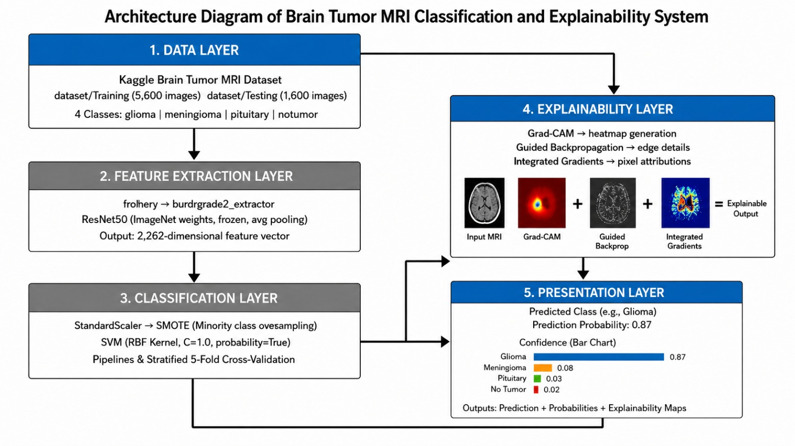

Fig 4.1: End-to-End Brain tumor Detection using Deep Learning

Figure 4.1 illustrates the overall architecture of the Brain Tumor Classification and Explainability System, which is organized into five interconnected layers. The Data Layer uses the Kaggle Brain Tumor MRI Dataset containing training and testing images from four classes: glioma, meningioma, pituitary tumor, and no tumor. In the Feature Extraction Layer, a pre-trained ResNet50 model extracts 2048-dimensional feature vectors from MRI images. These features are processed in the Classification Layer, where a StandardScaler and an SVM classifier predict the tumor category and generate probability scores. The Explainability Layer uses Grad-CAM with a ResNet50-based CNN model to generate heatmaps highlighting important regions in the MRI scan. Finally, the Presentation Layer provides a Flask-based web interface for uploading MRI images, viewing predictions, confidence scores, and Grad-CAM visualizations. Together, these layers enable accurate and interpretable brain tumor classification.

Data Flow Diagram
The data flow through the system follows a sequential pipeline from network traffic capture to dashboard display:
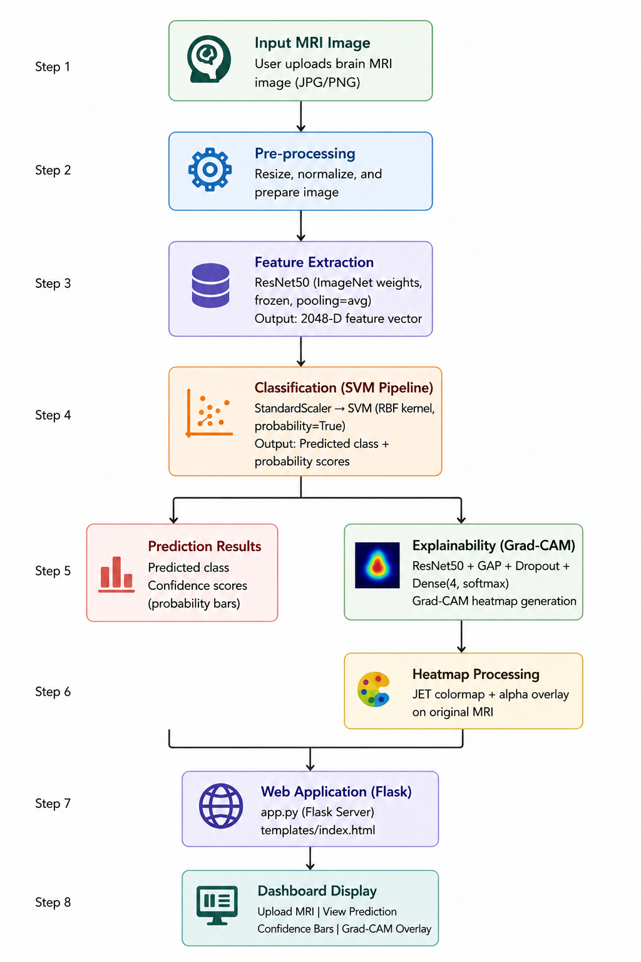

Fig. 4.2: Data Flow Diagram of Attack Detection

Project File Structure
The project follows a clean modular structure with each file serving a specific purpose:
File | Purpose
train_model.py | Trains Random Forest and Isolation Forest models on CICIDS2017 dataset
packet_capture.py | Captures real-time network statistics using psutil library
app.py | Main Flask application with detection loop and all API routes
rf_model.pkl | Saved trained Random Forest classifier model

iso_model.pkl | Saved trained Isolation Forest anomaly detection model
data/sett.csv | CICIDS2017 dataset used for model training
logs/logs.txt | Persistent audit log of all detections
templates/index.html | Home page of the Flask web application
templates/dashboard.html | Live monitoring dashboard with auto-refresh

Table 4.1: Project File Structure

CHAPTER 5
EXPECTED OUTCOMES

Functional Detection System
The primary expected outcome is a fully functional Brain Tumor MRI Detection System that classifies uploaded MRI images into glioma, meningioma, pituitary tumor, or no tumor with associated confidence scores. The system operates through a user-friendly Flask web interface requiring no command-line expertise.

The hybrid Deep Learning and machine learning
The system is expected to demonstrate the effectiveness of combining deep learning feature extraction with classical machine learning classification. ResNet50 extracts rich visual features from MRI scans, while the SVM classifier provides efficient and interpretable multi-class decision boundaries in the 2048-dimensional feature space. This hybrid approach is expected to achieve accurate and reliable tumor classification performance.

Research Gap Resolution
The project is expected to demonstrate resolution of the key research gaps identified in three reviewed papers:
    - Kermany et al. (2018) gap: High GPU and data requirements of end-to-end CNN models — resolved through a hybrid CNN+SVM architecture using frozen ResNet50 feature extraction.
    - Deepak & Ameer (2019) gap: Lack of visual explainability in tumor classification — resolved thro
ugh Grad-CAM heatmap integration.
    - Selvaraju et al. (2017) gap: Requirement of spatial CNN feature maps for Grad-CAM generation —resolved through a dedicated CNN head model.

Explainable AI through Grad-CAM Visualization
The Grad-CAM explainability module is expected to generate heatmaps highlighting the brain regions that most influenced the model's prediction. This visual explanation mechanism improves transparency and trustworthiness in medical AI systems by allowing users and reviewers to verify whether the model focuses on clinically relevant tumor regions during classification.insights.

Web-Based Deployment
The Flask web application is expected to provide:
    - Drag-and-drop MRI image upload interface.
    - Instant prediction with class label and confidence percentage. Auto-refresh every five seconds ensuring administrators always see the latest detection results.

    - Demo Per-class probability bars for all four tumor categories.
    - Side-by-side display of the original MRI image and Grad-CAM heatmap overlay.
    - Responsive dark-theme user interface compatible with desktop and mobile browsers.
    - Clear error messages when uploads fail or required model artifacts are missing.

User-Friendly Medical Image Analysis Platform
The system is expected to provide a seamless and accessible experience for users by integrating image upload, classification, confidence estimation, and explainability visualization into a single platform. This enables rapid analysis of MRI scans without requiring expertise in machine learning or medical image processing tools.

Academic and Practical Contribution
Beyond its practical utility, this project serves as a comprehensive case study on applying hybrid deep learning and machine learning techniques in medical image analysis. It demonstrates transfer learning using ResNet50, data augmentation techniques, SVM-based classification, Grad-CAM explainability, and Flask-based deployment within a single integrated framework. The project provides a valuable reference implementation for future research and real-world medical AI applications.

REFERENCES

[1] Kermany, D. S., Goldbaum, M., Cai, W., et al., "Identifying Medical Diagnoses and Treatable Diseases by Image-Based Deep Learning," Cell, vol. 172, no. 5, pp. 1122-1131, 2018.
[2] S. Deepak and P. M. Ameer, "Brain Tumor Classification Using Deep CNN Features via Logistic Classifier," Journal of Medical Systems, vol. 43, no. 9, 2019.
[3] R. R. Selvaraju, M. Cogswell, A. Das, R. Vedantam, D. Parikh, and D. Batra, "Grad-CAM: Visual Explanations from Deep Networks via Gradient-based Localization," ICCV, 2017.
[4] K. He, X. Zhang, S. Ren, and J. Sun, "Deep Residual Learning for Image Recognition," CVPR, pp. 770-778, 2016.
[5] Cortes, C. and Vapnik, V., "Support-Vector Networks," Machine Learning, vol. 20, no. 3, pp. 273-297, 1995.
[6] F. Chollet, "Xception: Deep Learning with Depthwise Separable Convolutions," CVPR, 2017.
[7] TensorFlow Documentation, "Keras Applications — ResNet50," https://keras.io/api/applications/resnet/, 2024.
[8] scikit-learn Documentation, "Support Vector Machines," https://scikit-learn.org/stable/modules/svm.html, 2024.
[9] Kaggle, "Brain Tumor MRI Dataset," https://www.kaggle.com/datasets, accessed 2025.
[10] S. J. Pan and Q. Yang, "A Survey on Transfer Learning," IEEE Transactions on Knowledge and Data Engineering, vol. 22, no. 10, pp. 1345-1359, 2010.

Sustainable Development Goal (SDG):

This project aligns with the United Nations Sustainable Development Goals (SDGs) by contributing to health
innovation, responsible technology development, and accessible healthcare solutions.

SDG | Target | Core Project Contribution
SDG 3:  Good Health  and Well-Being | Ensure healthy lives and promote well-being for all. | Automated brain tumor detection from MRI scans supports early diagnosis and timely medical intervention, potentially improving patient outcomes and reducing diagnostic delays.
SDG 9:  Industry, Innovation  and Infrastructure | Build resilient infrastructure and foster innovation. | Introduces a hybrid ML architecture combining ResNet50, SVM, and Grad-CAM — demonstrating innovation in medical AI using open-source technologies and transfer learning.
SDG 4:  Quality Education | Ensure inclusive and equitable quality education. | Serves as a comprehensive academic project demonstrating deep learning, classical ML, Explainable AI, and web deployment — contributing to practical AI education in engineering curricula.
SDG 12:  Responsible Consumption  and Production | Ensure sustainable consumption and production patterns. | Built entirely on open-source technologies (Python, TensorFlow, Flask, scikit-learn) — promoting responsible, cost-effective, and sustainable software development without proprietary dependencies.
Table 6.1: Sustainable Development Goals (SDG) Alignment Matrix

Conclusion

