***PROJECT NAME: Personal Portfolio Website***

**TEAM MEMBERS:**

**1. NAME: SOUMYA RANJAN BEHERA**

**REG.NO-2462366**

**MAIL:** [**soumya.ranjan@btech.christuniversity.in**](mailto:soumya.ranjan@btech.christuniversity.in)

**2. NAME: JEREMIAH CHRISTIANO PAREIRA**

**REG.NO-2462330**

**MAIL: jeremiah.christiano@btech.christuniversity.in**

**3. NAME: KISHAN S T**

**REG.NO-2462338**

**MAIL: kishan.s@btech.christuniversity.in**

**INSTITUTION: Christ University,Kengeri Campus,Bengaluru**

**FACULTY NAME: Ms Nagaveena**

**COURSE: UI/UX Design Fundamentals**

**DATE OF SUBMISSION:26/09/2025**

# 2. Abstract

This project presents the design and development of a fully responsive personal portfolio website that serves as a digital identity for Soumya Ranjan. The key objective of the project is to create a visually appealing and user-friendly platform where potential employers, collaborators, or peers can quickly learn about the developer’s skills, projects, and contact details. Built entirely with HTML5, CSS3, and a small amount of JavaScript for smooth scrolling, the site demonstrates modern front-end practices such as semantic markup, flexible grid systems, and mobile-first responsiveness. Bootstrap was used to streamline layout consistency and provide a professional look, while custom CSS animations add a unique personal touch. The final outcome is a clean, interactive website that functions seamlessly across devices, ensuring accessibility and ease of navigation for all visitors.

# 3. Objectives

The primary goal of this project was to create a personal branding platform that showcases both technical ability and aesthetic sense.  
Detailed objectives include:

1. User-Centric Design: Apply modern UI/UX principles to craft an interface that feels intuitive, professional, and engaging to visitors from varied backgrounds.
2. Fully Responsive Layout: Implement a mobile-first strategy to ensure that all pages adapt fluidly to screens ranging from smartphones to large desktop monitors without losing clarity or functionality.
3. Structured HTML5 Markup: Use semantic elements such as <header>, <section>, and <footer> to create a logical content hierarchy that improves readability, maintainability, and SEO performance.
4. Advanced CSS Styling: Employ CSS Flexbox and Grid systems, CSS variables, hover effects, and transitions to deliver both aesthetic appeal and scalable design patterns.
5. Accessibility and Readability: Maintain high color contrast, clear typography, and appropriate aria-labels to make the site inclusive for users with visual or motor limitations.

# 4. Scope of the Project

The project is front-end focused, concentrating solely on client-side design and interaction.

* Included: Creation of a multi-section portfolio website containing an About page, Skills showcase, Project gallery, and a functional-looking Contact form. Responsive design techniques, basic animations, and smooth scrolling are fully implemented.
* Excluded: No backend server, database integration, or advanced JavaScript frameworks were used. The contact form does not yet send real emails; it serves as a design placeholder.
* Target Platforms: Modern desktop browsers, tablets, and mobile devices. The website was tested on Chrome, Edge, and Firefox to ensure cross-browser compatibility.

# 5. Tools & Technologies Used

| Tool / Technology | Purpose |
| --- | --- |
| HTML5 | Provides semantic structure and content hierarchy for every page and section. |
| CSS3 | Handles all styling, including layouts, responsive adjustments, and animations. |
| Bootstrap 5 | Simplifies grid-based layouts, navigation components, and responsive breakpoints. |
| JavaScript / jQuery | Adds smooth scrolling behavior and simple form interaction for demonstration. |
| VS Code | Primary code editor offering syntax highlighting, live server, and Git integration. |
| Chrome DevTools | Debugging and testing responsiveness on multiple screen sizes. |

# **6. HTML Structure Overview**

The site is divided into reusable, clearly named sections:

* <header> hosts the hero banner with a gradient background and a prominent introduction.
* <nav> contains a sticky Bootstrap navbar with smooth-scroll anchor links to each section.
* <main> holds the core content: About, Skills, Projects, and Contact sections.
* <footer> provides copyright information and subtle branding.

The use of semantic tags improves both SEO and developer readability.

# 7. CSS Styling Strategy

All visual design is controlled through an external style.css file, organized into logical blocks (header, hero, dark sections, footer).

* Layout Techniques: Flexbox and CSS Grid are used to achieve precise alignment without floats.
* Responsiveness: Media queries adjust typography and spacing for devices ranging from 320 px to 1920 px wide.
* Animations: A gradient background animation on the hero section adds dynamism while maintaining performance efficiency.
* Theme Variables: CSS variables define primary colors, ensuring quick updates to the entire palette.
* Hover Effects: Skill boxes and project cards feature subtle scaling and shadow effects to increase interactivity.

# 8. Key Features

* Responsive Design: The website dynamically adapts to various screen sizes, maintaining readability and balanced spacing on phones, tablets, and desktops.
* Smooth Navigation: A fixed top navigation bar provides instant access to all major sections, while JavaScript enables smooth scrolling for a polished browsing experience.
* Project Showcases: Interactive project cards highlight key academic and personal projects with engaging hover effects and concise descriptions.
* Contact Form (Demo): A styled form allows visitors to input name, email, and a message, giving the appearance of a functional communication channel even though no backend exists yet.
* Accessible Visuals: High-contrast color schemes and legible font sizes improve accessibility for all users, including those with visual impairments.

# 9. Challenges Faced & Solutions

| Challenge | Detailed Solution |
| --- | --- |
| Ensuring consistent layout on small devices | Adopted a mobile-first approach, progressively enhancing the design for larger screens rather than scaling down a desktop layout. |
| Overlapping content in hero section | Used flexbox centering with min-height to maintain proper vertical alignment across varied screen heights. |
| Color contrast for dark mode | Tested combinations using online contrast checkers to meet WCAG accessibility standards. |
| Typography scaling | Implemented relative units (em/rem) so text resizes gracefully with user preferences. |

# 10. Outcome

The completed project delivers a polished, professional portfolio website that functions smoothly across all tested platforms. Visitors can easily navigate through the About, Skills, and Projects sections and preview contact options. By working exclusively with HTML, CSS, and lightweight JavaScript, the project deepened understanding of responsive design, layout structuring, accessibility practices, and UI/UX fundamentals. The final product is ready for real-world deployment after adding a backend or hosting on a live domain.

# 11. Future Enhancements

1. Backend Integration for Real Email Delivery: Incorporating a backend (Node.js, PHP, or Django) with an SMTP service would enable the contact form to securely send messages, turning the current static placeholder into a functional communication tool.
2. Theme Toggler for Light/Dark Modes: Adding a toggle switch with CSS variables and JavaScript would allow users to choose between light and dark themes, improving personalization and comfort in different lighting conditions.
3. Dynamic Project Filtering: Using AJAX or a headless CMS like Contentful could enable live filtering of projects based on categories (e.g., Web, IoT, Algorithms) without reloading the page, giving the portfolio a more interactive and scalable structure.
4. Progressive Web App (PWA) Features: Implementing service workers and caching strategies would let visitors install the portfolio on their devices and access key pages offline, ensuring faster load times and improved user experience even with poor connectivity.

# 12. Sample Code (Excerpt)

[26-09-2025 00:29] Soumya Ranjan: <!DOCTYPE html>

<html lang="en">

<head>

<meta charset="UTF-8">

<meta name="viewport" content="width=device-width, initial-scale=1.0">

<meta name="description" content="Portfolio of Soumya Ranjan – Developer & Problem Solver">

<title>Soumya's Portfolio</title>

<link href="https://cdn.jsdelivr.net/npm/bootstrap@5.3.3/dist/css/bootstrap.min.css" rel="stylesheet">

<link rel="stylesheet" href="style.css">

</head>

<body data-bs-spy="scroll" data-bs-target="#mainNav" data-bs-offset="70">

<nav id="mainNav" class="navbar navbar-expand-lg navbar-dark bg-dark fixed-top">

<div class="container">

<a class="navbar-brand fw-bold" href="#">Soumya <span class="text-primary">Ranjan</span></a>

<button class="navbar-toggler" type="button" data-bs-toggle="collapse" data-bs-target="#navbarNav">

<span class="navbar-toggler-icon"></span>

</button>

<div class="collapse navbar-collapse" id="navbarNav">

<ul class="navbar-nav ms-auto">

<li class="nav-item"><a class="nav-link" href="#about">About</a></li>

<li class="nav-item"><a class="nav-link" href="#skills">Skills</a></li>

<li class="nav-item"><a class="nav-link" href="#projects">Projects</a></li>

<li class="nav-item"><a class="nav-link" href="#contact">Contact</a></li>

</ul>

</div>

</div>

</nav>

<header class="hero-section d-flex align-items-center text-center">

<div class="container">

<h1 class="display-4 fw-bold text-light">Hi, I'm <span class="text-warning">Soumya</span></h1>

<p class="lead text-light">A Passionate Developer & Problem Solver</p>

<a href="#projects" class="btn btn-outline-light btn-lg mt-3">View My Work</a>

</div>

</header>

<section id="about" class="py-5 bg-light">

<div class="container">

<h2 class="text-center mb-4">About Me</h2>

<div class="row align-items-center">

<div class="col-md-4 text-center mb-3 mb-md-0">

<img src="download.jpg" class="img-fluid rounded-circle shadow" alt="Portrait of Soumya Ranjan">

</div>

<div class="col-md-8">

<p>

I am Soumya Ranjan, currently pursuing my undergraduate degree at Christ University.

I enjoy solving problems, building creative projects, and continuously learning new skills.

</p>

</div>

</div>

</div>

</section>

<!-- Dark sections below -->

<section id="skills" class="py-5 section-dark">

<div class="container">

<h2 class="text-center text-light mb-4">Skills</h2>

<div class="row text-center">

<div class="col-6 col-md-4 mb-3 skill-box">HTML & CSS</div>

<div class="col-6 col-md-4 mb-3 skill-box">C Programming</div>

<div class="col-6 col-md-4 mb-3 skill-box">Java</div>

<div class="col-6 col-md-4 mb-3 skill-box">Problem Solving</div>

<div class="col-6 col-md-4 mb-3 skill-box">Team Collaboration</div>

</div>

</div>

</section>

<section id="projects" class="py-5 section-darker">

<div class="container">

<h2 class="text-center text-light mb-4">Projects</h2>

<div class="row g-4">

<div class="col-md-6">

<div class="card h-100 shadow-sm project-card">

<div class="card-body">

<h5 class="card-title text-light">Firefighter Robot</h5>

<p class="card-text text-muted">A robot capable of detecting and extinguishing fires automatically.</p>

</div>

</div>

</div>

<div class="col-md-6">

<div class="card h-100 shadow-sm project-card">

<div class="card-body">

<h5 class="card-title text-light">Operating System Simulation</h5>

<p class="card-text text-muted">Designed a simulation of OS-level process management techniques.</p>

</div>

</div>

</div>

</div>

</div>

</section>

<section id="contact" class="py-5 section-dark">

<div class="container">

<h2 class="text-center text-light mb-4">Contact Me</h2>

<div class="row justify-content-center">

<div class="col-lg-6">

<form id="contactForm">

<div class="mb-3">

<input type="text" class="form-control" name="name" placeholder="Your Name" required>

</div>

<div class="mb-3">

<input type="email" class="form-control" name="email" placeholder="Your Email" required>

</div>

<div class="mb-3">

<textarea class="form-control" name="message" rows="5" placeholder="Your Message" required></textarea>

</div>

<button type="submit" class="btn btn-warning w-100">Send Message</button>

</form>

<div id="formAlert" class="mt-3"></div>

</div>

</div>

</div>

</section>

<footer class="bg-black text-light text-center py-3">

&copy; 2025 Soumya Ranjan | All Rights Reserved

</footer>

<script src="https://code.jquery.com/jquery-3.6.4.min.js"></script>

<script src="https://cdn.jsdelivr.net/npm/bootstrap@5.3.3/dist/js/bootstrap.bundle.min.js"></script>

<script src="script.js"></script>

</body>

</html>

[26-09-2025 00:29] Soumya Ranjan: // Smooth scrolling for nav links

$(document).on('click','a.nav-link',function(e){

if (this.hash !== '') {

e.preventDefault();

const hash = this.hash;

$('html, body').animate({

scrollTop: $(hash).offset().top - 70

}, 600);

}

});

// Demo contact form handler

$('#contactForm').on('submit', function(e){

e.preventDefault();

$('#formAlert').html(

'<div class="alert alert-success">Thanks! Message sent (demo only).</div>'

);

this.reset();

});

[26-09-2025 00:30] Soumya Ranjan: /* Hero gradient stays the same */

.hero-section {

min-height: 100vh;

background: linear-gradient(-45deg, #0d6efd, #6610f2, #20c997, #0dcaf0);

background-size: 400% 400%;

animation: gradientShift 12s ease infinite;

padding-top: 80px;

}

@keyframes gradientShift {

0% {background-position: 0% 50%;}

50% {background-position: 100% 50%;}

100% {background-position: 0% 50%;}

}

/* Dark themes for lower sections */

.section-dark {

background: #111;

color: #f8f9fa;

}

.section-darker {

background: #000;

color: #f8f9fa;

}

/* Skill boxes on dark bg */

.skill-box {

background: #1c1c1c;

color: #f8f9fa;

padding: 12px;

border-radius: 10px;

transition: transform 0.3s, background 0.3s;

}

.skill-box:hover {

transform: translateY(-6px) scale(1.05);

background: #333;

}

/* Project cards dark style */

.project-card {

background: #1c1c1c;

border: none;

transition: transform 0.3s, box-shadow 0.3s;

}

.project-card:hover {

transform: translateY(-6px);

box-shadow: 0 0 20px rgba(255,255,255,0.1);

}

footer {

font-size: 0.9rem;

}

# 13. Screenshots of Final Output:

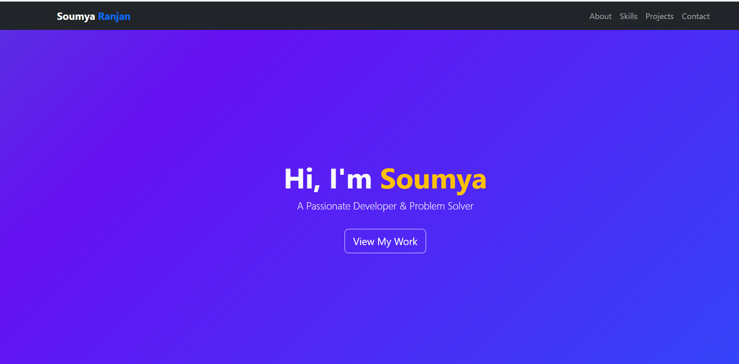

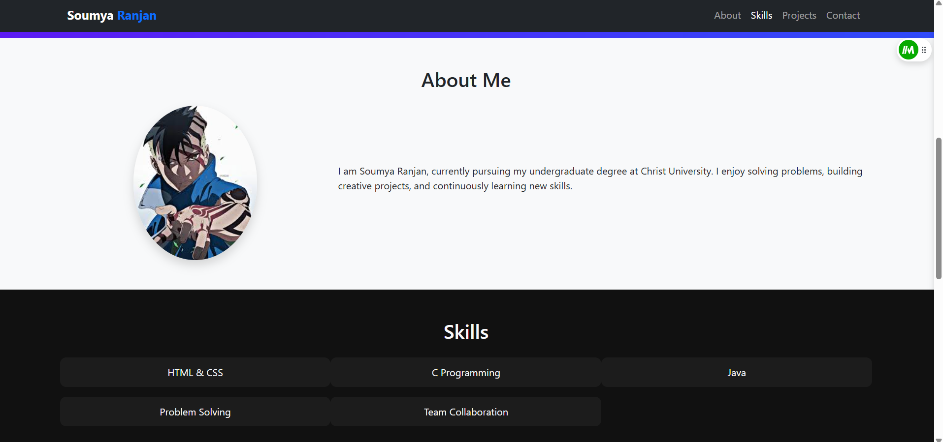

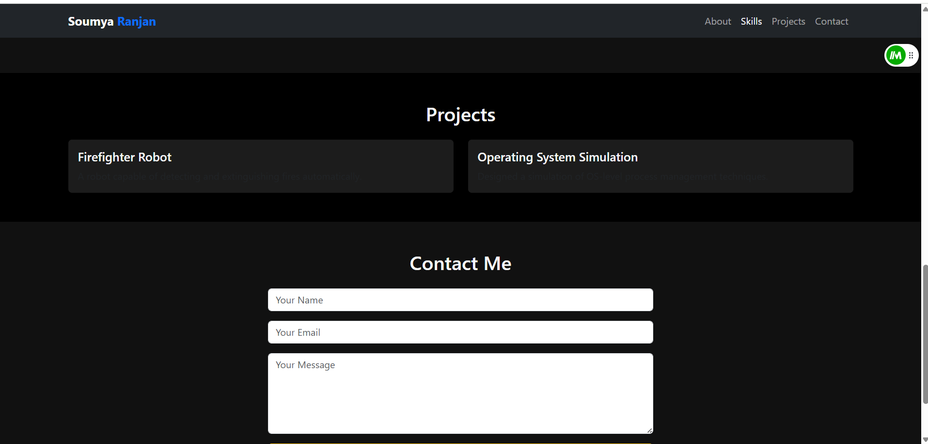

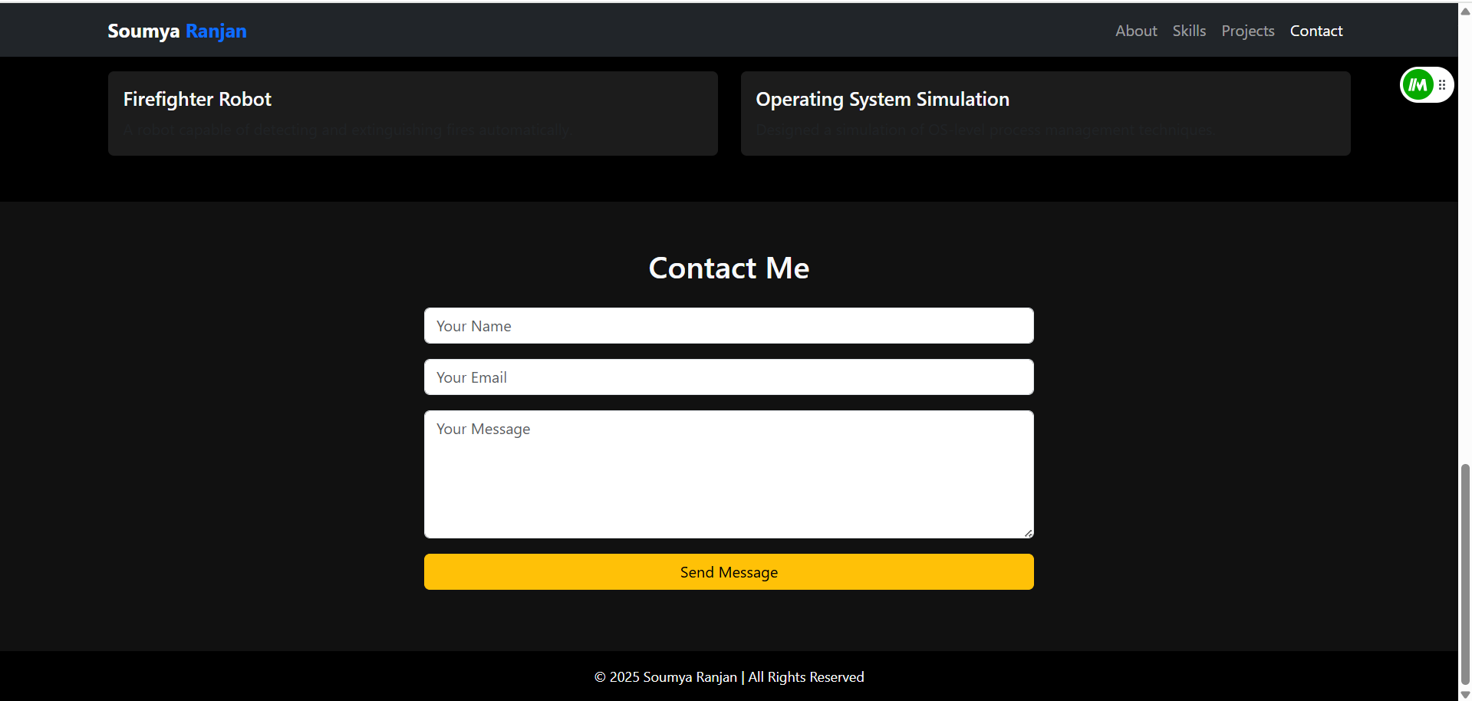

# 14. Conclusion

This mini-project successfully demonstrates the creation of a complete, responsive personal portfolio website using primarily HTML and CSS with minimal JavaScript. Through the design and coding process, key skills such as semantic markup, responsive layout strategies, color theory, and interactive design were strengthened. The project highlights the value of thoughtful UI/UX decisions and serves as a strong foundation for future enhancements like backend integration and advanced interactivity. By completing this work, the developer gained both technical expertise and practical experience in presenting personal achievements in a professional digital format.

**15. References**

* **L&T LMS :** [**https://learn.lntedutech.com/Landing/MyCourse**](https://learn.lntedutech.com/Landing/MyCourse)
* **Bootstrap Documentation : https://getbootstrap.com**
* **MDN Web Docs (HTML/CSS/JS):** [**https://developer.mozilla.org/**](https://developer.mozilla.org/)