***PROJECT NAME: Personal Portfolio Website***

**TEAM MEMBERS:**

**1. NAME: SOUMYA RANJAN BEHERA**

**REG.NO-2462366**

**MAIL:** [**soumya.ranjan@btech.christuniversity.in**](mailto:soumya.ranjan@btech.christuniversity.in)

**2. NAME: JEREMIAH CHRISTIANO PAREIRA**

**REG.NO-2462330**

**MAIL: jeremiah.christiano@btech.christuniversity.in**

**3. NAME: KISHAN S T**

**REG.NO-2462338**

**MAIL: kishan.s@btech.christuniversity.in**

**INSTITUTION: Christ University,Kengeri Campus,Bengaluru**

**FACULTY NAME: Ms Nagaveena**

**COURSE: UI/UX Design Fundamentals**

**DATE OF SUBMISSION:26/09/2025**

**2. Abstract**

This project focuses on designing and developing a **responsive landing page** for *NovaWatch*, a fictional smartwatch brand. The primary goal is to create an engaging user interface that highlights product features, encourages exploration, and builds brand identity. Core technologies include **HTML5**, **CSS3**, **Bootstrap 5**, and **JavaScript** to achieve a clean, interactive layout. The website adapts to multiple screen sizes, ensuring seamless viewing on desktops, tablets, and mobiles. The final output is a visually appealing, user-friendly landing page that demonstrates strong front-end development skills and modern UI/UX principles.

**3. Objectives**

The project was guided by the following goals:

* **Design a user-friendly interface:** Apply modern UI/UX practices to provide a clean, visually appealing layout.
* **Responsive Development:** Ensure the page adjusts smoothly to desktop, tablet, and mobile screens.
* **Structured Semantic HTML:** Use HTML5 elements for better readability, accessibility, and maintainability.
* **Brand Consistency:** Implement consistent colors, typography, and branding to reflect the futuristic smartwatch theme.
* **Interactive Elements:** Add scroll animations and hover effects using JavaScript for better user engagement.

**4. Scope of the Project**

The project is limited to **front-end design and implementation**.

* Covers only **UI/UX development**; no back-end database or server integration.
* Focused on showcasing **product features, images, testimonials, and a call-to-action** section.
* Designed to work across **desktop, tablet, and mobile** devices.
* Uses **open-source technologies** and manual coding—no paid plugins.
* Does not include real e-commerce functionality, checkout systems, or live product APIs.

**5. Tools & Technologies Used**

| **Tool / Technology** | **Purpose** |
| --- | --- |
| **HTML5** | Semantic markup for structure (header, sections, footer). |
| **CSS3** | Styling, layouts, colors, gradients, hover effects. |
| **Bootstrap 5** | Grid system for responsive design and reusable UI components. |
| **JavaScript** | Navbar scroll behavior, reveal animations, and image tilt effects. |
| **VS Code** | Code editing and file management. |
| **Chrome DevTools** | Testing, debugging, and responsiveness checks. |

**6. HTML Structure Overview**

* **Header:** Contains the NovaWatch logo and navigation menu with anchor links to sections.
* **Hero Section:** Features a large product image, tagline, and call-to-action button.
* **Features Section:** Highlights smartwatch features with icons and descriptions.
* **Gallery Section:** Displays watch models using image grids.
* **Testimonials:** User reviews in a carousel layout.
* **Footer:** Contact details, social links, and copyright.
* Semantic tags like <header>, <main>, <section>, <article>, and <footer> were used to improve accessibility and SEO.

**7. CSS Styling Strategy**

* **External Stylesheet:** A dedicated style.css file organizes all styling.
* **Layout Techniques:** Flexbox and Bootstrap Grid for precise alignment and spacing.
* **Color Palette:** Futuristic gradients of deep blue, black, and neon accents to match the tech brand.
* **Typography:** Clean, modern fonts for readability and brand consistency.
* **Media Queries:** Customized breakpoints for mobile-first design, ensuring smooth responsiveness.
* **Animations:** Smooth hover transitions, shadow effects, and fade-in scroll reveals to create an interactive experience.

**8. JavaScript Functionality**

* **Navbar Scroll Effect:** Changes background color when scrolling for better visibility.
* **Scroll Animations:** Reveals elements gradually as the user scrolls through sections.
* **Image Tilt:** Adds subtle 3D tilt effects to product images for a premium look.
* Scripts are lightweight to maintain fast loading speeds.

**9. Code Snippets**

**HTML :**

<!DOCTYPE html>

<html lang="en">

<head>

<meta charset="UTF-8">

<meta name="viewport" content="width=device-width, initial-scale=1">

<meta name="description" content="Landing page for a fictional product">

<title>NovaWatch – Smart & Stylish</title>

<link href="https://cdn.jsdelivr.net/npm/bootstrap@5.3.3/dist/css/bootstrap.min.css" rel="stylesheet">

<link rel="stylesheet" href="stylec.css">

</head>

<body>

<!-- Navbar -->

<nav class="navbar navbar-expand-lg navbar-dark bg-dark fixed-top">

<div class="container">

<a class="navbar-brand fw-bold" href="#">NovaWatch</a>

<button class="navbar-toggler" type="button" data-bs-toggle="collapse" data-bs-target="#navbarNav">

<span class="navbar-toggler-icon"></span>

</button>

<div class="collapse navbar-collapse" id="navbarNav">

<ul class="navbar-nav ms-auto">

<li class="nav-item"><a class="nav-link" href="#features">Features</a></li>

<li class="nav-item"><a class="nav-link" href="#testimonials">Reviews</a></li>

<li class="nav-item"><a class="nav-link btn btn-warning text-dark ms-2 px-3" href="#buy">Buy Now</a></li>

</ul>

</div>

</div>

</nav>

<!-- Hero -->

<header class="hero-section text-center d-flex align-items-center">

<div class="container">

<h1 class="display-3 fw-bold text-light">Meet <span class="text-warning">NovaWatch</span></h1>

<p class="lead text-light mb-4">The smart watch that blends style, health, and seamless connectivity.</p>

<a href="#buy" class="btn btn-warning btn-lg me-2">Buy Now</a>

<a href="#features" class="btn btn-outline-light btn-lg">Learn More</a>

</div>

</header>

<!-- Features -->

<section id="features" class="py-5 bg-light">

<div class="container">

<h2 class="text-center mb-5">Key Features</h2>

<div class="row g-4 text-center">

<div class="col-md-4">

<div class="feature-box p-4 shadow-sm">

<i class="bi bi-heart-pulse display-5 text-warning"></i>

<h4 class="mt-3">Health Tracking</h4>

<p>Monitor heart rate, sleep patterns, and activity 24/7 with precision sensors.</p>

</div>

</div>

<div class="col-md-4">

<div class="feature-box p-4 shadow-sm">

<i class="bi bi-battery-charging display-5 text-warning"></i>

<h4 class="mt-3">Week-long Battery</h4>

<p>Enjoy up to 7 days of use on a single charge—no more daily charging stress.</p>

</div>

</div>

<div class="col-md-4">

<div class="feature-box p-4 shadow-sm">

<i class="bi bi-phone display-5 text-warning"></i>

<h4 class="mt-3">Seamless Connectivity</h4>

<p>Receive calls, messages, and app alerts right on your wrist instantly.</p>

</div>

</div>

</div>

</div>

</section>

<!-- Watch Gallery -->

<section id="gallery" class="py-5 bg-dark text-light">

<div class="container">

<h2 class="text-center mb-5">Choose Your Style</h2>

<div class="row g-4">

<div class="col-md-4 text-center">

<img src="watch3.jpg" class="img-fluid rounded shadow gallery-img" alt="Watch 1">

<h5 class="mt-3">Watch 1</h5>

</div>

<div class="col-md-4 text-center">

<img src="watch2.avif" class="img-fluid rounded shadow gallery-img" alt="Watch 2">

<h5 class="mt-3">Watch 2</h5>

</div>

<div class="col-md-4 text-center">

<img src="watch1.jpg" class="img-fluid rounded shadow gallery-img" alt="Watch 3">

<h5 class="mt-3">Watch 3</h5>

</div>

</div>

</div>

</section>

<!-- Testimonials -->

<section id="testimonials" class="py-5 bg-dark text-light">

<div class="container">

<h2 class="text-center mb-5">What Customers Say</h2>

<div class="row g-4">

<div class="col-md-4">

<div class="p-4 bg-black rounded shadow-sm h-100">

<p>"NovaWatch keeps me on track with workouts and looks amazing!"</p>

<h6 class="text-warning mt-3">— Priya K.</h6>

</div>

</div>

<div class="col-md-4">

<div class="p-4 bg-black rounded shadow-sm h-100">

<p>"Battery lasts all week. Finally a watch that fits my lifestyle."</p>

<h6 class="text-warning mt-3">— Alex M.</h6>

</div>

</div>

<div class="col-md-4">

<div class="p-4 bg-black rounded shadow-sm h-100">

<p>"Crystal-clear display and instant notifications—worth every penny."</p>

<h6 class="text-warning mt-3">— Sara D.</h6>

</div>

</div>

</div>

</div>

</section>

<!-- Buy Section -->

<section id="buy" class="py-5 text-center">

<div class="container">

<h2 class="mb-4">Ready to Elevate Your Lifestyle?</h2>

<p class="mb-4">Order today and get free shipping plus a 1-year warranty.</p>

<a href="#" class="btn btn-warning btn-lg">Buy NovaWatch</a>

</div>

</section>

<!-- Footer -->

<footer class="bg-dark text-light text-center py-3">

&copy; 2025 NovaWatch. All rights reserved.

</footer>

<script src="https://code.jquery.com/jquery-3.6.4.min.js"></script>

<script src="https://cdn.jsdelivr.net/npm/bootstrap@5.3.3/dist/js/bootstrap.bundle.min.js"></script>

<script src="https://cdn.jsdelivr.net/npm/bootstrap-icons@1.11.3/font/bootstrap-icons.js"></script>

<script src="scripts.js"></script>

</body>

</html>

**CSS:**

/* === Global Reset === */

* { margin: 0; padding: 0; box-sizing: border-box; }

body {

font-family: 'Poppins', 'Segoe UI', sans-serif;

background: #0a0a0a;

color: #eaeaea;

line-height: 1.6;

scroll-behavior: smooth;

}

/* Navbar */

.navbar {

padding: 15px 0;

background: rgba(0, 0, 0, 0.6);

backdrop-filter: blur(10px);

transition: background 0.4s ease;

}

.navbar.scrolled {

background: linear-gradient(90deg, #3a3a3a, #000);

}

.navbar-brand {

color: #00c3ff !important;

font-weight: 700;

font-size: 1.7rem;

text-shadow: 0 0 10px #00c3ff;

}

.navbar-nav .nav-link {

margin-left: 20px;

color: #ccc !important;

transition: color 0.3s ease;

}

.navbar-nav .nav-link:hover {

color: #00c3ff !important;

}

/* Hero */

.hero-section {

height: 100vh;

background: linear-gradient(to bottom, rgba(0,0,0,0.8), rgba(10,10,10,0.9)),

url('hero-bg.jpg') center/cover no-repeat;

display: flex;

align-items: center;

justify-content: center;

text-align: center;

position: relative;

}

.hero-section h1 {

font-size: 4rem;

color: #fff;

text-transform: uppercase;

text-shadow: 0 0 20px #00c3ff;

}

.hero-section span {

color: #ff00c8;

text-shadow: 0 0 20px #ff00c8;

}

.hero-section p {

margin-top: 20px;

color: #ccc;

font-size: 1.2rem;

}

.hero-section .btn {

margin: 15px 10px 0;

padding: 14px 36px;

font-size: 1.1rem;

border-radius: 30px;

border: none;

transition: all 0.3s ease;

}

.btn-primary-glow {

background: linear-gradient(90deg,#00c3ff,#ff00c8);

color: #fff;

box-shadow: 0 0 15px #00c3ff;

}

.btn-primary-glow:hover {

box-shadow: 0 0 30px #ff00c8;

transform: translateY(-3px);

}

.btn-outline-light:hover {

background: #fff;

color: #000;

}

/* Section Titles */

section h2 {

color: #00c3ff;

text-align: center;

font-weight: 700;

text-shadow: 0 0 10px #00c3ff;

margin-bottom: 50px;

}

/* Features */

#features {

background: #111;

padding: 80px 0;

}

.feature-box {

background: #1a1a1a;

padding: 35px;

border-radius: 20px;

transition: all 0.4s ease;

border: 1px solid #222;

}

.feature-box:hover {

transform: translateY(-10px);

box-shadow: 0 0 25px rgba(0,195,255,0.4);

}

.feature-box i {

font-size: 2.8rem;

color: #ff00c8;

}

/* Watch Gallery */

#gallery {

background: radial-gradient(circle at top, #0d0d0d 0%, #000 100%);

padding: 80px 0;

}

.gallery-img {

border-radius: 20px;

max-height: 350px;

object-fit: cover;

transition: transform 0.4s ease, box-shadow 0.4s ease;

}

.gallery-img:hover {

transform: scale(1.05) rotate(-1deg);

box-shadow: 0 0 25px #00c3ff;

}

#gallery h5 {

margin-top: 15px;

color: #ff00c8;

}

/* Testimonials */

#testimonials {

background: #111;

padding: 80px 0;

}

#testimonials .review-box {

background: #1a1a1a;

border: 1px solid #222;

border-radius: 20px;

padding: 30px;

transition: all 0.3s ease;

}

#testimonials .review-box:hover {

box-shadow: 0 0 20px rgba(255,0,200,0.3);

}

#testimonials h6 {

color: #00c3ff;

}

/* Buy Section */

#buy {

background: linear-gradient(135deg, #00c3ff 0%, #ff00c8 100%);

padding: 80px 0;

color: #fff;

}

#buy h2 {

color: #fff;

}

#buy .btn {

background: #000;

color: #00c3ff;

border: 2px solid #00c3ff;

transition: all 0.3s ease;

}

#buy .btn:hover {

background: #00c3ff;

color: #000;

}

/* Footer */

footer {

background: #000;

text-align: center;

padding: 25px 0;

color: #888;

}

/* Scroll Reveal Animations */

.reveal { opacity: 0; transform: translateY(50px); transition: all 1s ease; }

.reveal.active { opacity: 1; transform: translateY(0); }

@media (max-width: 768px) {

.hero-section h1 { font-size: 2.8rem; }}

**JavaScript:**

/* === Global Reset === */

* { margin: 0; padding: 0; box-sizing: border-box; }

body {

font-family: 'Poppins', 'Segoe UI', sans-serif;

background: #0a0a0a;

color: #eaeaea;

line-height: 1.6;

scroll-behavior: smooth;

}

/* Navbar */

.navbar {

padding: 15px 0;

background: rgba(0, 0, 0, 0.6);

backdrop-filter: blur(10px);

transition: background 0.4s ease;

}

.navbar.scrolled {

background: linear-gradient(90deg, #3a3a3a, #000);

}

.navbar-brand {

color: #00c3ff !important;

font-weight: 700;

font-size: 1.7rem;

text-shadow: 0 0 10px #00c3ff;

}

.navbar-nav .nav-link {

margin-left: 20px;

color: #ccc !important;

transition: color 0.3s ease;

}

.navbar-nav .nav-link:hover {

color: #00c3ff !important;

}

/* Hero */

.hero-section {

height: 100vh;

background: linear-gradient(to bottom, rgba(0,0,0,0.8), rgba(10,10,10,0.9)),

url('hero-bg.jpg') center/cover no-repeat;

display: flex;

align-items: center;

justify-content: center;

text-align: center;

position: relative;

}

.hero-section h1 {

font-size: 4rem;

color: #fff;

text-transform: uppercase;

text-shadow: 0 0 20px #00c3ff;

}

.hero-section span {

color: #ff00c8;

text-shadow: 0 0 20px #ff00c8;

}

.hero-section p {

margin-top: 20px;

color: #ccc;

font-size: 1.2rem;

}

.hero-section .btn {

margin: 15px 10px 0;

padding: 14px 36px;

font-size: 1.1rem;

border-radius: 30px;

border: none;

transition: all 0.3s ease;

}

.btn-primary-glow {

background: linear-gradient(90deg,#00c3ff,#ff00c8);

color: #fff;

box-shadow: 0 0 15px #00c3ff;

}

.btn-primary-glow:hover {

box-shadow: 0 0 30px #ff00c8;

transform: translateY(-3px);

}

.btn-outline-light:hover {

background: #fff;

color: #000;

}

/* Section Titles */

section h2 {

color: #00c3ff;

text-align: center;

font-weight: 700;

text-shadow: 0 0 10px #00c3ff;

margin-bottom: 50px;

}

/* Features */

#features {

background: #111;

padding: 80px 0;

}

.feature-box {

background: #1a1a1a;

padding: 35px;

border-radius: 20px;

transition: all 0.4s ease;

border: 1px solid #222;

}

.feature-box:hover {

transform: translateY(-10px);

box-shadow: 0 0 25px rgba(0,195,255,0.4);

}

.feature-box i {

font-size: 2.8rem;

color: #ff00c8;

}

/* Watch Gallery */

#gallery {

background: radial-gradient(circle at top, #0d0d0d 0%, #000 100%);

padding: 80px 0;

}

.gallery-img {

border-radius: 20px;

max-height: 350px;

object-fit: cover;

transition: transform 0.4s ease, box-shadow 0.4s ease;

}

.gallery-img:hover {

transform: scale(1.05) rotate(-1deg);

box-shadow: 0 0 25px #00c3ff;

}

#gallery h5 {

margin-top: 15px;

color: #ff00c8;

}

/* Testimonials */

#testimonials {

background: #111;

padding: 80px 0;

}

#testimonials .review-box {

background: #1a1a1a;

border: 1px solid #222;

border-radius: 20px;

padding: 30px;

transition: all 0.3s ease;

}

#testimonials .review-box:hover {

box-shadow: 0 0 20px rgba(255,0,200,0.3);

}

#testimonials h6 {

color: #00c3ff;

}

/* Buy Section */

#buy {

background: linear-gradient(135deg, #00c3ff 0%, #ff00c8 100%);

padding: 80px 0;

color: #fff;

}

#buy h2 {

color: #fff;

}

#buy .btn {

background: #000;

color: #00c3ff;

border: 2px solid #00c3ff;

transition: all 0.3s ease;

}

#buy .btn:hover {

background: #00c3ff;

color: #000;

}

/* Footer */

footer {

background: #000;

text-align: center;

padding: 25px 0;

color: #888;

}

/* Scroll Reveal Animations */

.reveal { opacity: 0; transform: translateY(50px); transition: all 1s ease; }

.reveal.active { opacity: 1; transform: translateY(0); }

@media (max-width: 768px) {

.hero-section h1 { font-size: 2.8rem; }

}

**10. Output (Screenshots Description)**

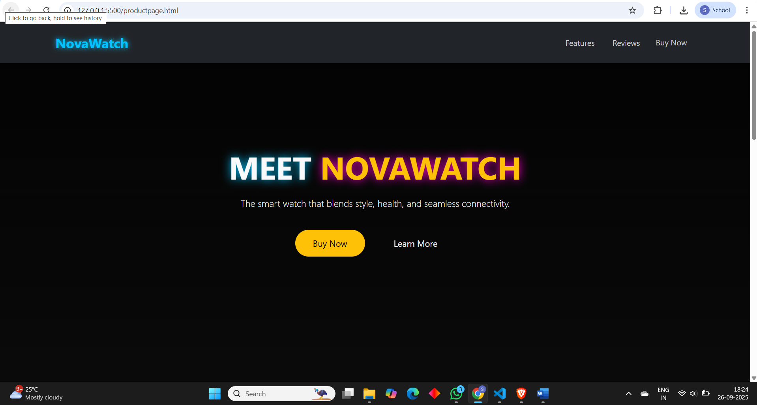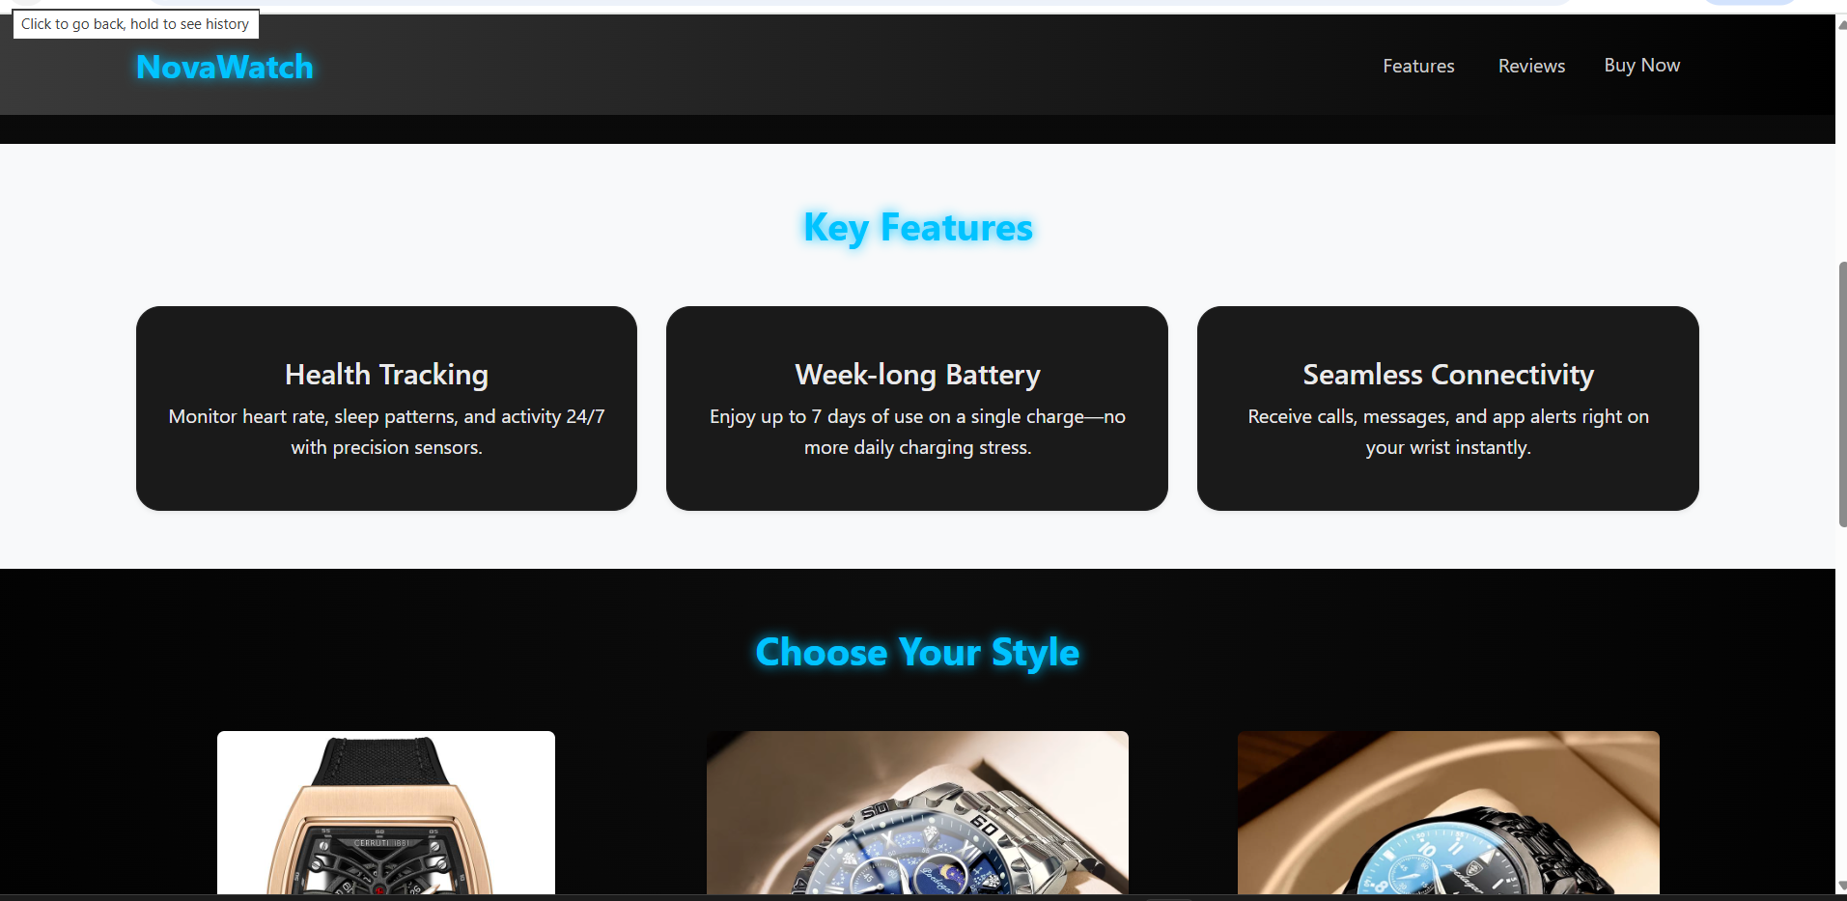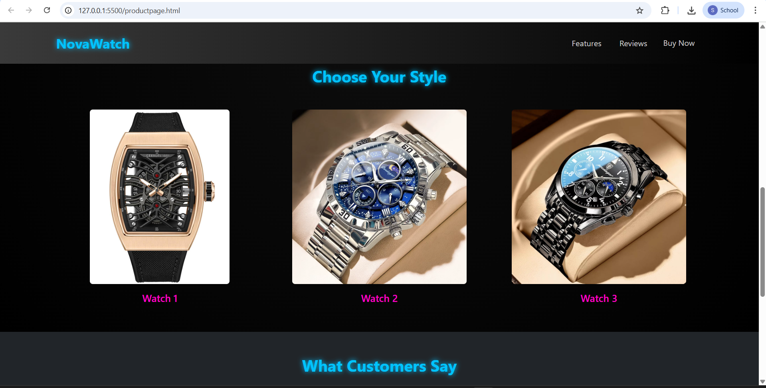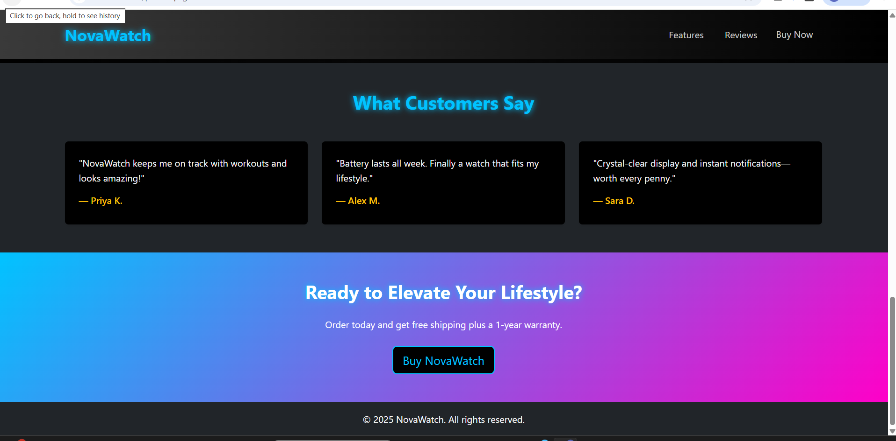

**11. Results and Outcome**

The landing page successfully demonstrates a modern, **interactive product website** that adapts across all devices. Visitors can learn about NovaWatch, explore product images, and engage with animations without performance issues. The polished UI and smooth UX showcase the capabilities of front-end web development.

**12. Conclusion**

This project proves how a combination of **semantic HTML, responsive CSS, Bootstrap utilities, and light JavaScript** can produce a professional product landing page. Future improvements may include integrating a real checkout system, adding live pricing updates, or linking to a back-end database for dynamic content.