***PROJECT NAME: Personal Portfolio Website***

**TEAM MEMBERS:**

**1. NAME: SOUMYA RANJAN BEHERA**

**REG.NO-2462366**

**MAIL:** [**soumya.ranjan@btech.christuniversity.in**](mailto:soumya.ranjan@btech.christuniversity.in)

**2. NAME: JEREMIAH CHRISTIANO PAREIRA**

**REG.NO-2462330**

**MAIL: jeremiah.christiano@btech.christuniversity.in**

**3. NAME: KISHAN S T**

**REG.NO-2462338**

**MAIL: kishan.s@btech.christuniversity.in**

**INSTITUTION: Christ University**

**Faculty Name:Ms Nagaveena**

**COURSE: UI/UX Design Fundamentals**

**DATE OF SUBMISSION:13/08/2025**

**Abstract**

This project aims to design and develop a responsive personal portfolio website for Soumya Ranjan using HTML5 and CSS3. The site serves as a professional showcase of skills, projects, and contact details. The key goal is to provide a visually engaging, easy-to-navigate online profile to support career and networking opportunities. Core technologies include semantic HTML5, CSS Flexbox, animations, and hover effects. The final outcome is a sleek, dark-themed portfolio with high usability across devices.

**Objectives**

a.Design a professional, user-friendly interface with a dark theme.

b.Develop a fully responsive layout using only HTML and CSS.

c.Implement structured HTML5 semantic elements.

d.Apply CSS animations and hover effects for visual appeal.

e.Ensure readability and accessibility across devices.

**Scope of the Project**

->Focused entirely on front-end design.

->No JavaScript or backend integration.

->Works on desktop, tablet, and mobile viewports.

->Pure code approach with no frameworks or libraries.

**Tools & Technologies Used**

Tool/Technology Purpose

HTML5 -- Content structure and semantic layout

CSS3-- Styling, animations, responsive design

VS Code-- Code editing

Chrome DevTools-- Testing, debugging, and responsiveness checks

**HTML Structure Overview**

Semantic tags: <header>, <nav>, <section>, <footer>.

Sections: Hero, About, Skills, Projects, Contact, Footer.

Navigation menu with anchor links to sections.

**CSS Styling Strategy**

->External CSS file (style.css).

Organized with sections for navigation, hero, about, skills, projects, contact, footer.

Techniques used:

Flexbox for alignment.

Hover effects for interactivity.

CSS animations (fadeIn).

Rounded elements for modern design.

Key Feature**s**

Feature Description

Responsive Design- Adapts seamlessly to various screen sizes

Dark Theme- Modern, high-contrast color scheme

Project Cards- Interactive hover effects for engagement

Skill Badges- Stylish, clickable skill representations

Contact Form Non-functional placeholder form for inquiries

**Challenges Faced & Solutions**

Challenge Solution

Alignment issues in About section Used Flexbox for centering and spacing

Font readability on dark theme Chose high-contrast text colors

Hover effect lag Optimized transitions for smoother performance

**Outcome**

Created a visually striking personal portfolio.

Fully responsive using only HTML and CSS.

Learned practical animation and hover styling techniques.

**Future Enhancements**

Add JavaScript for form validation.

Include portfolio filtering system.

Implement backend for contact form submissions.

Add a theme toggler for light/dark mode.

**Objectives**

To present Soumya Ranjan’s professional profile in a digital format.

To highlight skills, educational background, and completed projects.

To create a user-friendly, responsive, and modern portfolio design.

To allow visitors to contact Soumya directly through a built-in form.

To enhance personal branding and stand out in academic or job applications.

**Sample Code**

<!DOCTYPE html>

<html lang="en">

<head>

<meta charset="UTF-8">

<meta name="viewport" content="width=device-width, initial-scale=1.0">

<title>Soumya's Portfolio</title>

<link rel="stylesheet" href="style.css">

</head>

<body>

<!-- Navigation -->

<header>

<nav>

<div class="logo">Soumya <span>Ranjan</span></div>

<ul>

<li><a href="#about">About</a></li>

<li><a href="#skills">Skills</a></li>

<li><a href="#projects">Projects</a></li>

<li><a href="#contact">Contact</a></li>

</ul>

</nav>

</header>

<!-- Hero Section -->

<section class="hero">

<h1>Hi, I'm <span>Soumya</span></h1>

<p>A Passionate Developer & Problem Solver</p>

<a href="#projects" class="btn">View My Work</a>

</section>

<!-- About Section -->

<section id="about">

<h2>About Me</h2>

<div class="about-content">

<img src="download.jpg" alt="Soumya's photo">

<p>

I am Soumya Ranjan, currently pursuing my undergraduate degree at Christ University.

I enjoy solving problems, building creative projects, and continuously learning new skills.

</p>

</div>

</section>

<!-- Skills Section -->

<section id="skills">

<h2>Skills</h2>

<ul class="skill-list">

<li>HTML & CSS</li>

<li>C Programming</li>

<li>Java</li>

<li>Problem Solving</li>

<li>Team Collaboration</li>

</ul>

</section>

<!-- Projects Section -->

<section id="projects">

<h2>Projects</h2>

<div class="project-card">

<h3>Firefighter Robot</h3>

<p>A robot capable of detecting and extinguishing fires automatically.</p>

</div>

<div class="project-card">

<h3>Operating System Simulation</h3>

<p>Designed a simulation of OS-level process management techniques.</p>

</div>

</section>

<!-- Contact Section -->

<section id="contact">

<h2>Contact Me</h2>

<form>

<input type="text" placeholder="Your Name" required>

<input type="email" placeholder="Your Email" required>

<textarea placeholder="Your Message" rows="5" required></textarea>

<button type="submit">Send Message</button>

</form>

</section>

<!-- Footer -->

<footer>

<p>© 2025 Soumya Ranjan | All Rights Reserved</p>

</footer>

</body>

</html>

**Css:**

* {

margin: 0;

padding: 0;

box-sizing: border-box;

font-family: 'Poppins', sans-serif;

}

body {

background: #0f172a;

color: #f8fafc;

}

/* Navigation */

header {

background: rgba(15, 23, 42, 0.9);

padding: 15px 50px;

position: sticky;

top: 0;

backdrop-filter: blur(8px);

z-index: 1000;

}

nav {

display: flex;

justify-content: space-between;

align-items: center;

}

.logo {

font-size: 26px;

font-weight: bold;

}

.logo span {

color: #38bdf8;

}

nav ul {

display: flex;

list-style: none;

}

nav ul li {

margin-left: 25px;

}

nav ul li a {

text-decoration: none;

color: #f8fafc;

transition: 0.3s;

}

nav ul li a:hover {

color: #38bdf8;

}

/* Hero Section */

.hero {

text-align: center;

padding: 100px 20px;

animation: fadeIn 1.5s ease-in-out;

}

.hero span {

color: #38bdf8;

}

.btn {

display: inline-block;

margin-top: 15px;

padding: 10px 20px;

background: #38bdf8;

color: #0f172a;

font-weight: bold;

border-radius: 25px;

text-decoration: none;

transition: transform 0.3s, background 0.3s;

}

.btn:hover {

transform: scale(1.1);

background: #0ea5e9;

}

/* About */

#about {

padding: 60px 20px;

text-align: center;

}

.about-content {

display: flex;

flex-direction: column;

align-items: center;

margin-top: 20px;

}

.about-content img {

width: 220px;

height: 280px;

border-radius: 10px;

margin-bottom: 15px;

box-shadow: 0px 4px 12px rgba(0,0,0,0.5);

transition: transform 0.3s;

}

.about-content img:hover {

transform: scale(1.05);

}

.about-content p {

max-width: 600px;

line-height: 1.6;

}

/* Skills */

#skills {

padding: 60px 20px;

text-align: center;

}

.skill-list {

display: flex;

justify-content: center;

flex-wrap: wrap;

}

.skill-list li {

background: #1e293b;

margin: 8px;

padding: 10px 15px;

border-radius: 20px;

transition: transform 0.3s, background 0.3s;

}

.skill-list li:hover {

background: #38bdf8;

color: #0f172a;

transform: translateY(-5px);

}

/* Projects */

#projects {

padding: 60px 20px;

text-align: center;

}

.project-card {

background: #1e293b;

padding: 20px;

margin: 15px auto;

border-radius: 10px;

max-width: 600px;

transition: transform 0.3s, background 0.3s;

}

.project-card:hover {

background: #38bdf8;

color: #0f172a;

transform: translateY(-5px);

}

/* Contact */

#contact {

padding: 60px 20px;

text-align: center;

}

form {

display: flex;

flex-direction: column;

max-width: 400px;

margin: auto;

}

form input, form textarea {

margin: 8px 0;

padding: 10px;

border: none;

border-radius: 8px;

outline: none;

}

form button {

padding: 10px;

background: #38bdf8;

color: #0f172a;

font-weight: bold;

border: none;

border-radius: 25px;

cursor: pointer;

transition: transform 0.3s, background 0.3s;

}

form button:hover {

background: #0ea5e9;

transform: scale(1.05);

}

/* Footer */

footer {

background: #1e293b;

padding: 15px;

text-align: center;

margin-top: 40px;

}

/* Animations */

@keyframes fadeIn {

0% { opacity: 0; transform: translateY(30px); }

100% { opacity: 1; transform: translateY(0); }

}

**Website Screenshot**

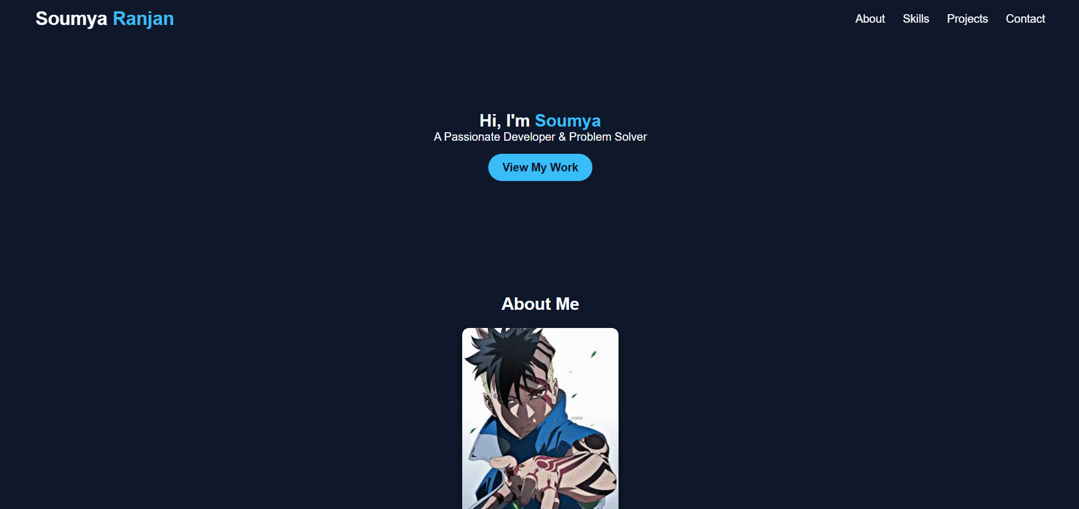

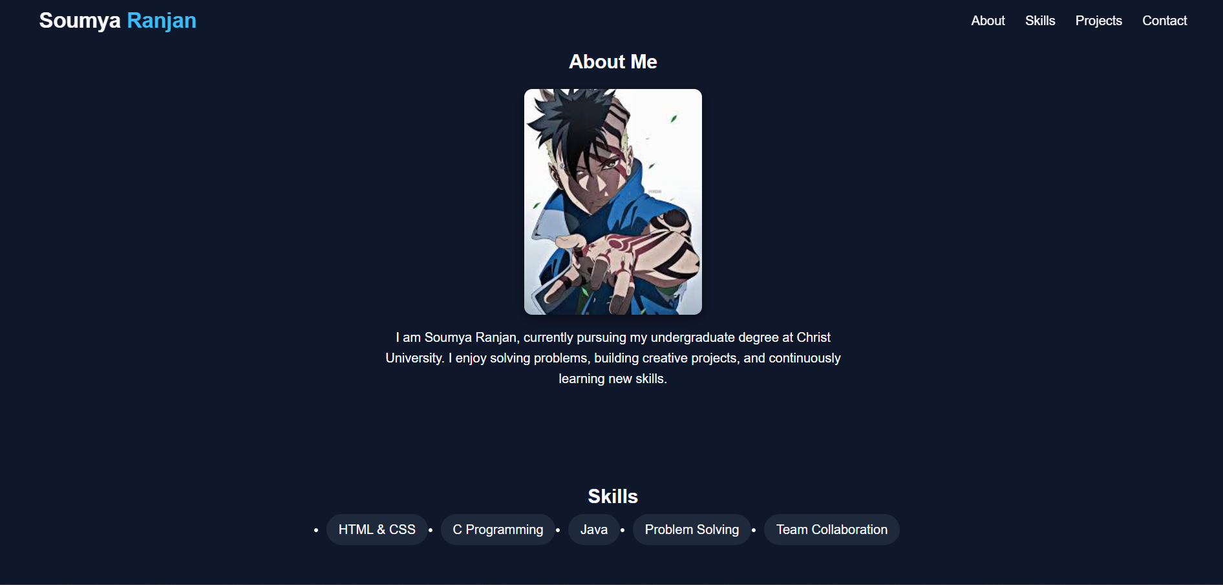

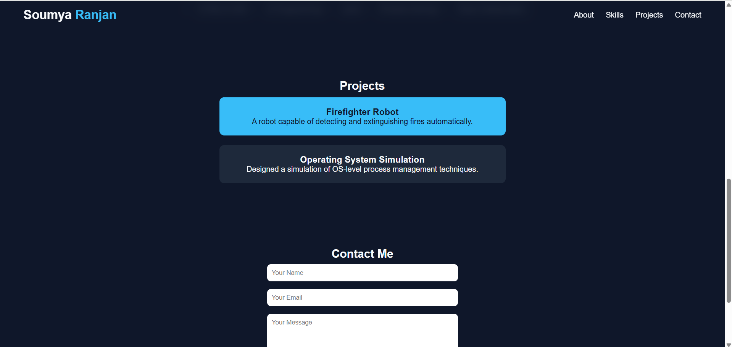

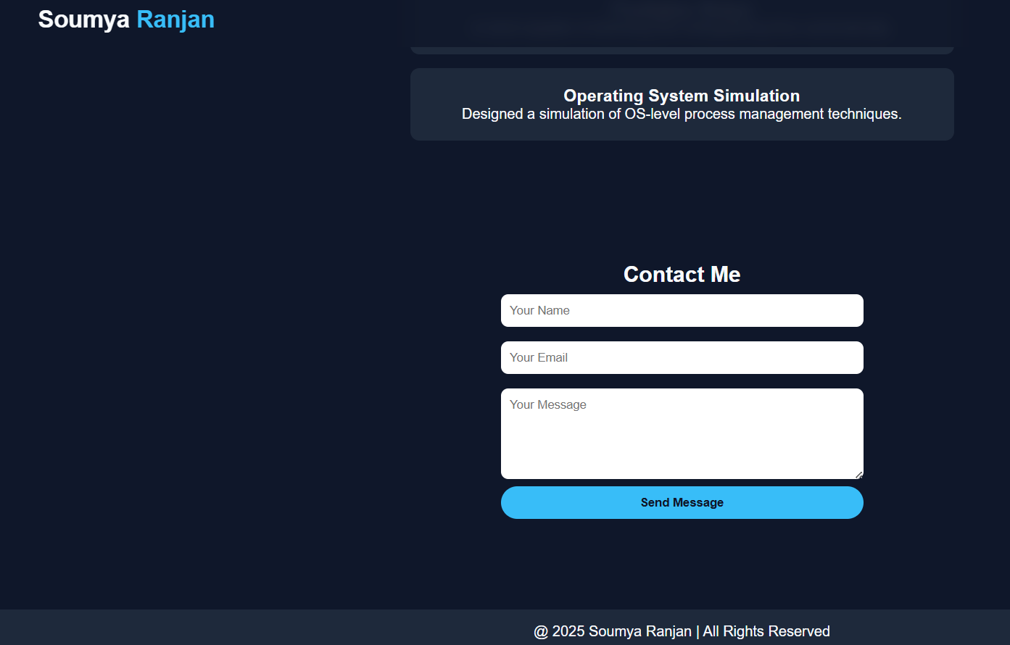

**Conclusion:**

The Soumya’s Portfolio website successfully fulfills its intended purpose of serving as a professional and visually appealing personal profile. Built entirely with HTML5 and CSS3, it demonstrates the capability to design a clean, responsive, and engaging user interface without relying on external libraries or frameworks. The project effectively showcases skills, projects, and personal branding, ensuring accessibility and ease of navigation. Through this development, an in-depth understanding of layout structuring, responsive design, and CSS styling techniques was achieved. This portfolio serves as a solid foundation for future enhancements such as interactivity, backend integration, and theme customization.

**References**

1. Mozilla Developer Network (MDN) Web Docs – HTML & CSS Documentation: <https://developer.mozilla.org>
2. W3Schools – HTML and CSS Tutorials: <https://www.w3schools.com>
3. CSS-Tricks – Flexbox and Responsive Design Guides: <https://css-tricks.com>
4. Google Fonts – Poppins Font: <https://fonts.google.com>