***PROJECT NAME: Local Business Website***

**TEAM MEMBERS:**

**1. NAME: SOUMYA RANJAN BEHERA**

**REG.NO-2462366**

**MAIL:** [**soumya.ranjan@btech.christuniversity.in**](mailto:soumya.ranjan@btech.christuniversity.in)

**2. NAME: JEREMIAH CHRISTIANO PAREIRA**

**REG.NO-2462330**

**MAIL: jeremiah.christiano@btech.christuniversity.in**

**3. NAME: KISHAN S T**

**REG.NO-2462338**

**MAIL: kishan.s@btech.christuniversity.in**

**INSTITUTION: Christ University**

**Faculty Name:Ms Nagaveena**

**COURSE: UI/UX Design Fundamentals**

**DATE OF SUBMISSION:13/08/2025**

### **Abstract**

This project involves designing and developing a responsive website for a local cafe named **Neighborhood Cafe** using HTML5, CSS3, and minimal JavaScript. The goal is to provide an attractive online presence showcasing the cafe’s services, ambiance, and contact options. The site features sections for services, about, contact form, and an engaging hero area. Core technologies include semantic HTML5, CSS variables, and Flexbox for layout. The final outcome is a visually appealing, mobile-friendly site that enhances customer engagement and provides essential information at a glance.

### **Objectives**

* Design a user-friendly interface with a cozy, welcoming theme.
* Develop a fully responsive layout using HTML and CSS.
* Use structured HTML5 semantic elements for clarity and SEO.
* Apply CSS for branding, layout, and responsive behavior.
* Ensure accessibility and readability across devices.

### **Scope of the Project**

* Focused on front-end design only.
* Minimal JavaScript (only for dynamic year update in footer).
* Intended for desktop, tablet, and mobile viewports.
* Uses only open-source tools and pure HTML/CSS code.

### **Tools & Technologies Used**

|  |  |
| --- | --- |
| **Tool/Technology** | **Purpose** |
| HTML5 | Markup and content structure |
| CSS3 | Styling and layout management |
| VS Code | Code editor |
| Chrome DevTools | Testing and debugging |

### **HTML Structure Overview**

* Used semantic tags: <header>, <nav>, <section>, <footer>.
* Structured into reusable sections: Hero, Services, About, Contact, Footer.
* Navigation menu uses <ul> with anchor links.

### **CSS Styling Strategy**

* External CSS file (mstyle.css).
* Organized with comments and sections.
* Techniques used:
  + Flexbox for layout.
  + CSS variables for theme colors.
  + Hover effects for interactivity.
  + Mobile-friendly flex wrapping.

### **Key Features**

|  |  |
| --- | --- |
| **Feature** | **Description** |
| Responsive Design | Adapts to desktop, tablet, and mobile layouts |
| Cozy Theme | Warm colors and rounded corners for a welcoming feel |
| Services Showcase | Card-based layout for offerings |
| Contact Form | Input fields and submit button for inquiries |
| Accessibility | Clear text and contrast for readability |

### **Challenges Faced & Solutions**

|  |  |
| --- | --- |
| **Challenge** | **Solution** |
| Content wrapping on small screens | Used flex-wrap and responsive design principles |
| Maintaining consistent spacing | Used CSS variables and padding rules |

### **Outcome**

* Delivered a **clean, inviting, and functional** cafe website.
* Fully responsive layout using only HTML and CSS.
* Improved understanding of Flexbox and theme consistency.

### **Future Enhancements**

* Add menu page with images and prices.
* Integrate map for location display.
* Backend integration for contact form submissions.
* Add subtle CSS animations for better engagement.

### **Objective**

* To create an **online portfolio** that highlights Soumya’s skills and accomplishments.
* To provide a **central platform** for showcasing projects and personal information.
* To make a **professional first impression** for recruiters, mentors, and collaborators.
* To allow easy **contact through a form** for networking and project inquiries.
* To maintain a **minimalist and responsive design** accessible on multiple devices.

### **Sample Code**

<!DOCTYPE html>

<html lang="en">

<head>

<meta charset="UTF-8">

<meta name="viewport" content="width=device-width, initial-scale=1.0">

<title>Neighborhood Cafe</title>

<link rel="stylesheet" href="mstyle.css">

</head>

<body>

<!-- Navigation -->

<nav class="nav">

<div class="brand">

<div class="logo">NB</div>

<div>

<h1>Neighborhood Cafe</h1>

<p>Open • 7:00 AM - 9:00 PM</p>

</div>

</div>

<ul class="nav-links">

<li><a href="#services">Services</a></li>

<li><a href="#about">About</a></li>

<li><a href="#contact">Contact</a></li>

<li><button class="cta">Order Now</button></li>

</ul>

</nav>

<!-- Hero -->

<header class="hero">

<div class="hero-text">

<h2>Warm brews, fresh bites — right in your neighbourhood</h2>

<p>Your cozy corner for specialty coffee, homemade sandwiches, and friendly faces.</p>

<div class="features">

<span>Free Wi-Fi</span>

<span>Locally sourced</span>

<span>Outdoor seating</span>

</div>

</div>

</header>

<!-- Services -->

<section id="services" class="services">

<h2>Our Services</h2>

<div class="service-list">

<div class="service">

<h3>☕ Specialty Coffee</h3>

<p>Single origin beans, skilled baristas.</p>

</div>

<div class="service">

<h3>🥪 Fresh Sandwiches</h3>

<p>Daily-baked bread & seasonal fillings.</p>

</div>

<div class="service">

<h3>🎂 Homemade Desserts</h3>

<p>Ask about today's specials.</p>

</div>

</div>

</section>

<!-- About + Contact -->

<section id="about" class="about-contact">

<div class="about">

<h2>About Us</h2>

<p>Started by locals with a love for coffee and conversation. We believe in friendly service and building community — one cup at a time.</p>

</div>

<div id="contact" class="contact-form">

<h2>Contact Us</h2>

<form>

<input type="text" placeholder="Your Name" required>

<input type="text" placeholder="Phone or Email" required>

<textarea placeholder="Message" rows="4"></textarea>

<button type="submit">Send Message</button>

</form>

</div>

</section>

<!-- Footer -->

<footer>

<p>@ <span id="year"></span> Neighborhood Cafe — Made with ☕</p>

</footer>

<script>

document.getElementById('year').textContent = new Date().getFullYear();

</script>

</body>

</html>

:root {

--bg: #f7f7f9;

--card: #fff;

--accent: #d97706;

--muted: #666768;

}

body {

font-family: Arial, sans-serif;

margin: 0;

background: var(--bg);

color: #111;

}

/* Navigation */

.nav {

display: flex;

justify-content: space-between;

align-items: center;

background: white;

padding: 10px 20px;

box-shadow: 0 4px 10px rgba(0,0,0,0.05);

}

.brand {

display: flex;

align-items: center;

gap: 10px;

}

.logo {

background: var(--accent);

color: white;

padding: 10px;

border-radius: 8px;

font-weight: bold;

}

.nav-links {

display: flex;

gap: 15px;

list-style: none;

}

.nav-links a {

text-decoration: none;

color: var(--muted);

font-weight: bold;

}

.cta {

background: var(--accent);

color: white;

border: none;

padding: 8px 12px;

border-radius: 6px;

cursor: pointer;

}

/* Hero */

.hero {

padding: 40px 20px;

text-align: center;

background: #fff3e0;

}

.features span {

background: var(--accent);

color: white;

padding: 5px 10px;

margin: 5px;

border-radius: 20px;

font-size: 0.9rem;

display: inline-block;

}

/* Services */

.services {

padding: 30px 20px;

text-align: center;

}

.service-list {

display: flex;

gap: 15px;

flex-wrap: wrap;

justify-content: center;

}

.service {

background: var(--card);

padding: 15px;

border-radius: 8px;

width: 250px;

box-shadow: 0 4px 10px rgba(0,0,0,0.05);

}

/* About + Contact */

.about-contact {

display: flex;

gap: 20px;

padding: 30px 20px;

flex-wrap: wrap;

}

.about, .contact-form {

flex: 1;

min-width: 280px;

background: var(--card);

padding: 15px;

border-radius: 8px;

box-shadow: 0 4px 10px rgba(0,0,0,0.05);

}

.contact-form input, .contact-form textarea, .contact-form button {

width: 100%;

padding: 8px;

margin-top: 8px;

border: 1px solid #ccc;

border-radius: 6px;

}

.contact-form button {

background: var(--accent);

color: white;

border: none;

cursor: pointer;

}

/* Footer */

footer {

text-align: center;

padding: 15px;

color: var(--muted);

font-size: 0.9rem;

}

### **Website Screenshots**

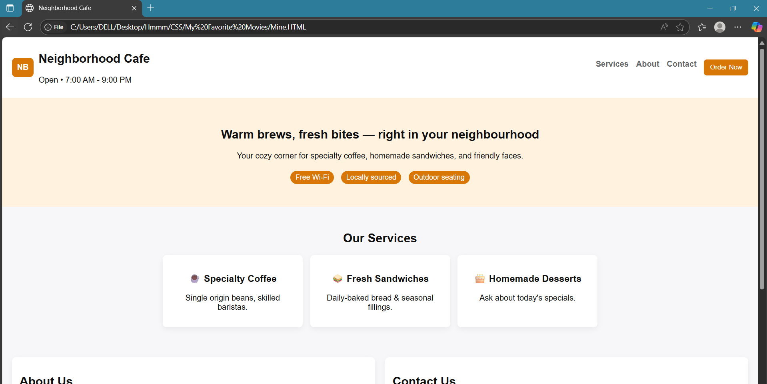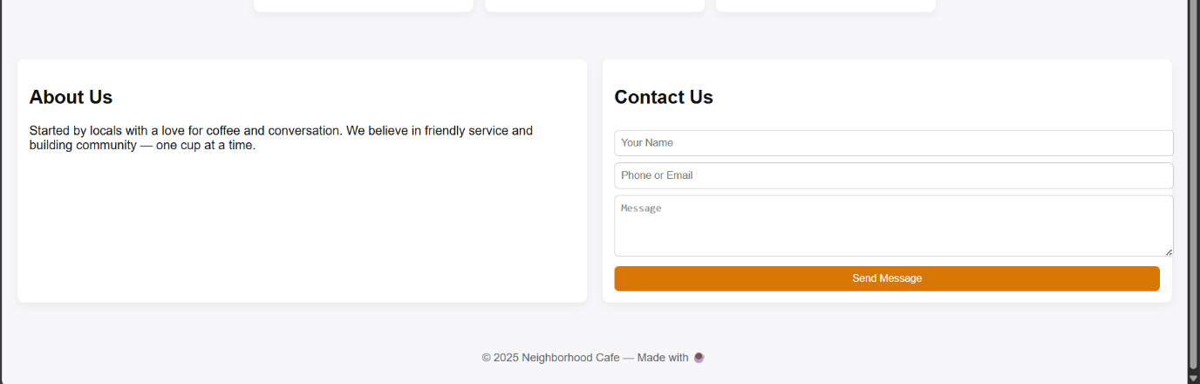

### **Conclusion**

The Neighborhood Cafe website successfully meets the project objectives by delivering an inviting, responsive, and functional online presence for the cafe. Using HTML5 and CSS3 with minimal JavaScript, the design captures the cozy and welcoming atmosphere of the cafe while providing clear navigation and essential information. The service cards, hero section, and contact form ensure that customers can quickly understand offerings and reach out easily. The project enhanced skills in semantic structuring, responsive design, and theme consistency. Overall, this website creates a strong digital identity for the cafe and serves as a foundation for future enhancements such as menu integration, location maps, and advanced interactivity.

### **References**

1. Mozilla Developer Network (MDN) Web Docs – HTML & CSS Documentation: <https://developer.mozilla.org>
2. W3Schools – HTML and CSS Tutorials: <https://www.w3schools.com>
3. CSS-Tricks – Flexbox Guide and Styling Tips: <https://css-tricks.com>
4. Google Fonts – Web Typography Resources: <https://fonts.google.com>