Agentic Software Engineering System
URL Shortener — Engineering Summary & Architecture Overview
Interview Assignment: Build an Agentic Software Engineering System
August 23, 2026
Prepared with Claude (Anthropic) as the agentic engineering assistant

Table of Contents

1. Executive Summary | 3
2. System Architecture — URL Shortener Application | 3
3. Engineering Judgment — Issues Found and Resolved | 5
4. Testing Strategy | 6
5. Agentic Orchestration Layer — the Critical Differentiator | 7
6. Demonstration Workflow — SDLC Pipeline | 9
7. Setup & Run Instructions | 10
8. Risks, Trade-offs & Assumptions | 11
9. Limitations & Suggested Next Steps | 11
10. Conclusion | 12

1. Executive Summary
This document covers a two-part engineering deliverable built against the assignment's URL Shortener scenario: (1) a working Spring Boot URL Shortener service, hardened through an iterative, test-driven engineering pass, and (2) a generic, reusable agentic orchestration engine — the assignment's “critical differentiator” — that coordinates a full SDLC lifecycle (requirements, design, implementation, testing, documentation, release) with governance, parallelism, and observability, demonstrated against three scenarios grounded in real changes made to this exact codebase.
The work proceeded as a sequence of deliberate, reviewable passes rather than one large undifferentiated change:
- Test coverage first. The project had zero test dependencies and zero tests. A 40-method unit test suite was written across every class with logic (util, service, controller, exception handling, DTO validation), which surfaced concrete defects rather than being written against an already-correct system.
- Fix what testing surfaced. Two real defects were found and fixed: unhandled exceptions surfacing as opaque HTTP 500s instead of 404/409, and a check-then-act race condition in custom-alias creation. Each fix shipped with a regression test proving the specific failure mode is closed.
- Build the orchestration layer. A 22-file core engine (dependency graph, gates, retries, fallback, rollback, approval checkpoints, policy guardrails, audit logging, metrics, dynamic re-planning) plus a concrete 7-stage SDLC workflow demo, covered by 24 tests split into 10 packages — one per engine concern.
- Document what remains open. Two lower-severity risks are deliberately left open and documented rather than silently patched, because their correct fix requires a judgment call outside this pass's scope (see Section 8).
Total delivered test suite: 64 automated tests across 16 packages, all runnable with a single mvn test command.

2. System Architecture — URL Shortener Application
The application is a Spring Boot 3.2 / Java 17 service with three REST endpoints, a Postgres-backed persistence layer, and a Redis read-through cache.
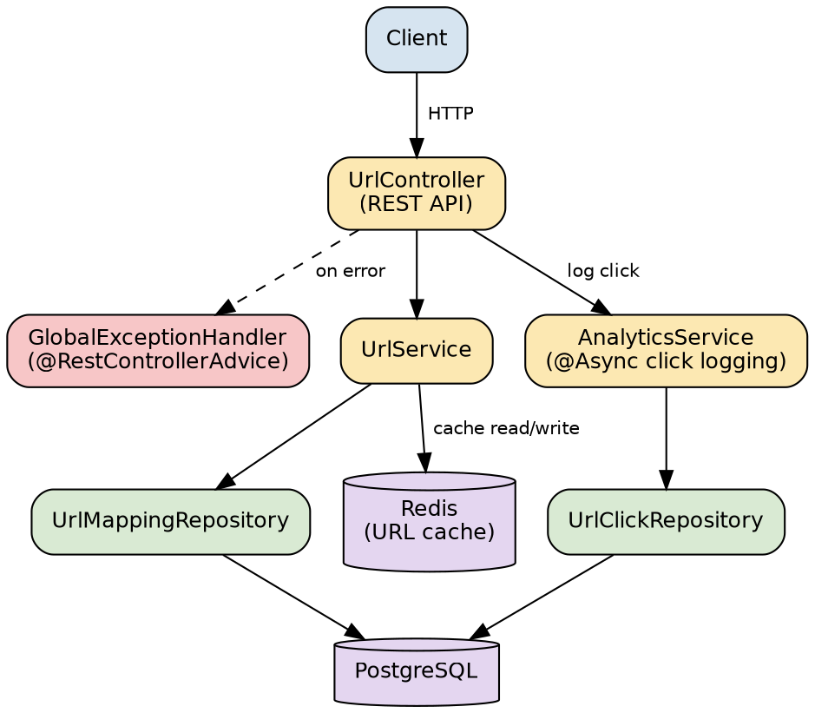
Figure 1. Component overview — request flow, caching, and persistence.

2.1 Core API Endpoints
Method | Path | Purpose
POST | /api/v1/shorten | Create a short link from a long URL, with an optional custom alias and optional expiry.
GET | /{shortKey} | Redirect (302) to the original URL and asynchronously log the click for analytics.
GET | /api/v1/analytics/{shortKey} | Return click-count and user-agent breakdown analytics for a short key.

2.2 Data Model
Entity | Key fields | Notes
UrlMapping | id, shortKey (unique), longUrl, createdAt, expiresAt | shortKey has a DB-level unique constraint — this is what the race-condition fix in Section 3 depends on.
UrlClick | id, shortKey, ipAddress, userAgent, clickedAt | Written asynchronously (@Async) by AnalyticsService so redirect latency isn't blocked on analytics writes.

2.3 Caching Strategy
UrlService reads through Redis before hitting Postgres: a cache hit on url:{shortKey} short-circuits the database lookup entirely. On a cache miss, the mapping is loaded from Postgres, and — only if it has not already expired — re-cached with a TTL computed from its expiresAt (or a 7-day default when no expiry was set). An already-expired mapping is deliberately not re-cached, so expired entries don't get a second, incorrect lease on life in the cache.

2.4 Exception Handling & Error Contract
A centralized GlobalExceptionHandler (@RestControllerAdvice) maps every failure mode to a consistent JSON ErrorResponse body ({ timestamp, status, error, message, fieldErrors }):
Condition | Exception type | HTTP status
Short key doesn't exist / has expired | ShortUrlNotFoundException | 404 Not Found
Custom alias already taken (upfront check or DB-level race) | AliasAlreadyExistsException | 409 Conflict
Request body fails @Valid constraints | MethodArgumentNotValidException | 400 Bad Request (with a field-level fieldErrors map)
Any other IllegalArgumentException | IllegalArgumentException | 400 Bad Request (defensive fallback)
Anything else unhandled | Exception | 500 Internal Server Error (generic message — never leaks internal detail)

3. Engineering Judgment — Issues Found and Resolved
These issues were not hypothetical: each was found by reading the code while writing tests against it, and each fix shipped with a test that specifically pins down the failure mode it closes.
# | Issue | Resolution | Status
1 | No @ExceptionHandler anywhere — an unknown analytics key surfaced as an opaque 500 instead of a 404; a taken alias and a missing resource both threw the same generic IllegalArgumentException. | Added GlobalExceptionHandler with two domain-specific exceptions (404 / 409) plus structured validation and a safe 500 fallback. | Fixed
2 | Custom-alias creation checked existsByShortKey() then called save() — a classic check-then-act race. A concurrent request could win the insert in between, and the resulting DataIntegrityViolationException was never caught. | saveMapping() now catches DataIntegrityViolationException around the insert and re-throws it as AliasAlreadyExistsException, so a request that loses the race gets the same clean 409 as one that failed the upfront check. | Fixed
3 | Auto-generated key path inserts a row with a placeholder shortKey = "temp" to obtain a DB-generated ID, then updates it. Two concurrent auto-generated requests could collide on "temp" itself. | Documented as an open risk (Section 8). The same DataIntegrityViolationException pattern would close it, but the correct status code for an internal placeholder collision (arguably 503/retry, not 409) is a distinct judgment call from issue #2's user-facing alias conflict. | Open — documented
4 | Base62.encode() has no input validation; a negative input silently returns "" instead of throwing. | Behavior pinned by a test documenting the current (arguably surprising) behavior. Auto-increment IDs shouldn't go negative in practice. | Open — documented
5 | application.properties has spring.data.redis.host=local host (a stray space) — would fail Redis connectivity at runtime. | Flagged; a one-line configuration fix, out of scope for a code-level testing/hardening pass. | Open — documented

4. Testing Strategy

4.1 Philosophy
Every test in this suite is a true unit test: collaborators (repositories, RedisTemplate, executors) are mocked or faked, so the entire suite runs without a database, Redis instance, or network access, and runs in seconds. Where a test needed to prove something a mock can't fake — like two stages genuinely executing on different threads — a real ExecutorService with a CountDownLatch is used instead of a mock, so the test would actually fail if execution silently became sequential.

4.2 Coverage Summary
Area | Packages | Test classes | Test methods
URL Shortener application | util, service, controller, dto, exception | 6 | 40
Orchestration engine | orchestration.* (10 dedicated packages, one per concern) | 10 | 24
Total | — | 16 | 64
The orchestration engine's tests are deliberately split one-package-per-concern (scheduling, gates, retry, fallback, rollback, approval, policy, replanning, metrics, definition) rather than one large test class, so each governance mechanism has its own clearly-scoped, independently-readable home.

4.3 Running the Tests
mvn test

5. Agentic Orchestration Layer — the Critical Differentiator
The assignment calls out workflow orchestration as the critical differentiator: an explicit dependency graph with entry/exit gates, sequential and parallel execution with synchronization, preserved cross-stage context and decision lineage, human approval checkpoints for high-impact actions, bounded retries with fallback and rollback, policy guardrails, audit-grade observability, reliability metrics, and dynamic re-planning. This section maps each of those requirements to a concrete, tested implementation.

5.1 Core Concepts
Type | Responsibility
Stage | One node in the graph: its dependencies, risk level, gates, retry policy, fallback agent, rollback group, and whether it requires human approval.
WorkflowDefinition | The validated dependency graph — rejects cycles and unknown dependencies at construction time, not at runtime.
WorkflowContext | Shared, thread-safe state for one run: cross-stage artifacts (decision lineage), the audit log, and the current plan-revision counter.
OrchestrationEngine | The scheduler: drives parallel execution, synchronization joins, gates, approval, retry/fallback, rollback, and dynamic re-planning.
AuditLog | Append-only, timestamped trail of every gate check, retry, approval, rollback, and re-plan — tagged with the plan revision in effect at the time.
Metrics | Success rate, retry/rollback frequency, mean time to recover (MTTR), and end-to-end latency for the run.
PolicyGuard / ApprovalPort | Pluggable interfaces for governance (security/compliance rules) and human sign-off, decoupled from the engine so a real deployment can swap in a genuine human-backed approval system.

5.2 Per-Stage Execution Flow
Every stage passes through the same governed sequence, regardless of what its agent actually does:
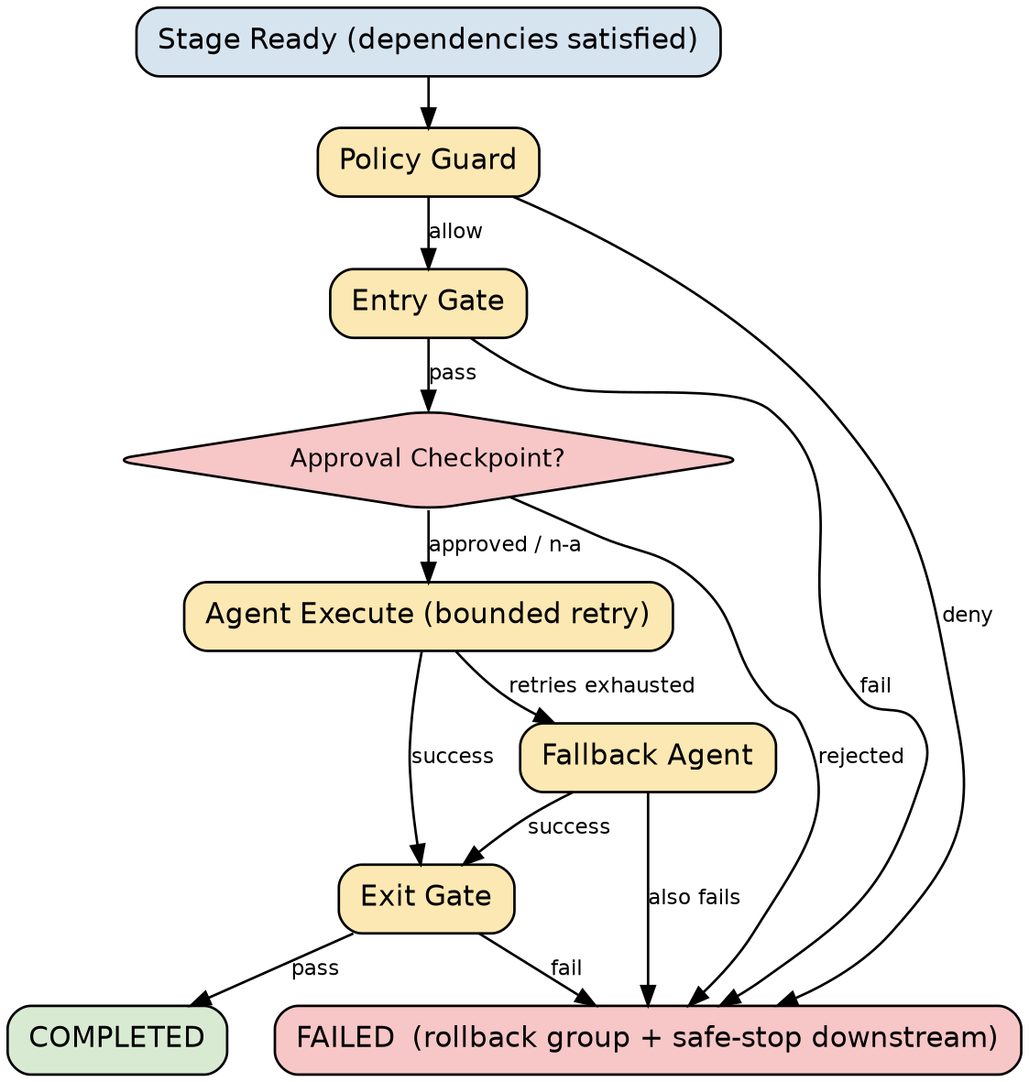
Figure 2. The per-stage control flow enforced by OrchestrationEngine.
Two design decisions are worth calling out explicitly:
- Policy is checked before retry/fallback, not woven into it. A policy denial is a hard stop — the engine never gives a denied stage's retry loop or fallback agent a chance to route around governance. This is verified directly by a test asserting the agent and fallback are never invoked when policy denies.
- Rollback operates on groups, not single stages. Stages can share a rollbackGroup; when one member fails unrecoverably, every already-completed member of that group is rolled back together, and everything downstream is safely skipped (not crashed) — this is the “safe-stop” behavior.

5.3 Dynamic Re-Planning
An agent can call context.markStale(stageId) on an already-completed upstream stage. On its next scheduling pass, the engine resets that stage and everything transitively downstream of it back to PENDING under a new plan revision, and re-executes them — while artifacts from stages outside that invalidated subgraph are left completely untouched. This is how the engine handles “upstream output changed” without re-running the entire workflow from scratch, and is demonstrated end-to-end in the Ambiguous scenario (Section 6.3).

5.4 Reliability Metrics
Every run collects: success rate, retry count and frequency (retries per stage), rollback count and frequency, fallback-invocation count, approvals requested, re-plans triggered, mean time to recover (MTTR — averaged time between a stage's first failure and its eventual success), and end-to-end wall-clock latency.

6. Demonstration Workflow — SDLC Pipeline
A concrete 7-stage SDLC workflow is built on top of the engine: requirements analysis, architecture & design, implementation and test generation in parallel, an integration-validation join, documentation, and release readiness.
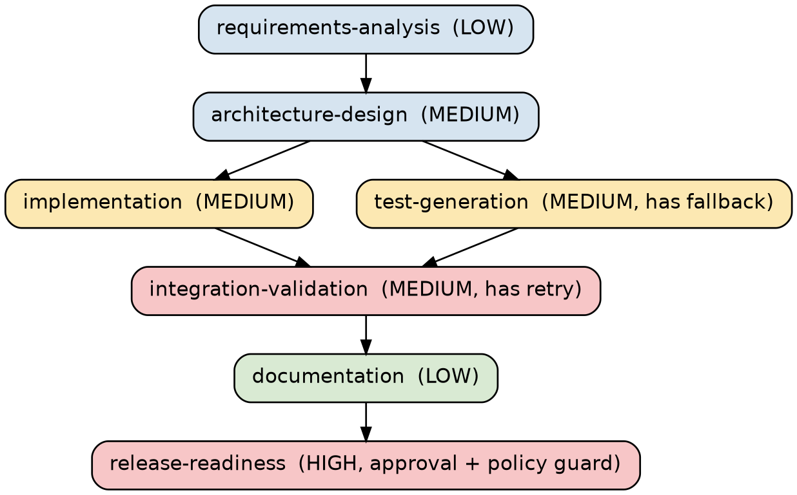
Figure 3. The demo SDLC workflow graph — note the parallel fan-out/join between design and integration.
The same graph shape runs all three required scenarios (greenfield, brownfield, ambiguous) — only the simulated conditions differ, which is itself part of the point: one governed pipeline handles a clean run, a recoverable hiccup, an ambiguous requirement, and an outright policy rejection without being rewritten per scenario.

6.1 Scenario: Brownfield — Fix Inconsistent Exception Handling
This scenario models the real fix made in Section 3, item 1: getAnalytics() returning a 500 for an unknown key instead of a clean 4xx. It demonstrates:
- Parallel execution — implementation and test-generation both depend only on architecture-design and run concurrently.
- Bounded retry — integration-validation simulates a transient CI failure on its first attempt and recovers on the second, without human intervention.
- The human approval checkpoint — release-readiness requires sign-off before completing.

6.2 Scenario: Ambiguous — Custom Alias + Expiry, Default TTL Unspecified
This scenario mirrors the real ShortenRequest behavior: the requester didn't specify what happens with a blank alias or an unset expiry. It demonstrates:
- Ambiguity detection — requirements-analysis flags the gap and normalizes an explicit assumption (blank alias = absent; default TTL = 7 days) rather than guessing silently.
- Dynamic re-planning — integration-validation discovers the initial design's blank-alias handling was underspecified, flags architecture-design as stale, and the engine automatically resets and re-executes design, implementation, and test-generation under a new plan revision before the workflow proceeds to a clean pass.

6.3 Scenario: Greenfield — Bulk URL Shortening Endpoint
A brand-new capability with more unknowns than a bug fix or a small addition. It demonstrates:
- Fallback — the primary test-generation agent can't derive edge cases for bulk input validation after exhausting its retries, so a fallback agent produces a reduced smoke-test scaffold instead of failing outright.
- A hard policy-guard denial — release-readiness is blocked because no load-test evidence was supplied for the new bulk endpoint, triggering rollback of the release-package group (documentation is un-published) and ending the run without a release, exactly as intended.

7. Setup & Run Instructions

7.1 Prerequisites
- Java 17
- Maven 3.8+
- PostgreSQL (for the application; not required to run tests or the orchestration demo)
- Redis (for the application's cache; not required to run tests or the orchestration demo)

7.2 Build & Run the Application
mvn clean package
mvn spring-boot:run

7.3 Run the Test Suite
mvn test

7.4 Run the Orchestration Demo
Runs all three scenarios end to end and prints final stage statuses, reliability metrics, and the full audit trail for each. This is a standalone entry point — it does not start the web server or touch Postgres/Redis.
mvn compile exec:java -Dexec.mainClass=com.example.orchestration.demo.OrchestrationDemo

8. Risks, Trade-offs & Assumptions

8.1 Assumptions
- Human approval is stood in with AutoApprovingApprovalPort for demo/test purposes only — clearly labeled in code and never used as anything but a stand-in. A production deployment must supply a real, human-backed implementation.
- The three demo scenarios simulate their conditions (transient failures, ambiguity, policy gaps) via configuration flags rather than a live LLM/Copilot call per stage, so the outcome is deterministic and reviewable — the StageAgent interface is where a real model call would plug in.

8.2 Open Risks (see Section 3 for full detail)
- Two-phase auto-generated key insert can collide on its "temp" placeholder under concurrent load (documented, not yet fixed).
- Base62.encode() silently returns an empty string for negative input rather than throwing (documented, low practical risk).
- A configuration typo in application.properties would break Redis connectivity at runtime (documented, trivial fix, out of scope for this pass).

8.3 Trade-offs
- Unit tests over integration tests. Every test mocks its collaborators rather than standing up a real Postgres/Redis/Spring context. This keeps the suite fast and dependency-free, at the cost of not proving real @Async threading behavior or real database constraint behavior end-to-end — both are called out explicitly as limitations rather than silently assumed to be covered.
- Policy checked once per stage, not per retry attempt. A denied stage cannot be retried or routed around via fallback. This is a deliberate governance choice — it does mean a stage that would pass policy on a corrected second attempt still has to go through a full re-plan cycle rather than a simple retry.

9. Limitations & Suggested Next Steps
- No @SpringBootTest/integration tests exist yet — a @DataJpaTest against a real (H2) database would validate the derived repository queries, and a @SpringBootTest would validate real @Async threading for click logging.
- Concurrency risks (the "temp" placeholder collision) are architectural findings from reading the code, not something a mocked, single-threaded unit test can exercise — a targeted concurrent-load test would be needed to observe it directly.
- The orchestration engine's StageAgent interface is where a real LLM/Copilot call belongs in a production deployment; this prototype uses deterministic simulated agents so the three scenarios are reviewable and repeatable.
- AutoApprovingApprovalPort must be replaced with a real human-backed implementation (UI, ticket queue, or chat-based approval bot) before any of this touches a real release process.

10. Conclusion
This submission demonstrates the full loop the assignment asks for: understanding a requirement (including recognizing ambiguity), decomposing it into actionable, dependency-ordered work, reasoning about an existing codebase to find and fix real defects, generating production-quality code and tests, and — as the critical differentiator — a governed, observable, non-linear orchestration engine that coordinates all of that work with human oversight retained at the points that matter. Every claim in this document is backed by a specific test, file, or diagram in the accompanying project archive, and every open risk is documented rather than silently left for someone else to discover.

