**SDM College of Engineering and Technology** Dhavalagiri , Dharwad-580002. Karnataka State. India.

Email: principal@sdmcet.ac.in, cse.sdmcet@gmail.com

Ph: 0836-2447465/ 2448327 Fax: 0836-2464638 Website: sdmcet.ac.in

DEPARTMENT OF

COMPUTER SCIENCE AND ENGINEERING

**[18UCSC503-SOFTWARE ENGINEERING]**

**Course Teacher: Prof. Rani R Shetty**

SOFTWARE REQUIREMENT SPECIFICATIONS DOCUMENT

ON

HOME SERVICES BOOKING WEB APPLICATION

Submitted by

Amulya Naik USN:2SD20CS015

Jesia D’Souza USN:2SD20CS045

Rashmi S S USN:2SD20CS086

Soumya S K USN:2SD20CS107

**Table of Contents**

# Table of Contents ...........................................................................................................................2

# 1. Introduction ..............................................................................................................................3

1.1 Purpose .......................................................................................................................................

1.2 Product Scope .............................................................................................................................

1.3 References ..................................................................................................................................

# 2. Overall Description ..................................................................................................................4

2.1 Product Perspective .....................................................................................................................

2.2 Product Functions .......................................................................................................................

2.3 User Classes and Characteristics .................................................................................................

2.4 Operating Environment ...............................................................................................................

2.5 Design and Implementation Constraints ......................................................................................

2.6 User Documentation ...................................................................................................................

2.7 Assumptions and Dependencies ..................................................................................................

# 3. External Interface Requirements ...........................................................................................7

3.1 User Interfaces ............................................................................................................................

3.2 Software Interfaces ...................................................................................................................

# 4. System Features .....................................................................................................................10

4.1 Use cases ..................................................................................................................................

4.2 Use case diagram ......................................................................................................................

4.3 Use case description ..................................................................................................................

# 5. Other Non- functional Requirement.....................................................................................13

5.1 Speed Requirement……………………………………………………………………….

5.2 Security Requirements .......................................................................................................

5.3 Portability Requirements .................................................................................................................

5.4 Compatibility Requirements ..............................................................................................................

5.5 Capacity Requirements ...........................................................................................................

5.6 Localization Requirements .............................................................................................................

**1.INTRODUCTION**

1.1 PURPOSE:

In the current era of faster service availability, if any customer wants to use any household services like Plumbing, Electrical, Electronic, Mechanical, Pest Control, Home Paint and Machine Repairing, and the like, they need to go through a personal or telephonic meetings. It is difficult for any customer to find such services in emergency at any time and place. So, we are presenting such an idea of having a web application which will help customers to find out solution for any problems related to all these household services regardless of time and location.

1.2 PRODUCT SCOPE:

The scope of our project is to designing a complete environment to provide a safe and user friendly environment for online service booking. The main aim of the project is to provider an easy to use application for services provided for customer. We often get frustrated while taking the appointment of service provider because there the many problems are occur, like the service provider is busy art somewhere else or his not receiving our call or his cost is very high according to problem. So in this project we will remove this headache.

* 1. REFERENCES:

1.Shahrzad Shahriari, Mohammadreza Shahriari, Saeid gheiji. “ ECommerce And It Impactson Global Trend And Market”.International Journal of Research – Granthaalayah. Vol.3 (Iss.4): April, 2015.

2.L.RichardYe, Yue Jeff Zhang, Dat-DaoNguyen, James Chiu,“Fee-based online services: Exploring consumers’willingness to pay ”. Journal of International Technologyand Information Management.

3. Zhang, Ruihan Yong, Meizi Li, Jianguo Pan, Jifeng Huanglaa, “ A Hybrid Trust Evaluation Framework for Ecommerce in Online Social Network: ”. 21693536 (c) 2016 IEEE. Translations and content mining are permitted for academic research

**2.OVER ALL DESCRIPTION:**

2.1 PRODUCT PERSPECTIVE:

1.To connect to the service providers through our application.

2.To develop a user-friendly web based online system for opting appropriate household services.

3.To design a interactive User Interface for seeking services on the go.

4.To provide a secured online payment gateway for service seekers.

2.2 PRODUCT FUNCTIONS:

The major functions that product performs are:

1.Database Management

Admin should have permission to update the records of the worker details or add new worker and the password of the login, or to communicate with the customers.

2.Worker Management

The owner will keep the workers ready updated by ordering new services every time when the services are booked. He will manage that the workers are ready to serve the services.

3.User-management module

The product will allow customer to register themselves. Customers should be provided with restricted access to the product with the facility to view home services that are available with the detailed information. Effective searching should be facilitated by a user friendly interface.

4. Handling billing

The product will generate a bill reciept for both the operation manager and the customer. Order verification and confirmation must be made for each other place. The order tracking is may be made available for the users.

2.3 USER CLASSES AND CHARACTERISTICS:

The above can be implemented by using the table diagram given below:

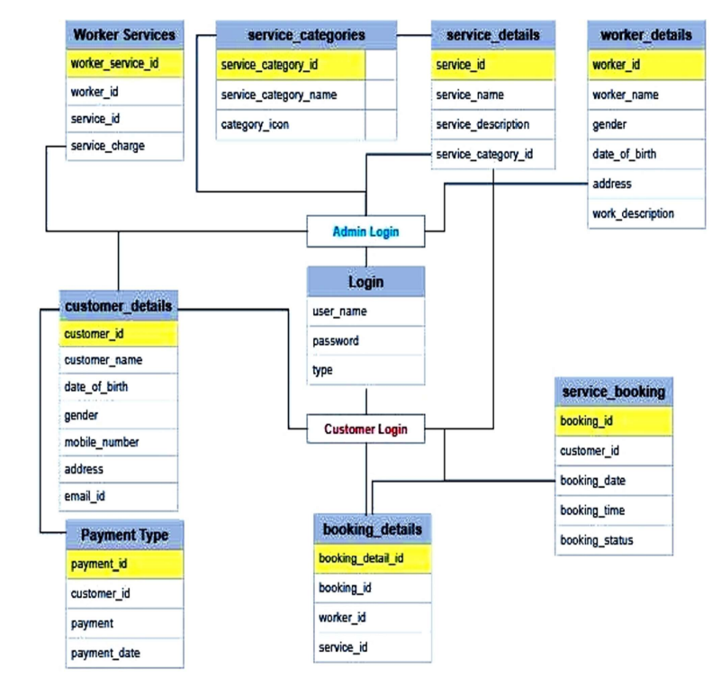

2.4 OPERATING ENVIRONMENT:

The software will operate with any operating system (Windows XP, Windows vista and Mac OS.) and browsers like Chrome, Mozilla Firefox, Internet Explorer with full support for network connectivity. It is application based so it will require a client and server GUI.

2.5 DESIGN AND IMPLEMENTATION CONSTRAINTS:

1. The constraints related to design and implementation of this software are specified by the programming language used for implementation, the software engineering environment, the programming methodology used, and the availability of supporting tools for automatic system analysis to keep the patent functions in distinct modules.

2. The interface of the software is designed to support only English language.

3. The system can store data up to 4 terra bytes but when the system is busy user may have to wait for one to two minutes for the pages to load otherwise the service booking system will not work smoothly.

4. This software system will allow more than one user to login at a time. It has no limitations for the number of users using it. The online service booking system will operate 24 hours on all weekdays.

5. Changing in the data and settings and records can only be done by authorized and permitted users. No unauthorized access to the system will be permitted.

2.6 USER DOCUMENTATION:

This software product will include a quick start guideline user manual covering complete overview of the product, configuration of SQL server along with other tools, technical details, and backup procedures.

2.7 ASSUMPTIONS AND DEPENDENCIES:

Online system for household services can be used by any authorized user intending to seek for household services through an ingenious web based system or a mobile application. To provide an authenticated and authorized login module for the users such as service seekers, service providers and the admin, by providing appropriate credentials at the time of registration

**3. EXTERNAL INTERFACE REQUIREMENTS:**

3.1: USER INTERFACE:

1.login page:

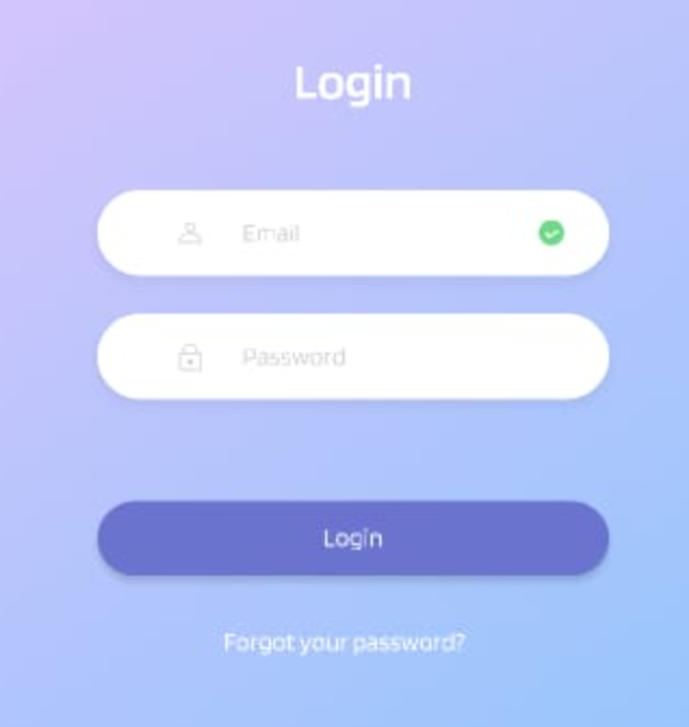

2.Home page

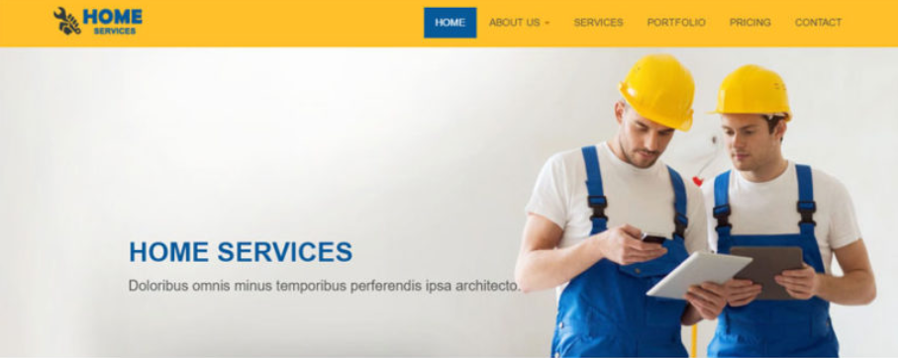

3.Selecting services:

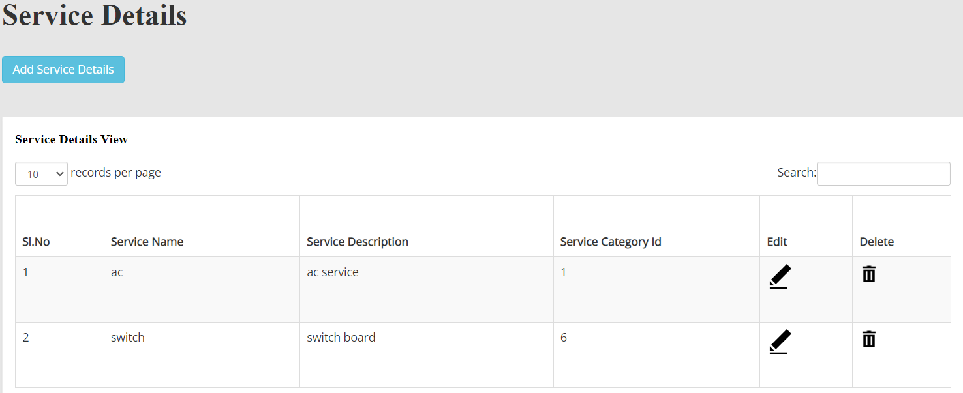

4.Customer details:

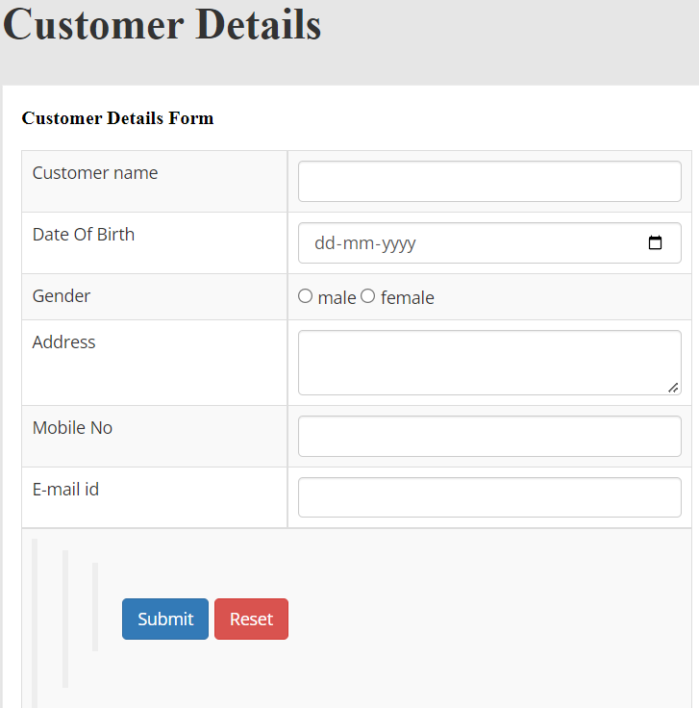

5. Worker details:

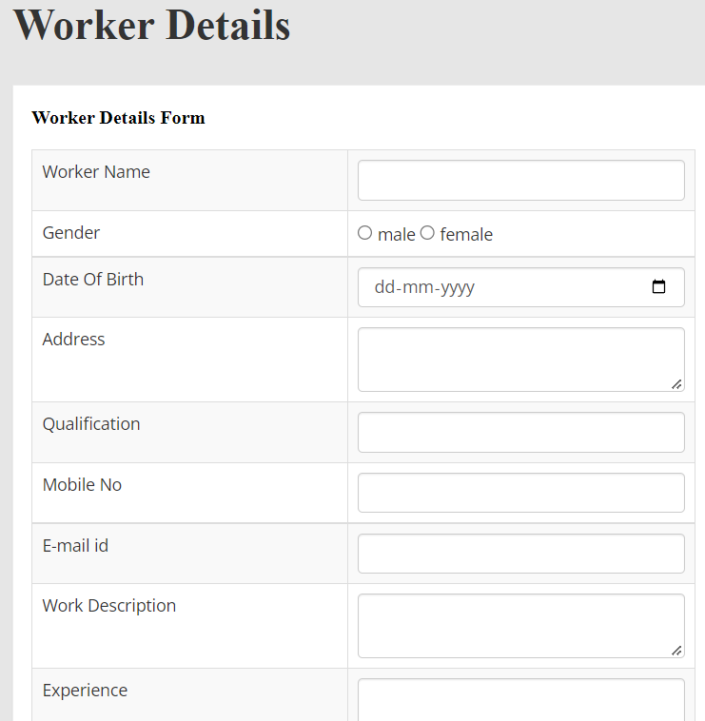

6. Service Booking:

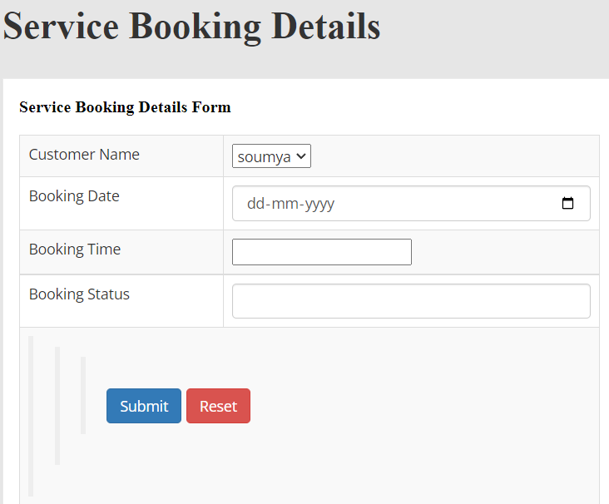

3.2 SOFTWARE INTERFACE:

1.Flow Chart 1:

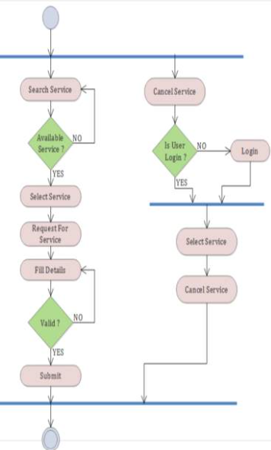

2.Flow chart 2:

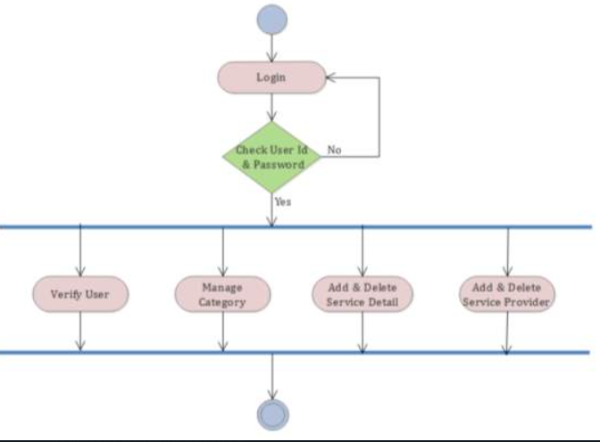

**4.SYSTEM FEATURES:**

4.1 USE CASES:

1.ADMIN

2.CUSTOMER

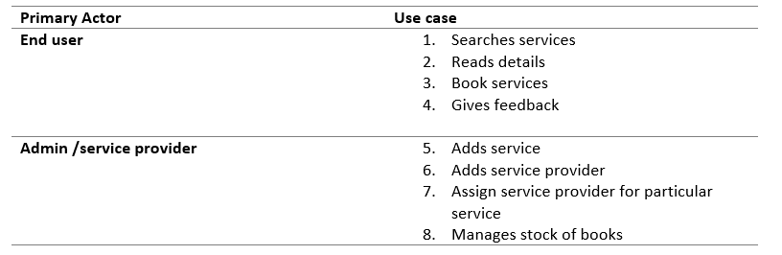

4.2 USE CASE DIAGRAMS:

ADMIN:

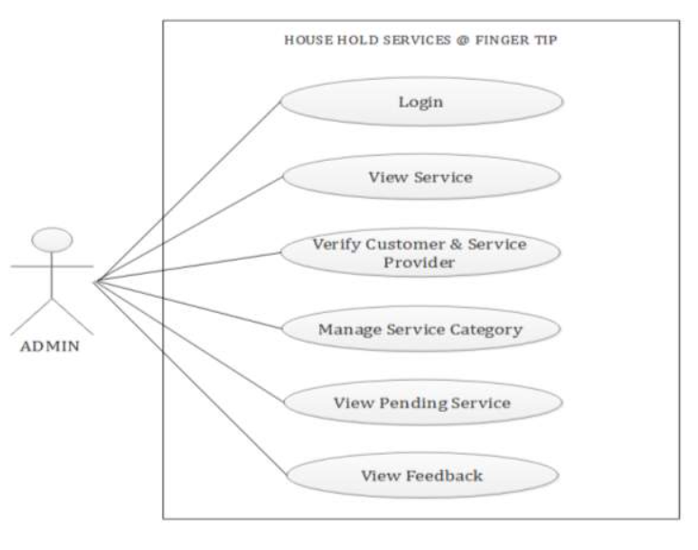

CUSTOMER:

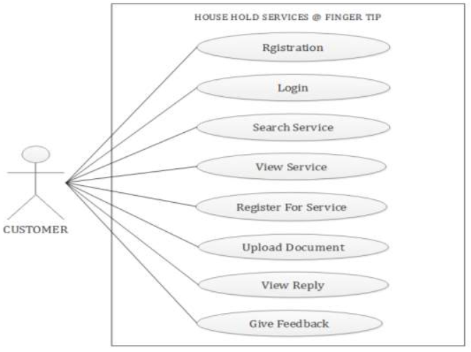

4.3 USE CASE DESCRIPTION:

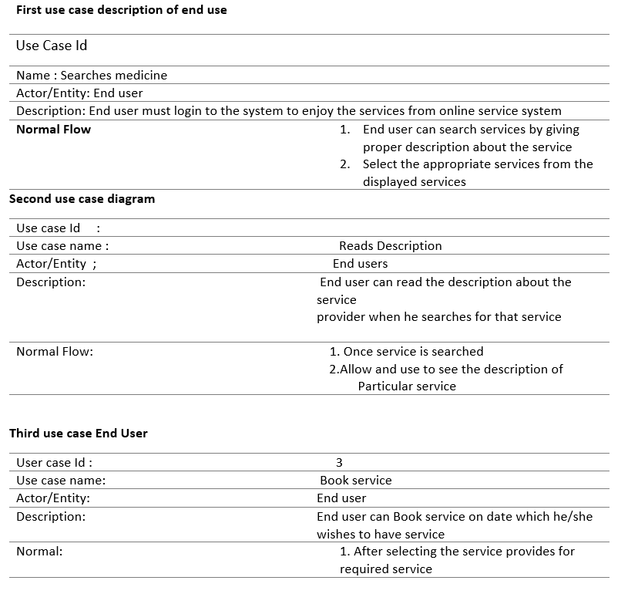

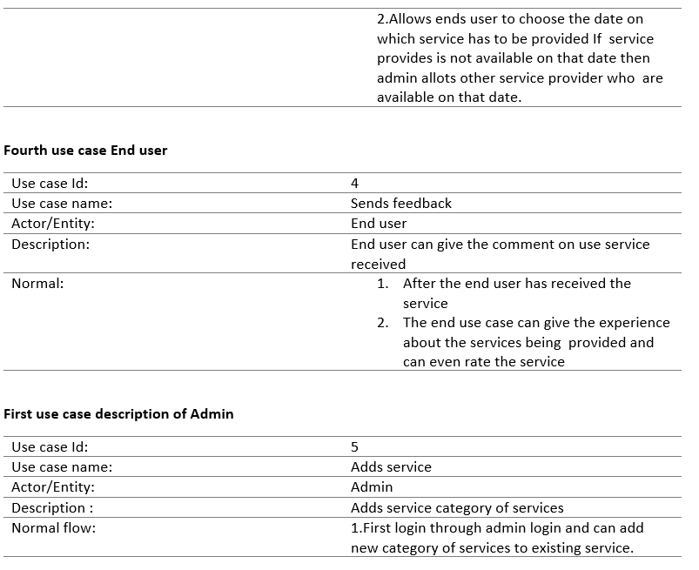

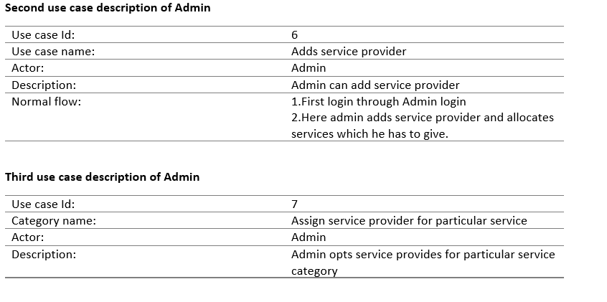

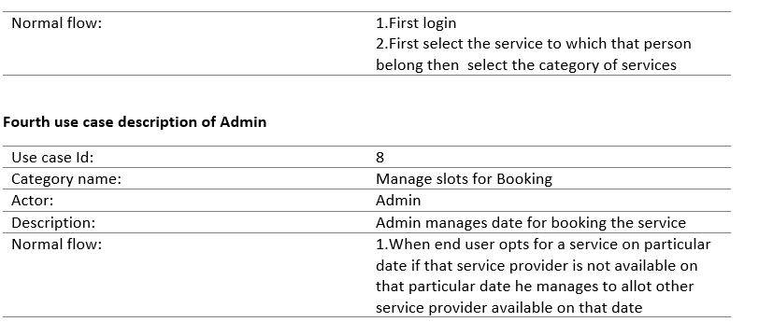

**5.OTHER NON-FUNCTIONAL REQUIREMENTS:**

A non-functional requirement is an attribute that dictates how a system operates. It makes applications or software run more efficiently and illustrates the system's quality.

5.1 Speed:

In our application, user might take pictures with a photo application while listening to music with an audio application. You can test the speed of a device by running multiple programs simultaneously and measuring how quickly they yield results and not interrupt the customer for finding their search.

5.2 Security:

Our web application facilitates secure use databases . The security on their databases may include firewalls to prevent unauthorized access.

Here are typical security measures on software:

Account creation: Systems may require users to create accounts to access applications that store information and display profiles. A security system typically grants access to accounts when enter the correct username and password

Password generation: An application may not grant access until the user creates a strong password. For example, a strong password might contain a certain number of characters and a capital letter.

Security question answering: A security system for a product may ask questions that only the user knows the answer to. This can help verify a user’ s identify when they log into an account. Examples of security question topics include the color of your first car or your mother’s maiden name.

Account locking: After a certain number of login attempts, a security system may lock an account to protect a user’s information from potential hackers. To unlock an account, a user can typically call the company to verify their identity and set a new password.

5.3 Portability

Portability means how effectively a system performs in one environment compared to another. As a developer, you can design your applications to function properly on multiple devices to improve portability.

5.4 Compatibility

Highly compatible systems typically function well when other applications are running on a device. Compatibility also allows people who have different operating systems to use the same applications.

5.5 Capacity

The capacity of system refers to the amount of storage it offers. When using some applications, user can adjust and save settings based on their preference. When a device has high storage capacity, a user may personalize more setting. product labels typically express capacity in megabytes also our website takes less of data as the user no need to download any app for browsing or booking any services.

5.6 Localization

A localized application has features that match the geographical location of its users, including aspects such as

1. Languages
2. Currencies
3. Measurements such as pounds vs. kilograms
4. Time zones