**VISVESVARAYA TECHNOLOGICAL UNIVERSITY,**

**BELGAUM, KARNATAKA**



**MINOR-PROJECT-I**

**REPORT ON,**

**“HOME SERVICES BOOKING WEB APPLICATION”**

***Submitted in partial fulfillment of the requirement for the award of the degree of***

**BACHELOR OF ENGINEERING**

**IN**

**COMPUTER SCIENCE AND ENGINEERING**

**Submitted by**

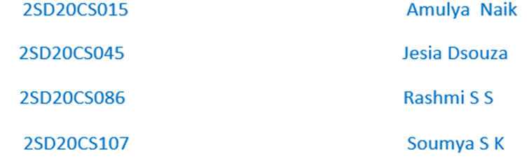

**Under the Guidance of**

**Prof. Indira Umarji**

**Dept. of CSE, SDMCET, Dharwad**



**DEPARTMENT OF COMPUTER SCIENCE AND ENGINEERING**

**S.D.M. COLLEGE OF ENGINEERING & TECHNOLOGY,**

**DHARWAD-580002**

**S.D.M COLLEGE OF ENGINEERING & TECHNOLOGY,**

**DHARWAD –580002**



**DEPARTMENT OF COMPUTER SCIENCE AND ENGINEERING**

**CERTIFICATE**

*Certified that the Minor-Project-1 work and presentation entitled* **“HOME SERVICES BOOKING WEB APPLICATION”** *is a bonafide work carried out by* **AMULYA U NAIK (2SD20CS015)**, **JESIA D’SOUZA (2SD20CS045)**, **RASHMI S S (2SD20CS086)**, and **SOUMYA S K (2SD20CS107),** *students of*

*S. D. M. College of Engineering & Technology, Dharwad, in partial fulfillment for the award of* **Bachelor of Engineering in Computer Science and Engineering of *Visvesvaraya Technological University, Belgaum****, during the year 2021-2022. It is certified that all corrections/suggestions indicated for internal assessment have been incorporated in the report deposited in the department library. The Minor-Project-1 has been approved, as it satisfies the academic requirements in respect of project report prescribed for the said degree.*

----------------------- ------------------------

**Prof. Indira Umarji Dr. S M Joshi**

Project Guide HOD-CSE

**ABSTRACT**

*In the current era of faster service availability, if any customer wants to use any household services like Plumbing, Electrical, Electronic, Mechanical, Pest Control, Home Paint and Machine Repairing, and the like, they need to go through a personal or telephonic meetings. It is difficult for any customer to find such services in emergency at any time and place. So, we are presenting such an idea of having a web application which will help customers to find out solution for any problems related to all these household services regardless of time and location. Our project also includes the facilities like security, online payment, map navigation and also advertisement.*

Table of Contents:

|  |  |
| --- | --- |
| CONTENT | PAGE NO. |
| PROBLEM STATEMENT | 5 |
| CHAPTER 1: INTRODUCTION | 6 |
| CHAPTER 2: LITERATURE SURVEY | 8 |
| CHAPTER 3: DETAILED DESIGN | 9 |
| CHAPTER 4: PROJECT SPECIFIC REQUIREMENTS | 12 |
| CHAPTER 5: IMPLEMENTATION | 16 |
| CHAPTER 6: RESULTS | 21 |
| CHAPTER 7: CONCLUSION AND FUTURE SCOPE | 27 |
| REFERENCES | 28 |

**PROBLEM STATEMENT:**

Developing a secured, convenient and an easy service providing Web Application for any Home Appliances related problems that are faced by customer to find an easy access to services and service providers to reach out customer for their service.

**CHAPTER 1: INTRODUCTION**

Due to the hectic schedule in day to day life we do not have convenient medium for the problems that are related to the daily activities like plumbing, electrical services, electronic appliances repair, ac services, CCTV installation, washing machine and fridge repair services, carpentry work and many more. When someone need aid with small but major household tasks, the trouble arises when service skilled persons are unavailable or the trusted providers are impossible to find, who delivers consistently flawless service on instance. Our online system for household services provides the most expedient and annoys free way to get your domestic work done. We aim to help in providing optimal solutions to all your household troubles with more efficiency, ease and majorly, a delicate touch.

A single click system describes booking highly skilled in-house professionals and gets your service done on time. Customers’ overall willingness to pay is significantly and positively correlated with the expectation that feebased services would be better, and with the belief that “pay for what you get” is the right thing to do. Keeping that in sense our proposed system is basically a marketplace for household services and it is the platform where the rates were standardized and there is no necessitate haggling over prices. Several aspects like painting, pest control, home cleaning, plumbing, electrical works and carpentry services are involved in a system to provide happy and healthy home atmosphere in order to satisfy consumers.

The primary objective of the online system for household services is about delivering the home services at the door step just by one click. This paper discusses about main theme of the online home services, numerous services provided and how the ordering and delivery of services takes place. Online system for household services can be used by any authorized user intending to seek for household services through an ingenious web based system or a mobile application.

To provide an authenticated and authorized login module for the users such as service seekers, service providers and the admin, by providing appropriate credentials at the time of registration. To develop a web based online system for opting household services and to develop an identical mobile application for opting the services and interactive User Interface for seeking services on the go. To provide a secured online payment gateway for service seekers. To acknowledge the conformation of services opted by the users.

**CHAPTER 2: LITERATURE SURVEY**

As we have gone through some apps like Urban company, Home serve, Mr. Right and JOBOY we found some of limitations, such as

1.Not available everywhere mean app Urban company don’t provide services to all the areas only to the cities like Pune, Dubai, Pondicherry etc.

2.Only two interface is present in some apps like admin and customer there is no service provider interface.

3.Some apps shown service unavailable when we logged in.

4.It is observed that such online facility is not provided in Hubli – Dharwad.

**CHAPTER 3: DETAILED DESIGN**

ER - DIAGRAM:

In software engineering, an Entity-Relationship Model (ER model for short) is an abstract and conceptual representation of data. Entity-Relationship modeling is a database modeling method, used to produce a type of conceptual schema or semantic data model of a system, often a relational database, and its requirements in a top-down fashion. Diagrams created by this process are called Entity-Relationship Diagrams or ER Diagrams. The first stage of information system design uses these models during the requirement analysis to describe information needs or the type of information that is to be stored in database

An entity may be defined as a thing which is recognized as being capable of an independent existence and which can be uniquely identified. An entity is an abstraction from the complexities of some domain. When we speak of an entity we normally speak of some aspect of the real world which can be distinguished from other aspects of the real.

An entity may be a physical object such as a house or car, an event such as a house sale or a car service, or a concept such as customer transaction or order. Although the term entity is the one most commonly used, following we should really distinguish between an entity and entity type. A entity- type is a category. An entity, strictly speaking, is an instance of a given entity type. There are usually many instances of an entity –type.

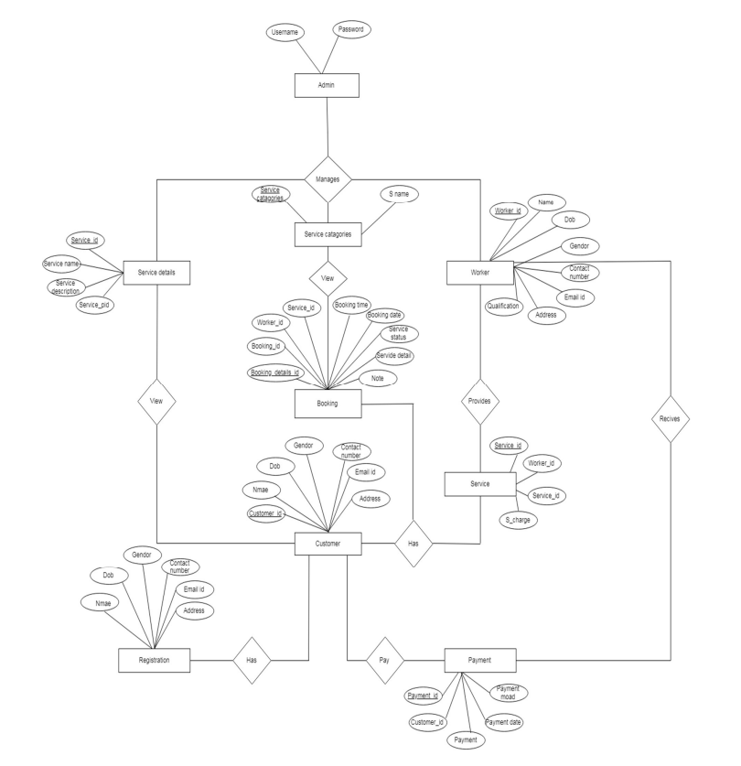

TABLE DIAGRAM:

The following table diagram gives us the information about the tables and its attributes and how they are linked to each other which helps us to implement in efficient way.

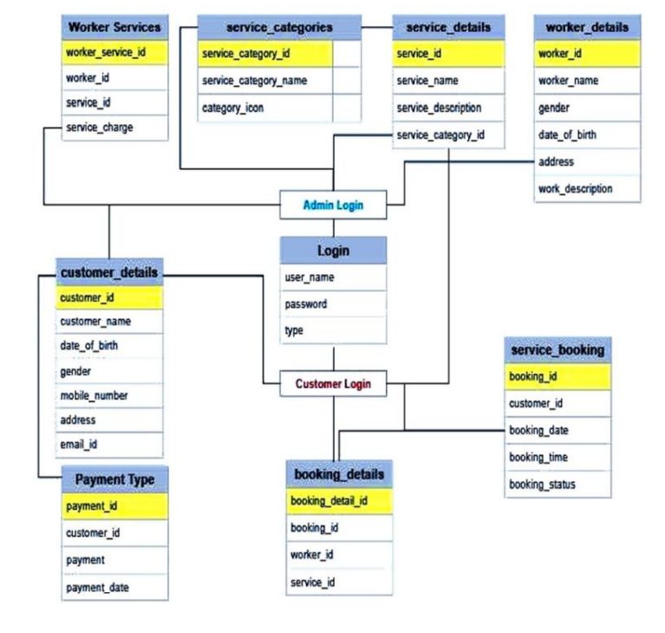

**CHAPTER 4: PROJECT SPECIFIC REQUIREMENTS**

**Software Requirements:**

* OS: Windows 7 or above
* Frontend: HTML, CSS, JavaScript
* Middleware: Php
* Backend: MySql
* web server: WAMP

**Why You Need WAMP, MySQL, and PHP?**

PHP is a powerful scripting language that can be run by itself in the command line of any computer with PHP installed. However, PHP alone isn't enough in order to build dynamic web sites. To use PHP on a web site, you need a server that can process PHP scripts. WAMP server allows developers to test PHP scripts locally; this makes it an invaluable piece of your local development environment.

Additionally, dynamic websites are dependent on stored information that can be and easily; this is the main difference between a dynamic site and a static HTML site. However, PHP doesn’t provide a simple, efficient way to store data. This is where a relational database management system like MySQL comes into play

.

**PHP:**

PHP originally stood for “Personal Home Page” and was released as a free, open source project. Over time, the language was reworked to meet the needs of its users. In 1997, PHP was renamed to the current “PHP: Hypertext Preprocessor”. PHP is generally used as a server-side scripting language; it is especially well-suited for creating dynamic web pages and client-side GUI applications. . PHP generally runs on a web server, taking PHP code as its input and creating web pages as output The scripting language features integrated support for interfacing with databases such as MySQL, which makes it a prime candidate for building all manner of web applications, from simple personal web sites to complex enterprise-level applications.

Unlike HTML, which is parsed by a browser when a page loads, PHP is preprocessed by the machine that serves the document (this machine is referred to as a server). All PHP code contained with the document is processed by the server before the document is sent to the visitor’s browser. PHP is a scripted language, which is another great advantage for PHP programmers. PHP can be deployed on most web servers, many operating systems and platforms, and can be used with many relational database management systems. It is available free of charge, and the PHP Group provides the complete source code for users to build, customize and extend for their own use. Many programming languages require that you compile files into machine code before they can be run, which is a time-consuming process. Bypassing the need to compile means you’re able to edit and test code much more quickly Because PHP is a server-side language, running PHP scripts on your local machine requires installing a server on your local machine.

PHP is free software released under the PHP License; however it is incompatible with the GNU General Public License (GPL), due to restrictions on the usage of the term PHP. It is a widely-used general-purpose scripting language that is especially suited for web development and can be embedded into HTML. It generally runs on a web server, taking PHP code as its input and creating web pages as output. It can be deployed on most web servers and on almost every operating system and platform free of charge. PHP is installed on more than 20 million websites and 1 million web servers.

**HTML:**

HTML means Hypertext Markup Language. HTML is a method of describing the format of document, which allows them to be viewed on computer screen. Web browsers display HTML documents, program which can navigate across networks and display a wide variety of types of information. HTML pages can be developed to be simple text or to be complex multimedia extra advantages containing, moving images, virtual reality, and java applets.

The global publishing format of the Internet is HTML. It allows authors to use not only text but also format that text with headings, list and tables, and also includes still images videos, and sound within text. Readers can access pages information from anywhere in the world at the click of mouse button information can be downloaded to readers own PC or workstations HTML pages can also be used for entering a data and as a front end for commercial transaction.

**MY SQL:**

SQL Server is a Relational Database Management System (RDBMS) that runs exclusively under the Windows operating system. One benefit of using Windows exclusively is that you can send and receive E-mail messages based on SQL Server "events" and you can also let the operating system handle login security. The data base is an organized collection of data. A database management system (DBMS) such as Access, FileMaker Pro, Oracle or SQL Server provides you with the software tools you need to organize that data in a flexible manner. It includes facilities to add, modify or delete data from the database, ask questions (or queries) about the data stored in the database and produce reports summarizing selected contents.

MySQL is a multithreaded, multi-user SQL database management system (DBMS). The basic program runs as a server providing multi-user access to a number of databases. Originally financed in a similar fashion to the JBoss model, MySQL was owned and sponsored by a single for-profit firm, the Swedish company MySQL now a subsidiary of Sun Micro system , which holds the copyright to most of the codebase.

**MySQL Functions:**

What is a database? Quite simply, it’s an organized collection of data. A database management system (DBMS) such as Access, FileMaker Pro, Oracle or SQL Server provides you with the software tools you need to organize that data in a flexible manner. It includes facilities to add, modify or delete data from the database, ask questions (or queries) about the data stored in the database and produce reports summarizing selected contents.

MySQL is a multithreaded, multi-user SQL database management system (DBMS). The basic program runs as a server providing multi-user access to a number of databases., MySQL was owned and sponsored by a single for-profit firm, the Swedish company MySQL now a subsidiary of Sun Micro system , which holds the copyright to most of the codebase. The project’s source code is available under terms of the GNU General Public License, as well as under a variety of proprietary agreements. MySQL is a database. The data in MySQL is stored in database objects called tables. A table is a collection of related data entries and it consists of columns and rows. Databases are useful when storing information categorically.

**CHAPTER 5: IMPLEMENTATION**

**SAMPLE CODE:** The sample code of admin page, customer details ,worker details and payment types are given below**.**

<!DOCTYPE html>

<?php include('medatada.php');?>

<?php include('header.php');?>

<?php include('sidebar.php');?>

<title>Home Services</title>

<html xmlns="http://www.w3.org/1999/xhtml">

<body>

<!-- /. NAV SIDE -->

<div id="page-wrapper">

<div id="page-inner">

<div class="row">

<div class="col-md-12">

<h1 class="page-header">

<strong>Welcome to Admin</strong>

<img src="../img/Home.png" width="1007" height="555">

<?php include('footer.php');?> <!-- End Hover Rows -->

</div>

<div class="col-md-6">

<!-- Context Classes -->

<div class="panel panel-default">

</div>

<!-- end Context Classes -->

</div>

</div>

</body>

</html>

<form name="form1" id="formID" method="post" action="customers_details_insert.php">

<table align="center" class="table table-striped table-bordered table-hover">

<tr>

<td width="176">Customer name </td>

<td width="268"><input type="text" name="customer_name" class ="validate[required] form-control"></td>

</tr>

<tr>

<td>Date Of Birth </td>

<td><input type="date" name="dob" class="form-control"></td>

</tr>

<tr>

<td>Gender</td>

<td><input name="gender" type="radio" value="male">

male

<input name="gender" type="radio" value="female">

female</td>

</tr>

<tr>

<td>Address</td>

<td><textarea name="address" class="form-control"></textarea></td>

</tr>

<tr>

<td>Mobile No </td>

<td><input type="text" name="mobile_no" class="form-control"></td>

</tr>

<tr>

<td>E-mail id </td>

<td><input type="text" name="email"class="validate[required,custom[email] form-control"></td>

</tr>

<tr>

<td colspan="2"><blockquote>

<p>

<input type="submit" name="Submit" value="Submit" class="btn btn-primary">

<input type="reset" name="Reset" value="Reset" class="btn btn-danger">

</p>

</td>

</tr>

</table>

</form>

<form name="form1" id="formID" method="post" action="workers_service_insert.php">

<table align="center" class="table table-striped table-bordered table-hover">

<tr>

<td width="213">Worker Name</td>

<td width="290"><select name="worker_id" class="form-control">

<?php

include("dbconnect.php");

$sql1="select *from worker_details";

$res1= mysqli_query($conn,$sql1);

while($row1=mysqli_fetch_array($res1))

{

?>

<option value="<?php echo $row1['worker_id'];?>"><?php echo $row1['worker_name'];?></option>

<?php } ;?>

</select></td>

</tr>

<tr>

<td>Service Name</td>

<td><select name="service_id" class="form-control">

<?php

include("dbconnect.php");

$sql2="select *from service_details";

$res2= mysqli_query($conn,$sql2);

while($row2=mysqli_fetch_array($res2))

{

?>

<option value="<?php echo $row2['service_id'];?>"><?php echo $row2['service_name'];?></option>

<?php } ;?>

</select></td>

</tr>

<tr>

<td>Service Charge </td>

<td><input type="text" name="service_charge" class="validate[required] form-control"></td>

</tr>

<tr>

<td colspan="2"><blockquote>

<p>

<input type="submit" name="Submit" value="Submit" class="btn btn-primary">

<input type="reset" name="Reset" value="Reset" class="btn btn-danger">

</p>

</td>

</tr>

</table>

<form name="form1" id="formID" method="post" action="payment_type_insert.php">

<table align="center" class="table table-striped table-bordered table-hover">

<tr>

<td width="230">Customer Name</td>

<td width="323"><select name="customer_id">

<?php

include("dbconnect.php");

$sql="select * from customer_details";

$res=mysqli_query($conn,$sql);

while($row=mysqli_fetch_array($res))

{

?>

<option value="<?php echo $row['customer_id'];?>"><?php echo $row['customer_name'];?></option>

<?php } ;?>

</select></td>

</tr>

<tr>

<td>Payment</td>

<td><input type="text" name="payment" class="form-control"></td>

</tr>

<tr>

<td>Payment Date </td>

<td><input type="date" name="payment_date"class ="validate[required] form-control"></td>

</tr>

<tr>

<td>Payment Mode </td>

<td><input type="text" name="payment_mode"class ="validate[required] form-control"></td>

</tr>

<tr>

<td colspan="2"><blockquote>

<p>

<input type="submit" name="Submit" value="Submit" class="btn btn-primary" >

<input type="reset" name="Reset" value="Reset" class="btn btn-danger">

</p>

</td>

</tr>

</table>

<!DOCTYPE html>

<?php include('medatada.php');?>

<?php include('header.php');?>

<?php include('sidebar.php');?>

<title>Home Services</title>

<html xmlns="http://www.w3.org/1999/xhtml">

<body>

<!-- /. NAV SIDE -->

<div id="page-wrapper">

<div id="page-inner">

<div class="row">

<div class="col-md-12">

<h1 class="page-header">

<strong>Welcome to Admin</strong>

</h1>

<img src="../img/Home.png" width="1007" height="555">

<?php include('footer.php');?> <!-- End Hover Rows -->

</div>

<div class="col-md-6">

<!-- Context Classes -->

<div class="panel panel-default">

</div>

<!-- end Context Classes -->

</div>

</div>

<!-- /. ROW -->

</div>

</body>

</html>

**CHAPTER 6: RESULTS**

SCREEN SHOTS OF IMPLEMENTED CODE:

Home Page:

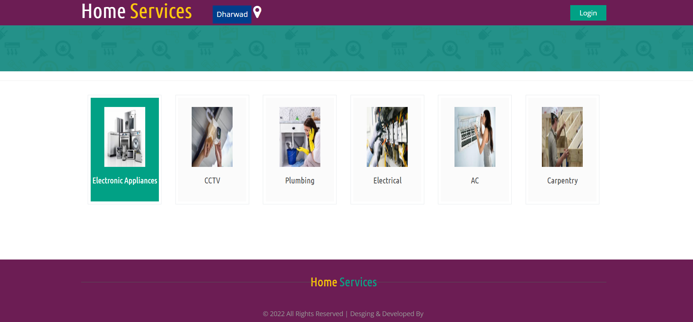

Admin login Page:

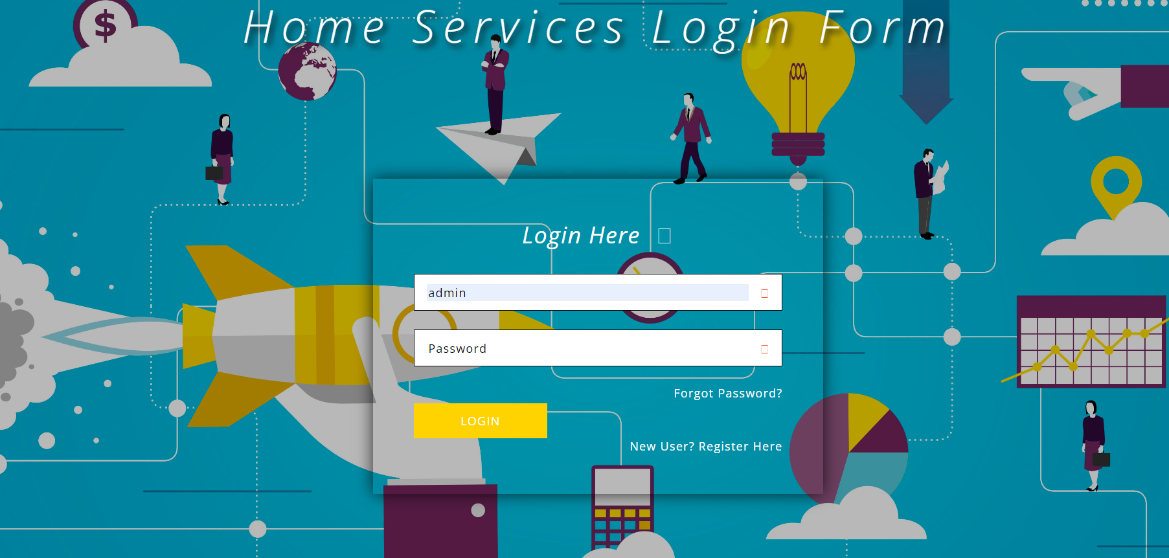

Customer Registration:

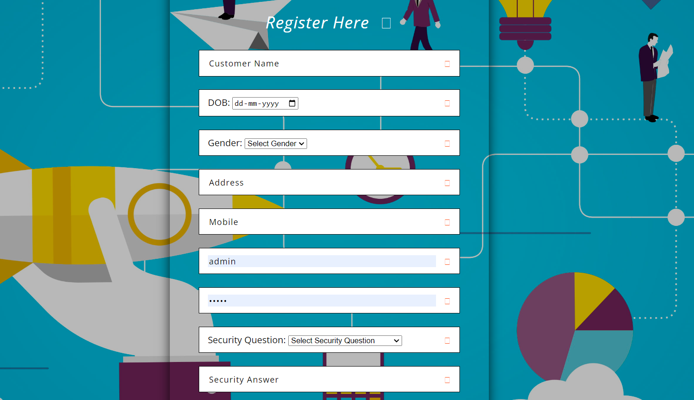

Customer Details Form:

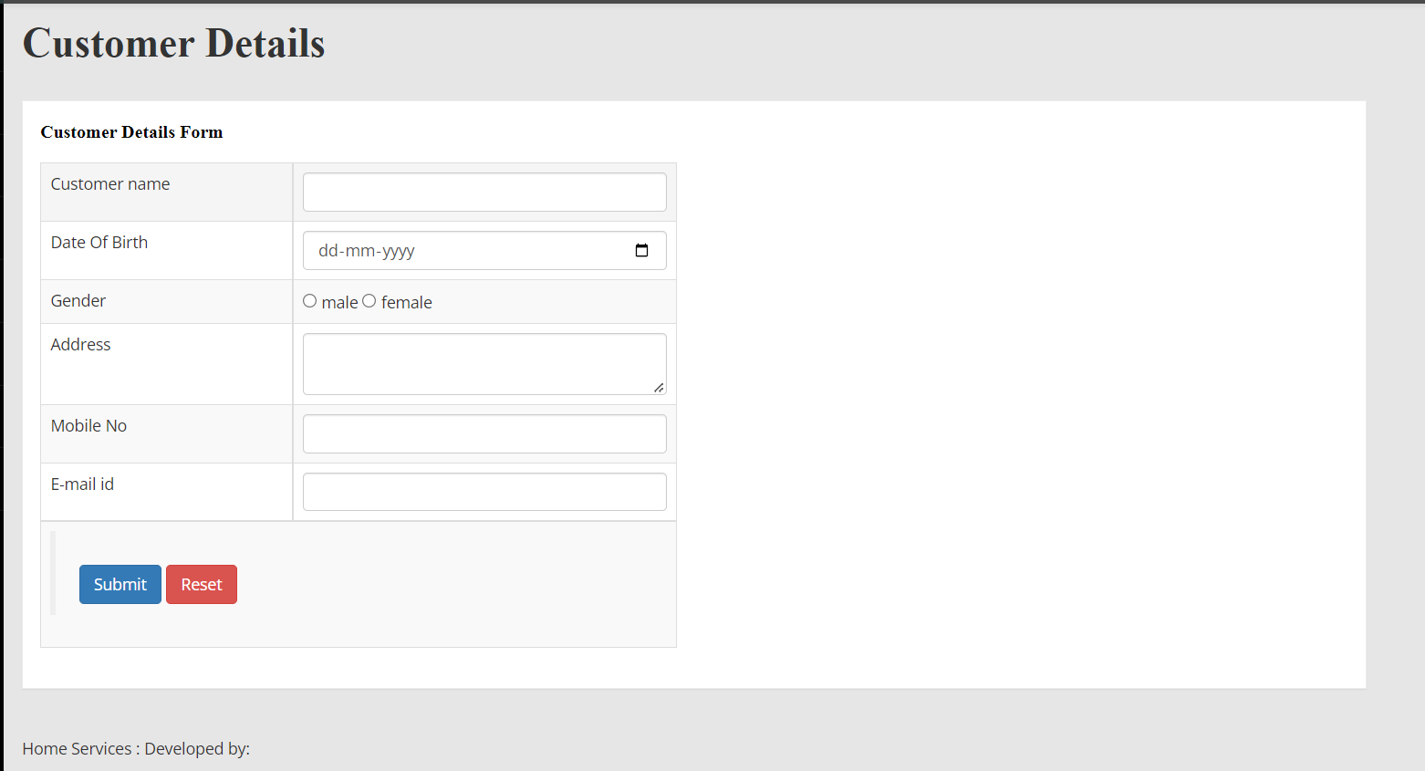

Worker Details Form:

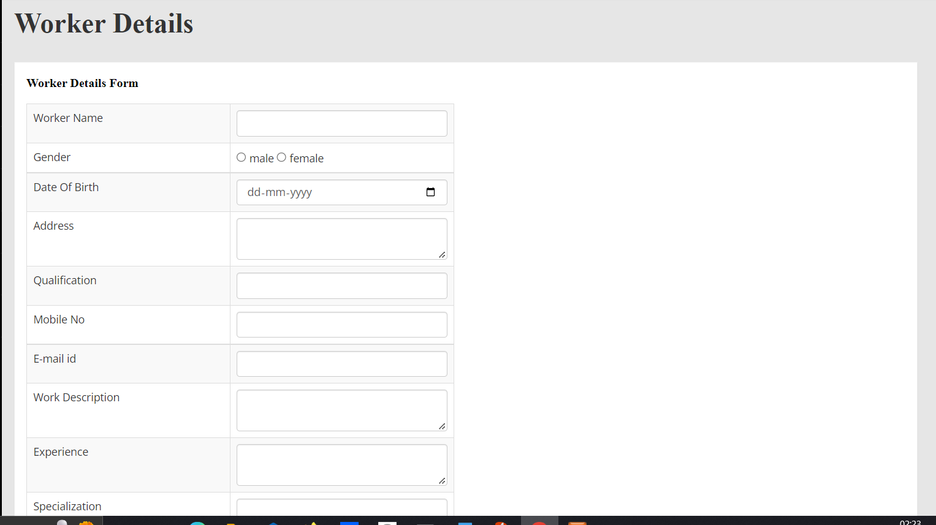

Service Booking Form:

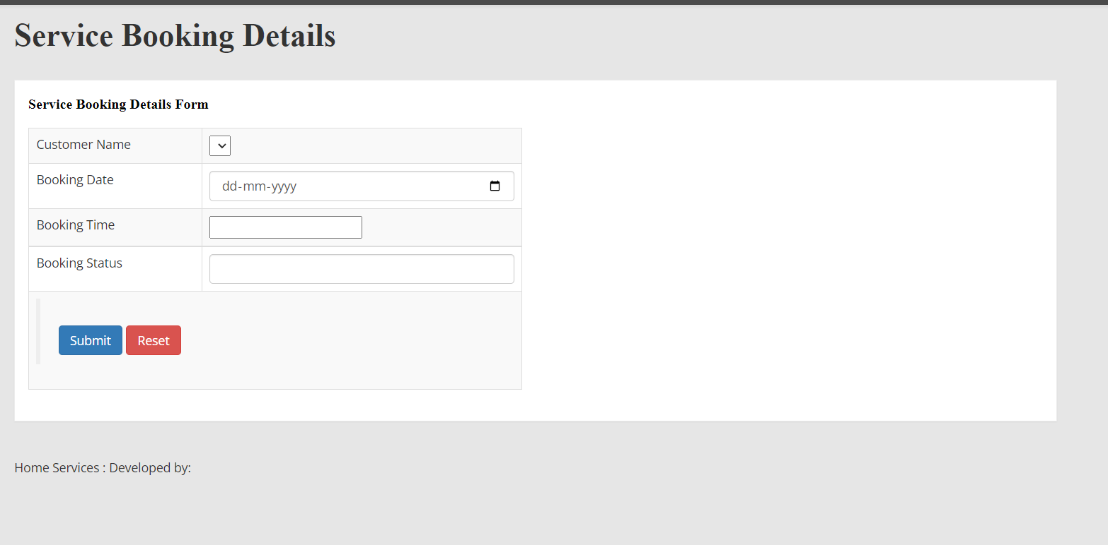

Online Payment:

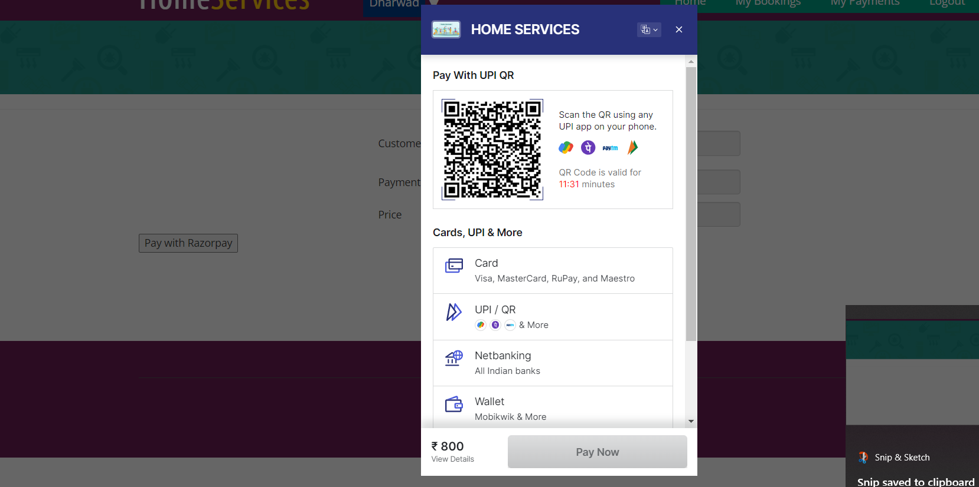

Service selection:

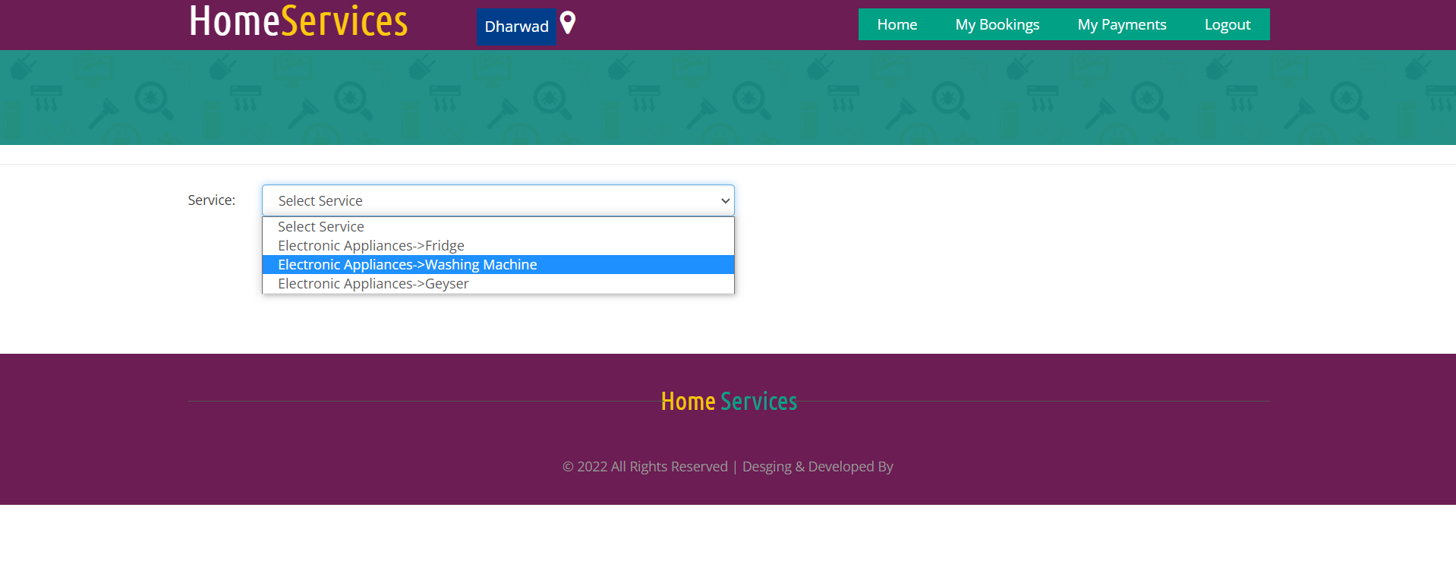

Forgot password:



Email and password sent to registered mail:

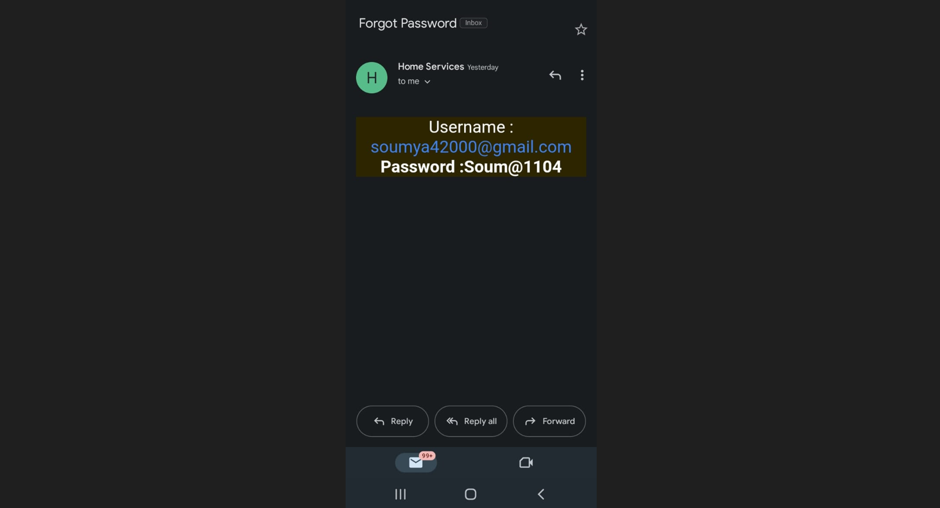

**CHAPTER 7: CONCLUSION AND FUTURE SCOPE**

An application is developed which provide online service booking and will provide a good user friendly interface for booking the services and give a security. Provides notification so that user keep updated everytime and help the people and the society.

The scope of our project is to designing a complete environment to provide a safe and user friendly environment for online service booking. The main aim of the project is to provider an easy to use application for services provided for customer. We often get frustrated while taking the appointment of service provider because there the many problems are occur, like the service provider is busy art somewhere else or his not receiving our call or his cost is very high according to problem. So in this project we will remove this headache.

**REFERENCES:**

[1] Shahrzad Shahriari, Mohammadreza Shahriari, Saeid gheiji. “ ECommerce And It Impactson Global Trend And Market”.International Journal of Research – Granthaalayah. Vol.3 (Iss.4): April, 2015.

[2] L.RichardYe, Yue Jeff Zhang, Dat-DaoNguyen, James Chiu,“Fee-based online services: Exploring consumers’willingness to pay ”. Journal of International Technologyand Information Management.

[3] Bo Zhang, Ruihan Yong, Meizi Li, Jianguo Pan, Jifeng Huanglaa, “ A Hybrid Trust Evaluation Framework for Ecommerce in Online Social Network: ”. 2169-3536 (c) 2016 IEEE. Translations and content mining are permitted for academic research