I have been working on my personal project that includes web scrapping of finn.no. To begin with, I wanted to tell you about the main purpose of the project.

Main Idea:

I started with parsing finn.no to get following details:
1. Houses sold.
2. Upcoming visnings.
3. Price Ups and Downs on a house.

Users can look up through the data collected using date filters.

Statistics:
Statistics include graphical representation of the following data.
1. Realestates added to finn.no.
2. Houses sold on finn.no.

Reports:
Reports include the info about the realestates that were filtered through the date. There are two views that user can browse through. Map View and List View(default).
1. View the sold houses on a specific date.
2. View the visnings planned on a specific date.
3. View the realestates added on a specific date.
4. View the price changes on a particular house.

So to focus on the main purpose here, it might be useful for the users to:
- browse through sold houses on a date and see the price on which the house was sold.
- sold houses list also contains all the information about scheduled visnings. It makes it easier to find out if the house was sold or not after the scheduled visning.
- to schedule a future visnings because users can filter visnings on the basis of the date.
- to view the price ups and downs on a house along with the date it was changed. Also which price it got sold and what were all the visnings on that house.

Screenshots of the website:
Here are some screenshots of what the website does:

STATISTICS

- Realestates added on finn.no on the dates.
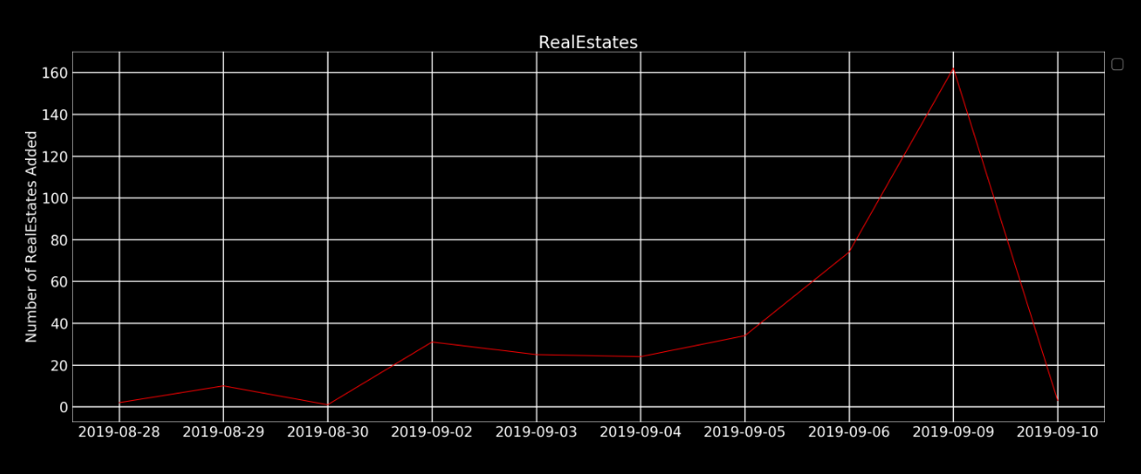

- Houses sold on the dates.
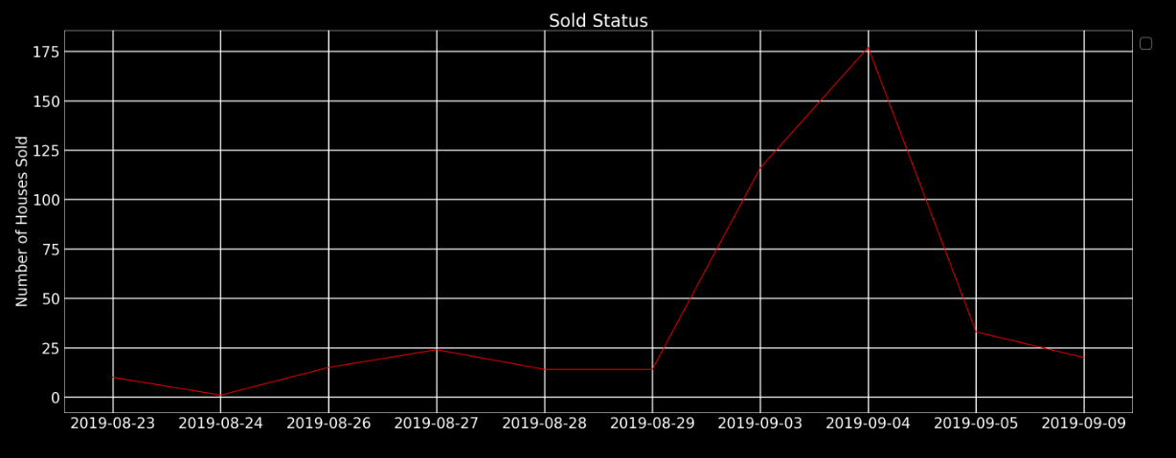

REPORTS

- User can browse through the data collected using date filter.

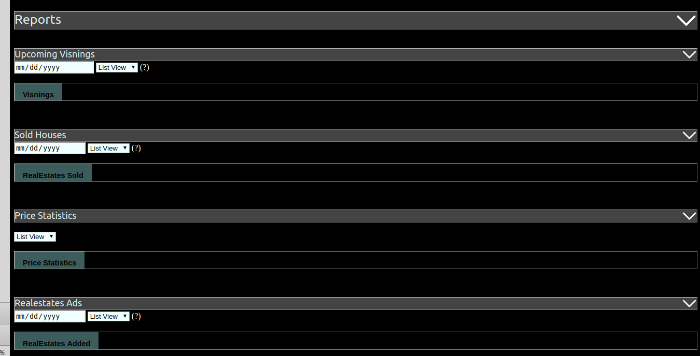

VISNINGS

- View the upcoming visning scheduled on a selected date.
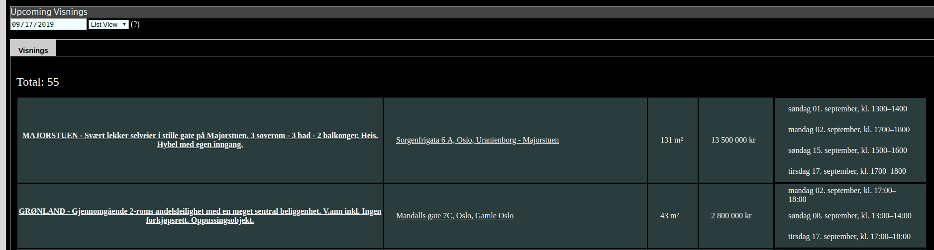

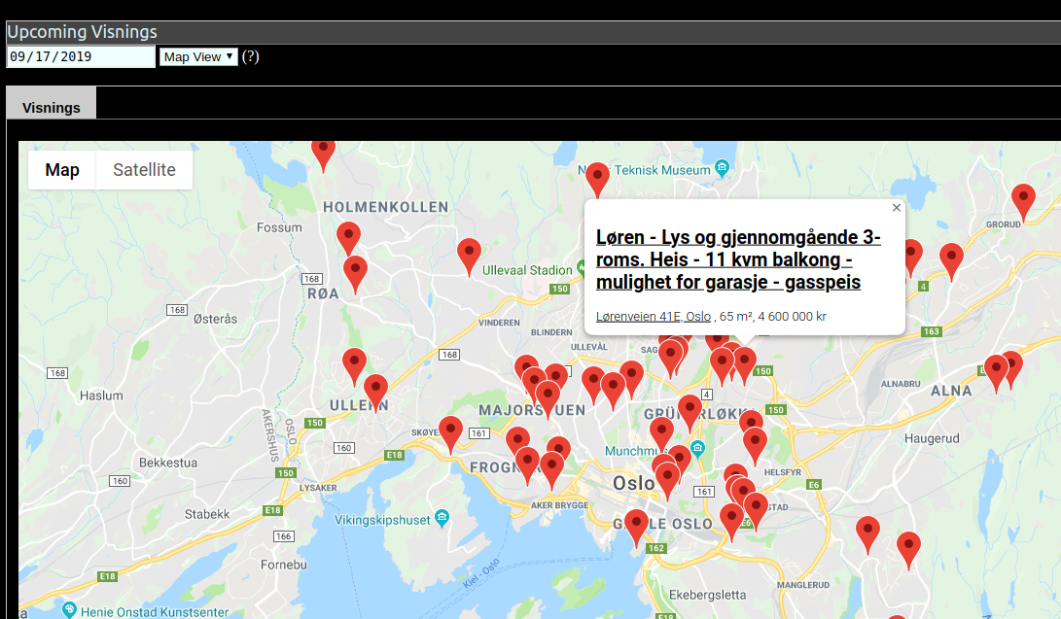
- Map View of the visning. Click on the location to view the details.

SOLD HOUSES

- Sold houses on that date along with their visning dates.
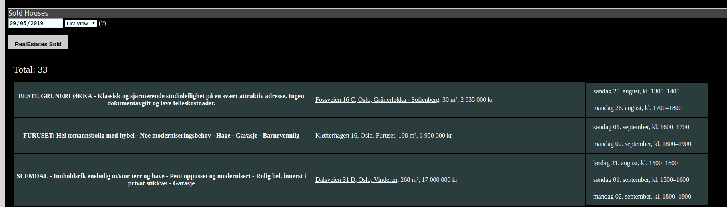

- Map view of the sold houses.
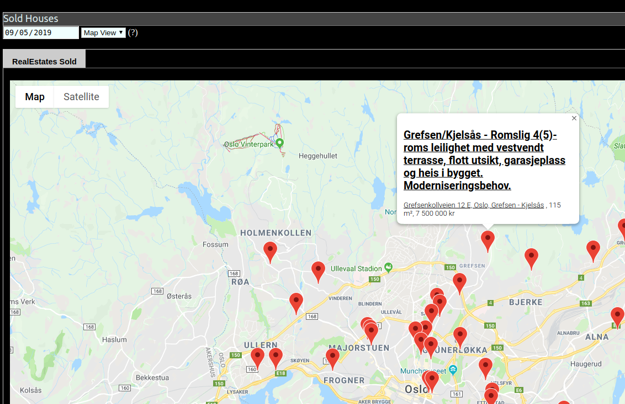

PRICE CHANGES

- Price changes on a house along with their visning info and sold status.
