Project Architecture

This project consists of 3 applications.
- scan finn.no and collect the data.
- display the results. The front end website for the users.
- schedule the scan.

Scan and collect the data

Logic:
This app as of now scans Oslo area for realestates ads. It doesn’t include any new buildings. To begin with, it will collect the links of the ads and stores them. Then the application picks each link stored and scans them for sold status, visnings, price and basic info like area, address, description.
For visnings and price changes, the same ads are scanned again and again and changes are being recorded. The Google Map Api has been implemented inside this code to calculate all the coordinates of the addresses. This is stored in the json along with other details.

Deployment:
This app has been deployed on Microsoft Azure and Google cloud (currently active here). It uses
Azure blob storage to store data in the Json. Since I haven’t scanned enough data, this storage works fine for me. If I continue with this project, I might need to move it to a bigger storage.

Display the data

Logic:
This app queries the blob storage for the data and formats and displays it on the website.
It also includes the filtering data using the input date and plotting map using the coordinates. The user can click on the location and can view the relevant details.

Deployment:
The app can be easily deployed on Microsoft Azure platform but currently it is active on Google Cloud.

Schedule the scan.

Logic:
This app sends requests to the app that scans the data to start scanning. It is scheduled to run every 3 hours that is very easy to reconfigure.

Deployment:
It is deployed on Microsoft Azure as a function timer app. Its working as expected to haven’t thought about migrating it to Google cloud.

Deployment Summary

The major apps (scan and display) were initially deployed on Microsoft Azure but I have moved them to the Google Cloud. The timer function that schedules the scan still runs on Azure. I am also using Azure blob storage to store my jsons.

Source Code

The project is available on GitHub.

Performance

Over the span of two months, this project has gone through many architectural changes. I have been continuously looking for opportunities to improve the performance. I have lots of challenges to discuss that I had faced before. I started this with deploying it in my local machine. Later I decided to move it to the cloud so that I can automate everything. I faced few challenges with the availability and performance. But all worked out in the end. I chose Azure initially as I had the free tier. Then I moved it to Google App Engine. Its deployed there currently.

Future Plans

- As of now the only filter available to date. But other filters like date range, area, price can be implemented.
- As the scanned data grows, I might have to move it out of the blob storage to some big data store.
- When the data becomes huge, the scanning will probably take a lot of time. Right now it takes around 7-8 minutes to scan around 420 pages, so around 60 pages/min.

DESIGN



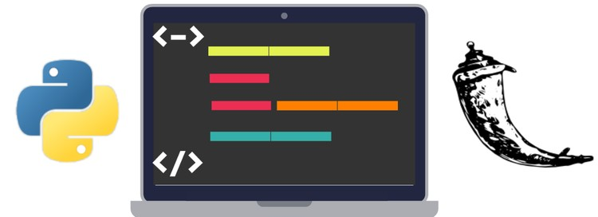
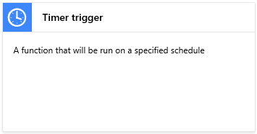
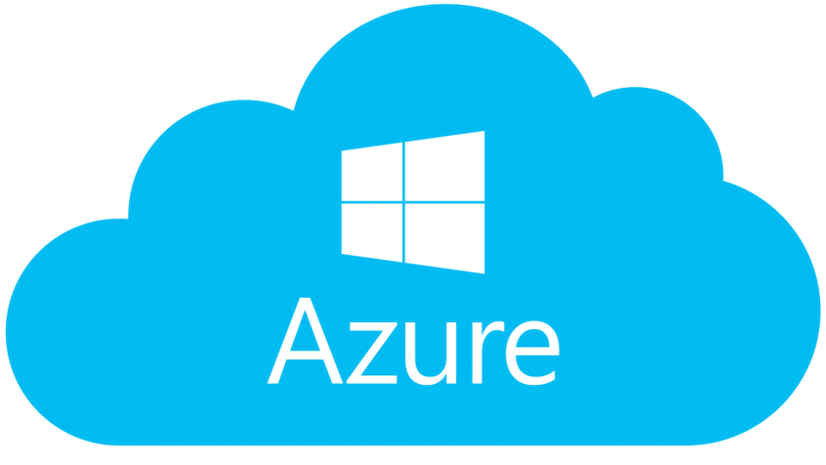

Schedules web scrapping
Scans and stores data in Azure blob
Scans and stores data in Azure blob
Queries Data from Azure Blob and displays

