Marine Trace AI: An End-to-End System for SAR Oil Spill Detection, Look-Alike Discrimination and AIS-Based Polluter Attribution
Soumyaranjan Satapathy
MCA (Machine Learning), Centurion University of Technology and Management
Bhubaneswar, Odisha, India
[e-mail address]
[Guide name], [Designation]
[Department], Centurion University of Technology and Management
Bhubaneswar, Odisha, India

Abstract—Operational oil spill monitoring needs more than a detector: an analyst must know whether a dark patch on a radar image is really oil, which ship is likely to have caused it, and where the oil will go next. This paper presents Marine Trace AI, an end-to-end system that combines Sentinel-1 synthetic aperture radar (SAR), Automatic Identification System (AIS) ship tracks and reanalysis weather in one workflow. Spills are segmented by an ensemble of U-Net, DeepLabV3+ and SegFormer models trained on the public SOS dataset; the best single model reaches an oil intersection-over-union (IoU) of 0.770 and an oil F1-score of 0.870 on 839 held-out images. A second stage tests every detection against wind, contrast, edge, shape and texture evidence to flag look-alikes. Detected slicks are back-tracked with a particle drift model, and candidate ships are ranked by a gradient-boosted model that reaches 72.4% top-1 and 87.6% top-3 accuracy on 250 synthetic test cases, against 57.2% and 69.2% for a hand-written rule baseline, with SHAP explanations for each suspect. The system also forecasts 72-hour drift, estimates landfall and threatened sites, and supports investigation through a web platform with alerts, evidence packages and analyst feedback. Case studies on the 2021 Huntington Beach pipeline spill and the 2025 MSC ELSA 3 sinking off Kerala, and an honest validation against NOAA drifters and an expert-labelled look-alike dataset, show both the strengths of the approach and where it still fails.
Index Terms—oil spill detection, synthetic aperture radar, Sentinel-1, semantic segmentation, AIS, vessel attribution, drift modelling, explainable AI.
I. Introduction
Oil discharged at sea, whether from accidents or from illegal tank washing, harms marine life, fisheries and coastal economies. Spaceborne SAR is the main tool for oil spill surveillance because it works day and night and through cloud: oil damps the short capillary waves that scatter radar energy back to the sensor, so a slick appears as a dark patch on a brighter sea [1], [2]. Free and open Sentinel-1 data now make routine monitoring possible even for organisations with small budgets.
Detection alone, however, does not answer the questions enforcement agencies ask. Many dark patches are look-alikes—areas of low wind, rain cells, natural biogenic films or current fronts—that are hard to separate from oil [2], [3]. When a slick is real, the agency needs to know which ship was nearby, and coastal authorities need to know where the oil is heading. In practice these steps are done by different people with different tools, which slows the response.
This work, carried out for Smart India Hackathon problem statement SIH26143, builds a single system that links these steps. Its contributions are: (i) an ensemble SAR segmentation pipeline with radiometric calibration and a physically based look-alike check; (ii) an attribution module that back-tracks a slick with wind and current data and ranks candidate ships from AIS with an explainable learning-to-rank model; (iii) a drift forecast with landfall and sensitive-site impact; (iv) a complete web platform for monitoring, case management and evidence export; and (v) a candid evaluation that includes negative results, such as a look-alike model that does not transfer between regions.
II. Related Work
A. SAR Oil Spill Detection
Early systems segmented dark spots by adaptive thresholding and classified them with hand-crafted features and statistical classifiers [3]. Deep learning replaced much of this pipeline: Krestenitis et al. released a Sentinel-1 dataset with oil, look-alike, ship and land classes and compared encoder–decoder networks on it [4]. Zhu et al. introduced the SOS dataset of 8,070 Sentinel-1 and ALOS PALSAR patches from the Gulf of Mexico and the Persian Gulf with a contextual, boundary-supervised network [5]. Common architectures are FCN [10], U-Net [6], DeepLabV3+ [7] and, more recently, transformer models such as SegFormer [8] and Swin [9].
B. Look-Alike Discrimination
Look-alikes are the main source of false alarms. Classic approaches use wind speed (oil is best seen between about 3 and 10 m/s), contrast to the surrounding sea, edge gradient and shape descriptors [2], [3]. Yang and Singha recently published an expert-checked Sentinel-1 dataset of 3,225 oil slicks and 2,290 look-alike patches from the Eastern Mediterranean [12], which we use to train and test a learned look-alike model.
C. Drift Modelling and Polluter Identification
Oil at the surface moves with the current plus roughly 3% of the 10-m wind speed (windage) [21]. Running this model backward in time from a detected slick gives a source region that can be matched to AIS ship tracks. Trajectory forecasts are usually judged by the separation from real drifter tracks and by the skill score of Liu and Weisberg [18]. Most published work treats detection, attribution and forecasting separately; the aim here is to integrate them and to rank suspects with an explainable machine-learning model [14]–[16].
III. System Overview
Fig. 1 shows the workflow. Sentinel-1 Ground Range Detected (GRD) scenes are searched and downloaded from the Copernicus Data Space Ecosystem, either on demand or by a scheduler that watches user-defined monitoring zones (for example Mumbai, Kochi or Paradip). Each scene is calibrated, filtered and segmented; every detected patch passes through the look-alike check. Wind and current fields for the scene time and area are downloaded automatically. For each oil polygon the system back-tracks the slick, ranks candidate ships, forecasts its drift for 72 hours and creates an incident with a priority score. Analysts review incidents in a web application, and their decisions are stored as feedback for retraining.
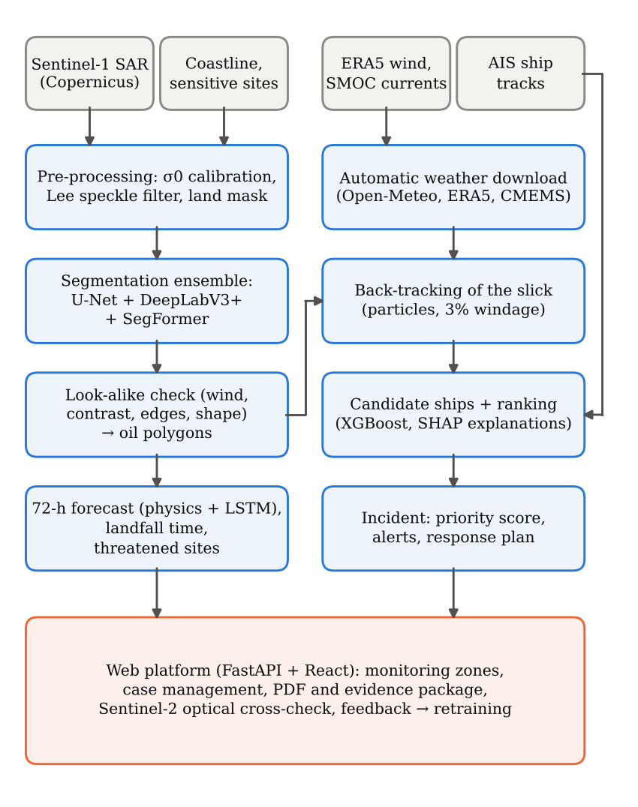
Fig. 1. Marine Trace AI workflow: data sources (grey), processing modules (blue) and the analyst-facing platform (orange).
IV. Methods
A. Data
Five data sources are used. (1) The SOS dataset [5] (256 × 256 pixel patches with binary oil masks) for training and testing the segmentation models; 839 patches are kept for testing. (2) Sentinel-1 IW GRD scenes for the case studies. (3) AIS ship positions from MarineCadastre CSV files and, for live monitoring, the AISStream service. (4) ERA5 10-m wind [13] and Copernicus Marine SMOC surface currents, obtained through the Open-Meteo archive or directly from the Copernicus services. (5) NOAA Global Drifter Program hourly tracks [22] for drift validation and the Yang–Singha dataset [12] for look-alike learning. Coastlines and a list of sensitive sites (ports, mangroves, marine protected areas, offshore platforms) support land masking and impact assessment.
B. Pre-processing and Calibration
Digital numbers (DN) are converted to the radar backscatter coefficient σ⁰ using the calibration and thermal-noise look-up tables in the SAFE product [19]:
σ⁰ = (DN² − N) / A_{σ}² (1)
where N is the noise power and Aσ the sigma-nought calibration value, both interpolated bilinearly from the annotation grids. Because the segmentation models were trained on DN-derived images, the model input remains the dB image of the DN values, while σ⁰ in dB is stored separately for physical interpretation. A Lee speckle filter [11] is applied, the area of interest is cropped and down-sampled to at most 2048 pixels on its longer side, and land is masked with a coastline layer.
C. Segmentation Ensemble
Five architectures were trained on SOS with the same split: FCN with a ResNet-34 encoder, U-Net (ResNet-34), DeepLabV3+ (ResNet-50), SegFormer (MiT-B1) and Swin-Tiny. Training used batch size 16, 20–30 epochs and learning rates of 1×10⁻⁴ (6×10⁻⁵ for SegFormer). The deployed detector averages the oil probabilities of U-Net, DeepLabV3+ and SegFormer; the per-pixel spread between the three models is shown to the analyst as an uncertainty map, and patches where the models disagree strongly are flagged. Connected oil regions smaller than 60 pixels are discarded, and the remaining regions are converted to polygons with area, elongation, confidence and an order-of-magnitude volume range.
D. Look-Alike Check
Each detected patch is scored by a second stage that uses evidence the segmentation models do not see directly: wind speed at the patch (from the downloaded weather), contrast to a 10-pixel ring of surrounding sea, border gradient relative to the background gradient (edge sharpness), elongation, size and internal texture. Each piece of evidence adds to or subtracts from an oil score that starts at 0.5, and every adjustment is shown to the analyst with a plain-language reason. Scores of 0.6 or more are labelled Likely oil, below 0.4 Likely look-alike, and Uncertain in between. Two wind rules were added after the Kerala case study: above 10 m/s slicks break up and rain cells or wind shadows dominate, so the score is lowered (−0.05 up to 12 m/s, −0.15 above), and very large dark areas are rejected when the local wind at that area, not only at the scene centre, is strong.
A learned model was also trained on the Yang–Singha dataset [12]. Each oil slick (inside its expert bounding box) and each dark area in the look-alike patches was described by ten scale-free measurements at a common pixel size of about 80 m, giving 2,987 oil and 6,178 look-alike samples from 405 satellite passes. Its results and its limits are discussed in Section V-D.
E. Drift, Back-Tracking and Forecasting
The slick is represented by particles that move with the surface current uc and a windage fraction α of the 10-m wind u10:
dx/dt = u_{c}(x, t) + α u₁₀(x, t), α = 0.03 (2)
with a small random walk for turbulent diffusion. Integrating (2) backward over the 12 hours before the image gives a time-dependent source corridor; integrating it forward gives the 72-hour forecast, the first landfall time and the sensitive sites inside the forecast area. An LSTM [17] with 32 hidden units, driven by the same wind and current fields, was trained to emulate and refine the physical model for fast forecasts.
F. Vessel Attribution
AIS tracks are cleaned (duplicates, impossible speeds) and filtered to ships whose interpolated positions pass through the back-tracked corridor within the time window. For each candidate, nine features are computed: overlap with the corridor, minimum distance, alignment of the track with the slick axis, hours before the image, longest AIS gap (possible 'dark' behaviour), speed ratio inside versus outside the slick area, loitering time, ship-type risk and ship length. Known fixed structures such as platforms and pipelines are checked separately. Three rankers were compared: XGBoost [14], LightGBM LambdaRank [15] and a cross-attention model [20] in which ship features attend to a spill-and-environment context. Because labelled real cases are rare, the rankers were trained on 1,000 synthetic cases built from real AIS tracks: a randomly chosen moving ship 'discharges' oil for 0.5–2 h, the oil drifts under a random wind and current until a simulated satellite pass 1–8 h later, and all other ships in the area act as decoys; 250 cases were held out for testing. SHAP values [16] explain each suspect's rank in the incident view and in the PDF report.
G. Platform
The backend is written in FastAPI with SQLAlchemy and the frontend in React with Leaflet maps. It provides monitoring zones and a satellite feed, live AIS display, incidents with priority (Critical/High/Medium/Low), alerts by dashboard, e-mail and Telegram, case management with assignment and deadlines, a response plan with the nearest Indian Coast Guard resources and cost estimate, PDF reports and evidence packages with SHA-256 file fingerprints, English and Hindi summaries, a Sentinel-2 optical cross-check, and an analyst feedback loop that exports reviewed cases and retrains the models from the web interface.
V. Experiments and Results
A. Segmentation
Table I lists the test results of the five architectures on the 839 SOS test patches. U-Net, DeepLabV3+, SegFormer and Swin-Tiny perform within one IoU point of each other, all clearly ahead of the FCN baseline. All models show higher recall (about 0.92) than precision (about 0.82): they rarely miss oil but sometimes mark dark sea as oil, which motivates the second-stage look-alike check.
TABLE I
Segmentation results on the SOS test set (839 patches)
Model (encoder) | mIoU | Oil IoU | Prec. | Recall | F1
FCN (ResNet-34) | 0.721 | 0.668 | 0.722 | 0.899 | 0.801
U-Net (ResNet-34) | 0.815 | 0.770 | 0.822 | 0.924 | 0.870
DeepLabV3+ (ResNet-50) | 0.810 | 0.765 | 0.817 | 0.923 | 0.867
SegFormer (MiT-B1) | 0.814 | 0.769 | 0.828 | 0.915 | 0.869
Swin-Tiny | 0.812 | 0.767 | 0.819 | 0.924 | 0.868
The ensemble itself was not scored separately on SOS; it is used for its stability and for the uncertainty map it provides.
B. Vessel Attribution
On the 250 held-out synthetic cases, the candidate filter kept the true polluter in 93.7% of cases. Fig. 2 compares the rankers. XGBoost ranked the polluter first in 72.4% of cases and in the top three in 87.6%, an improvement of 15.2 and 18.4 points over the rule baseline. The most important features were overlap with the drift corridor (0.335), speed ratio (0.321) and loitering time (0.110), which matches the behaviour of a ship discharging while slowing down along the slick.
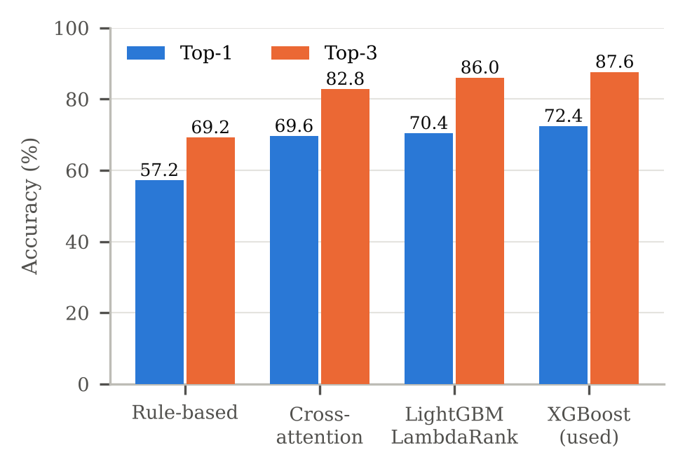
Fig. 2. Top-1 and top-3 accuracy of the attribution rankers on 250 held-out synthetic cases.
C. Drift Forecast
On 120 test sequences generated with the physical model and real forcing, the LSTM reproduced positions with a mean error of 0.06–0.07 km at 6–24 h, against 1.2–6.1 km for persistence (no movement). This only shows that the LSTM emulates the physical model well. A harder test used 30 real 72-hour drifter segments in the Arabian Sea (2022) [22] (Table II). Here the model was slightly worse than assuming no movement (60.9 km versus 57.9 km after 72 h), and adding 1% wind made it worse. The drifters moved 66.9 km on average, so neither method is good; the likely cause is the coarse resolution of the free current data. This is an important limitation for operational use.
TABLE II
Mean separation from 30 NOAA drifter segments (km)
Forecast | 24 h | 48 h | 72 h | Skill
Current only (model) | 25.5 | 44.0 | 60.9 | 0.03
Current + 1% wind | 27.5 | 47.6 | 66.3 | 0.00
No movement | 20.9 | 40.3 | 57.9 | 0.11
D. Look-Alike Model
Table III shows 5-fold cross-validation on the Yang–Singha samples, grouped by satellite pass so that no pass appears in both training and testing. Gradient boosting reached an AUC of 0.992 and an accuracy of 96.2%, against 0.734 and 41.9% for the rule-based check; edge sharpness was by far the most useful measurement. These scores are probably optimistic, because the oil samples come from expert boxes while the look-alike samples were extracted automatically.
TABLE III
Oil versus look-alike, unseen satellite passes
Method | AUC | Accuracy | F1 (oil)
Rule-based check | 0.734 | 0.419 | 0.511
Logistic regression | 0.984 | 0.950 | 0.922
Gradient boosting | 0.992 | 0.962 | 0.941
The model did not transfer to our own scenes. On the confirmed Huntington Beach slicks (Section V-E) it gave oil probabilities of 0.00–0.03 to the three patches that the rule-based check rated as likely oil, even after the image was resampled to the training pixel size. The Mediterranean model has therefore been kept for information only: its output is shown to the analyst but does not change the oil score. Training on images from more regions is left for future work.
E. Case Studies
Huntington Beach, California, 2021. A damaged offshore pipeline released crude oil in San Pedro Bay in early October 2021 [23]. On the Sentinel-1B image of 3 October 2021 (01:49 UTC), the system found five dark areas; the rule-based check rated three of them (4.4, 2.6 and 0.3 km²) as likely oil and two as look-alikes, one of which (23.5 km²) was also flagged as low reliability. 881 ships were present in the AIS data. Because the real source was a pipeline and not a discharging ship, this case tests detection and the fixed-structure check rather than ship attribution. A second image 12 hours later could not validate the forecast, because the wind had dropped to 0.6 m/s and the whole sea appeared dark.
MSC ELSA 3, Kerala, 2025. The container ship sank about 14.6 nautical miles off the Kerala coast on 25 May 2025 with roughly 84 t of diesel and 367 t of fuel oil on board, and slicks were reported in the following days [24]. On the Sentinel-1A image of 28 May 2025 the first version of the system marked several very large dark areas as oil. The wind at the scene was 12.4 m/s during the monsoon, and the dark areas were most likely rain cells and wind shadows. After the per-area wind rules were added, the large areas were rejected; the largest remaining detection (35.6 km², 9.50° N, 75.76° E) was labelled Uncertain with low reliability, and most others were labelled look-alikes. No AIS data were available for this area, and no cloud-free Sentinel-2 image covered it because it lies more than 20 km offshore. This case shows why a wind-aware check is essential in monsoon conditions.
VI. Discussion and Limitations
The system is useful as a decision-support tool, but several limitations remain. First, the attribution model was trained and tested on synthetic cases; its real-world accuracy can only be measured with confirmed enforcement cases. Second, drift accuracy is limited by the resolution of freely available current data, as the drifter test shows. Third, look-alike discrimination remains the weakest point: a learned model that looks excellent in cross-validation failed on a different region, which underlines the need to test on independent data. Fourth, SAR cannot measure oil thickness, so volumes are given only as a wide range. Finally, AIS can be switched off; the system flags AIS gaps but cannot identify a ship that never transmitted.
VII. Conclusion and Future Work
Marine Trace AI joins SAR spill detection, look-alike screening, drift back-tracking, explainable ship ranking, forecasting and case management in one open-source workflow built only on free data. The segmentation ensemble reaches an oil F1-score of about 0.87, the attribution ranker improves top-1 accuracy by 15 points over rules on synthetic cases, and the platform turns these results into incidents an analyst can act on. Future work will collect confirmed cases from enforcement agencies to train and test attribution on real data, train the look-alike model on scenes from Indian waters, use higher-resolution regional current models, and add SAR-based ship detection to find vessels without AIS.
Acknowledgment
The author thanks the project guide for support, and ESA/Copernicus, ECMWF, Copernicus Marine, NOAA, MarineCadastre, Open-Meteo and the authors of the SOS and Yang–Singha datasets for making their data freely available.
References
[1] M. Fingas and C. Brown, “Review of oil spill remote sensing,” Mar. Pollut. Bull., vol. 83, no. 1, pp. 9–23, 2014.
[2] C. Brekke and A. H. S. Solberg, “Oil spill detection by satellite remote sensing,” Remote Sens. Environ., vol. 95, no. 1, pp. 1–13, 2005.
[3] A. H. S. Solberg, G. Storvik, R. Solberg, and E. Volden, “Automatic detection of oil spills in ERS SAR images,” IEEE Trans. Geosci. Remote Sens., vol. 37, no. 4, pp. 1916–1924, 1999.
[4] M. Krestenitis, G. Orfanidis, K. Ioannidis, K. Avgerinakis, S. Vrochidis, and I. Kompatsiaris, “Oil spill identification from satellite images using deep neural networks,” Remote Sens., vol. 11, no. 15, Art. 1762, 2019.
[5] Q. Zhu et al., “Oil spill contextual and boundary-supervised detection network based on marine SAR images,” IEEE Trans. Geosci. Remote Sens., vol. 60, Art. 5213910, 2022.
[6] O. Ronneberger, P. Fischer, and T. Brox, “U-Net: Convolutional networks for biomedical image segmentation,” in Proc. MICCAI, 2015, pp. 234–241.
[7] L.-C. Chen, Y. Zhu, G. Papandreou, F. Schroff, and H. Adam, “Encoder-decoder with atrous separable convolution for semantic image segmentation,” in Proc. ECCV, 2018, pp. 801–818.
[8] E. Xie et al., “SegFormer: Simple and efficient design for semantic segmentation with transformers,” in Proc. NeurIPS, 2021.
[9] Z. Liu et al., “Swin Transformer: Hierarchical vision transformer using shifted windows,” in Proc. ICCV, 2021, pp. 10012–10022.
[10] J. Long, E. Shelhamer, and T. Darrell, “Fully convolutional networks for semantic segmentation,” in Proc. CVPR, 2015, pp. 3431–3440.
[11] J.-S. Lee, “Digital image enhancement and noise filtering by use of local statistics,” IEEE Trans. Pattern Anal. Mach. Intell., vol. PAMI-2, no. 2, pp. 165–168, 1980.
[12] Y.-J. Yang, S. Singha, R. Goldman, and F. Schütte, “Dataset of oil slicks, look-alikes and remarkable SAR signatures obtained from Sentinel-1 data in the Eastern Mediterranean Sea,” Earth Syst. Sci. Data, vol. 17, pp. 6807–6837, 2025.
[13] H. Hersbach et al., “The ERA5 global reanalysis,” Q. J. R. Meteorol. Soc., vol. 146, no. 730, pp. 1999–2049, 2020.
[14] T. Chen and C. Guestrin, “XGBoost: A scalable tree boosting system,” in Proc. ACM SIGKDD, 2016, pp. 785–794.
[15] G. Ke et al., “LightGBM: A highly efficient gradient boosting decision tree,” in Proc. NeurIPS, 2017.
[16] S. M. Lundberg and S.-I. Lee, “A unified approach to interpreting model predictions,” in Proc. NeurIPS, 2017.
[17] S. Hochreiter and J. Schmidhuber, “Long short-term memory,” Neural Comput., vol. 9, no. 8, pp. 1735–1780, 1997.
[18] Y. Liu and R. H. Weisberg, “Evaluation of trajectory modeling in different dynamic regions using normalized cumulative Lagrangian separation,” J. Geophys. Res., vol. 116, C09013, 2011.
[19] N. Miranda and P. J. Meadows, “Radiometric calibration of S-1 Level-1 products generated by the S-1 IPF,” ESA, Tech. Note ESA-EOPG-CSCOP-TN-0002, 2015.
[20] A. Vaswani et al., “Attention is all you need,” in Proc. NeurIPS, 2017.
[21] M. Reed et al., “Oil spill modeling towards the close of the 20th century: Overview of the state of the art,” Spill Sci. Technol. Bull., vol. 5, no. 1, pp. 3–16, 1999.
[22] R. Lumpkin and M. Pazos, “Measuring surface currents with Surface Velocity Program drifters,” in Lagrangian Analysis and Prediction of Coastal and Ocean Dynamics. Cambridge, U.K.: Cambridge Univ. Press, 2007, pp. 39–67.
[23] National Transportation Safety Board, “Anchor strike of underwater pipeline and eventual crude oil release, San Pedro Bay, California, October 1, 2021,” Marine Investigation Report MIR-24-01, 2024.
[24] Cedre, “MSC Elsa 3,” incident information sheet, Cedre, Brest, France, 2025.

