
ADVANCED EXCEL PROJECT REPORT
Sales Revenue Dashboard with KPI Tracker
Advanced Excel Dashboard & Analytics Project

Project Information | Details
Student Name | Soumya Roy
AF Code | AF05332103
Project Title | Sales Revenue Dashboard with KPI Tracker
Project Duration | 4 days
Trainer Name | Sayan Sau
Submission Date | 02.09.2026
GitHub Username | Soumya2-Roy
GitHub Repository Link | https://github.com/Soumya2-Roy/Sales-Revenue-Dashboard-with-KPI-Tracker/tree/main

1. Project Objective
The main objective of this project is to transform an transaction-level Sales Data dataset into an interactive Excel-based analytics solution. The workbook summarizes revenue, orders, customer activity, product performance, regional performance, payment methods and customer segments. An interactive dashboard provides KPI cards, charts and slicers so that users can explore the data and identify important business trends.

2. Tools & Technologies Used
- Microsoft Excel workbook with structured Excel Table (SalesData).
- Structured references and Excel formulas for KPI calculations.
- SUM for total revenue and quantity calculations.
- COUNTA for order counts.
- SUMPRODUCT with COUNTIF for distinct customer counting.
- AVERAGE for average customer rating.
- Pivot-style backend summaries for category, month, region, product, payment method and customer segment analysis.
- Charts/PivotCharts: monthly revenue trend, revenue by category, top products by revenue, revenue by region, revenue by customer segment and payment method distribution.
- Interactive slicers for Category, City, Customer Segment, Order Status, Payment Method and Region.
- Data Dictionary sheet for documenting the meaning of dataset columns.

3. Dataset Description
The workbook uses an transaction-level Sales Data dataset containing 9,993 transaction records. The records cover orders dated from 2020 to 2023. The dataset combines order details, customer attributes, geography, product information, payment details, order status, ratings and calculated sales measures.
Attribute | Dataset Detail
Records | 9,993 sales records
Fields / Measures | Order Date, Customer Name, State, Category, Sub-Category, Product Name, Sales, Quantity, Profit
Customers | 793 unique customers
Products | Product-level records in the Sales Data sheet
Categories | Technology, Furniture, Office Supplies
Geography | State-level analysis
Time Period | 2020–2023
States | multiple states
Payment methods | Sales, Quantity and Profit measures
Order statuses | Not applicable to this sales dataset
Customer segments | Customer-level analysis
Date range | January–August 2026

4. Workbook Structure
Sheet | Purpose
Dashboard | Management dashboard containing KPI cards and analytical charts.
Sales Data | Primary transaction-level source dataset used for all calculations.
Supporting summaries | Aggregated values used for dashboard visualizations.
Analysis | Supporting grouped analysis for year, month, category, state and customer.
Dashboard Data | Supporting aggregated values used for dashboard visuals.
Data Definitions | Definitions used for source fields and KPI calculations.

5. Key Features
Feature | Implementation / Purpose
KPI Dashboard | Displays Total Sales, Total Profit, Orders, Customers, Units Sold and Average Order Value.
Year-wise Analysis | Compares sales and profit across 2020–2023.
Monthly Trend | Shows monthly sales movement and identifies high-sales periods.
Category Analysis | Compares Technology, Furniture and Office Supplies by sales and profit.
Sub-Category Analysis | Ranks major sub-categories by sales and compares profit contribution.
State Analysis | Compares sales, profit and order volume across states.
Customer Analysis | Identifies customers with the highest profit contribution.
Management View | Combines key KPIs and charts into a single decision-support view.
Data Documentation | The Data_Dictionary sheet explains every source and calculated field.

6. Formula & Calculation Logic
KPI / Measure | Formula Logic Used
Total Sales | SUM of Sales column
Total Profit | SUM of Profit column
Total Orders | Count of transaction records
Unique Customers | Unique count of Customer Name
Units Sold | SUM of Quantity
Average Order Value | Total Sales ÷ Total Orders
Profit Margin | Total Profit ÷ Total Sales
The workbook also contains calculated source columns for Gross Sales, Discount Amount and Sales. According to the Data Dictionary, Gross Sales is Quantity × Unit Price, Discount Amount is Gross Sales × Discount, and Sales is Gross Sales − Discount Amount + Shipping Cost.

7. Key Analytical Results
Metric | Result
Total Sales | $2,296,919.70
Total Profit | $286,409.85
Profit Margin | 12.5%
Total Orders | 9,993
Unique Customers | 793
Units Sold | 37,871
Average Order Value | $229.91
Highest Sales Year | 2023 — $733,215.19
Highest Sales Category | Technology — $836,154.10
Highest Sales State | New Delhi — $502,576.82
Highest Profit Customer | Tamara Chand — $8,981.32
Highest Sales Sub-Category | Phones — $330,007.10
These results are calculated from the 100 records in Raw_Data and the supporting dashboard/backend summaries. They provide a concise view of the strongest categories, products, regions, customer segments and months in the dataset.

8. Dashboard Overview
The dashboard combines KPI cards, trend analysis and category/product/region/customer/payment visualizations. The workbook also contains Excel slicer objects for interactive filtering.
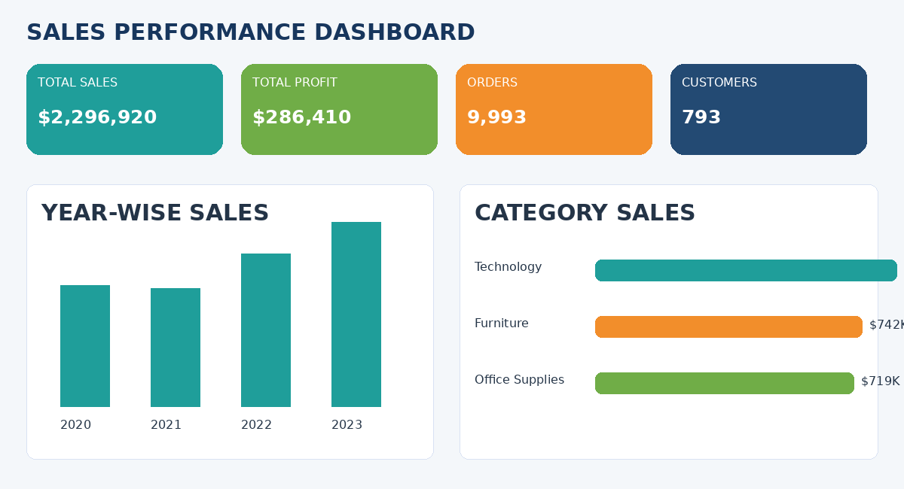
Figure 1. Sales dashboard management overview.
Note: the screenshot is an exported preview. Some Excel slicer objects are not rendered by non-Excel spreadsheet exporters; the original workbook should be opened in Microsoft Excel to view and operate the slicers.

9. Learning Outcome
- Learned how to organize and document a structured e-commerce dataset in Excel.
- Practiced using structured references and formulas to create dynamic KPI calculations.
- Learned how to summarize large datasets using PivotTable-style analysis and supporting backend summaries.
- Developed skills in selecting appropriate charts for trend, comparison and distribution analysis.
- Learned how Excel slicers can make dashboards interactive and user-friendly.
- Improved dashboard layout, formatting, readability and business-oriented data presentation.
- Understood how a Data Dictionary improves clarity and maintainability of an analytical workbook.

10. Conclusion
The Sales Performance Dashboard & Analytics project converts raw order-level information into a structured and interactive Excel analytics solution. The final workbook provides clear KPIs and multiple visual analyses for revenue, products, categories, regions, customer segments and payment methods. With slicer-based filtering and documented calculations, the dashboard supports faster exploration of the dataset and demonstrates practical application of Advanced Excel skills.

11. Project File / Source Submission

Item | Details
Project Source | Sales Revenue Dashboard with KPI Tracker
Primary Data Source | Sales Data sheet
Project Name | Sales Performance Dashboard & Analytics

12. Trainer Verification
Trainer Remarks
Signature | ____________________________

