**New-York-Restaurants**

***Goal: To find the best dinner spots in the city***

|  |
| --- |
| **neighborhood** |
| Brooklyn |
| Midtown |
| Chinatown |
| Uptown |
| Queens |
| Downtown |

1. **Distinct neighborhoods**

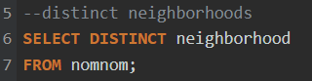

|  |
| --- |
| **cuisine** |
| Steak |
| Korean |
| Chinese |
| Pizza |
| Ethiopian |
| Vegetarian |
| Italian |
| Japanese |
| American |
| Mediterranean |
| Indian |
| Soul Food |
| Mexican |

1. **Distinct Cuisines**

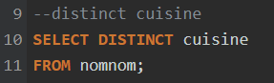

1. **What are our options for Chinese takeout?**

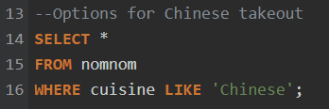

|  |  |  |  |  |  |
| --- | --- | --- | --- | --- | --- |
| **name** | **neighborhood** | **cuisine** | **review** | **price** | **health** |
| Nom Wah Tea Parlor | Chinatown | Chinese | 4.2 | $ | A |
| Nan Xiang Xiao Long Bao | Queens | Chinese | 4.2 | $ | A |
| Mission Chinese Food | Downtown | Chinese | 3.9 | $$ | A |
| Baohaus | Downtown | Chinese | 4.2 | $ | A |
| Xi'an Famous Foods | Midtown | Chinese | 4.4 | $ | A |
| Sonnyboy's | Brooklyn | Chinese | 4.2 | $$ | A |
| Great NY Noodletown | Chinatown | Chinese | 4.1 | $$ | B |
| Golden Unicorn | Chinatown | Chinese | 3.8 | $$ | A |
| Wo Hop | Chinatown | Chinese | 4.2 | $$ | 0 |
| Ping's Seafood | Chinatown | Chinese | 4.2 | $$ | A |
| XO Kitchen | Chinatown | Chinese | 4 | $ | B |

1. **Restaurants with reviews of 4 and above**

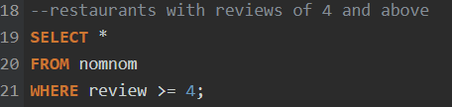

* Here, restaurants **‘Russ & Daughters’**, **‘Lighthouse’**, **‘Bunna Café’** has the highest review of 4.6.

1. **If X and Y want to have a fancy dinner date IN the restaurants that are Italian and $$$**

|  |  |  |  |  |  |
| --- | --- | --- | --- | --- | --- |
| **name** | **neighborhood** | **cuisine** | **review** | **price** | **health** |
| al di la Trattoria | Brooklyn | Italian | 4.4 | $$$ | A |
| Locanda Vini & Olii | Brooklyn | Italian | 4.4 | $$$ | A |
| Rao's | Uptown | Italian | 4.2 | $$$ | A |
| Carbone | Downtown | Italian | 4.3 | $$$ | A |
| I Sodi | Downtown | Italian | 4.5 | $$$ | A |
| Lilia | Brooklyn | Italian | 4.4 | $$$ | A |

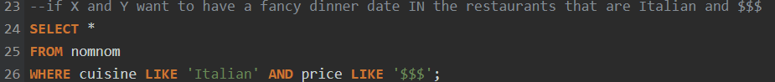

1. **Restaurant name which contains the word ‘meatball’ in it**

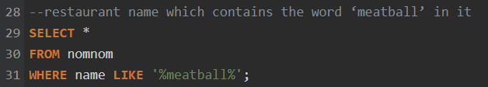

|  |  |  |  |  |  |
| --- | --- | --- | --- | --- | --- |
| **name** | **neighborhood** | **cuisine** | **review** | **price** | **health** |
| The Meatball Shop | Downtown | American | 4.2 | $ | A |

1. **All close by spots in Midtown, Downtown or Chinatown**

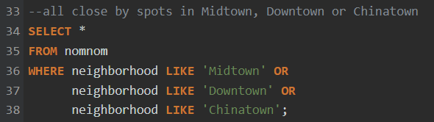

|  |  |  |  |  |  |
| --- | --- | --- | --- | --- | --- |
| **name** | **neighborhood** | **cuisine** | **review** | **price** | **health** |
| Jongro BBQ | Midtown | Korean | 4.5 | $$ | A |
| Pocha 32 | Midtown | Korean | 4 | $$ | A |
| Nom Wah Tea Parlor | Chinatown | Chinese | 4.2 | $ | A |
| Buddha Bodai | Chinatown | Vegetarian | 4.2 | $$ | A |
| Mission Chinese Food | Downtown | Chinese | 3.9 | $$ | A |
| Baohaus | Downtown | Chinese | 4.2 | $ | A |
| Minca | Downtown | Japanese | 4.4 | $$ | A |
| Kenka | Downtown | Japanese | 4.3 | $ | B |
| Yakitori Taisho | Downtown | Japanese | 4.1 | $ | B |
| Xi'an Famous Foods | Midtown | Chinese | 4.4 | $ | A |
| Shake Shack | Midtown | American | 4.4 | $ | A |
| The Halal Guys | Midtown | Mediterranean | 4.4 | $ | A |
| Foodcademy | Midtown | American | 4.4 | $$ | A |
| Scorpio Sisters | Downtown | American | 4.2 | $$ | A |
| Great NY Noodletown | Chinatown | Chinese | 4.1 | $$ | B |
| Golden Unicorn | Chinatown | Chinese | 3.8 | $$ | A |
| Wo Hop | Chinatown | Chinese | 4.2 | $$ | 0 |
| Kang Ho Dong Baekjeong | Midtown | Korean | 4.3 | $$$ | C |
| Dan and John's Wings | Downtown | American | 4.5 | $ | A |
| Ping's Seafood | Chinatown | Chinese | 4.2 | $$ | A |
| XO Kitchen | Chinatown | Chinese | 4 | $ | B |
| Carbone | Downtown | Italian | 4.3 | $$$ | A |
| I Sodi | Downtown | Italian | 4.5 | $$$ | A |
| Jajaja | Downtown | Vegetarian | 4.5 | $$ | A |
| Smalls Jazz Club | Downtown | American | null | $$ | A |
| Russ & Daughters | Downtown | American | 4.6 | $$ | A |
| The Meatball Shop | Downtown | American | 4.2 | $ | A |
| Dirt Candy | Downtown | Vegetarian | 4.4 | $$$ | A |
| Ippudo | Downtown | Japanese | 4.4 | $$ | A |
| Marea | Midtown | Italian | 4.5 | $$$$ | A |
| The Standard Biergarten | Downtown | American | 4 | $$ | A |
| Ootoya | Downtown | Japanese | 4.5 | $$ | A |

1. **Top 10 Restaurants Ranking based on reviews**

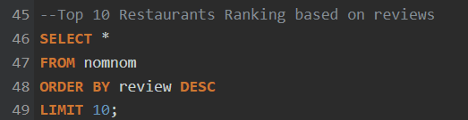

* The top 10 restaurants are **‘Bunna Café’**, **’Russ & Daughters’**, **’Lighthouse’**, **’Jongro BBQ’**, **’Dan and John's Wings’**, **’I Sodi’** ,**’Jajaja’**, **’St. Anselm’**, ’**Marea**’, **’Ootoya’**.

1. **Using a CASE statement to change the rating system**

